3GPP TSG-RAN WG4 Meeting #110bis R4-2408945
Changsha, China, 15th – 19th April, 2024

Agenda item: 10.13.4
Source: Moderator (CMCC)
Title: Topic summary for [111][134] FS_Ambient_IoT_solutions_part1
Document for: Information

Introduction
This way forward captures the agreements for co-existence evaluation for Rel-19 ambient IOT study item.
The summary in RAN4#111 is R4-2408945. The way forward agreed in RAN4#110bis is in R4-2406714.

Deployment scenarios and spectrum usage

Topic 2-1: Deployment scenario
Issue 2-1-1: deployment scenarios for D1T1
Agreement in RAN4#110bis:
Issue 2-1-1: deployment scenarios for D1T1
Option 1-1: Legacy NR gNB are outdoor macro gNB while AIoT reader/CW/devices are all indoors. Legacy NR UE is only allowed outdoors.
Option 1-2: Legacy NR gNB are outdoor macro gNB while AIoT reader/CW/devices are all indoors. Legacy NR UE is indoor accessing to outdoor NR marco gNB
Option 2-1: Legacy NR gNB are co-located with AIoT reader and CW. All of NR and AIoT BS/UE/Reader/Device/CW are indoors. AIoT reader /CW and Legacy gNB share same hardware
Option 2-2: Legacy NR gNB are co-located with AIoT reader and CW. All of NR and AIoT BS/UE/Reader/Device/CW are indoors. AIoT reader /CW and Legacy NR gNB do not share same hardware. (less limitation on the power boosting)
Agreement:
- RAN4 to first evaluate co-existence for deployment scenario of option 1-1 and 1-2, and further study option 2-1 and 2-2.
Issue 2-3-2: Priorities of spectrum deployment mode for co-existence evaluation
Agreement:
- Prioritize the following spectrum deployment mode for RAN4 co-existence evaluation
  - A-IoT is located within a NR transmission bandwidth configuration
  - A-IoT which is operating indoor shares in-band spectrum with outdoor macro BS

Agreement in RAN4#111:
- Consider only adjacent RB/channel co-existence evaluation for in-band deployment scenario for NR and AIOT
- Encourage companies to provide the simulation results for option 1-1 and 1-2
  - FFS on co-site scenario (option 2-1 and 2-2)
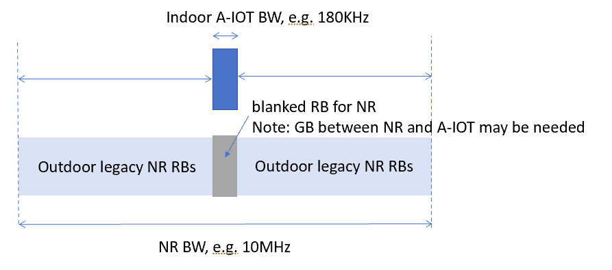

Issue 2-1-2: deployment scenarios for D2T2
Agreement in RAN4#110bis:
Option 1-1: Legacy NR gNB are outdoor macro gNB, AIoT intermediate UE/CW/devices are all indoors. Legacy NR UE is only allowed outdoor.
Option 1-2: Legacy NR gNB are outdoor macro gNB, AIoT intermediate UE/CW/devices are all indoors. Legacy NR UE is indoor.
Agreement:
- For D2T2 co-existence evaluation, Legacy NR gNB are outdoor macro gNB, AIoT intermediate UE/CW/devices are all indoors.
  - Consider option 1-1 and option 1-2 as the starting point

Topic 2-2: Spectrum usage
Issue 2-2-1: Spectrum usage for R2D in D1T1
Agreement in RAN4#110bis:
- FFS on whether to prioritize FDD DL spectrum for R2D for D1T1 for co-existence evaluation.

Agreement in RAN4#111:
- Use FDD DL as starting point for co-existence evaluation for R2D in D1T1
  - FFS on FDD UL spectrum.

Issue 2-2-2: Spectrum usage for CW transmission in D1T1 for the case that D2R backscattering is transmitted in the same carrier as CW for D2R backscattering
Agreement in RAN4#110bis:
For the case that D2R backscattering is transmitted in the same carrier as CW for D2R backscattering, and for topology 1, the following cases for CW transmission are studied.
· Case 1-1: CW is transmitted from inside the topology, transmitted in DL spectrum
· Case 1-2: CW is transmitted from inside the topology, transmitted in UL spectrum
· Case 1-4: CW is transmitted from outside the topology, transmitted in UL spectrum

Agreement:
- For the case that D2R backscattering is transmitted in the same carrier as CW for D2R backscattering, consider the following for co-existence evaluation
  - CW transmits in either UL or DL spectrum
  - FFS on inside topology and outside topology.

Agreement in RAN4#111:
- Use inside topology as starting point for co-existence evaluation (case 1-1, case 1-2) for calibration.
- Further discuss the difference of outside topology (case 1-4) from co-existence study perspective.

Issue 2-2-4: Spectrum usage for R2D in D2T2
Agreement in RAN4#110bis:
- Use FDD UL spectrum for R2D in D2T2.

Issue 2-2-5: Spectrum usage for CW transmission in D2T2 for the case that D2R backscattering is transmitted in the same carrier as CW for D2R backscattering
Agreement in RAN4#110bis:
For the case that D2R backscattering is transmitted in the same carrier as CW for D2R backscattering, and for topology 2, the following cases for CW transmission are studied.
· Case 2-2: CW is transmitted from inside the topology (i.e., intermediate UE), transmitted in UL spectrum
· Case 2-3: CW is transmitted from outside the topology, transmitted in DL spectrum
· Case 2-4: CW is transmitted from outside the topology, transmitted in UL spectrum
Agreement:
- For the case that D2R backscattering is transmitted in the same carrier as CW for D2R backscattering
  - Use UL spectrum as the starting point for co-existence evaluation.
    - It won’t preclude the use of DL for backscattering transmission.
    - FFS on the minimum distance between the intermediate UE and A-IoT device

Tentative Agreement:
- Use case 2-2 as starting point for co-existence evaluation for calibration.
  - FFS on case 2-3
- Further discuss the difference of outside topology (case2-4) from co-existence study perspective.

Issue 2-2-6: Minimum distance between intermediate UE and device
Agreement in RAN4#111:
- Use 1m as starting point for minimum distance between intermediate UE and device.

Evaluation methodology and cases

Topic 3-1: Evaluation methodology
Issue 2-4-1: Evaluation methodology
Agreement in RAN4#110bis:
- Use the Monte-Carlo method as baseline for co-existence evaluation, i.e. Section 5.3 in TR38.803
- Depending on the discussion on deployment scenarios, for some cases, calculation for the worst interference link may be enough.
- FFS on whether RAN4 needs to perform link level simulation

Agreement in RAN4#111:
- Use the Monte-Carlo method as baseline for co-existence evaluation, i.e. Section 5.3 in TR38.803
- Depending on the discussion on deployment scenarios, for some cases, calculation for the worst interference link may be enough.
- FFS on whether RAN4 needs to perform link level simulation

Issue 2-4-2: Performance metric for AIOT
Agreement in RAN4#110bis:
- For NR system, use 5% throughput loss as performance metric as legacy.
- For AIOT system, including reader, device, intermediate UE, further discuss the performance metric:
  - Option 1: [10%] BLER, [Rx power]
  - Option 2: SINR degradation
  - Other options are precluded

Agreement in RAN4#111:
- Use [SINR/SIR] for calibration purpose
  - FFS on the details of SINR definition
- FFS on performance metric for co-existence evaluation and requirements definition.

Issue 2-4-2: SINR definition for D2R
Agreement in RAN4#111:
Do not consider CW interference for calibration purpose for D1T1-A2 and D2T2-A2
FFS on how to consider CW cancellation capability in formal simulation

Issue 2-4-2: SINR definition for R2D
RAN1 agreement (R4-2403815):
Proposal#5 (V05r1)
For the R2D LLS for ED, report followings (as start point).
- CINR/CNR, where CINR/CNR is defined as the ratio of signal power spectral density in the transmission bandwidth to the noise and interference (if any) power spectral density in the device ED channel bandwidth.
- signal transmission bandwidth
- ED channel bandwidth
FFS: exact definition of ED channel bandwidth for RF-ED, IF receiver
FFS: which and how to report for R2D ZIF receiver and D2R

Agreement in RAN4#111:
Use RAN1 definition of CINR/CNR for R2D link evaluation.

Topic 3-2: Evaluation cases
Issue 3-2-1: device type
Agreement in RAN4#110bis:
- Prioritize device 1 and 2a without a frequency shifter for coexistence evaluation.

Issue 3-2-4: Evaluation cases for D1T1 for device 1 and 2a between NR and AIOT
Agreement in RAN4#111:
Use the following cases for calibration purposes.
Deployment scenario and topology | spectrum | aggressor | victim
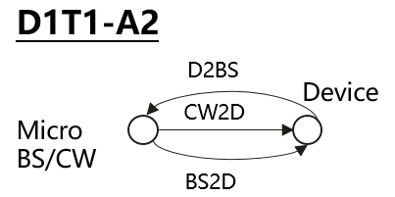  · Case 1-1: CW is transmitted from inside the topology, transmitted in DL spectrum | R2D: DL  CW2D and D2R: UL | CW and/or device | NR UL
 |  | NR UL | device and/or reader
 |  | reader | NR DL
 |  | NR DL | device
 | R2D: DL  CW2D and D2R: DL | CW and/or device | NR DL
 |  | NR DL | device and/or reader

Issue 3-2-5: Evaluation cases for D2T2 for device 1 and 2a between NR and AIOT
Agreement in RAN4#111:
Use the following cases for calibration purposes.
Deployment scenario and topology | spectrum | aggressor | victim
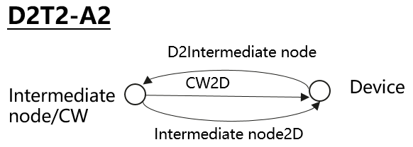  \  Case 2-2: CW is transmitted from inside the topology (i.e., intermediate UE), transmitted in UL spectrum | R2D: UL  CW2D and D2R: UL | CW and/or device | NR UL
 |  | NR UL | Device and/or reader
 |  | reader | NR UL
 |  | NR UL | device

Evaluation parameters

Topic 4-1: Adjacent RB Tx and Rx charateristics
Issue 4-1-1: A-IOT reader
Agreement in RAN4#111:
For calibration purpose, use 0RB guard band between AIOT and NR for in-band spectrum deployment mode
 |  | In-band
 |  | Tx | Rx
NR UE/A-IOT Intermediate UE | For calibration purpose | Legacy UE IBE | ACS
NR BS | For calibration purpose | ACLR of legacy gNB | ACS of legacy gNB
A-IOT BS | For calibration purpose | ACLR of legacy gNB (i.e. 45) | ACS of legacy gNB
 | For calibration purpose | ACLR of legacy gNB 45 | ACS of legacy gNB

Issue 4-1-2: Tx for device 1 and 2a
Agreement in RAN4#111:
For device 1 and 2a, 25dBc is used for calibration purposes
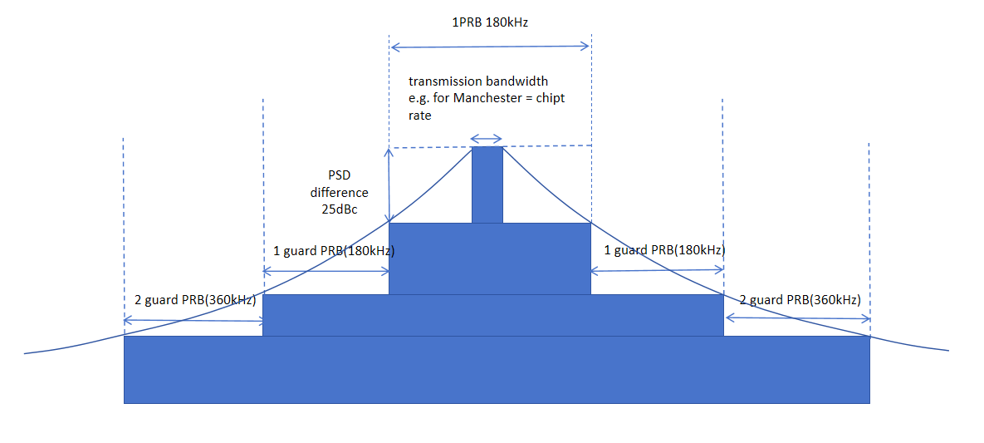
Issue 4-1-3: Rx for device 1 and 2a
Agreement in RAN4#111:
Assume no frequency selectivity for co-existence evaluation for calibration purposes for device 1 and 2a.

Topic 4-2: General paramters and layout
Issue 4-2-1: General parameters
Agreement in RAN4#111:
Use following parameters for calibration purposes.
General Parameter | D1T1&D2T2  Values for calibration purposes
Carrier frequency | 900MHz
BW for NR | 10MHz with 15KHz SCS
BW for AIOT system | R2D: 180kHz with 15KHz SCS  D2R: 15KHz or 180KHz (check until Friday)
Waveform (CW) | CW: Unmodulated single tone
Waveform (R2D) | OOK waveform generated by OFDM modulator
A-IoT DL power control | No
A-IoT UL power control | No
Traffic model | Full buffer
Frequency reuse | 1

Issue 4-2-2: Layout for D1T1
Agreement in RAN4#111:
Use following parameters for calibration purposes, i.e. scenario 1-1 and 1-2.
For Indoor NR, parameters are FFS, i.e. scenario 2-1 and 2-2.
Parameter | Assumptions for D1T1
Scenario | InF-DH
Hall size | 120x60 m
Room height | 10 m
Sectorization | None
Pathloss model | NLOS and LOS
BS deployment / Intermediate UE dropping | For D1T1-A2: 18 BSs on a square lattice with spacing D, located D/2 from the walls.  - L=120m x W=60m; D=20m  - BS height = 8 m  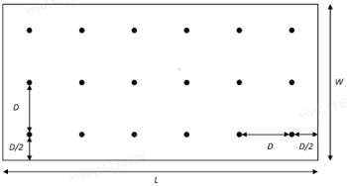  For D1T1-A1:  - FFS on layout: one node as transmission and CW, the neighbour node as reception
Device distribution | Device Height= 1.5 m  AIoT devices drop uniformly distributed over the horizontal area  Number of A-IoTs = Total area × activated density (1.5 A-IOT devices/m²)  1 active AIOT device under one reader at one drop  Minimum distance between device and reader along the ground equal to [2m] for calibration (check until Friday)
NR BS deployment (outdoor), i.e. scenario 1-1 and 1-2 | Hexagonal grid, 19 macro sites, 3 sectors per site with wrap around, 1 AIOT indoor scenario per sector  the minimum 2D distance between macro BS and indoor factory centre is set as 100m.  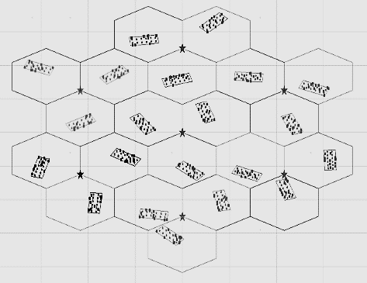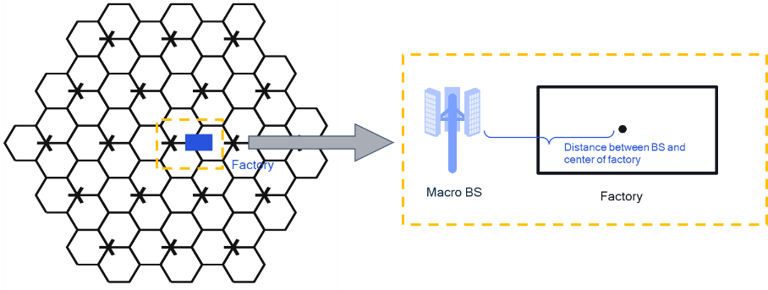
NR BS Inter-site distance | 750
Minimum NR BS – NR UE distance (2D) | 35 m
NR UE (D1T1) dropping | For scenario option 1-1, uniformly distributed outdoor.  For scenario option 1-2, uniformly distributed, 80% indoor, 20% outdoor  UE number:  DL active: 1 UE per cell  UL active UE: 3UE per cell
O2I penetration loss | High penetration loss as in TR 38.901 for calibration

Issue 4-2-3: Layout for D2T2
Agreement in RAN4#111:
Use InH-office as baseline for D2T2 co-existence evaluation.
Use following parameters for calibration purposes, i.e. scenario 1-1 and 1-2.
Parameter | Assumptions for D2T2
Scenario | InH-office
Hall size | 120 x50 m
Room height | 3m
Sectorization | None
Pathloss model | LOS and NLOS
BS deployment / Intermediate UE dropping | - L=120m x W=50m;  - Intermediate UE height = 1.5 m  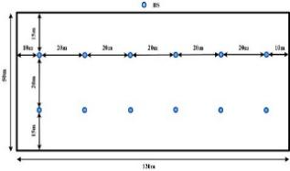  For D2T2-A2:  The intermediate UEs selected from the fixed positions.  Number of intermediate UE: 2 UE at one drop for calibration (check until Friday)  For D2T2-A1: FFS on layout
Device distribution | Device Height= 1.5 m  AIoT devices drop uniformly distributed over the horizontal area  Number of A-IoTs = Total area × activated density (1.5 A-IOT devices/m²)  1 active AIOT device under one reader at one drop  Minimum distance between reader and device is 1m
NR BS deployment | Hexagonal grid, 19 macro sites, 3 sectors per site with wrap around, 1 AIOT indoor scenario per sector  the minimum 2D distance between macro BS and indoor factory centre is set as 100m.
NR UE dropping | For scenario option 1-1, uniformly distributed outdoor.  For scenario option 1-2, uniformly distributed, 80% indoor, 20% outdoor  UE number:  - DL active UE: 1 UE per cell  - UL active UE: 3 UE per cell
O2I penetration loss | High penetration loss as in TR 38.901

Topic 4-3: Paramters for AIOT BS/intermedaite UE and device
Issue 4-3-1: AIOT micro-BS parameters for D1T1
Agreement in RAN4#111:
Use following parameters for calibration purposes.
A-IoT micro BS parameters | Values for calibration purposes
A-IoT micro-BS total Tx power | 33dBm
A-IoT micro-BS receiver Noise Figure（dB） | 10
A-IoT micro-BS antenna gain including feeder loss (dBi) | 6 dBi(M)
Antenna configuration | 2 antenna elements, with (M,N,P,Mg,Ng) = (1,1,2,1,1)

Issue 4-3-2: Intermediate UE parameters for D2T2
Agreement in RAN4#111:
Use following parameters for calibration purposes.
intermediate UE parameters | Values for calibration purposes
intermediate UE total Tx power（dBm） | 23dBm
gain of antenna intermediate UE (dBi) | 0
intermediate UE receiver Noise Figure（dB） | 9
Antenna configuration | Omni direction antenna

Issue 4-3-3: CW parameters
Agreement in RAN4#111:
Do not use CW2D for calibration purposes.
FFS on:
- CW interference to NR BS/UE/AIOT
- CW remaining interference after CW cancellation.
  - [CW IBE]

Issue 4-3-4: AIOT device parameters
Agreement in RAN4#111:
Use Device 1 with following parameters for calibration purposes.
A-IoT device parameters | Device 1  Values for calibration purposes
A-IoT device effective antenna gain per Tx or Rx branch (dBi) | 0
A-IoT device reflection （backscatter）loss (dB)  Note: due to, e.g., impedance mismatch | OOK: -6 dB
A-IoT device power gain of reflection amplifier (dB) | N/A
A-IoT Device receiver sensitivity (dBm)  Use this value to determine whether device can camp on the cell. | -36
A-IoT device noise figure (dB) | 24
Guard band | 0PRB

Topic 4-4: Paramters for legacy NR
Issue 4-4-1: NR macro BS parameters
Agreement in RAN4#111:
Use following parameters for calibration purposes.
NR macro-BS Parameter | Values for calibration purposes
Macro-BS Tx power (dBm) | 46
BS antenna gain (dBi) | Refer to TR36.942
Height of macro NR BS (m) | 25
NR Macro-BS Noise Figure(dB) | 5
Network location | outdoor

Issue 4-4-2: NR UE parameters
Agreement in RAN4#111:
Use following parameters for calibration purposes.
NR UE Parameter | Values for calibration purposes
UE TX power in dBm | -40 to 23
NR UE Antenna gain (dBi) | 0
Height of UE antenna (m) | 1.5
NR UE ACLR（dB） | 30
NR UE Noise Figure（dB） | 9
Antenna configuration | Omni direction antenna

