3GPP TSG-RAN WG4 Meeting #111 R4-24xxxxx
Fukuoka, Japan, May 20 - 24, 2024
Title: WF on power domain enhancements
Agenda Item: 10.1.2
Source: Huawei, HiSilicon
Document for: Approval

1. Power domain enhancements for single carrier

1.1 Consideration on relaxation of requirements for identified scenarios
Agreement in main session:
- No relaxation of level of spurious emission requirements
  - FFS on whether to change the spurious emission boundary

1.2. Mechanisms for enabling MPR reduction and/or power boosting
Way forward:
- Study the approach to convert full RB allocation in UE CBW to “inner RB allocation” with an extended UE BW, e.g. each side of the UE BW is equal to ½ of the UE BW, inside a larger BS CBW as starting point with consideration of the following aspects
  - The edge of the extended UE BW, i.e. the UE CBW plus the shifted frequency symmetrically at each side of the UE CBW, should be inside BS CBW or at least aligned with the BS CBW edge
    - ① FFS feasibility of case where extended UE CBW edge exceeds the BS CBW edge, i.e. gap between edges of UE CBW and BS CBW < 1/2 UE CBW
    - ② FFS whether IBE is used between edges of UE CBW and BS CBW or between edges of UE CBW and extended UE CBW
    - ③ FFS ACLR and SEM are applicable from the edge of extended UE CBW or edge of BS CBW, i.e. the start point of Δf_{OOB}
    - ④ FFS integral region of OOBE is based on extended UE CBW or UE CBW
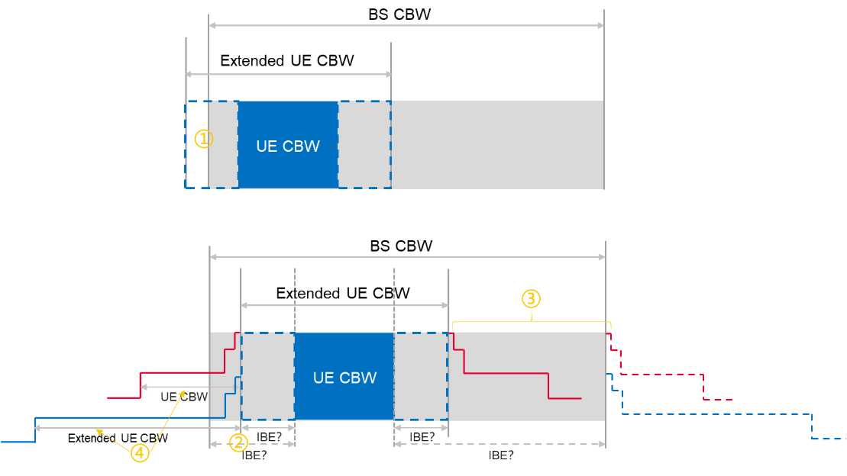
- Other mechanisms are not precluded

1.3 Simulation assumption for power boosting and/or MPR reduction
Way forward:
Agree with the preliminary simulation assumptions for following evaluation. Assumptions are subject to revisions with further study.
  - PA model calibration
    - DFT-s-OFDM QPSK 20MHz
    - 100RB0
    - 4dB post PA loss
    - 1dB MP
  - Carrier Leakage: 28dB
  - IQ Image: 28dBc
  - CIM3: 60dBc
  - EVM: 17.5%
  - ACLR: 30dB for PC3, 31dB for PC2

2. MPR applicability for FR1 and FR2 intra-band UL CA based on the UL CCs with activated cells

2.1. MPR applicability for FR1 intra-band contiguous UL CA
Way forward:
- For PC3 and PC2 contiguous UL CA use the corresponding single CC MPR tables when only 1 CC is activated.
  - MPR defined in Table 6.2.2-1 applies for UE power class 3 CA bandwidth classes B and C, along with configTx requirements for 6.2.4
  - MPR defined in Table 6.2D.2-1 applies for power class 2 CA bandwidth classes B and C when TxD capability is indicated, along with configTx requirements for 6.2D.4
  - MPR defined in Table 6.2.2-2 applies for power class 2 CA bandwidth classes B and C when TxD capability is absent, along with configTx requirements for 6.2.4

2.2. MPR applicability for FR1 intra-band UL non-contiguous CA
Proposals:
  - Proposal 1: For PC3 and PC2 intra-band non-contiguous CA as the standard already accounts for the use of the single CC MPR tables when only 1 CC is scheduled no further changes to the standard are required. (Qualcomm, Samsung, Huawei)
  - Proposal 2: There is no justification to specify new MPR requirements/values based on the UL CCs with activated cells for NR intra-band non-contiguous UL CA configuration. (Samsung)
  - Proposal 3: introduce a capability “single-CC-transmission-with-single-CC-MPR” for single-PA architecture (could also be indicated for dual-PA architecture) per band combination to indicate support of single-CC MPR with two configured non-contiguous carriers and one scheduled/activated. (Ericsson)
    - the capability applicable for a frequency separation ≤ 50 MHz for FDD and ≤ 100 MHz for TDD for a single-PA architecture to facilitate implementation with a single Tx chain.
  - Proposal 4: RAN4 should first discuss whether need modify the MPR value for intra-band non-contiguous UL CA with only one UL CC activated. (Xiaomi)
    - If not, the applicable MPR for intra-band non-contiguous UL CA with only one UL CC activated doesn’t need further enhancement.
    - If needed, RAN4 need further discuss how to modify the MPR, i.e., allow LO shifting or reduce the allocation size B.
  - Proposal 5: It’s up to UE implementation that the application of single-carrier MPR in 1CC scheduling for intra-band NC CA narrow B configuration. (vivo)
  - Proposal 6: Whether MPR for single CC can be applied to these excluded cases requires input from operators. (ZTE)
    - There are some cases are excluded, e.g. B < 9 MHz where 5.5 dB MPR is used. These exclusions are defined for specific bands
Way forward:
For the case of MPR applicability based on the UL CCs with activated cells for FR1 intra-band UL non-contiguous CA, no further enhancement is needed.
- Moderator Note: MPR enhancement beyond applicability of existing requirement is not included in the current WI objective for the time being.

2.3. Applicable MPR for FR2 single carrier UL with DL intra band CA
Way forward:
- For the case of single carrier UL with DL intra band CA, the MPR requirements of single carrier case in clause 6.2.2 of TS 38.101-2 applies with UE indication of independent LO for UL and DL.
- FFS if other UE implementation, e.g., LO switching, is feasible to support the MPR improvement

2.4. Applicable MPR for FR2 UL CA with DL intra band CA
Way forward:
- MPR based on UL BW_{channel_CA} applies instead that based on cumulative aggregated channel BW (CABW) with UE indication of independent LO for UL and DL
  - If only 1 UL CC is activated, the MPR requirements of single carrier could be reused
- FFS if other UE implementation, e.g., LO switching, is feasible to support the MPR improvement
- FFS whether new MPR requirement could be defined for CABW < 400 MHz (e.g., 200 MHz).
  - Moderator note: only MPR applicability is included in the current WID objective

