3GPP TSG-RAN4 Meeting # 111 R4-2410585

Fukuoka, Japan, 20th – 24th May, 2024
CR-Form-v12.3
CHANGE REQUEST
 | 38.101-5 | CR | draft-CR | rev | - | Current version: | 18.5.0
For HELP on using this form: comprehensive instructions can be found at
http://www.3gpp.org/Change-Requests.

Proposed change affects: | UICC apps |  | ME | X | Radio Access Network |  | Core Network

Title: | Draft CR to TS 38.101-5: Chapter 9.2.1
Source to WG: | Samsung, Qualcomm, Ericsson, Thales
Source to TSG: | R4
Work item code: | NR_NTN_enh-Core |  |  |  |  |  | Date: |  |  | 2024-5-13
Category: | F |  |  |  |  |  | Release: |  |  | Rel-18
 | Use one of the following categories:  F (correction)  A (mirror corresponding to a change in an earlier release)  B (addition of feature),  C (functional modification of feature)  D (editorial modification)  Detailed explanations of the above categories can  be found in 3GPP TR 21.900. |  |  |  |  |  |  |  | Use one of the following releases:  Rel-8 (Release 8)  Rel-9 (Release 9)  Rel-10 (Release 10)  Rel-11 (Release 11)  …  Rel-17 (Release 17)  Rel-18 (Release 18)  Rel-19 (Release 19)  Rel-20 (Release 20)
Reason for change: |  | To apply the changes for min peak EIRP, max TRP, and measurement metrics.
Summary of change: |  | To include figures for min peak EIRP test metrics;  To update the text to describe the min peak EIRP test metrics.  To amend the max TRP values.  To amend Note for off-axis eirp power reduction.  Minor editorial corrections.
Consequences if not approved: |  | The requirements and test configuration for Tx is incomplete.
Clauses affected: |  | 9.2.1
 |  | Y | N
Other specs |  |  | X | Other core specifications |  |  |  | TS/TR ... CR ...
affected: |  |  | X | Test specifications |  |  |  | TS/TR ... CR ...
(show related CRs) |  |  | X | O&M Specifications |  |  |  | TS/TR ... CR ...
Other comments:
This CR's revision history:

<Start of Change>

9.2.1 NTN VSAT maximum output power

9.2.1.0 General
The NTN VSAT classes are specified based on the assumptions of certain NTN VSAT types with specific device architectures including antenna beam steering types. The requirements are specified for different NTN VSAT types. And for the hybrid beam steering capable NTN VSAT, which can adjust its antenna(s) or beam(s) in both electronic steering and mechanical steering ways, the applicable requirements should follow either electronic or mechanical beam steering requirements depending on the NTN VSAT type it declared. The NTN VSAT types can be found in Table 9.2.1.0-1 below.
Table 9.2.1.0-1: Assumptions of NTN VSAT Types
NTN VSAT class | NTN VSAT type | Type description
Fixed VSAT | 1 | Fixed VSAT communicating with GSO and LEO with mechanical steering antenna.
 | 2² | Fixed VSAT communicating with GSO and LEO with electronic steering antenna.
 | 3 | Fixed VSAT communicating with LEO only with electronic steering antenna.
Mobile VSAT | 4 | Mobile VSAT communicating with GSO with mechanical steering antenna.
 | 5² | Mobile VSAT communicating with GSO with electronic steering antenna.
Note 1: The NTN VSAT types are assuming NTN VSAT has only one antenna beam towards one satellite at a given time in this release.
Note 2: UE may need power reduction for meeting OFF-axis EIRP requirement defined in clause 9.2.2. Value is implementation dependent

9.2.1.1 Minimum requirements for Fixed VSAT
The following requirements define the maximum output power radiated by the Fixed VSAT for any transmission bandwidth within the channel bandwidth for non-CA configuration, unless otherwise stated. The period of measurement shall be at least one sub frame (1ms). The minimum output power values for EIRP are found in Table 9.2.1.1-1. The requirement should be verified with test metrics of EIRP (Link=Tx beam peak direction, Meas=Link angle).
The peak EIRP of Tx beam peak direction should be verified within the declared minimum elevation angle supported for transmitting. The steered beam peak directions can be achieved by mechanical steering and/or electronic steering according to VSAT Type. Where the supported minimum elevation angle shall be declared by manufacturer and within the range of 3°≤minimum elevation angle≤75°, and it can be expressed as (90-θ) if the coordinate systems in Figure 9.2.1.1-X below is taken as an example.
Figure 9.2.1.1-X Example measurement grid for min peak EIRP with the declared supported minimum elevation angle

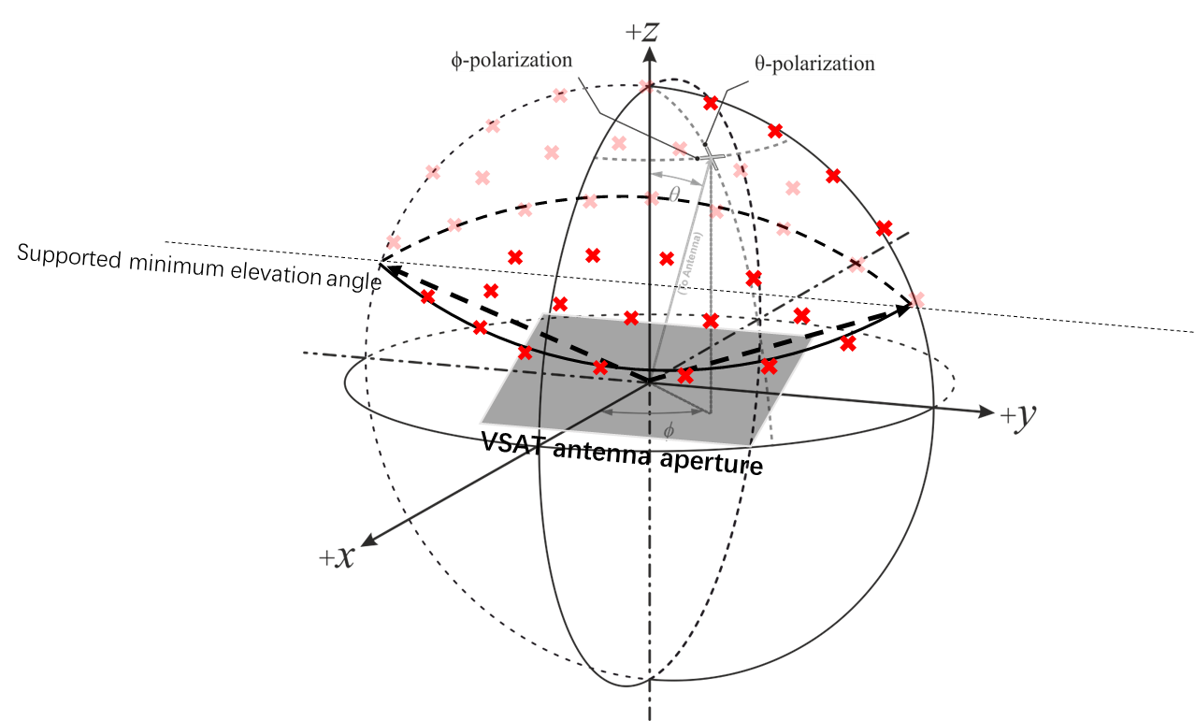
Table 9.2.1.1-1: Minimum peak EIRP for Fixed VSAT
Operating band | UE Type | Min peak EIRP (dBm)
n512, n511, n510 | 1 | 70
 | 2 | 70
 | 3 | 61
NOTE: Minimum peak EIRP is defined as the lower limit without tolerance.

The maximum output power values for TRP and EIRP are found in Table 9.2.1.1-2 below.
Table 9.2.1.1-2: Maximum output power limits for Fixed VSAT
Operating band | UE Type | TRP_{MAX} (dBm) | EIRP_{max} (dBm)
n512, n511, n510 | 1 | 35 | 76.2
 | 2, 3 | 43 | 76.2
NOTE: Maximum EIRP is defined using 13RBs allocation with 120kHz SCS.

9.2.1.2 Minimum requirements for Mobile VSAT
The following requirements define the maximum output power radiated by the Mobile VSAT for any transmission bandwidth within the channel bandwidth for non-CA configuration, unless otherwise stated. The period of measurement shall be at least one sub frame (1ms). The minimum output power values for EIRP are found in Table 9.2.1.2-1. The requirement should be verified with test metrics of EIRP (Link=Tx beam peak direction, Meas=Link angle).
The peak EIRP of Tx beam peak direction should be verified within the declared minimum elevation angle supported for transmitting. The steered beam peak directions can be achieved by mechanical steering and/or electronic steering according to VSAT Type. Where the supported minimum elevation angle shall be declared by manufacturer and within the range of $3°≤minimum elevation angle≤75°$, and it can be expressed as (90-θ) if the coordinate systems in Figure 9.2.1.2-X below is taken as an example.
Figure 9.2.1.2-X Example measurement grid for min peak EIRP with the declared supported minimum elevation angle
Table 9.2.1.2-1: Minimum peak EIRP for Mobile VSAT
Operating band | UE Type | Min peak EIRP (dBm)
n512, n511 | 4 | 70
 | 5 | 70
NOTE: Minimum peak EIRP is defined as the lower limit without tolerance.

The maximum output power values for TRP and EIRP are found in Table 9.2.1.2-2 below.
Table 9.2.1.2-2: Maximum output power limits for Mobile VSAT
Operating band | UE Type | TRP_{MAX} (dBm) | EIRP_{max} (dBm)
n512, n511, n510 | 4 | 35 | 76.2
 | 5 | 43 | 76.2
NOTE: Maximum EIRP is defined using 13RBs allocation with 120kHz SCS.

<End of Change>

