3GPP TSG-RAN WG4 Meeting # 111 R4-2410582

Fukuoka, Japan, May 20 – May 24, 2024
CR-Form-v12.3
CHANGE REQUEST
 | 38.101-5 | CR | DraftCR | rev | - | Current version: | 18.5.0
For HELP on using this form: comprehensive instructions can be found at
http://www.3gpp.org/Change-Requests.

Proposed change affects: | UICC apps |  | ME | X | Radio Access Network |  | Core Network

Title: | Draft CR for 38.101-5 to introduce clause 10.1~10.3
Source to WG: | Huawei, HiSilicon
Source to TSG: | R4
Work item code: | NR_NTN_enh-Core |  |  |  |  |  | Date: |  |  | 2024-04-30
Category: | B |  |  |  |  |  | Release: |  |  | Rel-18
 | Use one of the following categories:  F (correction)  A (mirror corresponding to a change in an earlier release)  B (addition of feature),  C (functional modification of feature)  D (editorial modification)  Detailed explanations of the above categories can  be found in 3GPP TR 21.900. |  |  |  |  |  |  |  | Use one of the following releases:  Rel-8 (Release 8)  Rel-9 (Release 9)  Rel-10 (Release 10)  Rel-11 (Release 11)  …  Rel-17 (Release 17)  Rel-18 (Release 18)  Rel-19 (Release 19)  Rel-20 (Release 20)
Reason for change: |  | Based on the ACS discussion in lasting meeting, NTN VSAT vendors may declare the OTA sensitivity level for ACS testing referring to the definition of FR2 TN BS ACS requirements. In addition, the minimum EIS requirements specified in current spec cannot reflect the real performance of the NTN VSAT as different antenna apertures lead to different EIS requirements.  Thus, it’s proposed to consider declaration method for the NTN VSAT EIS requirements referring to the FR2 TN BS REFSENS requirements.
Summary of change: |  | - To update OTA reference sensitivity level based on the declaration method
Consequences if not approved: |  | - the minimum EIS requirements specified in current spec cannot reflect the real performance of the NTN VSAT as different antenna apertures lead to different EIS requirements
Clauses affected: |  | 10.1, 10.2, 10.3
 |  | Y | N
Other specs |  |  | X | Other core specifications |  |  |  | TS/TR ... CR ...
affected: |  | X |  | Test specifications |  |  |  | TS 38.521-5
(show related CRs) |  |  | X | O&M Specifications |  |  |  | TS/TR ... CR ...
Other comments:
This CR's revision history:

<<Start of Change for TS 38.101-5>>

10.1 General
Unless otherwise stated, the receiver characteristics are specified over the air (OTA) at the RIB for Ka bands fixed and mobile VSAT. The reference effective isotropic sensitivity (EIS), wanted signals and interference is defined assuming a 0 dBi reference antenna located at the center of the quiet zone.

10.2 Polarization characteristics
The minimum requirements on the receiver characteristics apply under either LHCP (Left Hand Circular Polarization) or RHCP (Right Hand Circular Polarization).

10.3 OTA reference sensitivity level

10.3.1 General
The OTA REFSENS requirement is a directional requirement and is intended to ensure the minimum OTA reference sensitivity level at the centre of the quiet zone in the RX beam peak direction. The OTA reference sensitivity power level EIS_{REFSENS} is the minimum mean power received over the air at the RIB, at which the throughput shall meet or exceed the requirements for a specified reference measurement channel.

10.3.2 Minimum requirement
The throughput shall be ≥ 95 % of the maximum throughput of the reference measurement channels as [specified in Annexes A.2.3.2 and A.3.3.2 (with one sided dynamic OCNG Pattern OP.1 FDD for the DL-signal as described in Annex A.5.2.1) with peak reference sensitivity specified in Table 10.3.2-1. And EIS_{REFSENS_50M} declared by the vendor is an integer value in the range specified in Table 10.3.2-2 for different types of NTN VSAT]. The requirement is verified with the test metric of EIS (Link=RX beam peak direction, Meas=Link Angle).
The EIS of Rx beam peak direction should be verified within the declared minimum elevation angle supported for receiving. The steered beam peak directions can be achieved by mechanical steering and/or electronic steering according to VSAT Type. Where the supported minimum elevation angle shall be declared by manufacturer and within the range of $3°≤minimum elevation angle≤75°$, and it can be expressed as (90-θ) if the coordinate systems in Figure 10.3.2-1 below is taken as an example.
Figure 10.3.2-1 Example measurement grid for EIS with the declared supported minimum elevation angle
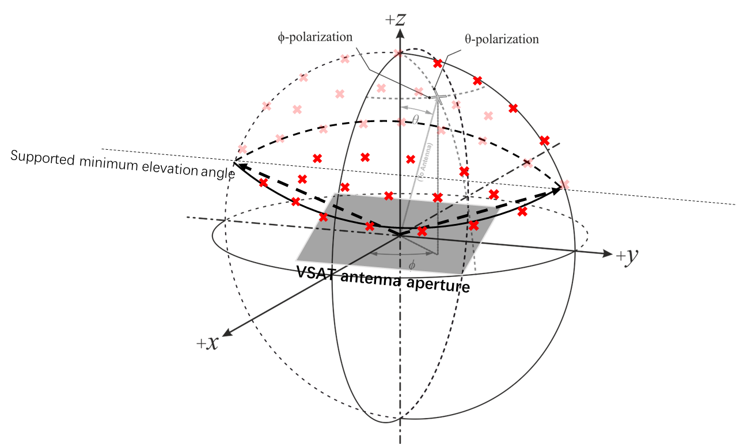
Table 10.3.2-1: OTA reference sensitivity requirement for NTN VSAT
NTN VSAT channel bandwidth (MHz) |  | UL/DL RB allocation |  | OTA reference sensitivity level, EIS_{REFSENS}  (dBm)
50, 100, 200, 400 |  | Full RB allocation N_{RB} as specified in clause 5.3.2 |  | EIS_{REFSENS_50MHz} + 10log₁₀(N_{RB} x SCS x 12 / factor)  (NOTE 1)
NOTE 1: The “factor” represents the normalized factor to scale EIS for different (Channel bandwidth, SCS) configurations. The value of factor is 66 RBs x 60 kHz SCS x 12, i.e. 47520 kHz.

Table 10.3.2-2: The range of EIS_{REFSENS_50MHz} declared by vendor per NTN VSAT
Operating band | NTN VSAT class | NTN VSAT type | The range of EIS_{REFSENS_50MHz}  (dBm)
n512, n511 | Fixed VSAT | 1, 2 | ≤ -122
 |  | 3 | ≤ -115.6
n512, n511, n510 | Mobile VSAT | 4, 5 | ≤ -122

<<End of Change>>

