3GPP TSG-RAN WG2 Meeting #128 R2-24XXXXX
Orlando, USA, Nov 18th – 22th, 2024

Source: ZTE Corporation
Title: [AT128][402][POS] Spatial relation info source for positioning in RRC_INACTIVE (ZTE)
Agenda item: 6.3.1
Document for: Discussion and Decision

Introduction
This document is to trigger the following email discussion:
- [AT128][402][POS] Spatial relation info source for positioning in RRC_INACTIVE (ZTE)
Scope: Polish the RRC and MAC CRs in R2-2409565 and R2-2409607 and their shadows, and discuss to converge on what level of changes to the MAC spec are acceptable.
Intended outcome: Agreeable CRs (with CB) in R2-2410985 / R2-2410986 / R2-2410987 / R2-2410988
Deadline: Wednesday 2024-11-20 1600 EST

The related CR is referenced as below:
R2-2409565 Correction on spatial relation info in SP SRS activation deactivation MAC CE (R17) ZTE Corporation, Ericsson CR Rel-17 38.321 17.10.0 1977 - F NR_pos_enh-Core
R2-2409566 Correction on spatial relation info in SP SRS activation deactivation MAC CE (R18) ZTE Corporation, Ericsson CR Rel-18 38.321 18.3.0 1978 - A NR_pos_enh-Core
R2-2409607 Correction on spatial relation info in SRS configuration (R17) ZTE Corporation, Ericsson CR Rel-17 38.331 17.10.0 5101 - F NR_pos_enh-Core
R2-2409608 Correction on spatial relation info in SRS configuration (R18) ZTE Corporation, Ericsson CR Rel-18 38.331 18.3.0 5102 - A NR_pos_enh-Core

Discussion

Background
RAN1 has replied with the LS R2-2409508 indicating that CSI-RS and SRS configured in RRC_CONNECTED should not be used as spatial relation RS for SRS transmission in RRC_INACTIVE:
RAN1 thanks RAN2 for the LS on CSI-RS/SRS for spatial relation in RRC_INACTIVE, with regard to RAN2’s following questions, RAN1 provides the corresponding answers.
Q1: When activating semi-persistent SRS for positioning in RRC_INACTIVE, whether NZP-CSI-RS and SRS can be used as source for spatial relation indication in the MAC CE?
[RAN1 reply] SRS configured by the SRS-PosResource for RRC_INACTIVE can be used as source, but NZP CSI-RS and SRS configured by the SRS-Resource cannot be used as source for spatial relation indication in MAC CE for activating semi-persistent SRS for positioning in RRC_INACTIVE state.

Q2: When activating semi-persistent SRS for positioning in RRC_INACTIVE, whether NZP-CSI-RS and SRS which are configured in RRC_CONNECTED can be used as source for spatial relation indication in the MAC CE?
[RAN1 reply] NZP-CSI-RS and SRS configured by the SRS-PosResource or SRS-Resource in RRC_CONNECTED cannot be used as source for spatial relation indication in the MAC CE for activating semi-persistent SRS for positioning in RRC_INACTIVE.

Q3: Whether the above answers are applicable for SP-SRS without validity area activation in RRC_INACTIVE, SP-SRS with validity area activation in RRC_INACTIVE and aggregated SP-SRS activation in RRC_INACTIVE?
[RAN1 reply] The above answers can be applicable for SP-SRS without validity area activation in RRC_INACTIVE, SP-SRS with validity area activation in RRC_INACTIVE and aggregated SP-SRS activation in RRC_INACTIVE.

The RRC CR and MAC CR are provided to address this constriction.

RRC CR
According to online comments and offline discussion with some companies, the RRC CR is updated as below:
spatialRelationInfoPos
Configuration of the spatial relation between a reference RS and the target SRS. Reference RS can be SSB/CSI-RS/SRS/DL-PRS (see TS 38.214 [19], clause 6.2.1).
If the IE srs-ResourceId-Ext is present, the IE srs-ResourceId in spatialRelationInfoPos represents the index from 0 to 63. Otherwise the IE srs-ResourceId in spatialRelationInfoPos represents the index from 0 to 31. If the SRS is transmitted in RRC_INACTIVE, srs-ResourceId, csi-RS-IndexServing or srs-PosResourceId that configured in RRC_CONNECTED are not contained in this field.

Question 1: Do companies agree with the above polishing of the RRC CR? (If you have better wording, please provide it in Comments)
Companies | Agree/disagree | Comments
Huawei, HiSilicon |  | Without change, it is already not supported to indicate SRS ID, CSI_RS ID or posSRS ID configured in RRC_CONNECED in RRC_INACTIVE. I would consider it as redundant to add it to the field description. If companies insist, it is fine with us to have the change.

MAC CR
During online discussion, one company do not agree with the current MAC CR. Therefore, Rapporteur provides the following options:
Option 1: Take the original CR with the following word polishing (i.e., in a formative way):
- SRS resource ID: When F₁ is set to 0, the field indicates an index for SRS resource SRS-ResourceId as defined in TS 38.331 [5]; When F₁ is set to 1, the field indicates an index for Positioning SRS resource SRS-PosResourceId as defined in TS 38.331 [5]. When the MAC CE is used for SP SRS activation in RRC_INACTIVE, this field can only indicate an index for Positioning SRS resource SRS-PosResourceId configured in RRC_INACTIVE. The length of the field is 5 bits representing the index from 0 to 31;

Option 2: Add a note under the MAC CE to address the restriction (i.e., in an informative way):
Note: When the MAC CE is used for activation of SP-SRS in RRC_INACTIVE, the SRS configured in RRC_CONNECTED and the CSI-RS cannot be configured as spatial relation source RS by this MAC CE.

Question 2: If companies agree to have MAC CR, which option of the MAC CR do companies agree to?
Companies | Option1/Option2/Both are ok | Comments
Huawei, HiSilicon |  | The spatialRelationInfoPOS is configured as follows:  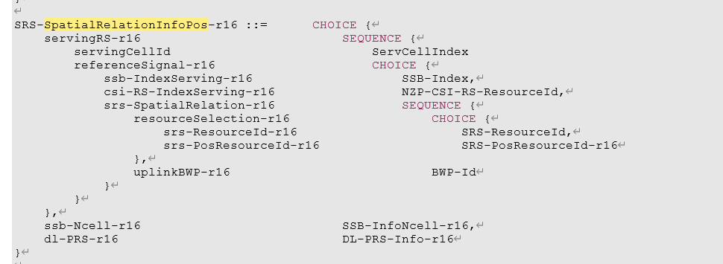  Within the IE, CSI-RS as the source is configured by NZP-CSI-RS-ResourceId, but within suspendConfig with RRCRelease message, there is no CSI-RS configuration and there is no NZP-CSi-RS-ResourceId. Hence, it is already impossible to configure CSI-RS for semi-persistent SRS in RRC_INACTIVE.  Then, coming to the MAC spec, since, it is not possible to configure CSI-RS, it is not possible to indicate CS-RS as the source for spatial relation. The change is redundant as well.

Conclusion
TBD

