**3GPP TSG-RAN WG2 Meeting #128 *R2-2410971***

**Orlando, US, 18 – 22 Nov, 2024**

**Title:** Report of [AT128][301][R18 NR NTN] SMTC issues (Huawei)

**Source:** Huawei, HiSilicon

**Agenda item:** 7.4.2

**Document Type:** Discussion and Decision

# Introduction

This report captures the outcome of the following discussion:

* [AT128][301][R18 NR NTN] SMTC issues (Huawei)

Scope: Continue the discussion on p2 and p3 from R2-2410750

Intended outcome: Report of the offline discussion

F2F offline time and location: FFS

Deadline for rapporteur's summary (in R2-2410971): Thursday 2024-11-22 08:00

# Issue 1: SSB shifting for soft satellite switch

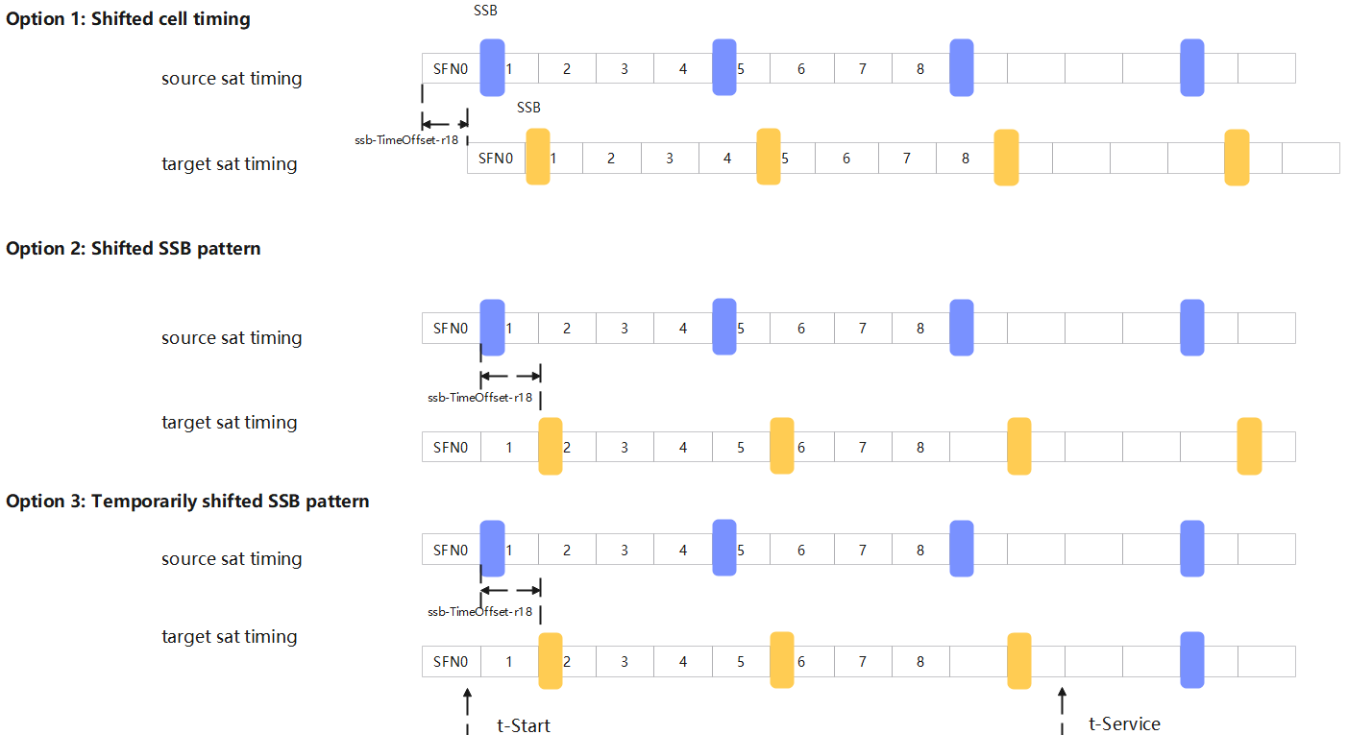

**When SMTC is considered:**

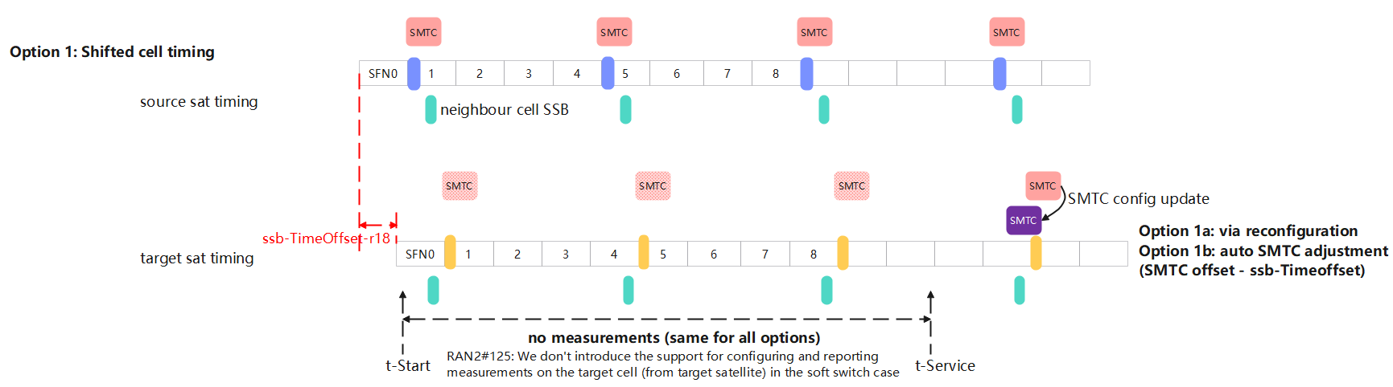

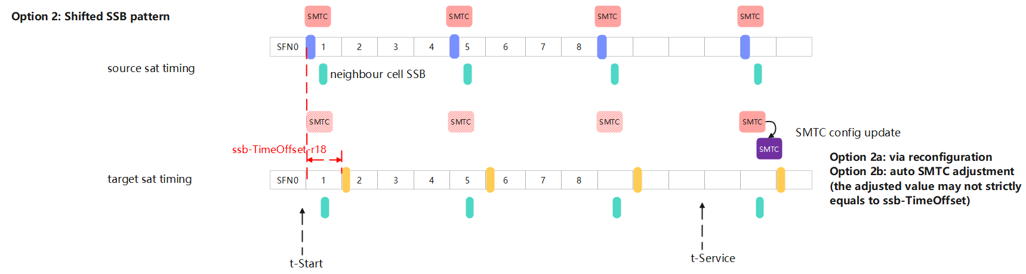

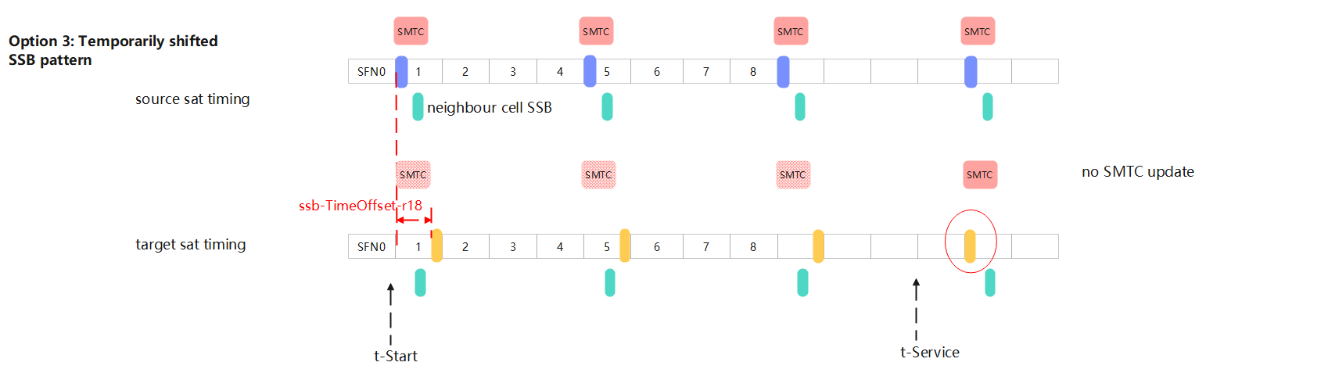

Understanding: In Option 3, the UE is not required to re-sync with target sat. The SSB location change does not affect the fact that UE is already synchronized with target satellite during [t-Start, t-Service]

# Issue 2: PCI list in SMTC4

RAN2 to determine whether PCI list in SMTC4 is mandatory, and choose from the following:

• Option 1: Clarify in the field description of *pci-List* of *SSB-MTC4* that “The network shall always configure this field when *SSB-MTC4-r17* is configured”;

• Option 2: Add the following description in 38.331 clause 5.5.2:

|  |
| --- |
| If *smtc4list* is present, for cells indicated in the *pci-List* parameter in each *SSB-MTC4* element of the list in the same *MeasObjectNR*, the UE shall setup an additional SS/PBCH block measurement timing configuration (SMTC) in accordance with the received *offset* parameter in each *SSB-MTC4* configuration and use the *duration* parameter and *periodicity* (derived from parameter *periodicityAndOffset*) from the *smtc1* configuration. The first subframe of each SMTC occasion occurs at an SFN and subframe of the NR SpCell meeting the above condition. If *pci-List* parameter is absent in an SSB-MTC4 in SIB2/SIB4, it is up to UE implementation to detect neighbour cells associated with the SMTC, based on the ephemeris information in SIB19. |

# Conclusion

# Reference

1. R2-2410750, Remaining issues on SMTC, Huawei, HiSilicon
2. R2-2410878, Remaining open issues of satellite switch with resync, Sequans Communications
3. R2-2409187, Remaining open issues, Ericsson