3GPP TSG-RAN WG2 Meeting #128 draft R2-2410951

Orlando, USA, Nov. 18th – 22nd , 2024

**Agenda item: 7.0.2.13**

**Source: Samsung**

**Title: Report of [AT128][201][MIMOevo] Proposals/CRs for PHR**

**WID/SID: NR_MIMO_evo_DL_UL-Core**

**Document for: Discussion and Decision**

# Introduction

This document records inputs and outcome for the following offline discussion.

* [AT128][201][MIMOevo] Proposals/CRs for PHR

Scope: Discuss PHR related proposals for MIMOevo

Intended outcome: Proposals in R2-2410951 for CB, updated CR(s) in R2-24xxxxx.

Deadline: 11/20 Wednesday 12pm US local time.

|  |  |  |
| --- | --- | --- |
| **Company** | **Name** | **Contact** |
| Samsung | Shiyang Leng | shiyang.leng@samsung.com |
| CATT | Da Wang | wangda@catt.cn |
| LGE | Hanul Lee | hanul.lee@lge.com |
| Huawei, HiSilicon | David Lecompte | david.lecompte@huawei.com |
| ASUSTeK | Xinra Kung | Xinra_Kung@asus.com |
| Qualcomm | Ruiming Zheng | rzheng@qti.qualcomm.com |

# Discussion

## 2.1 CR 1: R2-2410175

R2-2410175 Correction on PHR for MIMO ASUSTeK CR Rel-18 38.321 18.3.0 1991 - F NR_MIMO_evo_DL_UL-Core

**Change 1:** According to RAN1 LS R1-2405619 and agreement in RAN2#127, Type 3 PH is not reported for serving cell that is configured with mTRP PUSCH repetition or multipanelSchemeSDM or multipanelSchemeSFN. In MAC specification, however, the UE will obtain Type 3 PH for a Serving Cell even when the Serving is configured with mTRP PUSCH and should be changed. The change is to remove reporting of Type 3 power headroom for Serving Cell configured with mTRP PUSCH repetition if the reporting MAC entity is configured with twoPHRmode.

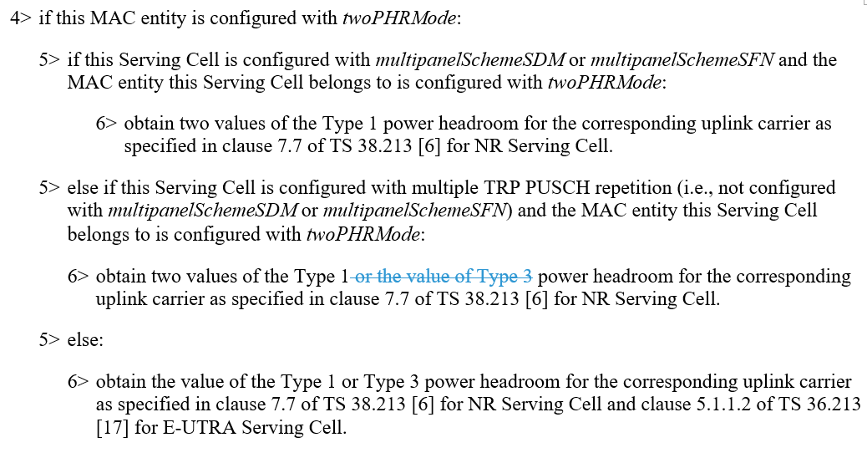

However, the relevant changes have been discussed in main session for Rel-17 correction and mirrored to Rel-18. See agreed CRs R2-2411095, R2-2411096, R2-2411097, R2-2411098, R2-2411099, R2-2411100. Change 1 is not needed.

**Change 2:** When obtaining PH for Single Entry PHR, the condition text may need to clarified so that Multiple TRP PUSCH repetition and multipanelSchemeSDM or multipanelSchemeSFN are configured per Serving Cell instead of per-MAC entity. The change is to clarify in the condition text in obtaining Type 1 PH for Single Entry PHR that two values of PHs are obtained when the PCell is configured with mTRP PUSCH repetition or multipanelSchemeSDM or multipanelSchemeSFN.

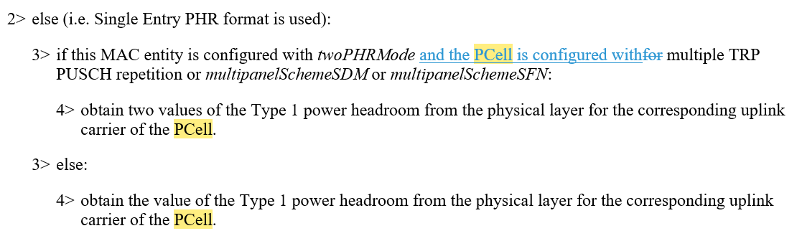

For single entry PHR, i.e., multiplePHR is not configured.

***multiplePHR***

Indicates if power headroom shall be reported using the Single Entry PHR MAC control element or Multiple Entry PHR MAC control element defined in TS 38.321 [3]. True means to use Multiple Entry PHR MAC control element and False means to use the Single Entry PHR MAC control element defined in TS 38.321 [3]. The network configures this field to *true* for MR-DC and UL CA for NR, and to *false* in all other cases.

**Q1-1: Do you agree to remove Change 1 and keep Change 2?**

|  |  |  |
| --- | --- | --- |
| **Company** | **Y/N** | **Reason/Comment** |
| CATT | Yes |  |
| LGE | Yes |  |
| ZTE | N, No any change is needed | We think the CR is not needed since ‘for’ is used in the condition and there is no room for misunderstanding , it does not imply that the multiple PUSCH repetition and multiple panel scheme is configured per MAC entity.  3> if this MAC entity is configured with *twoPHRMode* for multiple TRP PUSCH repetition or *multipanelSchemeSDM* or *multipanelSchemeSFN*:  4> obtain two values of the Type 1 power headroom from the physical layer for the corresponding uplink carrier of the PCell. |
| ASUSTeK | Yes | Proponent. “twoPHRmode” and “Multiple TRP PUSCH repetition and multipanelSchemeSDM or multipanelSchemeSFN” are different configurations and should be clarified. |
| OPPO | Yes | The change make the spec clearer. |
| Qualcomm | No | For change 2, share the same view with ZTE. The original text is clear enough. |
| Samsung | No | Change 2 is not essential, relevant RRC parameters makes the procedure clear. |

**Q1-2: Do you have any other comments on the CR, e.g., cover sheet, etc.?**

|  |  |  |
| --- | --- | --- |
| **Company** | **Y/N** | **Reason/Comment** |
|  |  |  |
|  |  |  |

Summary:

Change 1 is not needed.

Change 2

4 yes: for clarification purpose;

3 no: the current text is clear enough.

**Proposal 1: Change 1 in R2-2410175 is not needed. Discuss whether Change 2 is needed.**

## 2.2 CR 2: R2-2410625

R2-2410625 Clarification to 38.321 on R17 PHR MAC CE for mTRP PUSCH Repetition ZTE Corporation CR Rel-18 38.321 18.3.0 2008 - F NR_MIMO_evo_DL_UL-Core

**Reason for the change:**

In rel-18 MAC spec for PHR, the PHR MAC CE for multiple TRP PUSCH repetition would be generated for carrying two type 1 PH values for each serving cell if this MAC entity is configured with twoPHRMode, and any associated serving cell is configured with multiple TRP PUSCH Repetition.

--------------------------- From 38.321 i30--------------------------------------------

For the case that multiple entry PHR format is used:

3> else if this MAC entity is configured with *twoPHRMode* and any associated Serving Cell is configured with multiple TRP PUSCH repetition:

4> instruct the Multiplexing and Assembly procedure to generate and transmit the Enhanced Multiple Entry PHR for multiple TRP MAC CE as defined in clause 6.1.3.51 based on the values reported by the physical layer.

For the case that single entry PHR format is used:

3> else if this MAC entity is configured with *twoPHRMode* and this Serving Cell is configured with multiple TRP PUSCH repetition:

4> instruct the Multiplexing and Assembly procedure to generate and transmit the Enhanced Single Entry PHR for multiple TRP MAC CE as defined in clause 6.1.3.50 based on the values reported by the physical layer.

--------------------------- From 38.321 i30 --------------------------------------------

However, for obtaining the PH values, it has been defined in the same text procedure, two type1 PH values can be obtained for multiple entry PHR format cases as long as this MAC entity is configured with twoPHRMode.

--------------------- From 38.321 i30 -------------------------------------------------------

2> if *multiplePHR* with value *true* is configured:

/omit for short/

4> if this MAC entity is configured with *twoPHRMode*:

5> if this Serving Cell is configured with *multipanelSchemeSDM* or *multipanelSchemeSFN* and the MAC entity this Serving Cell belongs to is configured with *twoPHRMode*:

6> obtain two values of the Type 1 power headroom for the corresponding uplink carrier as specified in clause 7.7 of TS 38.213 [6] for NR Serving Cell.

5> else if this Serving Cell is configured with multiple TRP PUSCH repetition (i.e., not configured with *multipanelSchemeSDM* or *multipanelSchemeSFN*) and the MAC entity this Serving Cell belongs to is configured with *twoPHRMode*:

6> obtain **two** values of the Type 1 or the value of Type 3 power headroom for the corresponding uplink carrier as specified in clause 7.7 of TS 38.213 [6] for NR Serving Cell.

5> else:

6> obtain the value of the Type 1 or Type 3 power headroom for the corresponding uplink carrier as specified in clause 7.7 of TS 38.213 [6] for NR Serving Cell and clause 5.1.1.2 of TS 36.213 [17] for E-UTRA Serving Cell.

--------------------- From 38.321 i30 -------------------------------------------------------

In one case of multiple entry PHR format, something wrong would be happened if this MAC entity is configured with twoPHRMode and no serving cell associated with this MAC entity is configured with mTRP PUSCH repetition. In this case, only legacy PHR format (e.g. R15/R16 PHR MAC CE) can be generated in which only one PH value can be accommodated for each serving cell, but the MAC entity of the UE may obtain two type 1 PH values for the serving cell of the other MAC entity if this serving cell is configured with mTRP PUSCH repetition and the other MAC entity is configured with twoPHRMode, in this case, two ehavior PH values cannot be accommodated into the legacy PHR MAC CE.

Furthermore, in rel-17, UE ehavior for generating the PHR MAC CE for multiple TRP PUSCH repetition is only dependent on whether the twoPHRmode is configured for this MAC entity regardless of the serving cell configuration of any MAC entity, compare to the R17 UE, R18 UE have a brand new ehavior for generating the R17 PHR MAC CE for multiple TRP PUSCH repetition.

---------------------------- From 38.321-h80 ---------------------------------------------

For the case of multiple entry PHR format

3> instruct the Multiplexing and Assembly procedure to generate and transmit the Enhanced Multiple entry PHR as defined in clause 6.1.3.49 if this MAC entity is configured with *mpe-Reporting-FR2-r17* or the Enhanced Multiple Entry PHR for multiple TRP MAC CE as defined in clause 6.1.3.51 if this MAC entity is configured with *twoPHRMode* or the Multiple Entry PHR MAC CE as defined in clause 6.1.3.9 otherwise based on the values reported by the physical layer.

---------------------------- From 38.321-h80 ---------------------------------------------

In this sense, we suggest to R18 UE shall be aligned with R17 UE for generating the R17 PHR MAC CE for multiple TRP PUSCH Repetition, that is, as long as this MAC entity is configured with twoPHRmode, the R17 PHR MAC CE for multiple TRP PUSCH Repetition shall be generated regardless of the associated serving cell configuration.

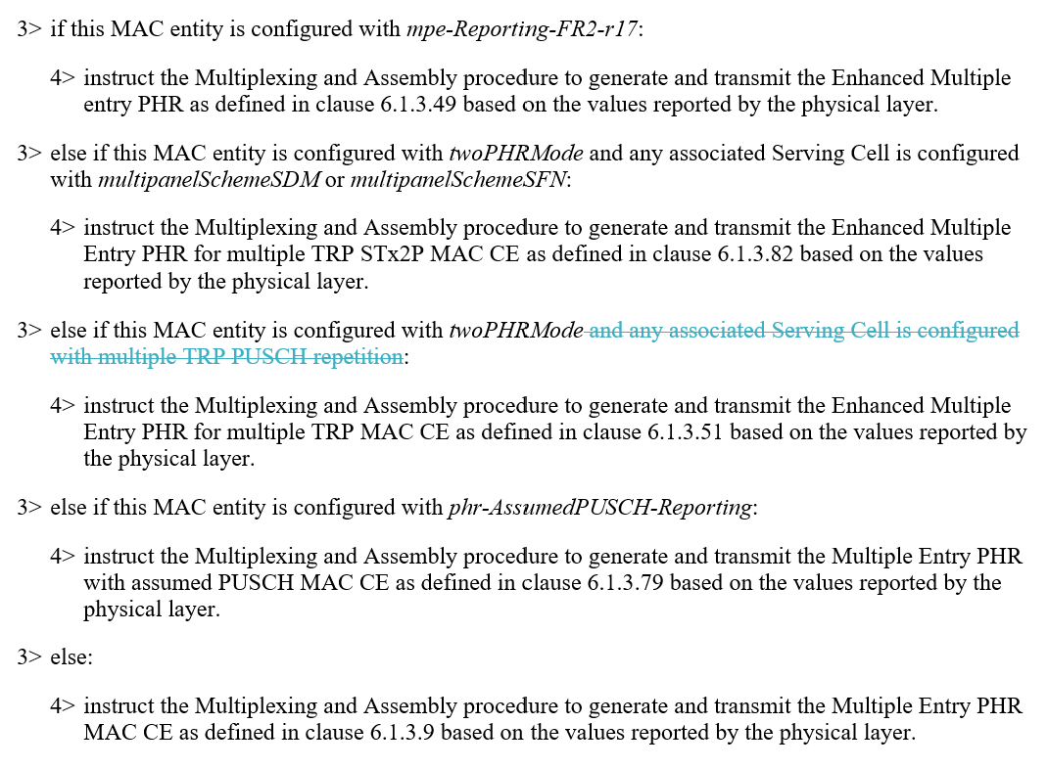

The change is also applied to the single entry case, if it is adopt for the multiple entry case.

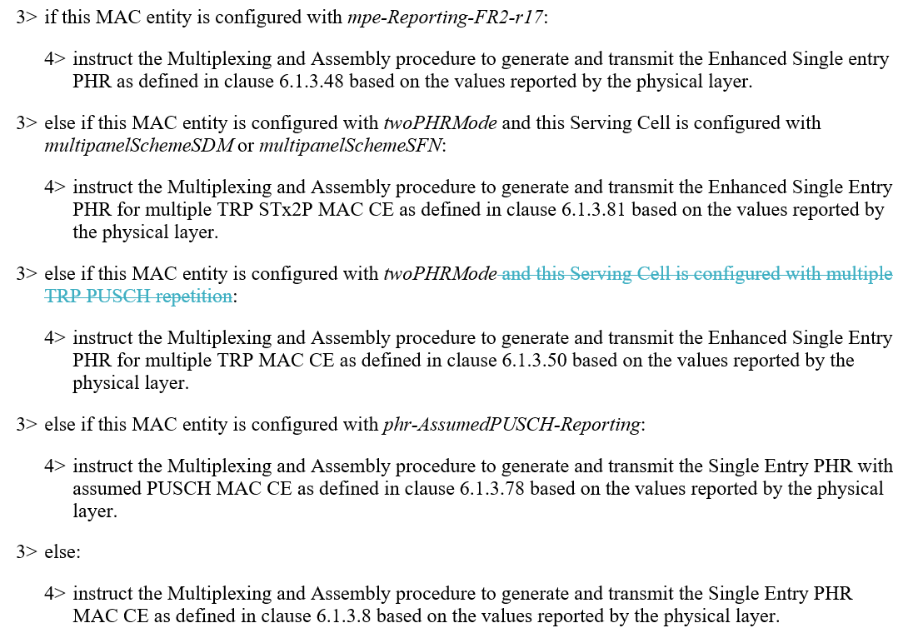

**Understanding 1**: A MAC entity **will not** be configured with twoPHRmode if in this MAC entity no serving cell is configured with Rel-17 mTRP PUSCH repetition or Rel-18 mTRP STx2P multi-panel scheme. There is no difference between the two specifications. The change is not needed.

**Understanding 2:** A MAC entity **can** be configured with twoPHRmode if in this MAC entity no serving cell is configured with Rel-17 mTRP PUSCH repetition or Rel-18 mTRP STx2P multi-panel scheme. In this case, the MAC entity also generates the Rel-17 PHR MAC CE for mTRP PUSCH repetition. There is a difference between the two specification. The change is needed.

**Q2-1: Do you agree on the changes?**

|  |  |  |
| --- | --- | --- |
| **Company** | **Y/N** | **Reason/Comment** |
| CATT | No | As per the last meeting agreement,  **Proposal 1: Confirm the procedure on whether to generate R17 or R18 mTRP PHR MAC CE:**   * If the MAC entity generating and transmitting the PHR MAC CE (i.e., MAC1) is configured with R18 feature multi-panel scheme (i.e., twoPHRmode and at least one serving cell belong to this MAC entity is configured with multi-panel scheme):   + R18 multi-entry PHR MAC CE for STx2P is generated;   + Up to 2 Type 1 PH, 2 Pcmax, and 2 MPE can be reported for each serving cell belonging to this MAC entity or the other MAC entity. * Else if the MAC entity generating and transmitting the PHR MAC CE (i.e., MAC1) is configured with R17 feature mTRP PUSCH repetition (i.e., twoPHRmode and at least one serving cell belong to this MAC entity is configured with mTRP PUSCH repetition):   + R17 multi-entry PHR MAC CE for mTRP is generated;   + Up to 2 Type 1 PH, 1 Pcmax, and 1 MPE can be reported for each serving cell belonging to this MAC entity or the other MAC entity.   The term of “configured with R17/R18 feature” means twoPHRmode is configured in the MAC entity generating and transmitting the PHR MAC CE and at least one serving cell belong to this MAC entity is configured with the corresponding R17/R18 feature. So we prefer understanding 1, i.e., no further changes are needed. |
| LGE | No | Our understanding is aligned with Understanding 1. There is no motivation to configure twoPHRMode if no serving cell is configured with R17/R18 feature. No change is needed. |
| ZTE | Proponent | It is not related to how to understand which NW implementation is applied to the whole normal text**, it is related to alignment of the back and forth in the same text procedure.**  If understanding 1 is applied for the whole text procedure, the change is as above in the contribution,  If understanding 2 is applied for the whole text procedure, the change shall be as following:  /*omit for short*/  4> if this MAC entity is configured with *twoPHRMode* and at least one associated serving cell is configured with either multiple PUSCH Repetition or multiple Pannel scheme:  5> if this Serving Cell is configured with *multipanelSchemeSDM* or *multipanelSchemeSFN* and the MAC entity this Serving Cell belongs to is configured with *twoPHRMode*:  6> obtain two values of the Type 1 power headroom for the corresponding uplink carrier as specified in clause 7.7 of TS 38.213 [6] for NR Serving Cell.  5> else if this Serving Cell is configured with multiple TRP PUSCH repetition (i.e., not configured with *multipanelSchemeSDM* or *multipanelSchemeSFN*) and the MAC entity this Serving Cell belongs to is configured with *twoPHRMode*:  6> obtain two values of the Type 1 or the value of Type 3 power headroom for the corresponding uplink carrier as specified in clause 7.7 of TS 38.213 [6] for NR Serving Cell.  5> else:  6> obtain the value of the Type 1 or Type 3 power headroom for the corresponding uplink carrier as specified in clause 7.7 of TS 38.213 [6] for NR Serving Cell and clause 5.1.1.2 of TS 36.213 [17] for E-UTRA Serving Cell.  /omit for short/  3> if this MAC entity is configured with *mpe-Reporting-FR2-r17*:  4> instruct the Multiplexing and Assembly procedure to generate and transmit the Enhanced Multiple entry PHR as defined in clause 6.1.3.49 based on the values reported by the physical layer.  3> else if this MAC entity is configured with *twoPHRMode* and any associated Serving Cell is configured with *multipanelSchemeSDM* or *multipanelSchemeSFN*:  4> instruct the Multiplexing and Assembly procedure to generate and transmit the Enhanced Multiple Entry PHR for multiple TRP STx2P MAC CE as defined in clause 6.1.3.82 based on the values reported by the physical layer.  3> else if this MAC entity is configured with *twoPHRMode* and any associated Serving Cell is configured with multiple TRP PUSCH repetition:  4> instruct the Multiplexing and Assembly procedure to generate and transmit the Enhanced Multiple Entry PHR for multiple TRP MAC CE as defined in clause 6.1.3.51 based on the values reported by the physical layer.  3> else if this MAC entity is configured with *phr-AssumedPUSCH-Reporting*:  4> instruct the Multiplexing and Assembly procedure to generate and transmit the Multiple Entry PHR with assumed PUSCH MAC CE as defined in clause 6.1.3.79 based on the values reported by the physical layer.  [ZTE]  Moreover, we do not think the understanding 1 is correct since, in NR-DC (e.g. FR1 for MCG, FR2 for SCG), in this case, the serving cell belongs to MCG will NOT be configured with mTRP PUSCH Repetition, and the serving cell belongs to SCG may be configured with mTRP PUSCH repetition, in this case, NW can get PH information of both TRPs for the serving cell configured with mTRP in SCG no matter in which MAC entity the uplink grant coming earlier since the R17 PHR MAC CE would be generated as long as this MAC entity is configured with TwoPHmode.  In Rel-17, NW can configured TwoPHRMode for both MCG and SCG in order to get the full PH information of the serving cell that is configured with mTRP PUSCH repetition in SCG since the Rel 17 PHR MAC CE for multiple TRP PUSCH repetition can be generated by both MAC entities, however, in Rel-18, the NW cannot get the full PH information for those serving cells if the MAC entity of the MCG have an earlier Uplink grant and only legacy PHR MAC CE is generated according to the R18 specification. |
| Huawei, HiSilicon | No |  |
| OPPO | No |  |
| Qualcomm | No | Our view is Understanding 1.  In our view, the twoPHRmode is introduced starting from the Rel-17 mTRP PUSCH repetition, and now Rel-18 mTRP STx2p multi-panel. We fail to observe any use cases that twoPHRmode is configured w/o any serving cell with Rel-17 Rel-17 mTRP PUSCH repetition or Rel-18 mTRP STx2P multi-panel feature. |
| Samsung | No | We agree understanding 1. |

**Q2-2: Do you have any other comments on the CR, e.g., cover sheet, etc.?**

|  |  |  |
| --- | --- | --- |
| **Company** | **Y/N** | **Reason/Comment** |
|  |  |  |
|  |  |  |

Summary:

1 yes: proponent for the text alignment between Rel-17 and Rel-18

6 no: understand that there is no difference between Rel-17 and Rel-18.

Rapporteur view: we try to build a common understanding that a MAC entity is not be configured with twoPHRmode if in this MAC entity no serving cell is configured with Rel-17 mTRP PUSCH repetition or Rel-18 mTRP STx2P multi-panel scheme.

**Proposal 2: RAN2 understands a MAC entity is not be configured with twoPHRmode if in this MAC entity no serving cell is configured with Rel-17 mTRP PUSCH repetition or Rel-18 mTRP STx2P multi-panel scheme.**

## 2.3 CR 3: R2-2410528

R2-2410528 Correction on PHR for MIMO STx2P multi-panel scheme Samsung, LG, Huawei, CATT, Ericsson CR Rel-18 38.321 18.3.0 1959 1 F NR_MIMO_evo_DL_UL-Core R2-2409024

This CR has been prepared based on based on last meeting’s offline discussion and agreements, and discussed unofficially via email before the meeting.

During the unofficial email offline discussion before the meeting, ZTE raised a comment that the following green highlighted sentence should be removed since it is redundant. Some companies commented that it should be kept for easy reading.

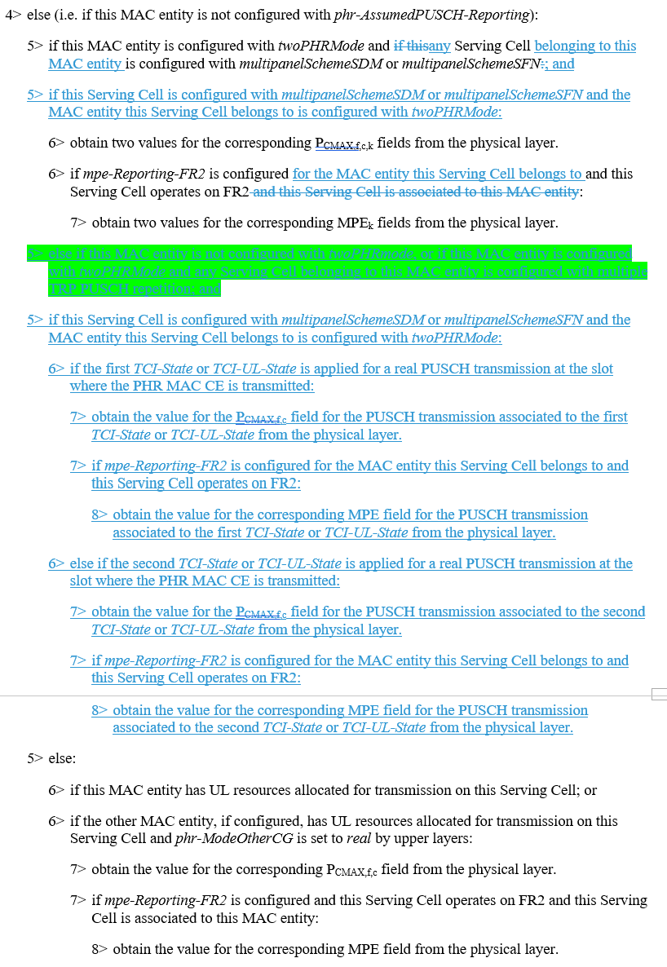

The intention of that sentence is to describe the condition of generating a Rel-17 PHR MAC CE for mTRP PUSCH repetition or a Rel-15/16 PHR MAC CE, i.e., excluding Rel-18 PHR MAC CE for mTRP STx2P.

If the understanding 2 for CR2 is the common understanding, the above green highlighted sentence is missing the case that the transmitting MAC entity is configured with twoPHRmode but in this MAC entity no serving cell is configured with Rel-17 mTRP PUSCH repetition. Then the change can be

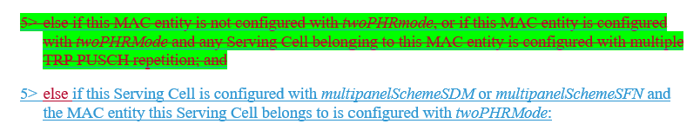

**Q3-1: Do you think the above change is needed based on Q2?**

|  |  |  |
| --- | --- | --- |
| **Company** | **Y/N** | **Reason/Comment** |
| CATT | No | According to our answer to Q2, there is no further missing case in above green highlighted sentence. So we prefer to keep this sentence for easy reading. |
| LGE | No | We prefer to keep the text for easy understanding. |
| ZTE | Yes | This is just a wording optimization, we can follow the majorities. |
| Huawei, HiSilicon | No |  |
| OPPO | No |  |
| Qualcomm | No | The TP in R2-2410528 is fine for us. |
| Samsung | No | Further change is not needed. |

**Q3-2: Do you have any other comments on the CR, e.g., cover sheet, etc.? If no, please indicate if you agree on the CR.**

|  |  |  |
| --- | --- | --- |
| **Company** | **Y/N** | **Reason/Comment** |
|  |  |  |
|  |  |  |
|  |  |  |
|  |  |  |

Summary:

1 thinks the green highlighted sentence should be removed.

6 thinks the current CR is agreeable, no further change is needed.

**Proposal 3: Agree CR** **R2-2410528.**

# Conclusion

**Proposal 1: Change 1 in R2-2410175 is not needed. Discuss whether Change 2 is needed.**

**Proposal 2: RAN2 understands a MAC entity is not be configured with twoPHRmode if in this MAC entity no serving cell is configured with Rel-17 mTRP PUSCH repetition or Rel-18 mTRP STx2P multi-panel scheme.**

**Proposal 3: Agree CR** **R2-2410528.**

# Reference

[1] R2-2410528 Correction on PHR for MIMO STx2P multi-panel scheme Samsung, LG, Huawei, CATT, Ericsson CR Rel-18 38.321 18.3.0 1959 1 F NR_MIMO_evo_DL_UL-Core R2-2409024

[2] R2-2410175 Correction on PHR for MIMO ASUSTeK CR Rel-18 38.321 18.3.0 1991 - F NR_MIMO_evo_DL_UL-Core

[3] R2-2410625 Clarification to 38.321 on R17 PHR MAC CE for mTRP PUSCH Repetition ZTE Corporation CR Rel-18 38.321 18.3.0 2008 - F NR_MIMO_evo_DL_UL-Core