3GPP TSG-RAN2 Meeting #128 R2-24xxxxx
Orlando, USA, 18th - 22nd Nov 2024

Title: Discussion on MCSt

Source: ZTE Corporation, Sanechips

Agenda Item: 7.6.3

Document for: Discussion, Decision

Introduction
In this paper, we discuss MCSt related issues.

RAN2 agreement
RAN2 123bis：
5. For a resource pool configured with PSFCH resource, UE can NOT select consecutive slots (i.e., MCSt) for transmissions of a single TB.
RAN2 124：
1. For remaining slot(s) in case transmission is successful for one TB in MCSt (multiple TB case), the UE still performs retransmission for this TB in the remaining slot(s).

MAC specification
NOTE 3Ag: When the MAC entity selects the time and frequency resources from the resources indicated by the physical layer as specified in clause 8.1.4 of TS 38.214 [7], it is up to the UE implementation whether to randomly select resources for transmission opportunities from the resources indicated by the physical layer or to select resources in consecutive slots by UE implementation from the resources indicated by the physical layer.
NOTE 3Ah: For a resource pool configured with PSFCH resource, UE cannot select consecutive slots for SL transmissions of a single TB for Multi-consecutive slots transmission.
1> if a selected sidelink grant is available for retransmission(s) of a MAC PDU which has been positively acknowledged as specified in clause 5.22.1.3.1a, except a positive acknowledgement to Multi-consecutive slots transmission (i.e., multiple TBs case) of the MAC PDU and there is remaining slot(s) for this MAC PDU:
2> clear the PSCCH duration(s) and PSSCH duration(s) corresponding to retransmission(s) of the MAC PDU from the selected sidelink grant.

1> if a positive acknowledgement to this transmission of the MAC PDU was received according to clause 5.22.1.3.2, except a positive acknowledgement to Multi-consecutive slots transmission (i.e., multiple TBs case) of the MAC PDU and there is remaining slot(s) for this MAC PDU; or
1> if negative-only acknowledgement was enabled in the SCI and no negative acknowledgement was received for this transmission of the MAC PDU according to clause 5.22.1.3.2:
2> flush the HARQ buffer of the associated Sidelink process.

Observation1：current agreement and specification show that MCSt for multiple TBs is supported in pool with PSFCH.
Observation2：current agreement and specification show that MCSt for single TB is not supported in pool with PSFCH.

Scenario

Resource pool with PSFCH
Case1a: | N = 1 is indicated to PHY layer or no value N is indicated to PHY layer. | Based on MAC implementation, UE only select consecutive slot for single TB
Case1b: |  | And based on MAC implementation, UE select consecutive slot for single TBs and multiple TBs
Case1c: |  | Based on MAC implementation, UE select consecutive slot for only multiple TBs.  If
Case2a: | N=3 is indicated to PHY layer | Based on MAC implementation, UE only select consecutive slot for single TB
Case2b: | N=3 is indicated to PHY layer | UE select MCSt for single TB.  Based on MAC implementation, UE select consecutive slot for multiple TBs

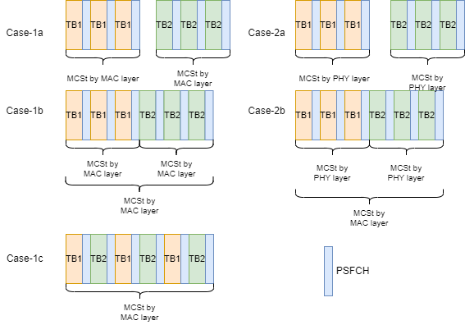
Figure 1: MCSt for pool with PSFCH.
Question1: Check companies view：
Case | Supported or not supported scenario | Reason
1a, 1b, 2a | Not supported. | Since it can not ensure the minimum time gap, current specification already captured this. No specification change is needed for these cases.

Question2: Check companies view：
Case | Supported or not supported scenario | Reason
2b | Not supportted | Supported companies:  Not supported companies:

Draft Proposal1: If 2b is not supported.

Question2: Check companies view：
Case | Supported or not supported scenario | Reason
1c | Supported if minumim time gap for HAQR feedback is ensured.  Note: it may block all other transmitter’s HARQ feedabck. | Supported companies:  Not supported companies:  Qualcomm: follow majority from specification view. But from practically, it can not be supported.
Draft Proposal2: If 1c is supported, then as long as N=1 or no value N is indicated to PHY layer(for MCSt sensing), for a resource pool configured with PSFCH resource, UE can select consecutive slots (i.e., MCSt) for transmissions of a nultiple TBs, if minumim time gap for HAQR feedback is ensured.
Note: It may block all other transmitter’s HARQ feedabck.
Note: MAC layer may need to indicate the number of consecutive slot(not for sensing, but for data transmission) to PHY layer is MAC layer select the MSCt resource for multiple TBs to allow PHY layer perform e.g. CPE.

R2-2410073(ZTE)
According to current specification, in case multiple TBs MCSt, UE can keep retransmission if HARQ ACK is received for these TBs, and corresponding HARQ buffer and SL grant will not be flushed or cleared.
However, without flushing or clearing behaviour, HARQ based transmission becomes useless and the system performance will be decreased, event if the retransmission TBs belongs to another set of MCSt resource.
Additionally, the benefit for keeping retransmission is that UE can keep using LBT type2 for retransmission slot within the COT for TBs within MCSt. However, it is possible that the retransmission slots belongs to another COT, for these retransmission slots, keeping re-transmission is not needed.
For example, considering following case:
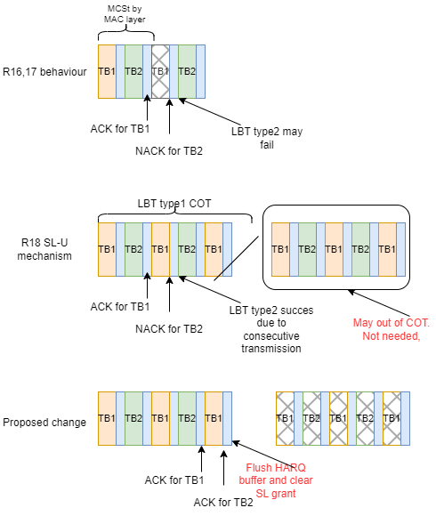
Figure 2: MCSt retransmission
To solve this issue, we suggest to adopt the R2-2410073.
Draft proposal3: suggest to adopt following statement:
NOTE *: If a selected sidelink grant is available for retransmission(s) of a MAC PDU which has been positively acknowledgement to all Multi-consecutive slots transmissions (i.e., multiple TBs case) of the MAC PDU, UE may clear the PSCCH duration(s) and PSSCH duration(s) corresponding to retransmission(s) of the MAC PDU from the selected sidelink grant.
NOTE *: If a positive acknowledgement to all Multi-consecutive slots transmissions (i.e., multiple TBs case) of the MAC PDU, UE may flush the HARQ buffer of the associated Sidelink process.

Resource pool without PSFCH

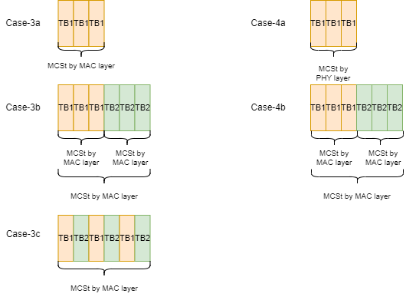
Figure 1: MCSt for pool without PSFCH.
I believe above cases are all supported;
Draft proposal4: Update the stage2 specification as following:
A UE using mode 2 resource allocation and operating in a pool of resources without PSFCH configured supports resource selection for multiple consecutive slot transmission (MCSt). A UE using mode 2 resource allocation and operating in a pool of resources with PSFCH configured supports resource selection for multiple consecutive slot transmission (MCSt), if the N=1 or no value N is indicated to PHY layer. A UE autonomously determines whether to use MCSt, and the number of consecutive slots in an MCSt up to the maximum COT duration for a specific SL-CAPC as defined in TS 37.213 [37]. MCSt can be used for transmission of a single TB or multiple TBs. For each TB transmitted in an MCSt, the UE triggers resource (re)selection only when LBT failure is detected on the resources for the initial transmission and all retransmissions of the TB.

Conclusion
Proposal1: Case 2b is not supported, that is N larger than one is indicated to PHY for MCSt sensing for single TB, for a resource pool configured with PSFCH, MAC layer further select consecutive MCSt resource for multiple TBs.
Proposal2: Case 1c is supported, that is N=1 or no value N is indicated to PHY layer for sensing, for a resource pool configured with PSFCH resource, MAC layer may select consecutive slots (i.e., MCSt) for transmissions of multiple TBs, if minimum time gap for HAQR feedback is ensured.
Note: It may block all other transmitter’s HARQ feedabck.
Note: MAC layer may need to indicate the number of consecutive slot(not for sensing, but for data transmission) to PHY layer if MAC layer select the MSCt resource for multiple TBs to allow PHY layer perform type2 LBT.
Proposal3: Regarding R2-2410073, suggest RAN2 to discuss following statement:
NOTE *: If a selected sidelink grant is available for retransmission(s) of a MAC PDU which has been positively acknowledgement to all Multi-consecutive slots transmissions (i.e., multiple TBs case) of the MAC PDU, UE may clear the PSCCH duration(s) and PSSCH duration(s) corresponding to retransmission(s) of the MAC PDU from the selected sidelink grant.
NOTE *: If a positive acknowledgement to all Multi-consecutive slots transmissions (i.e., multiple TBs case) of the MAC PDU, UE may flush the HARQ buffer of the associated Sidelink process.

Reference
R2-2313617 Summary of [AT124][112][V2X/SL] MAC details (LG) LG discussion Rel-18

