3GPP TSG-RAN WG2 Meeting #127bis R2-240xxxx

Hefei, China, 14 – 18 October 2024

**Agenda item: 8.1.2.2**

**Source: Nokia**

**Title: [017] Report of Offline Discussion on LCM Definitions**

**WID/SID: NR_AIML_air-Core - Release 19**

**Document for: Discussion and Decision**

# 1 Introduction

Proposals from papers regarding LCM definitions submitted by Nokia and Interdigital were discussed during the afternoon session on AI/ML Air on 15/10/24. The aim of this offline discussion is to agree on basic definitions for activation, deactivation, and fallback. To ease the discussion, we will avoid the term “functionality” as to allow RAN1 to determine the definition and consider configurations for AI/ML Beam Management and legacy Beam Management instead.

# 2 Background

## 2.1 Proposals Discussed

The following proposals were discussed.

[R2-2408553](https://www.3gpp.org/ftp/tsg_ran/WG2_RL2/TSGR2_127bis/Docs/R2-2408553.zip) LCM for UE-side Beam Management Nokia discussion Rel-19 NR_AIML_air-Core

*Proposal 2: A deactivated functionality is an AI/ML functionality for which the UE has received a radio configuration via a CSI-ReportConfig, but which is neither configured to perform inference nor to report its outputs to the NW.*

*Proposal 3: Functionality fallback to non-AI/ML means deactivating one AI/ML-enabled functionality and activating a non-AI/ML feature of the same type, e.g., Beam Management.*

*Proposal 4: Functionality switching means simultaneously deactivating one AI/ML-enabled functionality and activating another of the same type, e.g., Beam Management.*

[R2-2408921](https://www.3gpp.org/ftp/tsg_ran/WG2_RL2/TSGR2_127bis/Docs/R2-2408921.zip) Remaining details of applicable functionality reporting InterDigital discussion Rel-19 NR_AIML_air-Core

*Proposal 1: Upon AI/ML functionality deactivation, UE falls back to legacy (i.e., non-AI/ML) operation as baseline.*

During the discussion, it was raised by Huawei that for CSI measurement reporting, we already have the following:

* Aperiodic – CSI reporting activated via a DCI indication
* Semipersistent – CSI reporting activated via a MAC CE indication
* Periodic – CSI reporting activated via an RRCReconfiguration message

Definitions for switching will be left out of this discussion.

## 2.2 Legacy Activation and Deactivation of CSI Reports

However, it is still unclear what the term activated means in the context of BM LCM. As a starting point for the discussion, we suggest discussing the behaviour of the legacy mechanisms. *CSI-ReportConfigs* are configured, i.e., added, modified, or released via *CSI-MeasConfig* in lists named *csi-ReportConfigToAddModList* and *csi-ReportConfigToReleaseList*.

The following table, 5.2.1.4-1 from TS38.214 summarizes the different CSI-RS configuration and Reporting combinations.

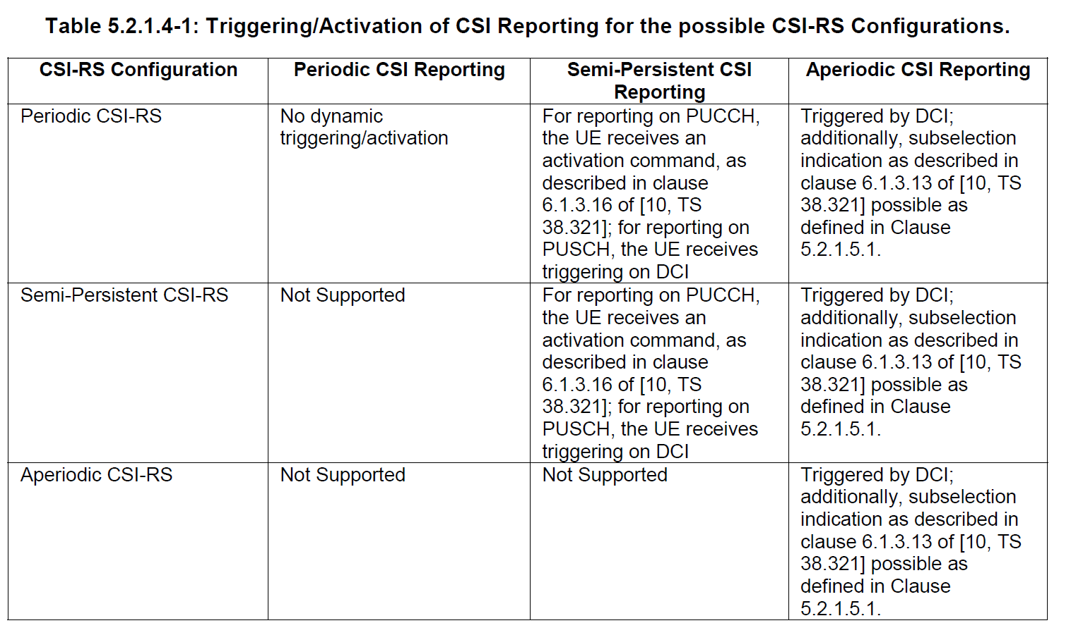

The following sections go into further details for each CSI Reporting Type. Further details can be found in TS38.214 and TS38.331.

**Aperiodic**

The UE receives a configuration for aperiodic reporting via *CSI-ReportConfig* with a *ReportConfigType* set to *aperiodic*.

The NW is not required to send any CSI-RS associated an aperiodic CSI-RS configuration until the triggering of an aperiodic reporting occurs. When triggered by a DCI, the NW begins to transmit CSI-RS, if the CSI-RS are also aperiodic, the UE makes measurements, and then the UE is expected to produce one report over PUCCH or PUSCH and to produce no further reports until triggered again.

**Semipersistent on PUCCH**

The UE receives a configuration for semipersistent reporting via *CSI-ReportConfig* with a *ReportConfigType* set to *semiPersistentOnPUCCH*. When triggered by an “SP CSI reporting on PUCCH Activation/Deactivation” or “SP CSI reporting on PUSCH Activation/Deactivation” MAC CE, the UE is expected to produce reports when activated until deactivated. An index into a list derived from the list of *CSI-ReportConfigs* of the *ReportConfigType* set to *semiPersistentOnPUCCH*.

**Semipersistent on PUSCH**

The UE receives a configuration for semipersistent reporting via *CSI-ReportConfig* with a *ReportConfigType* set to *semiPersistentOnPUSCH*. A semipersistent on PUSCH reporting configuration is activated via a DCI, with an index configured in the CSI-Request field, and continues to report until deactivated by a DCI, setting the CSI-Request field to 0.

**Periodic**

The UE receives a configuration for periodic reporting via *CSI-ReportConfig* with a *ReportConfigType* set to *periodic*. Upon reception of a periodic CSI reporting configuration, it is expected that the UE will periodically report CSI measurements of the type configured in *reportQuantity* until the configuration is released. Therefore, according to the legacy procedures, a periodic configuration for CSI measurement reporting should begin reporting when “added” or “modified” and should cease reporting when “released”.

# 3 Discussion

## 3.1 What is Activation?

**Question 1:** Is AI/ML BM activated simply having been provided an aperiodic, semipersistent, or periodic configuration, or, for at least the latter two, is an activation command also required?

**Question 2:** Is a periodic AI/ML BM configuration initially activated and can it be configured in an initially deactivated state?

Given the following agreement made in RAN2#127, it seems that reporting must occur to be considered “activated”.

1. Activated functionalities refers to functionalities already enabled for performing inference

In the previous section, four different CSI reporting configuration types from legacy CSI reporting were described, all but one of which are initially deactivated.

**Question 3:** Is a configured AI/ML BM *CSI-ReportConfig* that is not producing reports considered an activated functionality?

**Question 4:** Is a configured AI/ML BM *CSI-ReportConfig*, which has been triggered to produce reports considered an activated functionality?

## 3.2 What is Deactivation?

As noted in Section 2.2, aperiodic and semipersistent CSI reporting configurations are initially deactivated, until triggered by a DCI or a DCI or MAC CE, respectively. Additionally, an aperiodic CSI reporting configuration automatically stops reporting after a report has been sent.

**Question 5:** For an aperiodic AI/ML BM CSI reporting configuration, is it considered to be automatically deactivated after having sent the report which it was triggered to send?

Semipersistent and Periodic AI/ML BM CSI reporting configurations report until deactivated either by a DCI or MAC CE, or by RRC Reconfiguration, respectively.

**Question 6:** Is a semipersistent AI/ML BM CSI reporting configuration considered to be deactivated after having received a DCI or MAC CE deactivation command?

**Question 7:** Is there an equivalent deactivation possible for a Periodic AI/ML CSI reporting configuration since the act of Releasing the configuration destroys the context for a deactivated state?

## 3.3 What is Fallback?

The following examples are provided for discussion on what procedural steps could define the fallback operation, mapped to legacy procedures. These procedures are provided for discussion only, and to begin to achieve a general sense for what will be required. Whether fallback could be pre-configured or whether a UE could be triggered to automatically fallback is out of scope for this short offline discussion.

1. Aperiodic
   1. DCI trigger Aperiodic AI/ML BM report
   2. Poor performance detected by network
   3. DCI trigger Aperiodic Legacy CSI-RS measurement report
2. Semipersistent PUCCH
   1. MAC activation of Semipersistent AI/ML BM reporting
   2. Poor performance detected by network
   3. One Step
      1. MAC deactivation of Semipersistent AI/ML BM reporting
      2. MAC activation of Semipersistent Legacy CSI-RS measurement reporting
3. Semipersistent PUSCH
4. Periodic
   1. RRC Reconfiguration with ToAddMod, adding AI/ML BM Periodic reporting configuration
   2. Poor performance detected by network
   3. RRC Reconfiguration
      1. ToAddMod, adding Legacy BM Periodic reporting configuration
      2. ToRelease, releasing AI/ML BM Periodic reporting configuration

# 4 Way Forward / Proposals

Here, we will capture discussion notes and proposals that we develop during the offline.