3GPP TSG-RAN WG2 Meeting #127 R2-240xxxx
Maastricht, Netherlands, Aug 19th – 23rd, 2024

Agenda item: 8.8.4
Source: Apple
Title: [Offline 307] [R19 NR NTN] service area information (Apple)
WID/SID: NR_NTN_Ph3-Core
Document for: Discussion and Decision

Introduction

This is to handle the following offline.
[AT127][307][R19 NR NTN] service area information (Apple)
Scope: Continue the discussion on the options to provide service area information: SIB20 vs MBSBroadcastConfiguration in MCCH
Intended outcome: report of offline discussion
Deadline for companies' feedback: Thursday 2024-08-22 20:00
Deadline for rapporteur's summary (in R2-2407619): Friday 2024-08-23 08:00

Discussions
#1: Observation from Online discussion (Tuesday)
From online discussion, we observed the following comments on two approaches, i.e., using SIB20 or MBSBroadcastConfiguration in MCCH to provide service area information for a broadcast session.
 | Pros | Cons
SIB20 | UE power saving from skipping monitoring MCCH if UE is not inside intended service area of its interested broadcast service. | 1) Signaling design is not clear to companies  2) How to support association for location dependent services.
MCCH | Simple signaling design | UE needs to always monitor MCCH to keep it up-to-date.

#2: Expected UE behavior when UE is not in any intended service area of its interested broadcast services
The understanding from SIB20 approach proponents is UE does not need to (re)acquire up-to-date MCCH when UE is not inside any intended service area of its interested broadcast services.
Question 1: Do companies share the understanding of expected UE behavior when UE is not in any intended service area of its interested broadcast interested broadcast services, UE does not need to (re)acquire up-to-date MCCH.
Company | Yes/No | Comments
TCL | Yes | To support the association for location dependent services, it is preferable to consider associating a service area or a cell level service area with MBS session information within SIB20.

#3: Signaling example to provision the mapping between intended service areas and broadcast services
The following two figures show our understanding on the signaling design in to approaches.
1) Assumption 1: For location dependent services, one cell may provide multiple sets of configurations (e.g., g-RNTI, MRB configuration, MTCH configuration) for one single TMGI.
TS 23.274:

6.2.3 Location dependent MBS service
A location dependent MBS is identified by MBS Session ID, and provided in several MBS service areas. The location dependent MBS service enables distribution of different content data to different MBS service areas. The same MBS Session ID is used but a different Area Session ID is used for each MBS service area.
2) Assumption 2: It is assumed a common service area pool is provided somewhere. And service area ID is used to do the association.
With those understanding, below are the possible signaling structures to provision the mapping between one broadcast session (either it is location dependent service, or normal broadcast service).
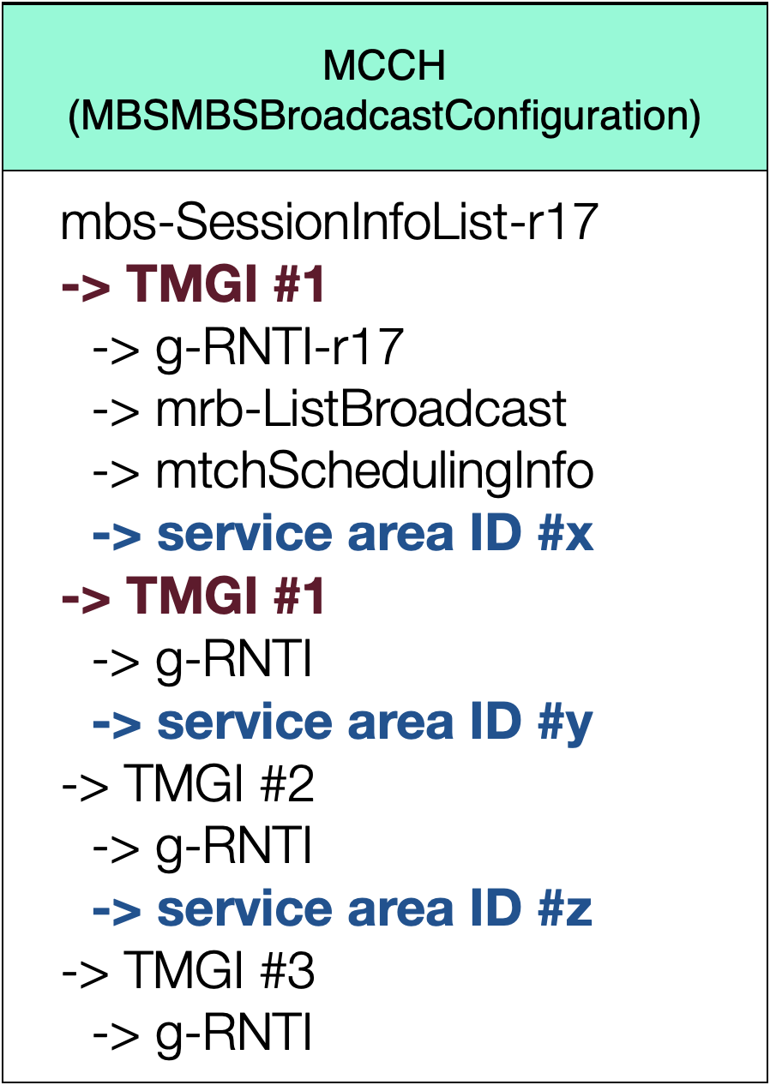
Fig. 1 – MCCH provisioning broadcast session and service area mapping
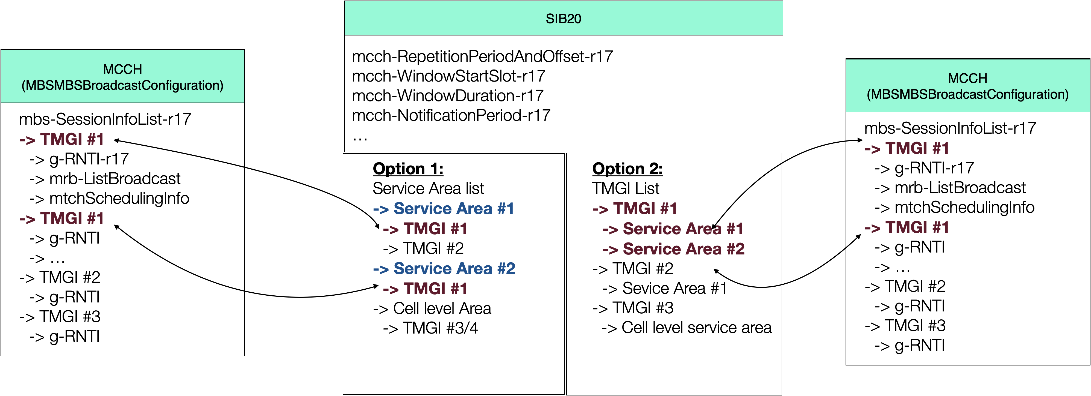
Fig. 2 – SIB20 provisioning broadcast session and service area mapping
Possible variants on configurations for SIB20 to provide the association between two lists in SIB20/MCCH:
1) For multiple entries associated with one single TMGI, association is done based on the entry order in two lists (as shown in Fig. 2).
2) Index can be used
3) Other solutions: TMGI + g-RNTI in SIB20

Question 2: Comments on signaling example above and possible down-selection.
- Approach 1: SIB20
- Approach 2: MCCH
Company | Approach 1/2 | Comments
TCL | Approach 1 | Allow skipping monitoring MCCH if UE outside of the intended service area

