3GPP TSG-RAN WG2 Meeting #127 R2-240xxxx
Maastricht, Netherlands, Aug 19th – 23rd, 2024

Agenda item: 8.8.4
Source: Apple
Title: [Offline 307] [R19 NR NTN] service area information (Apple)
WID/SID: NR_NTN_Ph3-Core
Document for: Discussion and Decision

Introduction

This is to handle the following offline.
* [AT127][307][R19 NR NTN] service area information (Apple)
Scope: Continue the discussion on the options to provide service area information: SIB20 vs MBSBroadcastConfiguration in MCCH
Intended outcome: report of offline discussion
Deadline for companies' feedback: Thursday 2024-08-22 20:00
Deadline for rapporteur's summary (in R2-2407619): Friday 2024-08-23 08:00

Discussions
#1: Observation from Online discussion (Tuesday)
From online discussion, we observed the following comments on two approaches, i.e., using SIB20 or MBSBroadcastConfiguration in MCCH to provide service area information for a broadcast session.
 | Pros | Cons
SIB20 | UE power saving from skipping monitoring MCCH if UE is not inside intended service area of its interested broadcast service. | 1) Signaling design is not clear to companies  2) How to support association for location dependent services.
MCCH | Simple signaling design | UE needs to always monitor MCCH to keep it up-to-date.

#2: Expected UE behavior when UE is not in any intended service area of its interested broadcast services
The understanding from SIB20 approach proponents is UE does not need to (re)acquire up-to-date MCCH when UE is not inside any intended service area of its interested broadcast services.
Question 1: Do companies share the understanding of expected UE behavior when UE is not in any intended service area of its interested broadcast interested broadcast services, UE does not need to (re)acquire up-to-date MCCH.
Company | Yes/No | Comments
vivo | Yes | Whether cell-area service need to be provisioned.  Apple: should be supported as legacy.
LG |  | Does UE skip monitoring the MSB in notification of MCCH?
QC | Yes
vivo | Yes
ZTE | Yes
TCL | Yes | To support the association for location dependent services, it is preferable to consider associating a service area or a cell level service area with MBS session information within SIB20.
Vivo (from draft folder) | Comments | There may be some broadcast services that the UE is interested in are provided without related intended service area. Then the UE cannot just simply determine not to acquire the MCCH based on the UE location and the intended service area (i.e. the UE should acquire the latest MCCH to check if there is any service that the UE is interested in is provided in the current cell). Thus, for user experience, UE should (re)acquire up-to-date MCCH.  Maybe RAN2 has to discuss whether the service associated with the intended area can be provided together with the service not associated with the intended area.
THALES (from draft folder) | Yes
Qualcomm (from draft folder) | Yes
Continental Automotive (from draft folder) | Yes
ITRI (from draft folder) | Comments | Regardless of the intended service area of MBS services, UE needs to obtain info of the modification of the MBS session provided in the neighbouring cell from up-to-date MCCH.  UE could determine whether to acquire the updated MCCH by receiving MCCH change notification, e.g., according to the LSB in the 2-bit bitmap of MCCH change notification which may indicate neighbouring cell information modification.
InterDigital | Yes | If UE has an interested service, the UE acquires an MCCH message at the cell and UE won’t need to re-acquire the MCCH message until MCCH modification is indicated (i.e. UE doesn’t need to continuously monitor MCCH.)
Yes: 8 companies
Summary: During offline discussion, there is a concern that confirming this expected UE behavior may imply that SIB20 is the only possible solution. Rapporteur received some comments after the offline that MCCH approach can also achieve relaxation on MCCH monitoring (when UE is out of intended service area of interested MBS broadcast services).
Proposal 1: Discuss online whether the expected UE behavior can be agreed.
- When UE is not in any intended service area of its interested broadcast services, UE may not need to (re)acquire up-to-date MCCH.

#3: Signaling example to provision the mapping between intended service areas and broadcast services
The following two figures show our understanding on the signaling design in to approaches.
1) Assumption 1: For location dependent services, one cell may provide multiple sets of configurations (e.g., g-RNTI, MRB configuration, MTCH configuration) for one single TMGI.
TS 23.274:

6.2.3 Location dependent MBS service
A location dependent MBS is identified by MBS Session ID, and provided in several MBS service areas. The location dependent MBS service enables distribution of different content data to different MBS service areas. The same MBS Session ID is used but a different Area Session ID is used for each MBS service area.
2) Assumption 2: It is assumed a common service area pool is provided somewhere. And service area ID is used to do the association.
With those understanding, below are the possible signaling structures to provision the mapping between one broadcast session (either it is location dependent service, or normal broadcast service).
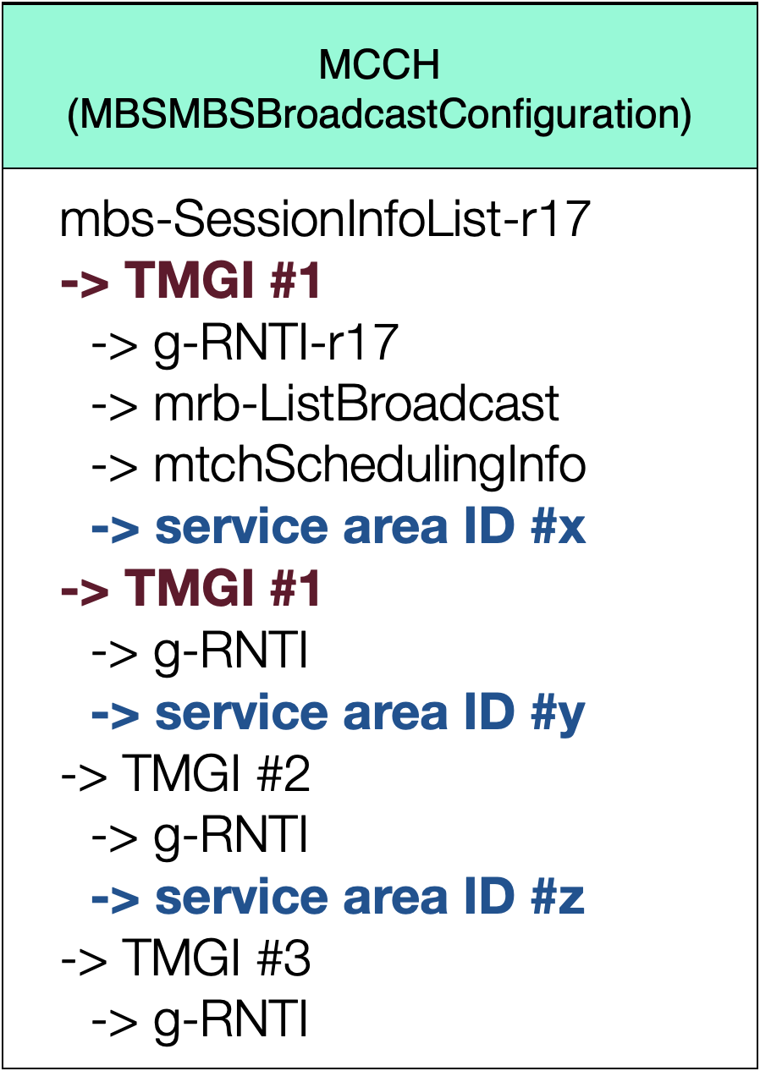
Fig. 1 – MCCH provisioning broadcast session and service area mapping
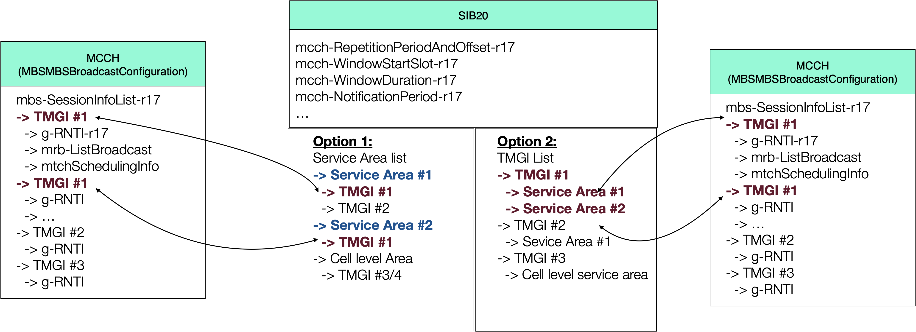
Fig. 2 – SIB20 provisioning broadcast session and service area mapping
Possible variants on configurations for SIB20 to provide the association between two lists in SIB20/MCCH:
1) For multiple entries associated with one single TMGI, association is done based on the entry order in two lists (as shown in Fig. 2).
2) Index can be used
3) Other solutions: TMGI + g-RNTI in SIB20

Question 2: Comments on signaling example above and possible down-selection.
- Approach 1: SIB20
- Approach 2: MCCH
Company | Approach 1/2 | Comments
CMCC | MCCH | No NAS solution here, right? [Apple]: yes.  Option 1 saves signaling than Option 2, for SIB20.
vivo | SIB20
ZTE | SIB20 | g-RNTI is needed for linkage for location dependent service.
Fujitsu | MCCH | How many signaling required to provide the linkage. Prefer MCCH.
xiaomi | MCCH | SIB20 needs to be updated if session ID changes, which requires UE to re-acquire SIB20.  SIB20 carry area pool, then MCCH do the linkage.
Huawei | MCCH | Concern on signaling overhead
LG | MCCH | Wondering how frequently the modification of MCCH in NTN cell.  Gain of UE power saving is not clear so far.  MCCH modification notification for the start of a new service? [Apple]: yes.  Skipping monitoring MCCH can be possible by indicating the area into MCCH.
QC | SIB20 | If MCCH carries area ID, when UE moves out of the area, how UE skips MCCH.
Ericsson | MCCH | Legacy MBS requires UE decoding MCCH, If put to SIB20, the change of service area would require all UE to update SIB20.
TCL (from draft folder) | Approach 1 | Allow skipping monitoring MCCH if UE outside of the intended service area
Vivo (from draft folder) | Approach 2 (Apple: this entry not counted, instead online comment was counted.) | For Approach 1, there might be SIB20 and MCCH update mismatch issues (i.e. the modification period of MCCH message and SIB20 is different). For example, when NW adds TMGI#1 which UE is interested in, NW should inform MCCH change notification. Under this use case, it is not suitable for UE to determine whether a new TMGI#1 is provided based on the intended service area info of TMGI#1 in SIB20. Assuming MCCH modification period is sf=2 and the SIB modification period sf=8 respectively. This means that NW cannot update timely SIB20 to provide the intended area info of new TMGI#1, which makes UE consider that TMGI#1 is not provided in NW (without reading MCCH). As a result, it will miss the interested broadcast service for a while. There may be an argument that NW can update MCCH message and SIB20 with the same modification period, e.g., based on modification period with sf2. However, on the one hand, this will restrict NW implementation. On the other hand, this will bring transmission delay of broadcast service TMGI#1.  For Approach 2, the intended area info of a broadcast service should be put outside of the MBS-SessionInfoList IE as the current signaling structure of MBS-SessionInfoList IE cannot be extended.  The signaling example of Approach 2 can be as following:  MBSBroadcastConfiguration-r17  -> mbs-SessionInfoList-r17  -> serviceareaofTMGI list-r19  ->> service area info of TMGI #1  ->> service area info of TMGI #2  ….  ->> service area info of TMGI #N  The mbs-SessionInfoList-r17 and serviceareaofTMGI list-r19 should have the same number of entries and has one-one mapping.
THALES (from draft folder) | See comment | Preference for Approach 1 since it enables the UE only to monitor if there are/are not Broadcast service in NTN area. But no opposition to Approach 2 that is more cleaner if intended service area is limited to MBS Broadcast. FFS if a new SIB is introduce if service area had to be broadcasted for another purpose.
Qualcomm (from draft folder) | Approach 1 (Apple: this entry not counted) | Also better not to add overheads in MCCH.
Continental Automotive (from draft folder) | Approach 1 with comments | Enable UE to save power by skipping monitoring MCCH, if UE is not inside intended service area of its interested broadcast service.
ITRI | No strong preference | No strong preference.
InterDigital | Approach 1 | It’s better in terms of MCCH overhead.
Summary: SIB20 vs MCCH: 7:6.
- Concerns on using SIB20 include signaling overhead and extra modification of SIB20 caused by service area info update.
- Concern on using MCCH is UE power consumption to always monitor MCCH update.
Proposal 2: FFS on solutions.

