3GPP TSG-RAN WG2 Meeting #126 R2-240xxx
Fukuoka, Japan, May 20th – 26th, 2024

Agenda item: 4.4
Source: Huawei, HiSilicon, Ericsson
Title: Summary for [AT126][401][POS] Rel-15 LTE positioning
Document for: Discussion and Decision

Introduction
During RAN2#126, the following tdocs have been submitted to the agenda 4.4 for LTE Release 15 positioning:
R2-2404749 Correction to mandatory 80ms scheduling offset for positioning SI acquisition Huawei, HiSilicon, Ericsson CR Rel-15 36.306 15.11.0 1885 - F LCS_LTE_acc_enh-Core
R2-2404750 Correction to mandatory 80ms scheduling offset for positioning SI acquisition Huawei, HiSilicon, Ericsson CR Rel-16 36.306 16.12.0 1886 - A LCS_LTE_acc_enh-Core
R2-2404751 Correction to mandatory 80ms scheduling offset for positioning SI acquisition Huawei, HiSilicon, Ericsson CR Rel-17 36.306 17.6.0 1887 - A LCS_LTE_acc_enh-Core
R2-2404752 Correction to mandatory 80ms scheduling offset for positioning SI acquisition Huawei, HiSilicon, Ericsson CR Rel-18 36.306 18.1.0 1888 - A LCS_LTE_acc_enh-Core
In this email discussion, we discuss on the issues have been presented in these papers

Discussion
During the discussion in R15 LTE for positioning system information broadcast, the following has been adopted for the system information reception in the UE.
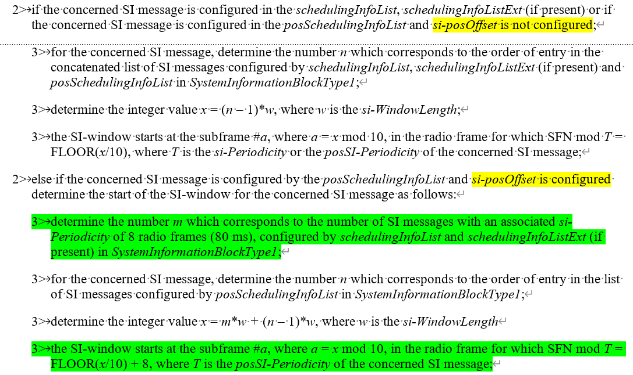
During RAN2#125bis, the following CR for NR has been discussed and agreed in principle.
R2-2403553 Missing Conditionally mandatory features without UE radio access capability parameters for 80ms scheduling offset for positioning SI acquisition Ericsson CR Rel-16 38.306 16.16.0 1087 - F NR_pos-Core
- Replace “for UEs which support the posSIB types” with “for UEs which support acquisition of the posSIB types”.
- Agreed in principle with this change as R2-2403797, with shadow CRs in R2-2403798 and R2-2403799
For LTE, the proponents of the above papers think the same also needs to be applied since NR and LTE share the common mechanism for positioning SIB broadcast. For this email discusion, we would like to ask the following qustion:
Question: Do companies agree that LTE should also have clarification for the mandatory without signaling on the 80ms scheduling offset for pos SI msg acquisition?
Companies | Yes/No | Comments

Conclusion
TBD

