3GPP TSG RAN WG1 #118bis R1-2409060
Hefei, China, October 14th – 18th, 2024

Agenda item: 9.2.2
Source: Moderator (Samsung)
Title: Moderator Summary#4 on Rel-19 CSI enhancements: Round 4
Document for: Discussion and Decision

Introduction
The scope given in the Rel-19 NR MIMO Phase 5 WID pertaining to CSI enhancement is as follows (2d added in [1]):
- Specify CSI support for up to 128 CSI-RS ports, targeting FR1
  - Type-I codebook refinement supporting up to a total of 128 CSI-RS ports across all resources, assuming legacy CSI-RS resources (with up to 32 CSI-RS ports per resource), based on extension of legacy codebooks
  - Type-II codebook refinement supporting up to a total of 128 CSI-RS ports across all resources, assuming legacy CSI-RS resources (with up to 32 CSI-RS ports per resource), based on extension of legacy codebooks, without modifying any codebook parameter other than introducing additional values for the number of ports codebook parameter(s)
  - Extension of CRI(s)-based CSI reporting (CQI/PMI/RI calculated per CRI for ≥1 CRIs) for hybrid beamforming supporting up to a total of 128 CSI-RS ports across all resources, with up to 32 CSI-RS ports per resource, without new codebook design
  - SRS port grouping and its association to the two codewords for the 6/8Rx low complexity receiver supporting more than 4 layers, with legacy codebook
    - No enhancement on codeword-to-layer mapping, DL resource allocation, CSI feedback, and DCI format
    - Note: Whether to support 6Rx with more than 4 layers is to be decided in RAN4 Rel-19 RF enhancements WI
- Specify UE reporting enhancement for CJT deployments under non-ideal synchronization and backhaul, targeting FR1, both FDD and TDD
- Inter-TRP time misalignment and frequency/phase offset measurement and reporting, assuming legacy CSI-RS design, with stand-alone aperiodic reporting on PUSCH

Summary of companies’ proposals and views

1.1.2 | Conclusion 1.A.2: For a UE configured with a total of P_{SRS}=6 or 8 ports across ≥1 SRS resources for antenna switching intended for xT6R or xT8R, respectively, when SRS port grouping is configured, regarding the mapping between CSI-RS ports and SRS port groups, no additional specification support is introduced  - Note: When SRS port grouping is configured, the UE, if capable of ‘non-PMI-PortIndication’, doesn’t expect reportQuantity set to ‘cri-RI-CQI’ without ‘non-PMI-PortIndication’  FL assessment: After further discussion with Qualcomm and Huawei, the Note can be removed.
3.3.5 | Proposal 3.C.5: For the Rel-19 aperiodic standalone CJT calibration (CJTC) reporting, when linking CJTC Dd and Rel-18 eType-II CJT CSI reports is configured with two separate triggers, introduce a UE capability for the following:  - The UE capability is used to inform the NW on the maximum duration of 2 sec the UE can store the latest CJTC Dd report, measured from the transmission of the linked CJTC Dd report  - When the UE does not report this UE capability, it is assumed that the UE can store a CJTC Dd report [indefinitely]  FL assessment: Wording is based on the outcome of Monday and Wednesday offline sessions.  This is intended to avoid stale Dd report from being utilized. However, it can be argued that this can be handled via NW implementation. | Support/fine: Lenovo/MotM, ZTE, Qualcomm, vivo, OPPO, Xiaomi, Huawei/HiSi, NEC, HONOR, Sharp, KDDI, MediaTek, NTT DOCOMO, Apple, Google, Spreadtrum, CATT,  Not support (concern): Intel, Ericsson, Nokia/NSB,

Ground rules in sharing your inputs:
- Please do NOT input anything in Tables 1A, 2A, and 3A
  - Including company names - appreciate your trying to save me some work, but …
  - For some reason, most likely due to poor MS Word inter-platform/version compatibility support (if any), the formatting of the FL proposals will change (for the worse) if you do so. This has happened several times in Athens and Changsha ☹
- Please input your comments ONLY in Tables 1C, 2C, and 3C, thanks! 😊

Issue 1 (WID objective 2a and 2b): Type-I and Type-II codebook refinement for up to 128 CSI-RS ports
Table 1A Summary: issue 1
# | Issue/proposal | Companies’ views
1.1.2 | Conclusion 1.A.2: For a UE configured with a total of P_{SRS}=6 or 8 ports across ≥1 SRS resources for antenna switching intended for xT6R or xT8R, respectively, when SRS port grouping is configured, regarding the mapping between CSI-RS ports and SRS port groups, no additional specification support is introduced  - Note: When SRS port grouping is configured, the UE, if capable of ‘non-PMI-PortIndication’, doesn’t expect reportQuantity set to ‘cri-RI-CQI’ without ‘non-PMI-PortIndication’  FL assessment: After further discussion with Qualcomm and Huawei, the Note can be removed.
Not discussed in Round-4 (may revisit in RAN1#119)

1.5 | Proposal 1.E: For the Rel-19 Type-I SP codebook refinement for 48, 64, and 128 CSI-RS ports, extend the agreed Scheme-A and Scheme-B to the legacy number of CSI-RS ports (i.e. 4, 8, 12, 16, 24, and 32 ports) for all applicable RI values (1, …, min(P_{CSI-RS},8)) with K=1 only, and without any further modification/enhancement of the sub-features pertinent to the Rel-19 Type-I SP design (including, e.g. the Rel-19 Type-I SP CBSR, soft scaling).  - [The following of Rel-19 Type-I SP are four separate UE features: (1) Scheme-A >32port; (2) Scheme-B >32port; (3) Scheme-A ≤32port; (4) Scheme-B ≤32 port.]  FL assessment: This was discussed during Monday Offline session.  This proposal is sound for the completeness of Rel-19 Type-I SP codebook. Note that this doesn’t impact the legacy Rel-15 Type-I SP design.  Re whether this is OOS or not, the WID says “… supporting up to a total of 128 CSI-RS ports across all resources, assuming legacy CSI-RS resources (with up to 32 CSI-RS ports per resource), …” which, strictly speaking, doesn’t preclude <=32 ports. So this extension proposal is not OOS. | Support/fine: ZTE, Lenovo/MotM, IDC, Samsung (ok), Xiaomi, Nokia/NSB, NEC, Fujitsu, Intel (FFS capability), NTT DOCOMO, CATT (only Scheme-B, no scheme-A), Spreadtrum, CMCC, MediaTek (ok with bullet),  Not support: Google, OPPO, HONOR, TCL, Fraunhofer IIS/HHI, Tejas,  Concern: Apple, vivo (ok RI=3-4 & 16, 24, 32 ports), Huawei/HiSi (same as vivo), Ericsson, Lenovo/MotM (strong)

Table 1B SLS results: issue 1
--
Table 1C Additional inputs: issue 1
Company | Input
Mod V0 | Please share your inputs on each of the issues and, if applicable, proposals in TABLE 1A
Samsung | Proposal 1.A.2  We are Ok with proposal. It seems the Note looks now a conclusion.
OPPO | Proposal 1.A.2:  We are fine with the note.  Furthermore, to avoid a bad configuration from network even with ‘non-PMI-PortIndication’, can we further say that “UE doesn’t expect one CSI-RS port to be associated with two SRS port groups”  Proposal 1.E:  We still think it is not needed. For large number of ports, e.g. 32, there may be some gain of scheme A/B over legacy codebook, but the CSI overhead would also be increased. Whether there would be still gain with UPT/OH comparison is unclear.
Qualcomm | Proposal 1.A.2:  Thanks FL for the updates of the note.  After some off-offline discussion with Huawei, I understand the concern regarding the optional UE feature 22-11 (Damn! This should had been a good argument for Alt2, pity I didn’t know this optional 22-11 FG until Yubo told me today – dear Yubo, why not tell me earlier? 😊)  [Mod: Please, no profanity in CSI FL summary 😊]  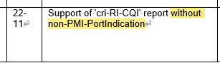  Based on my understanding, Huawei’s concern is that, for a UE supporting SRS PG but also reporting 22-11, the risk with this note is: It may result in CQI report not supported, if gNB does not config ‘non-PMI-PortIndication’.  My taken is, if UE reports 22-11 and without config of ‘non-PMI-PortIndication’, this has to be supported with legacy CSIRSport-to-(hypothetical)layer mapping, thus the so-called “supported” CQI/RI report is anyway mismatched.  Therefore, for a reasonable UE implementation, if it wants to support SRS PG, it won’t report 22-11 – please trust UE side 😊
Qualcomm | Updated a little with our response above
NTT DOCOMO | Proposal 1.A.2:  Support.
Mod V11 | No revision
Tejas | Conclusion 1.A.2:  Support. Appreciate the detailed note from Qualcomm.

Issue 2 (WID objective 2c): CRI-based CSI for hybrid beamforming (HBF)

Table 2A Summary: issue 2
# | Issue | Companies’ views
2.3 | [116bis] Agreement  For the Rel-19 CRI-based CSI refinement for up to 128 CSI-RS ports, on the configured K_{S}>1 NZP CSI-RS resources, reuse the legacy CMR and IMR rules for the Rel-15 CRI-based reporting. This includes:  - All the K_{S} NZP CSI-RS resources are associated with a same CSI-RS resource set  - …  Proposal 2.C: For the Rel-19 CRI-based CSI refinement for up to 128 CSI-RS ports, regarding aperiodic CSI-RS resource configuration, the resource-level slot offset is supported as follows:  - Reuse the same set of CSI-RS resource configuration to accommodate different DCI triggering time  FL assessment: The proposal is unclear. It was agreed that all the KS resources are associated with a same resource set. In this case, all the restrictions apply including the permitted resource-level slot offset | Support/fine: Huawei/HiSi  Not support: ZTE,

Table 2B SLS results: issue 2
--
Table 2C Additional inputs: issue 2
Company | Input
Mod V0 | Please share your inputs on each of the issues and, if applicable, proposals in TABLE 1A
Samsung | Proposal 2.C  The sub-bullet need clarification, we are not sure what the sub-bullet means.
OPPO | Some clarification is needed.
Ericsson | Similar to other comments above, the sub-bullet is unclear. The sub-bullet needs further clarification in order to understand the proposal.
NTT DOCOMO | Similar comments as other companies.
Mod V11 | @Huawei, please clarify – it seems no one understands the proposal
Huawei, HiSilicon | Given that gNB transmits CSI-RS resources corresponding to different analog beams in TDM manner under HBF architecture, which means multi-beam CSI measurement can distribute among up to Ks slots, apparently we need to determine the corresponding configuration methodology.  A straightforward solution is to adopt two-level offset similar to what is already agreed for 128 ports. Nevertheless, considering that multi-beam CSI measurement distributing among up to K_{s} slots can experience one or multiple times UL/DL switching, aforementioned two-level offset is unfortunately inefficient.  Specifically, as shown in the following figure, when the DCI is transmitted in different slot, imputing to the existence of UL/DL switching, configuring different aperiodicTriggeringOffset while reusing the same set of CSI-RS resource configuration becomes an unrealistic notion (to accommodate different DCI triggering time in following case 1 and 2, different sets of CSI-RS resources are needed, where one set comprises resources with resource-level offsets equaling to 0, 1, 3, and 4, respectively, and the other set comprises resources with resource-level offsets equaling to 0, 2, 3, and 4, respectively).  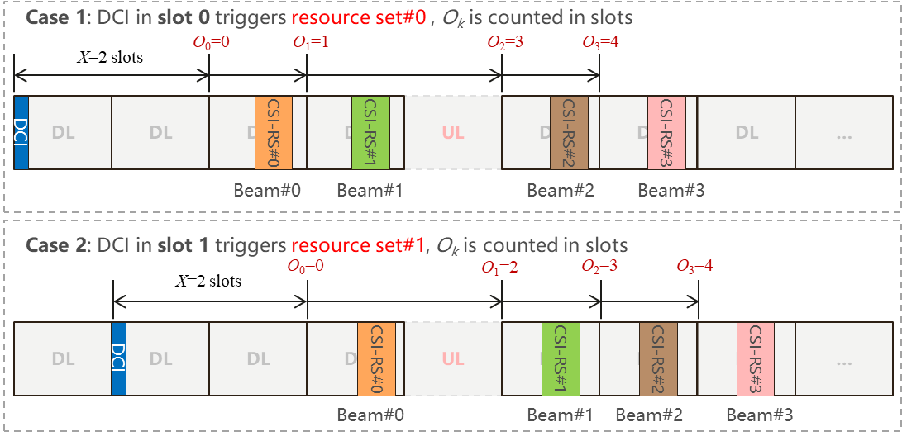  To avoid meaningless waste of UE capability (UE supports limited number of CSI-RS resources) and reserve configuration overhead, we should strive to reuse the same set of CSI-RS resource configuration to accommodate different DCI triggering time, the enabling mechanism of which can be further discussed.
ZTE | Proposal 2.C:  Do NOT support. The wording of this proposal is very confusing, we failed to understand whether resource-level slot offset is allowed or not if this proposal is agreed. Based on the 116bis agreement, “on the configured K_{S}>1 NZP CSI-RS resources, reuse the legacy CMR and IMR rules for the Rel-15 CRI-based reporting”. Then resource-level slot offset is NOT allowed based on Rel-15 legacy CMR and IMR rules. Besides, we do NOT think resource-level slot offset is needed for CRIs-based CSI reporting. Maybe just 1-bit per-resource indicator indicating whether the resource is located in the slot indicated by the resource-set-level offset or the next slot after that indicated by the resource-set-level offset is sufficient.  Related specs can be founded in the following:  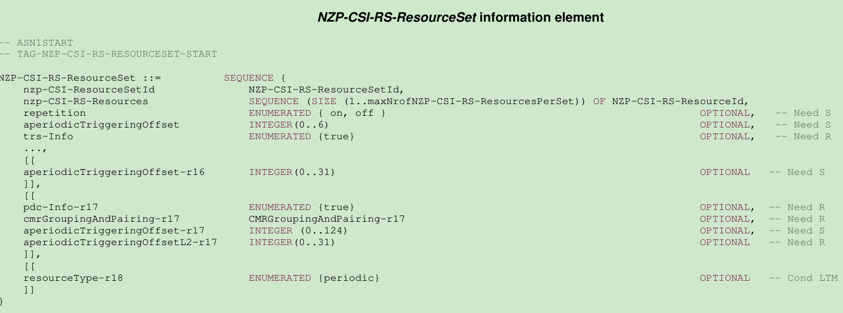  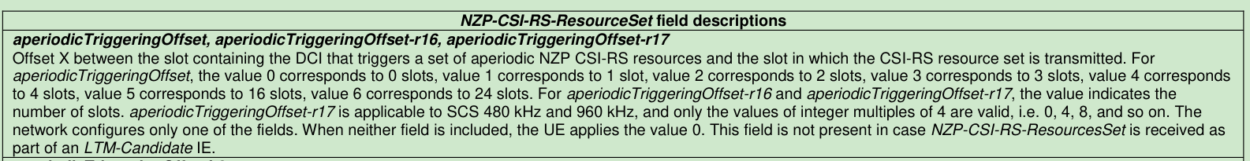
Mod VFinal | We will postpone 2.C to RAN1#119

Issue 3 (WID objective 3): CJT calibration reporting for non-ideal synchronization and backhaul

Table 3A Summary: issue 3
# | Issue | Companies’ views
3.3.5 | Proposal 3.C.5: For the Rel-19 aperiodic standalone CJT calibration (CJTC) reporting, when linking CJTC Dd and Rel-18 eType-II CJT CSI reports is configured with two separate triggers, introduce a UE capability for the following:  - The UE capability is used to inform the NW on the maximum duration of 2 sec the UE can store the latest CJTC Dd report, measured from the transmission of the linked CJTC Dd report  - When the UE does not report this UE capability, it is assumed that the UE can store a CJTC Dd report [indefinitely]  FL assessment: Wording is based on the outcome of Monday and Wednesday offline sessions.  This is intended to avoid stale Dd report from being utilized. However, it can be argued that this can be handled via NW implementation. | Support/fine: Lenovo/MotM, ZTE, Qualcomm, vivo, OPPO, Xiaomi, Huawei/HiSi, NEC, HONOR, Sharp, KDDI, MediaTek, NTT DOCOMO, Apple, Google, Spreadtrum, CATT,  Not support: Intel, Ericsson, Nokia/NSB,
3.6 | [117] Agreement  For the Rel-19 aperiodic standalone CJT calibration reporting, regarding the applicable type(s) of the configured N_{TRP} NZP CSI-RS resources/resource sets when ReportQuantity is ‘cjtc-P’ (DL/UL phase offset),  - all the ‘CSI-RS for CSI’ resources within each resource set follow the legacy pre-Rel-19 rules of CSI-RS resources associated with a same resource set  - all the resources across the N_{TRP} CSI-RS resources/resource sets are configured with the same bandwidth  Proposal 3.F: For the Rel-19 aperiodic standalone CJT calibration (CJTC) reporting, when ReportQuantity is ‘cjtc-P’ (DL/UL phase offset), the slot offsets of N_{TRP} P/SP CSI-RS resources are configured within X={1,[2]} slots, without DL/UL switching in between the N_{TRP} resources, where X=1 implies that the N_{TRP} resources are configured within a same slot, and X=2 implies that the N_{TRP} resources are configured within two adjacent slots.  FL assessment: This is analogous to legacy CMR behaviours for Rel-17 NCJT and Rel-18 Type-II CJT | Support/fine: Qualcomm, OPPO, NTT DOCOMO, Nokia/NSB, Apple, Huawei/HiSi,  Not support: Samsung, vivo, Ericsson, ZTE, CATT,
Not discussed in Round-4 (may revisit in RAN1#119)

3.3.9 | Proposal 3.C.9: For the Rel-19 aperiodic standalone CJT calibration (CJTC) reporting, when linking CJTC Dd and Rel-18 eType-II CJT CSI reports is configured with two separate triggers, when at least one of the N_{TRP} reported delay offset (DO) values in a linked CJTC Dd report is ‘out of range’, the UE does not perform DO compensation on the triggered Rel-18 eType-II CJT CSI associated with TRP(s) that are ‘out of range’  FL assessment: Tuesday OFFLINE outcome. | Support/fine: Huawei/HiSi, Qualcomm, Samsung, Ericsson, Sony, Lenovo/MotM, Xiaomi, NEC, HONOR, OPPO,  Not support: Nokia/NSB, vivo, ZTE, Apple, IDC, NTT DOCOMO, CATT,
3.4 | [118] Agreement  For the Rel-19 aperiodic standalone CJT calibration (CJTC) reporting, to facilitate UE-specific frequency offset pre-compensation on PDSCH by the NW, decide, by RAN1#118, whether to support configuring a UE (via RRC signaling) to perform PMI calculation for the Rel-18 eType-II CJT CSI report assuming pre-compensation using the UE-reported frequency offset (when ReportQuantity is ‘cjtc-F’). And if supported, whether any of the following is additionally supported or not:  - NW indicates the frequency offset value to be compensated for the Rel-18 eType-II CJT CSI report, and/or  - The two separately configured reports (i.e. Rel-18 eType-II CJT CSI report and the CJTC frequency offset report) are always jointly triggered and carried on a same PUSCH (hence on a same slot)  - The frequency offset value to be compensated is the latest reported fO before the DCI triggering the CJT CSI reporting  FFS: AP-CSI-RS can be configured for the Rel-18 eType-II CJT report  The above only applies when the CMRs do not share common QCL source for Doppler shift indication  Proposal 3.D.1: For the Rel-19 aperiodic standalone CJT calibration (CJTC) reporting, to facilitate UE-specific frequency offset pre-compensation on PDSCH by the NW, support configuring a UE (via RRC signaling) to perform PMI calculation for the Rel-18 eType-II CJT CSI report assuming pre-compensation using the UE-reported frequency offset (when ReportQuantity is ‘cjtc-F’), using the same mechanisms as that for UE-reported delay offset (when ReportQuantity is ‘cjtc-Dd’).  - This implies that all the supported sub-features associated with ReportQuantity = ‘cjtc-Dd’ linked to Rel-18 eType-II CJT CSI are extended to ReportQuantity = ‘cjtc-F’ linked to Rel-18 eType-II CJT CSI  FL assessment: The above issue needs some discussion. | Support/fine: vivo, Xiaomi, Fujitsu, Sharp, Sony, Samsung, ZTE,  Not support (NW implementation): Huawei/HiSi, MediaTek, CMCC, CATT, Nokia/NSB, Qualcomm, Lenovo/MotM, NTT DOCOMO, OPPO,
3.7.1 | Proposal 3.G.1: For the Rel-19 aperiodic standalone CJT calibration reporting, support joint Dd + phase offset (PO) reporting as follows:  - Only wideband (Σ=1) PO is supported  - No further optimization of CSI reporting format, e.g. configurability of not reporting {d_{n}}  - The UCI parameters are captured in the table below  When ReportQuantity is ‘cjtc-Dd-P’ (joint Doffset+d and PO)  Parameter Details/description  nref1 Reference TRS resource set index for Doffset+d, based on the ordering from RRC configuration: $\left\lceil log\left(N_{TRP}\right)\right\rceil$ bits  nref2 Reference TRS resource set index for PO, based on the ordering from RRC configuration: $\left\lceil log\left(N_{TRP}\right)\right\rceil$ bits  {D_{n,offset}, n=0, 1, …, N_{TRP} – 1 n≠nref1} Delay offset for CSI-RS resource set n: $\left(N_{TRP}-1\right)\left\lceil log\left(M_{D}\right)\right\rceil$ bits  {d_{n}, n=0, 1, …, N_{TRP} – 1, n≠nref1 } 1-bit inside/outside indicator for CSI-RS resource set n: $\left(N_{TRP}-1\right)$ bits  {PO_{n} , n=0, 1, …, N_{TRP} –1, n≠nref2} Wideband phase offset for CSI-RS resource n: $\left(N_{TRP}-1\right)\left\lceil log\left(M_{Φ}\right)\right\rceil$ bits  - The UCI mapping order is as follows:  - nref1,  - nref2,  - {D_{n,offset}, n=0, 1, …, N_{TRP} – 1, n≠nref} ordered from the lowest to highest CSI-RS resource set ID,  - {d_{n}, n=0, 1, …, N _{TRP} – 1, n≠nref} ordered from the lowest to highest CSI-RS resource set ID  - {PO_{n}, n=0, 1, …, N_{TRP} – 1, n≠nref} ordered from the lowest to highest CSI-RS resource ID,  FL assessment: This proposal (from RAN1#118) is an optimization since each can be reported separately. | Support/fine: Qualcomm, Sony, Samsung (ok), Google, ZTE, Fujitsu, Sony, Lenovo/MotM, Ericsson (open),  Not support: Huawei/HiSi, MediaTek, NTT DOCOMO, NEC, Intel, Apple, TCL, Huawei/HiSi, Xiaomi, IDC, Sharp, KDDI, CMCC, ETRI, OPPO, Apple, vivo, New H3C, Nokia/NSB, Spreadtrum, TCL,
3.7.2 | Proposal 3.G.2: For the Rel-19 aperiodic standalone CJT calibration reporting, support reporting, in one CSI reporting instance, L1-RSRPs associated with the configured N_{TRP} CSI-RS resources and the following CJT calibration report type:  - ReportQuantity is ‘cjtc-Dd’ (delay offset), or  - ReportQuantity is ‘cjtc-F’ (frequency offset), or  - ReportQuantity is ‘cjtc-Dd-F’ (delay+frequency offset), or  - ReportQuantity is ‘cjtc-P’ (DL/UL phase offset)  Regarding the L1-RSRP:  - The legacy L1-RSRP is fully reused, where the L1-RSRP associated with nref is the reference for the other (N_{TRP}-1) differential L1-RSRP(s)  - The N_{TRP} CRI(s) are not reported  - FFS: Whether this is supported via a new ReportQuantity or a joint CSI request/triggering  FL assessment: This proposal (from RAN1#118) is an optimization primarily for TRP selection (which utilizes both RSRP and CJTC report) | Support/fine: NEC, NTT DOCOMO, Lenovo/MotM, Samsung (ok), Sony (open),  Not support: ZTE, Xiaomi, Fujitsu, Ericsson, Apple, Huawei/HiSi, OPPO, TCL, ETRI, New H3C, Google, Nokia/NSB, vivo, Sharp, Intel, KDDI, Spreadtrum, TCL,

Table 3B LLS/SLS results: issue 3
--
Table 3C Additional inputs: issue 3
Company | Input
Mod V0 | Please share your inputs on each of the issues and, if applicable, proposals in TABLE 3A
Samsung | Proposal 3.C.5  Similar view with what Apple mentioned on the third bullet:  Introducing both a UE capability for the feature and an RRC parameter to enable/disable the feature are contradictive, which doesn’t make sense.  Also, we think the candidate values of X should be sufficiently large (otherwise, small values such as 10/20 slots are basically saying UE keeps deleting very frequently, which can lead this feature not meaningful). And, determining the candidate values should be defined not based on channel environment scenarios but based on UE’s hardware perspective since it is relevant a sort of RAM issue pertaining to UE’s hardware.  Proposal 3.F  We have two comments  - Compared to Rel-18 eTypeII CJT (allowing up to 128 ports), it is just one-port N_{TRP} CSI-RS resources which seems not that large burden to UE side. Do we really need this constraint again for this feature?  - It can be handled by NW implementation
OPPO | Proposal 3.C.5:  We think the second and third sub-bullets are not needed. UE is not mandated to support “Infinity”, and RRC signalling to disable UE capability reporting it not reasonable.  Proposal 3.F:  Fine.  Proposal 3.C.9:  If it is up to gNB implementation, and gNB trigger a CJT CSI reporting for a TRP with Dd=’out of range’, the UE behaviour is still unclear.  Proposal 3.D.1  Not support. For frequency offset, the pre-compensation is in time-domain, but we are not sure how to do that when there is only CSI-RS with time density of one symbol per port.
NTT DOCOMO | Proposal 3.C.5:  We concur what Samsung mentioned above, that is:  - X should be large enough, and should consider UE hardware point of view, not channel environment scenarios.  - The third bullet seems unnecessary.  And the second bullet is ok to be there, for which our understanding is not to mandate “infinity” to be supported by any UE but to help the future discussion in UE feature session.  Proposal 3.F:  OK  Proposal 3.D.1:  Not support
Ericsson | Proposal 3.C.5  We are concerned about the scheduling restriction that this feature will introduce to the network. For instance, if X is small, then the network is forced to trigger the DO report frequently which is counter-intuitive (note that DO does not change that frequently in practice).  Based on comments so far, companies don’t want RRC parameter to disable the feature and we see that some companies don’t want to have an X value of infinity as default if the UE doesn’t support this feature.  We need more discussion on the values of X (taking into account UE hardware impact). From network perspective, we need to check on the impact to network scheduling once values of X are stabilized.
Qualcomm | This is copying the wording from Rel-18 Type-II-CJT.  - No DL/UL switching is to guarantee a same receiving phase at UE, for all N_{TRP} resources.  - Within a threshold duration (e.g. 1 or 2 slots), is to prevent channel variate too much (same motivation as Rel-18 CJT or Rel-17 NCJT).  But it should be noted that, Rel-18 CJT assumes ideal FO=0.  However, Rel-19 assumes FO can be as large as 0.2ppm, and if we do a rough calculation,  - Even with a low band e.g. 30kHz@700MHz, 1 slot (0.5msec) can have a Tx phase variation of 25.2$°$ – not to mention middle-to-high FR1 bands.  Besides, it is just at most four single-port CSI-RSs, not too “crowded” for one slot.  Therefore, we suggest to put the value of X=2 into bracket for now:  X={1,[2]} slots  [Mod: Actually removing 2 would restrict NW choice even more]
Mod V11 | Revised proposal 3.C.5 per inputs (also offline inputs from Google)
Mod V12 | Outcome of the Wed Offline is included (proposals 3.C.5 and 3.F)
CATT | Proposal 3.C.5:  We are ok for the current version.  Proposal 3.F:  We share the view as Ericsson that NW is likely to configure the CSI-RS resources in 1 slot because there are at most 4 single port resources. If UE vendors think this can facilitate UE implementation and promote CJTC PO reporting, we are ok to support.
Nokia | Proposal 3.C.5  From the offline discussion today it seems no chipset vendor is planning to indicate this capability, so if even chipset vendors think we don’t need this, our suggestion is to just drop this proposal.
Mod V16 | No revision
Samsung | Proposal 3.C.5  as we said during the offline,  - We checked with our product team that the memory requirement for storing Dd report is very low, and it is almost nothing (max 3 Bytes), so it doesn’t seem matter even for UE to store it infinitely.  - From NW side, we sympathize with what Ericsson mentioned that a small value of X is risky from NW flexibility.  After we further thought, although we aren’t against the proposal, we aren’t supportive it either. (Neutral) so please remove Samsung from Support.
ZTE | Proposal 3.C.5:  Support current wording.  Proposal 3.C.9:  Do NOT support. To our understanding, if UE reports ‘out-of-range’ DO for one TRP, then the UE should NOT select this TRP for CJT transmission, and this can be completely handled by NW/UE implementations.  Proposal 3.F:  Do NOT support. We agree that, to guarantee good measurement of PO, there should NOT be DL/UL switching between the N_{TRP} resources, and the N_{TRP} resources should NOT be allocated two far. However, these can totally rely on NW implementation, and no spec impact is needed.
Mod VFinal | No revision

References

