3GPP TSG RAN Meeting #104 RP-241606

Shanghai, China, 17th – 20th June 2024

Source: Intelsat, Eutelsat Group, Thales, CHTTL

Title: New WID on Introduction of Ku Band for NR NTN

Document for: Approval

Agenda Item: 9.1.5 Proposals led by RAN4 (spectrum related)

3GPP™ Work Item Description
Information on Work Items can be found at http://www.3gpp.org/Work-Items
See also the 3GPP Working Procedures, article 39 and the TSG Working Methods in 3GPP TR 21.900

Title: [Draft] New WID on Introduction of Ku Band for NR NTN

Acronym: TBD

Unique identifier: TBD

Potential target Release: Rel-19

1 Impacts

Affects: | UICC apps | ME | AN | CN | Others (specify)
Yes |  | X | X
No | X |  |  | X | X
Don't know

2 Classification of the Work Item and linked work items

2.1 Primary classification

This work item is a …

 | Study
 | Normative – Stage 1
 | Normative – Stage 2
X | Normative – Stage 3
 | Normative – Other*
* Other = e.g. testing

2.2 Parent Work Item
For a brand-new topic, use “N/A” in the table below. Otherwise indicate the parent Work Item.
Parent Work / Study Items
Acronym | Working Group | Unique ID | Title (as in 3GPP Work Plan)
N/A

2.3 Other related Work Items and dependencies

Other related Work /Study Items (if any)
Unique ID | Title | Nature of relationship
941006 | NR NTN (Non-Terrestrial Networks) enhancements | The present WID will leverage where appropriate aspects of the work on NTN VSAT above 10 GHz (e.g. coexistence study in FR2 between NTN and TN)

3 Justification
The Ku band is allocated for primary satellite use for ITU regions 1, 2 and 3. Consequently, this WID introduces the Ku band into 3GPP specifications according to the ITU definitions in Table 1 and Table 2.
Table 1: Ku Band Downlink and Uplink Spectrum for ITU Regions 1 and 3
Ku band for GSO and Non GSO Space Segment | Downlink (Space to Earth) | 10.70 - 12.75 GHz
 | Uplink (Earth to Space) | 12.75-13.25 GHz & 13.75-14.5 GHz

Table 2: Ku Band Downlink and Uplink Spectrum for ITU Region 2
Ku band for GSO and Non GSO Space Segment | Downlink (Space to Earth) | 10.70 - 12.70 GHz
 | Uplink (Earth to Space) | 12.70-13.25 GHz & 13.75-14.5 GHz

Note: WRC-23 made the decision not to allocate mobile services in the Ku band.
Figures 1 and 2 show the respective frequency allocations graphically.
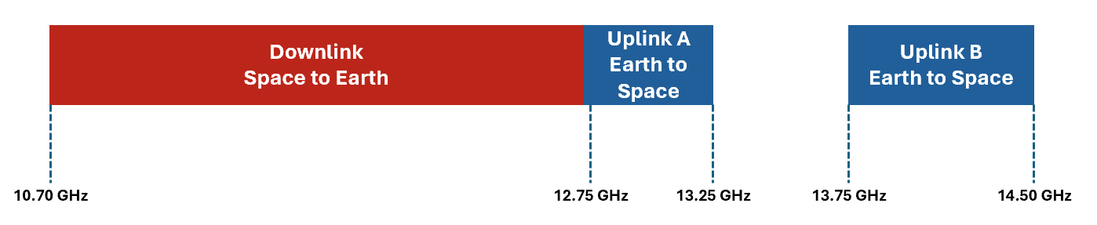
Figure 1: Ku band allocation for ITU regions 1 and 3

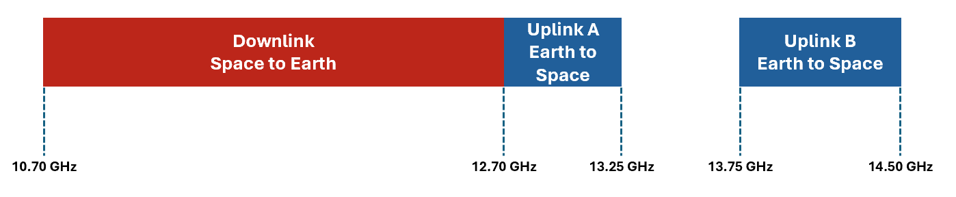
Figure 2: Ku band allocation for ITU region 2
The Ku Band is heavily used by satellite operators to provide broadband connectivity including but not limited to fixed, nomadic and vehicle mounted devices for the support of a variety of B2C and B2B applications. These applications include consumer and business broadband, cellular backhaul, and inflight connectivity as well as broadcast applications (e.g. in India to ESIM/MVSAT in 10.7 to 11.7, and Direct-to-Home/DTH in 11.7-12.5 GHz, and public warning and disaster recovery services in Japan). These legacy satcom systems use proprietary technologies that do not currently take advantage of 3GPP specifications.
With the definition of Ku band in 3GPP Specifications, future satellite networks will be able to inter-operate with the terrestrial mobile system under the 5G technology framework and provide coverage extension for broadband Machine-Type Communications devices.
The purpose of specifying Ku band in 3GPP is to enable NGSO and GSO satellite services operating in the Ku Band to use 3GPP 5G NTN standards rather than the currently used proprietary technologies.
The present Work Item will leverage the specification of Release 18 of the NTN Ka Band where appropriate, to reduce RAN4 workload [See also Ref R4-2305925 and RP-232694].
In order to benefit from the similarities with the Ka band specification work in Release 18, the following approach for the Ku band is considered:
- Extend the lower part of the current FR2-NTN Frequency Range definition if needed
(Note: This does not affect the current TN FR1/FR2 definitions, and is not supposed to apply to future terrestrial bands defined in the Ku frequency region)
- Reuse Ka band coexistence study with updates for frequency range .to ensure that Ku Band for NTN shall not impact the existing specifications of services operating in adjacent bands and shall not cause degradation to existing services in adjacent bands including 3GPP-specified bands adjacent to the targeted Ku band. It is assumed that the adjacent band coexistence study will be performed at the Ku band edges. It is not within the scope of this work item to newly evaluate coexistence with adjacent TN band.

Due to ongoing regulatory studies in the US (FCC) which are considering using the 12.7 GHz – 13.25 GHz frequency range for terrestrial services, it is proposed to conduct the Ku Band Normative work taking into account these ongoing FCC studies as

shown in Figure 3 and Figure 4:

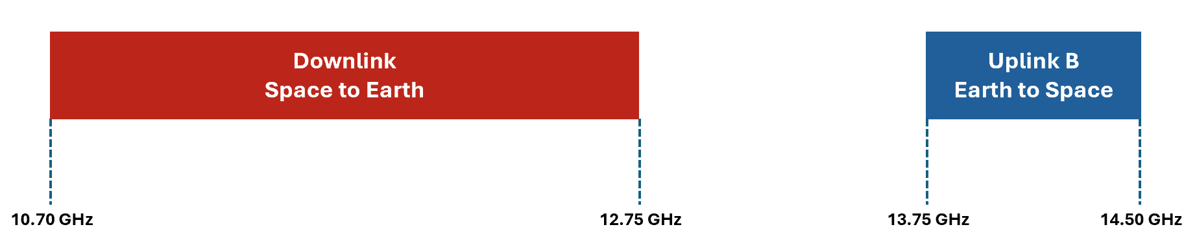
Figure 3. Normative work for all regions

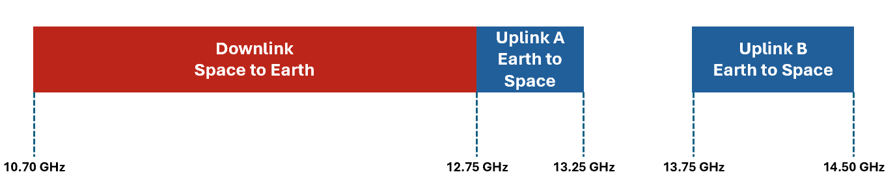
Figure 4. Additional normative work for all regions excluding US
The aspects of specifying Ku band VSAT core and performance requirements that relate to the testability will be considered later.
Note: The Release 18 NTN scope for operation above 10 GHz, does not support Mobile VSATs (ESIMs) connected to NGSO Satellites. This may be considered at a later date.

4 Objective

4.1 Objective of SI or Core part WI or Testing part WI
The following assumptions are taken as the baseline for this work:
- GSO and NGSO
- NTN capable UE type 1 to 5 (38.101-5 Table 9.2.1.0-1) for above 10 GHz
- FDD Mode
- GNSS Receiver capability

The objectives are:

- Update coexistence study . Reuse Ka band coexistence study with updates for frequency range. It is not within the scope of this work item to newly evaluate coexistence with adjacent TN band. [RAN4]
- Use the regulation requirements in ITU Regions 1, 2 and 3 to identify relevant adjacent band co-existence scenarios for NTN Ku Band covering the following frequency ranges, considering targeted deployment scenarios [RAN4]:
  - For all regions:
    - Downlink 10.70 – 12.75 GHz
    - Uplink 13.75-14.5 GHz
  - For all regions excluding US
    - Downlink 10.70 – 12.75 GHz
    - Uplink 12.75- 13.25 GHz & 13.75-14.5 GHz
- Specify RF requirements for satellite access node and NTN VSAT types in 38.101-5 also considering existing regulations on antenna sizes for certain parts of the Ku band. [RAN4].
- Specify RRM requirements to cover the Ku band. [RAN4]
- In addition to existing 3GPP channel bandwidths, support new channel bandwidths to align with existing Ku band deployments [RAN4]
  - For Ku band using FR1 numerology: 35 MHz, 70 MHz
  - For Ku band using FR2 numerology: 125 MHz UL (120 KHz SCS), 250 MHz DL (120 KHz SCS)

4.2 Objective of Performance part WI
The objective of the performance part is to update as appropriate for Ku band:
- RRM performance requirements and test cases [RAN4]
- UE demodulation and CSI reporting requirements [RAN4]
- Satellite access node demodulation requirements [RAN4]
- Satellite access node conformance tests [RAN4]

4.3 RAN time budget request (not applicable to RAN5 WIs/SIs)
NOTE: For all new RAN related WIs/SIs which are not led by RAN WG5 the WI/SI rapporteur has to fill out the attached Excel table to request time budgets for corresponding RAN WG meetings.
The Excel table has to be filled out for all affected RAN WGs and up to the target date of the WI/SI.
One time unit (TU) corresponds to ~ 2 hours in the meeting.
If no TU is needed, then leave the field empty otherwise enter a number >0 in the field.
For revisions of already approved WI/SI descriptions: Please remove the Excel table from the WID/SID's zip file. The time budgets are already recorded. If you want to modify them, then this has to be done via the status report and not via a revised WID/SID.
If this WID is covering Core and Performance part, then please fill out one line for each part in the attached Excel table.
additional comments to the time budget request in the attached Excel table:

Commencing in the RAN cycle following RAN #104

5 Expected Output and Time scale

New specifications {One line per specification. Create/delete lines as needed}
Type | TS/TR number | Title | For info  at TSG# | For approval at TSG# | Rapporteur

Impacted existing TS/TR {One line per specification. Create/delete lines as needed}
TS/TR No. | Description of change | Target completion plenary# | Remarks
TR 38.863 | NR; Solutions for NR to support non-terrestrial networks (NTN):  Non-terrestrial networks (NTN) related RF and co-existence aspects | RAN#108 | Study part
TS 38.101-5 | Support for a new NTN band | RAN #109 | Core part
TS 38.133 | Support for a new NTN band | RAN #109 | Core part
TS 38.108 | Support for a new NTN band | RAN #109 | Core part
TS 38.101-5 | Support for a new NTN band | RAN #111 | Perf part
TS 38.133 | Support for a new NTN band | RAN #111 | Perf part
TS 38.181 | Support for a new NTN band | RAN #111 | Perf part

6 Work item Rapporteur(s)
Soghomonian, Manook, Intelsat, Manook.soghomonian@intelsat.com

7 Work item leadership
Primary responsible Working Group: RAN WG4

8 Aspects that involve other WGs
None

9 Supporting Individual Members
Supporting IM name
Intelsat
Thales
Eutelsat Group
JSAT
Lockheed Martin
Airbus
Hispasat
Sateliot
Viavi Solutions
Panasonic
Gilat
Gatehouse
Omnispace
Fraunhofer IIS
Fraunhofer HHI
TTP
Rohde & Schwarz
ESA
Sequans
Mitsubishi Electric
InterDigital
Catapult
Keysight Technologies
SyncTechno
Tejas Networks
Sharp
SES
Deutsche Telekom
CHTTL
Softbank
ETRI

