**3GPP TSG RAN meeting #106 Draft-RP-xxx**

**Madrid, Spain, December 9-12, 2024**

**Agenda Item: 10.4.5**

**Source: IRDM**

**Title: Proposed way forward on the introduction of IoT-NTN TDD mode**

# Introduction

A new work item on introduction of IoT-NTN TDD mode was approved in RAN plenary #105. The detailed scope of this WI can be found in RP-242415 [1]. According this WID [1], there is a checkpoint at RAN #106 as follows:

|  |
| --- |
| The work item aims to specify enhancements for NB-IoT NTN to enable NTN operation with a NB-IoT TDD mode leveraging commonalities with half-duplex NB-IoT FDD NTN, by defining a new NB-IoT TDD mode for NTN based on minimum necessary changes to the NB-IoT NTN FDD frame structure and procedures for the NB-IoT operation in the targeted unpaired MSS allocated band (TN deployment is not expected in this band). The feature is not intended to be applicable to existing 3GPP bands.  The study and work objectives assume the following:   * LEO @600 km and @1200 km orbit respectively, with set-1 satellite parameters as reference scenarios (See 3GPP TR 36.763) * Target the 1616-1626.5 MHz MSS allocated band * Standalone deployment with anchor and non-anchor carriers (i.e. operating in carrier(s) used only for NB-IoT) * Operate with Earth fixed Tracking area, with either Earth fixed cells or Earth moving cells for NGSO * The new NB-IoT NTN TDD mode allows configuring the usage of radio resources in the targeted MSS allocated band with a periodic subset of the UL and DL subframes in N radio frames. The periodic pattern should consist of non-overlapping set of usable contiguous UL subframes and set of usable contiguous DL subframes, and guard periods, which is periodic every N radio frames, with N=9 as baseline. No blind detection is assumed at the UE side. The value of N and the configuration of the periodic pattern are fixed per band.   This work item includes the following objectives:   * Study the impact due to the periodic pattern, at least on UE downlink synchronization and other aspects (if identified) [RAN1, RAN4]   + Checkpoint in RAN#106 for the completion of the study phase. RAN1 start from Oct’24. RAN4 start from Nov’24 |

We invite companies to comment on the proposed way forward on the introduction of IoT-NTN TDD mode.

# Discussion

The TDD-DL-UL-Pattern can be defined with the following parameters:

* **DL-UL-TransmissionPeriodicity** (referred to as N in the WID) which indicates the periodicity of the DL-UL pattern. It can be provided in number of radio frames.
* **nrOfDownlinkSubframes (D)** corresponding to the number of consecutive/ contiguous DL subframes at the beginning of each DL-UL pattern.
* **nrOfUplinkSubframes (U)** which provides the number of consecutive/ contiguous UL subframes
* **DownlinkToUplinkGuardPeriod** which indicates the Downlink to uplink Guard Period for TDD operation. This parameter in provided in number of subframes.

These parameters are illustrated in Figure 1.

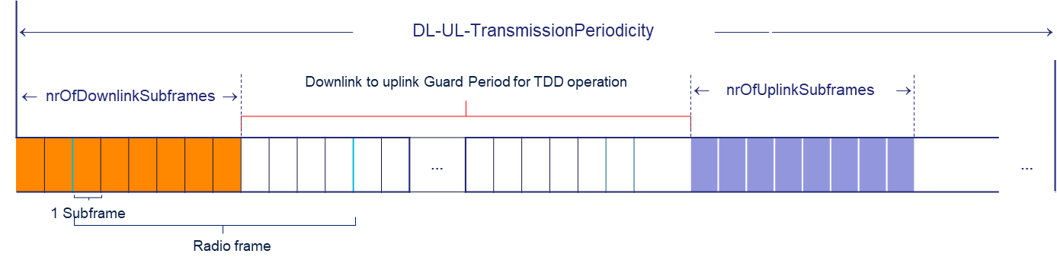

Figure 1 Definition of the periodic TDD-DL-UL-Pattern

**Observation 1:**

When defining the **DownlinkToUplinkGuardPeriod** in Non-Terrestrial networks, as outlined in clause 7.3.6 of [2, 38.811] this guard time directly depends on the propagation delay between UE and Base Station. Thereby, it should commensurate at least the round trip delay (RTD). The RTD could take different values depending on satellite orbit (LEO600km, LEO1200km or GEO) and the position of the reference point for uplink synchronization. For example:

* Minimum Downlink to Uplink Guard time for TDD operation for LEO at 600 km would range from 12.88 ms to 25.77 ms
* Minimum Downlink to Uplink Guard time for TDD operation for LEO at 1200 km would range from 20.88 ms to 41.77 ms.

**Downlink to uplink Guard Period for TDD operation should commensurate at least the round trip delay (RTD). Thereby, to suit different deployments/orbits it should not be fixed per band.**

**Observation 2:**

Legacy frame structure limitations

**The DL slot/UL slot pairs (e.g**. **DL1/UL1 and DL4/UL4) in existing system have different transmission gap and thereby different Downlink to uplink Guard Period should be supported.**

Based on the above discussion, we have the following two proposals:

**Proposal 1:**

Revise the WID paragraph to specify N=9, D=U=8 for this MSS band.

**Proposal 2:**

With N=9, D=U=8, specify the Guard Period to be configurable per cell, to accommodate the legacy frame structure limitations and to allow for multiple orbits’ RTDs (as per Observations 1 and 2 above.)

|  |  |
| --- | --- |
| Company | Comment |
| Iridium | Support Proposal 1  Support Proposal 2 |
| ZTE | For proposal-1: We are supportive to specify it in band level and no additional configurability, per UE state or cell, is needed;  For proposal-2: Not support. Let’s follow the traditionally TDD pattern design with fixed pattern. The configurability of GP is additional optimization and will lead to other issues, e.g., definition of the whole pattern since D+U+G may be smaller than N = 9.  BTW, the motivation is not justfied since the orbit of iridium system is also fixed. |
|  |  |
|  |  |