3GPP TSG RAN Meeting #106 RP-243314
Madrid, Spain, December 9th - 12th, 2024 (revision of RP-242981)

Source: Intelsat, Eutelsat Group, Thales, CHTTL, Hispasat, Airbus, Sharp, Mitre, JSAT

Title: Revised WID: Introduction of Ku bands for NR NTN

Document for: Approval
Agenda Item: 9.4.1.6

3GPP™ Work Item Description
Information on Work Items can be found at http://www.3gpp.org/Work-Items
See also the 3GPP Working Procedures, article 39 and the TSG Working Methods in 3GPP TR 21.900

Title: Introduction of Ku Band for NR NTN

Acronym: NR_NTN_Ku_bands

Unique identifier: 1040135
NOTE: For new WIs/SIs leave the Unique identifier empty and make a proposal for an Acronym.
For a revised WI/SI: Take Unique identifier and acronym as shown in 3GPP workplan.
If this is a RAN WID including Core and Perf. part, then Title, Acronym and Unique identifier refer to the feature WI.
Please tick (X) the applicable box(es) in the table below:
Either:
This WID includes a Core part | X
This WID includes a Performance part | X
or:
This WID includes a Testing part
and it addresses the following 3GPP work area: | Radio Access
and it addresses the following 3GPP work area: | Core Network
and it addresses the following 3GPP work area: | Services

Potential target Release: Rel-19
NOTE: In case of contradiction with the target dates of clause 5, clause 5 determines the target release.

1 Impacts
{For Normative work, identify the anticipated impacts. For a Study, identify the scope of the study}
Affects: | UICC apps | ME | AN | CN | Others (specify)
Yes |  | X | X
No | X |  |  | X | X
Don't know

2 Classification of the Work Item and linked work items

2.1 Primary classification
{The full structure of all existing Work Items is shown in the 3GPP Work Plan in https://ftp.3gpp.org/Information/WORK_PLAN}
This description is either a …
Study Item
or a
Normative Work Item:
tick applicable boxes below
 | Stage 1
 | Stage 2
X | Stage 3
 | Other (e.g. testing)

2.2 Parent Work Item
For a brand-new topic, use “N/A” in the table below. Otherwise indicate the parent Work Item.
Parent Work / Study Items
Acronym | Working Group | Unique ID | Title (as in 3GPP Work Plan)
N/A
NOTE: RAN agreed some time ago, that it describes the feature WI + Core/Perf. part WI or Testing part WI in one WID. Therefore the table above should include the feature WI data (In case the feature covers Core and Perf. part, please list under Working Group the leading WG of the Core part).

2.3 Other related Work Items and dependencies
Other related Work/Study Items (if any)
Acronym | Unique ID | Title | Nature of relationship
NR_NTN_enh | 941006 | NR NTN (Non-Terrestrial Networks) enhancements | The present WID will leverage where appropriate aspects of the work on NTN VSAT above 10 GHz (e.g. coexistence study in FR2 between NTN and TN)
NOTE: Also related or dependent WIs/SIs in other TSGs shall be indicated here.

3 Justification
The Ku band is allocated for primary satellite use for ITU regions 1, 2 and 3. Consequently, this WID introduces the Ku band into 3GPP specifications according to the ITU definitions in Table 1 and Table 2.
Table 1: Ku Band Downlink and Uplink Spectrum for ITU Regions 1 and 3
Ku band for GSO and Non GSO Space Segment | Downlink (Space to Earth) | 10.70 - 12.75 GHz
Ku band for GSO and Non GSO Space Segment | Uplink (Earth to Space) | 12.75-13.25 GHz & 13.75-14.5 GHz

Table 2: Ku Band Downlink and Uplink Spectrum for ITU Region 2
Ku band for GSO and Non GSO Space Segment | Downlink (Space to Earth) | 10.70 - 12.70 GHz
Ku band for GSO and Non GSO Space Segment | Uplink (Earth to Space) | 12.70-13.25 GHz & 13.75-14.5 GHz

Note: WRC-23 did not allocate mobile services in the Ku band.
Figures 1 and 2 show the respective frequency allocations graphically.
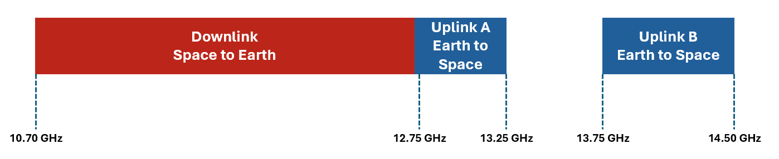
Figure 1: Ku band allocation for ITU regions 1 and 3

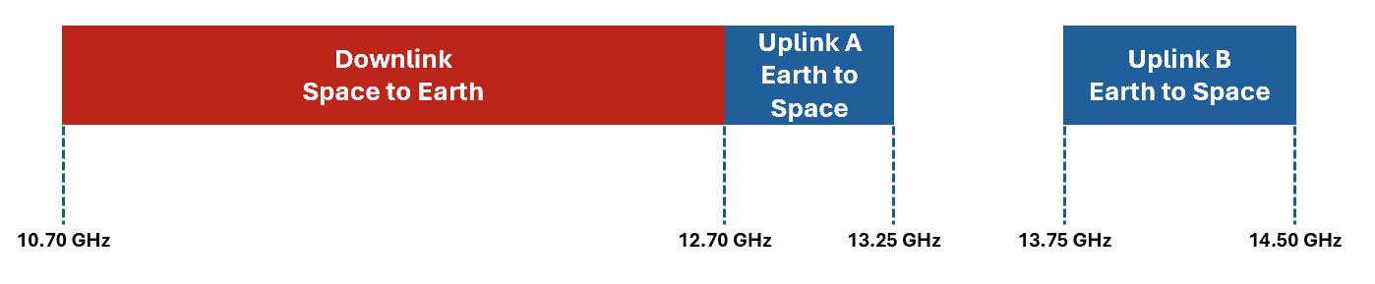
Figure 2: Ku band allocation for ITU region 2
The Ku Band is heavily used by satellite operators to provide broadband connectivity including but not limited to fixed, nomadic and vehicle mounted devices for the support of a variety of B2C and B2B applications. These applications include consumer and business broadband, cellular backhaul, and inflight connectivity as well as broadcast applications (e.g. in India to ESIM/MVSAT in 10.7 to 11.7, and Direct-to-Home/DTH in 11.7-12.5 GHz, and public warning and disaster recovery services in Japan). These legacy satcom systems use proprietary technologies that do not currently take advantage of 3GPP specifications.
With the definition of Ku band in 3GPP Specifications, future satellite networks will be able to inter-operate with the terrestrial mobile system under the 5G technology framework and provide coverage extension for broadband Machine-Type Communications devices.
The purpose of specifying Ku band in 3GPP is to enable NGSO and GSO satellite services operating in the Ku Band to use 3GPP 5G NTN standards rather than the currently used proprietary technologies.
The present Work Item will leverage the specification of Release 18 of the NTN Ka Band where appropriate, to reduce RAN4 workload [See also Ref R4-2305925 and RP-232694].
In order to benefit from the similarities with the Ka band specification work in Release 18, the following approach for the Ku band is considered:
- Extend the definition of FR1-NTN and/or FR2-NTN Frequency Range as required
(Note: This does not affect the current TN FR1/FR2 definitions, and is not supposed to apply to future terrestrial bands defined in the Ku frequency range)
- Reuse Ka band coexistence study assumptions as much as possible, with modifications where necessary, e.g. for frequency range and subcarrier spacing, to ensure that Ku Band for NTN shall not impact specifications of services operating in adjacent bands and shall not cause degradation to services in adjacent bands including 3GPP-specified bands adjacent to the targeted Ku band. It is assumed that the adjacent band coexistence study will be performed at the Ku band edges.

The Ku band comprises two non-contiguous uplink frequency blocks, and since there is no requirement for devices to simultaneously transmit in both uplink blocks, two Ku bands will be specified using the single downlink block and a single uplink block, which is consistent with legacy FDD band definitions.
Due to ongoing regulatory studies in the US (FCC) which are considering using the 12.7 GHz – 13.25 GHz frequency range for terrestrial services, it is proposed to conduct the Ku Band Normative work taking into account the ongoing FCC studies as shown in Figure 3 and Figure 4:

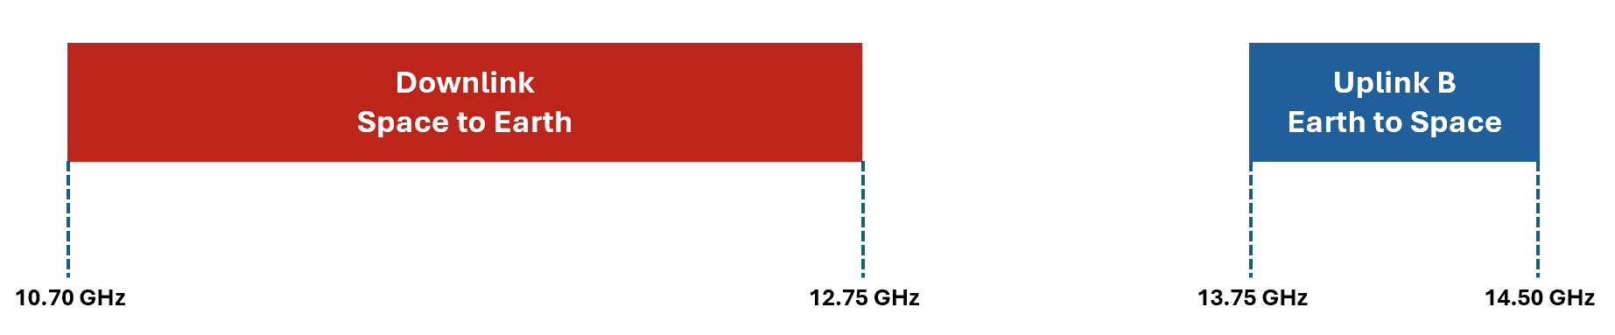
Figure 3a. Normative work for Ku band #1a for all ITU regions 1 and 3
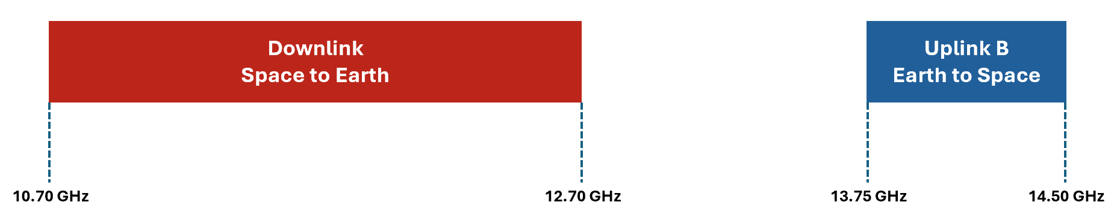
Figure 3b. Normative work for Ku band #1b for all ITU regions 2

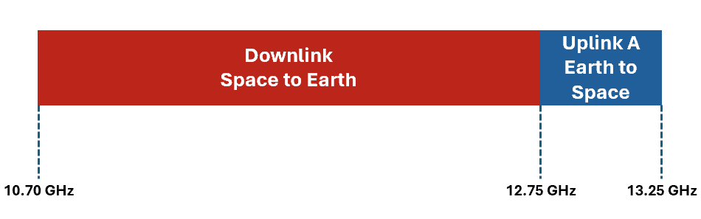
Figure 4a. Normative work Ku band #2a for ITU regions 1 and 3
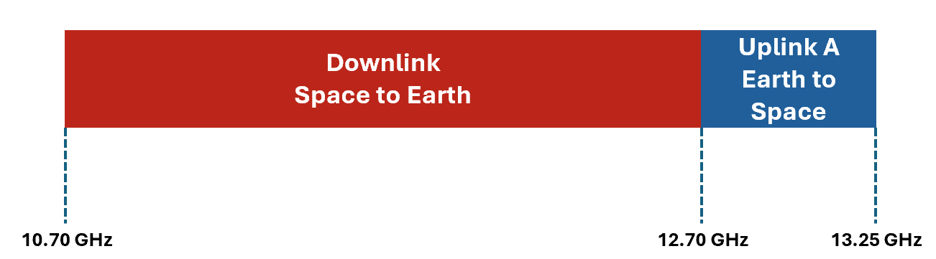
Figure 4b. Normative work Ku band #2b for ITU region 2 excluding US

The potential impact of a VSAT testability study on how Ku band VSAT core and performance requirements might be defined is not in this WID scope.
Note: The Release 18 NTN scope for operation above 10 GHz, does not support Mobile VSATs (ESIMs) connected to NGSO Satellites. This may be considered at a later date.
The following assumptions are taken as the baseline for this work:
- GSO and NGSO
- NTN capable UE type 4 and 5 (38.101-5 Table 9.2.1.0-1) for above 10 GHz (no handheld devices)
- FDD Mode
- GNSS Receiver capability

CA is not currently in scope for this spectrum only WI but will be necessary to enable supporting satellite services in 125 MHz (UL) and 250 MHz (DL) aggregated bandwidths based on existing channel bandwidths.

Note: Since only VSAT Type 4 and 5 are in scope, any implementation of type 2 (Fixed VSAT communicating with GSO and LEO with electronic steering antenna) can be based on the same RF requirements as VSAT type 5.

4 Objective

4.1 Objective of SI or Core part WI or Testing part WI

The objectives are:
- Use the regulation requirements in ITU Regions 1, 2 and 3 to identify relevant adjacent band co-existence scenarios for NTN Ku Band covering the following frequency ranges, considering targeted deployment scenarios:
  - For ITU regions 1 and 3:
    - Downlink 10.70 – 12.75 GHz
    - Uplink 13.75-14.5 GHz
  - For ITU regions 2 (The US is in scope for the WI using the current allocation of the Ku band. The band introduction in specification is pending FCC decision):
    - Downlink 10.70 – 12.70 GHz
    - Uplink 13.75-14.5 GHz
  - For ITU regions 1 and 3
    - Downlink 10.70 – 12.75 GHz
    - Uplink 12.75 - 13.25 GHz
  - For ITU regions 2 (The US is in scope for the WI using the current allocation of the Ku band. The band introduction in specification is pending FCC decision):
    - Downlink 10.70 – 12.70 GHz
    - Uplink 12.70 - 13.25 GHz
  - Note: Appropriate Tx/Rx separation for uplink downlink pairing will be required.
- Conduct coexistence study. Reuse Ka band coexistence study assumptions as much as possible, with modifications where necessary, e.g. for coexistence scenario, frequency range and subcarrier spacing. Conduct new co-existence studies based on adjacent services.
- Specify RF requirements for mobile VSAT served by NGSO and GSO based on existing mobile VSAT type 5 RF requirements
- Investigate and if possible specify common FR1 and FR2 radiated RF requirements for Satellite Access Node (SAN) and NTN VSAT types (excluding types 1 to 3) in 38.101-5 also considering existing regulations on antenna sizes for certain parts of the Ku band.
- Priority 1: for all ITU regions, define Ku band #1a and #1b for the downlink block and uplink block B. Define two sets of bands, one for FR1 numerology and the other for FR2 numerology, including the support of the following:
  - Ku band #1a and #1b as FR1-NTN supporting 10 MHz, 20 MHz, 25 MHz, 35 MHz, 50 MHz, 70 MHz and 100 MHz channel bandwidths with 30 kHz subcarrier spacing
  - Ku band #1a and #1b as FR2-NTN supporting 50 MHz, 100 MHz, 200 MHz, 400 MHz (120kHz SCS only) channel bandwidths with 120 kHz subcarrier spacing.

- Priority 2: for all ITU regions excluding the US in region 2, using the approach in Priority 1, define Ku band #2a and #2b as appropriate for the downlink block and uplink block A.
- Specify RRM requirements including timing requirements for mobile VSAT served by NGSO
  - NOTE: RRM requirements are defined for VSAT supporting FR1-NTN operation only, or for FR2-NTN operation only.
- RAN#107 checkpoint: Depending on the feedback from RAN1 and RAN2 ont the LS in R4-2419902, further WID updates may be needed to address feedback on specifying bands for both FR1 numerology and FR numerology or for other issues such as support for a single SCS.

4.2 Objective of Performance part WI
NOTE: Leave empty if the WI proposal does not contain a RAN performance part.
The objective of the performance part is to update as appropriate for Ku band:
- RRM performance requirements and test cases
- UE demodulation and CSI reporting requirements
- Satellite access node demodulation requirements
- Satellite access node conformance tests

4.3 RAN time budget request (not applicable to RAN5 WIs/SIs)
NOTE: For all new RAN related WIs/SIs which are not led by RAN WG5 the WI/SI rapporteur has to fill out the attached Excel table to request time budgets for corresponding RAN WG meetings.
The Excel table has to be filled out for all affected RAN WGs and up to the target date of the WI/SI.
One time unit (TU) corresponds to ~ 2 hours in the meeting.
If no TU is needed, then leave the field empty otherwise enter a number >0 in the field.
For revisions of already approved WI/SI descriptions: Please remove the Excel table from the WID/SID's zip file. The time budgets are already recorded. If you want to modify them, then this has to be done via the status report and not via a revised WID/SID.
If this WID is covering Core and Performance part, then please fill out one line for each part in the attached Excel table.
additional comments to the time budget request in the attached Excel table:

5 Expected Output and Time scale
New specifications {One line per specification. Create/delete lines as needed}
Type | TS/TR number | Title | For info  at TSG# | For approval at TSG# | Remarks
N/A
NOTE: If this is a RAN WI including Core and Perf. part, then all new Core part specs have to be listed first and then all new Perf. part specs. Indicate "Core part" or "Perf. part" under Remarks for each spec.
By default a new specs can only be new for one of both parts.

Impacted existing TS/TR {One line per specification. Create/delete lines as needed}
TS/TR No. | Description of change | Target completion plenary# | Remarks
TR 38.863 | NR; Solutions for NR to support non-terrestrial networks (NTN):  Non-terrestrial networks (NTN) related RF and co-existence aspects | RAN#108 | Core part
TS 38.101-5 | Support for a new NTN band | RAN #109 | Core part
TS 38.133 | Support for a new NTN band | RAN #109 | Core part
TS 38.108 | Support for a new NTN band | RAN #109 | Core part
TS 38.101-5 | Support for a new NTN band | RAN #111 | Perf part
TS 38.133 | Support for a new NTN band | RAN #111 | Perf part
TS 38.181 | Support for a new NTN band | RAN #111 | Perf part
NOTE: If this is a RAN WI including Core and Perf. part, then all new Core part specs have to be listed first and then all new Perf. part specs. Indicate "Core part" or "Perf. part" under Remarks for each spec.
If an existing spec is affected by both (Core part and Perf. part), then it has to be listed twice with appropriate approval dates.

6 Work item Rapporteur(s)
Soghomonian, Manook, Intelsat, Manook.soghomonian@intelsat.com
NOTE: The first listed Rapporteur has the overall responsibility for this WI (incl all secondary tasks).

7 Work item leadership
RAN WG4

8 Aspects that involve other WGs
None
NOTE: For RAN WIs: Section 8 applies only toWGs outside of TSG RAN because all RAN WG aspects have to be covered in section 4.

9 Supporting Individual Members
Supporting IM name
Intelsat
Thales
Eutelsat Group
JSAT
Lockheed Martin
Airbus
Hispasat
Sateliot
Viavi Solutions
Panasonic
Gilat
Gatehouse
Omnispace
Fraunhofer IIS
Fraunhofer HHI
TTP
Rohde & Schwarz
ESA
Sequans
Mitsubishi Electric
InterDigital
Catapult
Keysight Technologies
SyncTechno
Tejas Networks
Sharp
SES
Deutsche Telekom
CHTTL
Softbank
ETRI
LG Electronics
Novamint
Qualcomm
MediaTek
Toyota
BMW
FirstNet

