3GPP TSG-SA5 Meeting #155 S5-24xxxxd1

Jeju, South Korea, 27 - 31 May 2024
CR-Form-v12.1
CHANGE REQUEST
 | 28.105 | CR |  | rev | - | Current version: | 18.3.0
For HELP on using this form: comprehensive instructions can be found at
http://www.3gpp.org/Change-Requests.

Proposed change affects: | UICC apps |  | ME |  | Radio Access Network | X | Core Network | X

Title: | Input to draft CR Rel-18 TS28.105 Clarification on ML testing of ML Mode Lifecycle
Source to WG: | Asiainfo
Source to TSG: | S5
Work item code: | AIML_MGT |  |  |  |  |  | Date: |  |  | 2024-05-13
Category: | F |  |  |  |  |  | Release: |  |  | Rel-18
 | Use one of the following categories:  F (correction)  A (mirror corresponding to a change in an earlier release)  B (addition of feature),  C (functional modification of feature)  D (editorial modification)  Detailed explanations of the above categories can  be found in 3GPP TR 21.900. |  |  |  |  |  |  |  | Use one of the following releases:  Rel-8 (Release 8)  Rel-9 (Release 9)  Rel-10 (Release 10)  Rel-11 (Release 11)  …  Rel-15 (Release 15)  Rel-16 (Release 16)  Rel-17 (Release 17)  Rel-18 (Release 18)
Reason for change: |  | The desciription of ML testing step to ML trianing step is mising in ML testing of ML Model lifecyle
Summary of change: |  | Clarification on ML testing of ML Model Lifecycle.
Consequences if not approved: |  | The ML testing of ML Model lifecycle is not unclear
Clauses affected: |  | 4a.0
 |  | Y | N
Other specs |  |  |  | Other core specifications |  |  |  | TS/TR ... CR ...
affected: |  |  |  | Test specifications |  |  |  | TS/TR ... CR ...
(show related CRs) |  |  |  | O&M Specifications |  |  |  | TS/TR ... CR ...
Other comments:
This CR's revision history:

First Change

4a.0 ML model Lifecycle
AI/ML techniques are widely used in 5GS (including 5GC, NG-RAN, and management system), the generic AI/ML operational workflow in the lifecycle of an ML model is depicted in Figure 4a.0-1.
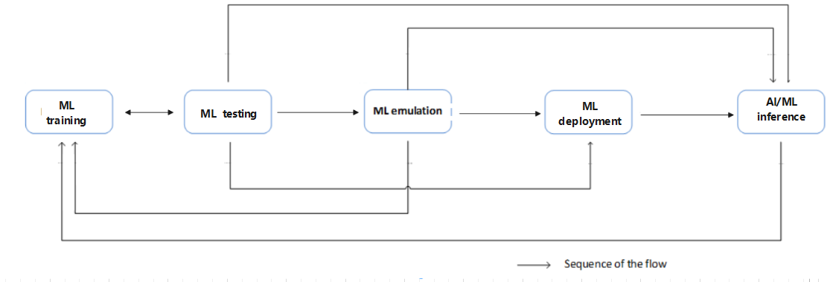
Figure 4a.0-1: ML model lifecycle
The ML model lifecyle includes training, emulation, deployment, and inference. These steps are briefly described below:
- ML training: training, including initial training and re-training of an ML model or a group of ML models. It also includes validation of the ML entity to evaluate the performance when the ML entity performs on the training data and validation data. If the validation result does not meet the expectations (e.g., the variance is not acceptable), the ML model associated with that entity needs to be re-trained.
- ML testing: testing of a validated ML entity to evaluate the performance of the trained ML model when it performs on testing data. If the testing result meets the expectations, the ML entity may proceed to the next step. If the testing result does not meet the expectations (e.g., the accuracy is not acceptable), the ML model needs to be re-trained.
- ML emulation: running an ML entity for inference in an emulation environment. The purpose is to evaluate the inference performance of the ML entity in the emulation environment prior to applying it to the target network or system.
NOTE: The ML emulation is considered optional and can be skipped in the AI/ML operational workflow.
- ML deployment: ML deployment includes the ML model loading process (a.k.a. a sequence of atomic actions) to make a trained ML model available for use at the target AI/ML inference function.
ML deployment step may not be needed in some cases, for example when the training function and inference function are co-located.
- AI/ML inference: performing inference using a trained ML entity by the AI/ML inference function. The AI/ML inference may also trigger model re-training or update based on e.g., performance monitoring and evaluation.
End Change

