3GPP TSG-SA5 Meeting #155 S5-243401
Jeju, South Korea, 27 – 31 May 2024

CR-Form-v12.1
CHANGE REQUEST
 | 32.422 | CR | 0456 | rev | 1 | Current version: | 18.2.0
For HELP on using this form: comprehensive instructions can be found at
http://www.3gpp.org/Change-Requests.

Proposed change affects: | UICC apps |  | ME |  | Radio Access Network | X | Core Network | X

Title: | R18 CR 32.422 Trace Report Format Correction
Source to WG: | Ericsson, Huawei
Source to TSG: | S5
Work item code: | TEI16 |  |  |  |  |  | Date: |  |  | 2024-05-15
Category: | A |  |  |  |  |  | Release: |  |  | Rel-18
 | Use one of the following categories:  F (correction)  A (mirror corresponding to a change in an earlier release)  B (addition of feature),  C (functional modification of feature)  D (editorial modification)  Detailed explanations of the above categories can  be found in 3GPP TR 21.900. |  |  |  |  |  |  |  | Use one of the following releases:  Rel-8 (Release 8)  Rel-9 (Release 9)  Rel-10 (Release 10)  Rel-11 (Release 11)  …  Rel-15 (Release 15)  Rel-16 (Release 16)  Rel-17 (Release 17)  Rel-18 (Release 18)
Reason for change: |  | File based trace reporting description is specified for 5G and pre-5G. Streaming based trace reporting description is added in R16 for 5G. It is specified that at NG-RAN activation procedure "Trace Collection Entity IP Address for the file-based trace reporting or Trace Reporting Consumer URI for the streaming trace reporting".  In section 5.9 Trace Collection Entity (TCE) IP Address "This parameter may be present only if the Trace Reporting MnS Consumer URI parameter is not present."  In section 5.9c Trace Reporting Consumer URI "The parameter may be present only if the IP address of TCE is not present"  The above statement is making a mandatory attribute optional which is not inline with the requirement specified in TS28.622 that “The attributes jobType, traceReference, traceRecordingSessionReference, traceCollectionEntityIPAddress, traceTarget and traceReportingFormat are mandatory for all job types.”  It is also not inline with RAN3 specification that Trace Collection Entity IP Address shall be included in the Trace Activation message and Trace Reporting Consumer URI may be included in the Trace Activation message. If the Trace Activation IE includes the Trace Reporting Consumer URI IE, the NG-RAN node shall use it as described in TS 32.422 and, if streaming based reporting is supported, ignore the Trace Collection Entity IP Address IE.  Making both TCE address IE and URI IE conditional mandatory, may leading Trace failure at handover. If both source gNB and target gNB are supporting only one trace reporting format and it is not same, the trace has to be discontinued after handover.  Besides, changing a mandatory IE into a conditional mandatory in later releases is not considered as backward compatible.
Summary of change: |  | Making TCE IP address mandatory without condition, adding condition of ignoring TCE IP addess when Trace Reporting Consumer URI is present
Consequences if not approved: |  | Misaligned with TS28.622 and RAN3 specification
Clauses affected: |  | 4.1.1.8, 4.1.1.9.1, 4.1.1.9.2, 4.1.2.15.1, 4.1.2.15.2, 4.1.2.15.3, 4.1.2.16, 4.3.3, 4.8.3, 5.9, 5.9c
 |  | Y | N
Other specs |  |  | X | Other core specifications |  |  |  | TS/TR ... CR ...
affected: |  |  | X | Test specifications |  |  |  | TS/TR ... CR ...
(show related CRs) |  | x |  | O&M Specifications |  |  |  | TS28.622 CR 0365
Other comments: |  | TS32.422 CR0454/0455/0456 , TS28.622 CR0363/0364/0365
This CR's revision history: |  | Revision of S5-242378 of S5-242378

*** START OF NEXT CHANGE ***

4.1.1.8 5GC Domain activation mechanisms
When an AF, AMF, AUSF, NEF, NRF, NSSF, PCF, SMF, SMSF, UPF or UDM receives Trace Session activation from the management function, it shall start a Trace Session. The following trace control and configuration parameters of the Trace Session are received in the Trace Session activation from the management function:
- Trace Target: SUPI or IMEISV.
- Trace Reference.
- Triggering Events for this network element.
- Trace Depth.
- List of Interfaces for this network element.
- Trace Collection Entity IP Address for the file-based trace reporting and Trace Reporting Consumer URI for the streaming trace reporting (if streaming based report is supported).
The AF, AMF, AUSF, NEF, NRF, NSSF, PCF, SMF, SMSF, UPF or UDM shall not forward these trace control and configuration parameters to other nodes. The received trace control and configuration parameters shall be saved and used to determine when and how to start a Trace Recording Session. (Starting a Trace Recording Session is described in subclause 4.2.2.9).
*** START OF NEXT CHANGE ***

4.1.1.9.1 General
In NG-RAN the Management Based Trace Activation can be fulfilled with the NG-RAN Cell Traffic trace functionality. In this case the Trace Session Activation is done to one or a list NG-RAN cells within one NG-RAN node, where Trace Session is activated.
The following trace control and configuration parameters of the Trace Session are received by NG-RAN node in the Trace Session activation message from the management system:
- Trace Reference.
- Trace Depth.
- Trace Target: NG-RAN cells list.
- List of Interfaces for NG-RAN node.
- Trace Collection Entity IP Address for the file-based trace reporting and Trace Reporting Consumer URI for the streaming trace reporting (if streaming based report is supported).
When NG-RAN node receives the Trace Session Activation message from the management system for a given or a list of NG-RAN cell(s) the NG-RAN node shall start a Trace Session for the given or list of NG-RAN cell(s). If no list of NG-RAN cell(s) is present the NG-RAN node shall start a Trace Session for all cells.
*** START OF NEXT CHANGE ***

4.1.1.9.2 NG-RAN activation mechanisms for management based MDT data collections without IMSI/IMEI(SV)/SUPI selection in the case of non-split architecture
For management based MDT data collection with no IMSI/IMEI(SV)/SUPI criteria in the case of non-split architecture, the UE selection can be done in the radio network at gNB based on the input information received from management system and the user consent information stored in the gNB. This mechanism works for the following OAM input parameters:
- Area information only
The following figure summarizes the flow as an example how the MDT configuration is done utilising the cell traffic trace functionality for this scenario:

Figure 4.1.1.9.2.1: Example for management based MDT activation in NG-RAN in the case of non-split architecture
Whenever the gNB receives the Management based MDT allowed IE in Initial Context Setup Request or in Handover Request message, it shall save it for possible later usage.
1) The management system sends a Trace Session activation request to the gNB. This request includes the parameters for configuring UE measurements:
- Job Type.
- Area Scope where the UE measurements should be collected: list of NG-RAN cells. Tracking Area should be converted to NG-RAN cell, s, additionally a list of NPN IDs in NG-RAN.
- List of Measurements.
- Reporting Trigger.
- Report Interval.
- Report Amount.
- Event Threshold.
- Logging Interval.
- Logging Duration.
- Trace Reference.
- TCE IP Address and Trace Reporting Consumer URI (if streaming based report is supported).
- Anonymization of MDT Data.
- Collection Period for RRM Measurements NR (present only if any of M4 or M5 measurements are requested).
- Collection Period M6 in NR (present only if any of M6 measurements (DL or UL) is requested).
- Collection Period M7 in NR (present only if any of M7 measurements (DL or UL) is requested).
- Positioning Method.
- MDT PLMN List.
- Report Type for Logged MDT (periodical logged or event-triggered measurement) for logged MDT only.
- Event Threshold, Hysteresis and Time to Trigger (present only if L1 event is configured for logged MDT)
- Event List for Event Triggered Measurement for logged MDT only.
- Area Configuration for Neighbouring Cells for logged MDT only.
- Sensor Information for logged MDT and immediate MDT.
- Excess packet delay thresholds (present only if M6 measurements are requested).

Note that at the same time not all the parameters can be present. The criteria for which parameters are present are described in clause 5 of the present document.
2) When gNB receives the Trace Session activation request from its management system, it shall start a Trace Session and should save the parameters associated to the Trace Session.
3) gNB shall select the suitable UEs for MDT data collection. The selection is based on the area received from the management system and the area where UE is located, user consent information received from the core network as part of the Management based MDT PLMN List IE (As described in section in 4.9.2 of this document). If the user is not in the specified area or if the Management based MDT PLMN List IE is not present in the UE context the UE shall not be selected by the gNB for MDT data collection. During UE selection, the gNB shall take into account also the UE capability (MDT capability) when it selects UE for logged MDT configuration. If the UE does not support logged MDT, the UE shall not be selected.
If M4 or M5 measurements are requested in the MDT configuration, gNB should start the measurement according to the received configuration. Details of the measurements are defined in TS 38.314 [50].
4) gNB shall activate the MDT functionality to the selected UEs. When gNB selects a UE, it shall take into account the availability of Management based MDT PLMN List IE in the user context and the area scope parameter received in MDT configuration (Trace Session activation). Detailed description about user consent handling and how it is provided to the gNB is described in section 4.9.2. If there is no Management based MDT PLMN List IE in the user context or the user is outside the area scope defined in the MDT configuration, the UE shall not be selected for MDT data collection. The gNB shall assign Trace Recording Session Reference corresponding to the selected UE. The gNB shall send at least the following configuration information to the UE in case of Logged MDT:
- Trace Reference
- Trace Recording Session Reference
- TCE Id
- Logging Interval
- Logging Duration
- Absolute time reference
- Area Scope where the UE measurements should be collected: list of NG-RAN cells/TA, additionally a list of NPN IDs in NR.
- MDT PLMN List

NOTE: For UEs currently being in idle or inactive mode and camping in the cell the logged MDT configuration cannot be sent. These UEs may be configured when they initiate some activity (e.g., Service Request or Tracking Area Update) at next time.
In case of Immediate MDT, the following parameters shall be sent to the UE:
- List of Measurements
- Reporting Trigger
- Report Interval
- Report Amount
- Event Threshold
- Excess packet delay thresholds (present only if M6 UL measurements are requested)
Note that at the same time not all the parameters can be present. Conditions of the parameters are described in clause 5 of the present document.
gNB performs necessary actions (e.g. activates GNSS module of the UE, enables and collects certain positioning measurements) specified in TS 38.305 [52] according to the value of Positioning Method (see clause 5.10.19) received in the Trace configuration. gNB captures location information and/or positioning measurements in the MDT trace record.
If Reporting Trigger parameter indicates that all configured RRM measurement trigger should be reported in MDT, then gNB should ask the UE to provide the "best effort" location information together with the measurement reporting by setting the includeCommonLocationInfo IE in all RRC measurement reporting configurations.
5) When UE receives the MDT activation it shall start the MDT functionality based on the received configuration parameters.
6) The gNB shall not retrieve MDT report from the UE if UE’s rPLMN does not match the PLMN where TCE used to collect MDT data resides (e.g. gNB’s primary PLMN). When the gNB receives the MDT report from UE, the gNB shall get the Trace Recording Session Reference, Trace Reference, and TCE Id from the report, and compare the Trace PLMN (PLMN portion of Trace Reference) with the PLMN where TCE used to collect MDT data resides (e.g. its primary PLMN) and discard MDT report in case of a mismatch. Otherwise if the MDT anonymization requires the IMEI-TAC in the MDT record gNB shall send the Trace Recording Session Reference, Trace Reference, serving cell CGI, and TCE IP Address (or Trace Reporting Consumer URI) in the CELL TRAFFIC TRACE message to the AMF via the NG connection. When AMF receives this NG signalling message containing the Trace Recording Session Reference, Trace Reference, serving cell CGI, and the Privacy Indicator (that shall be set to Logged MDT or Immediate MDT depending on the configured Job Type) if so indicated in the privacy indicator, the AMF shall look up the subscriber identities (IMEI(SV)) of the given call from its database, and send the IMEI-TAC together with the Trace Recording Session Reference and Trace Reference and for immediate MDT also the serving cell CGI to the TCE, as described in section 4.7 of the present document. For logged MDT, AMF will send the IMEI-TAC together with the Trace Recording Session Reference, Trace Reference to the TCE.
NOTE: For management based Immediate MDT, TRSR may be duplicated among different gNBs when multiple cells are selected as the area scope for the same MDT job. In this case, the combination of TRSR and the UE’s serving cell CGI in the MDT report can uniquely identify one trace recording session.
7) For Immediate MDT when the gNB receives the MDT report from the UE in the RRC message the gNB shall capture it and put the UE’s serving cell CGI together with the MDT report from the UE to the trace record. A UE configured to perform Logged MDT measurements in IDLE or INACTIVE indicates the availability of MDT measurements, by means of a one-bit indicator, in RRC messages definitions in 3GPP TS 38.331 [43], e.g., RRCSetupComplete message and RRCReconfigurationComplete message. The gNB can decide to retrieve the logged measurements based on this indication by sending the UEInformationRequest message to the UE. The UE can answer with the collected MDT logs in UEInformationResponse message.
8) The gNB shall forward the Trace Records to the Trace Collection Entity (TCE). In case of logged MDT, the TCE Id is indicated in the MDT report is translated to the actual IP address of the TCE or the URI of the Trace Reporting Consumer by the gNB before it forwards the measurement records. (The TCE identity translation is using configured mapping in the gNB.) In case of immediate MDT, the IP address of the TCE or the URI of the Trace Reporting Consumer is indicated for the gNB in the trace configuration.
The Immediate MDT measurement configuration is deleted in the UE together with the RRC context when entering idle or inactive mode.
The Logged MDT trace session is preserved in the UE until the duration time of the trace session expires, including also multiple idle or inactive periods interrupted by various state transistions such as idle-connected-idlestate transitions.
The Logged MDT trace session context of the UE is stored in the network as long as the trace session is active, including also the periods when the UE is in connected state.
Management system shall validate that the MCC and MNC specified in the Trace Reference is the same as the PLMN supported by all the cells specified in the area scope. If the gNB receives a request with a PLMN in the TraceReference that does not match any PLMN in its list, it shall ignore the request.
*** START OF NEXT CHANGE ***

4.1.2.15.1 UE attached to 5GC via NG-RAN
Figure 4.1.2.15.1.1 illustrates the signaling Trace Session activation procedure in 5GC as part of the Registration procedure:
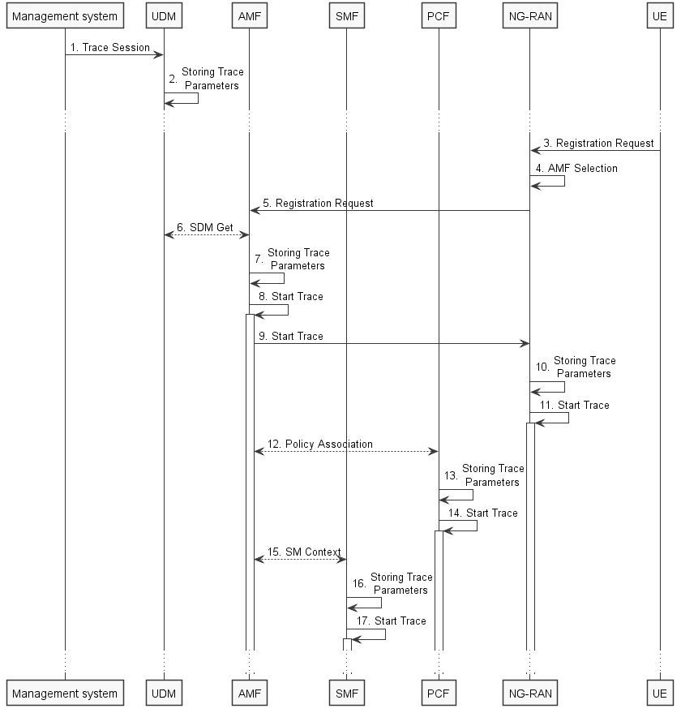
Figure 4.1.2.15.1.1: Trace activation in 5GC following the Registration procedure
The steps 3-6, 12 and 15 below are parts of the General Registration procedure - see 3GPP TS 23.502 [41] clause 4.2.2.2 for specific details. Present document does not attempt to re-define how General Registration procedure works, but rather illustrates the signaling Trace Activation aspects.
1. Management system activates Trace Session to the UDM. The following trace control and configuration parameters shall be included in the Trace Activation message:
- Trace Target: SUPI or IMEISV.
- Trace Reference.
- Triggering Events for AMF, SMF, UPF and PCF.
- Trace Depth.
- List of NE Types to trace.
- List of Interfaces for AMF, SMF, UPF, PCF and NG-RAN.
- Trace Collection Entity IP Address for the file-based trace reporting and Trace Reporting Consumer URI for the streaming trace reporting (if streaming based report is supported).
2. UDM stores the trace control and configuration parameters received from the management system.
3. UE sends Registration request to NG-RAN node.
4. NG-RAN node selects appropriate AMF.
5. NG-RAN node forwards the UE Registration request to the selected AMF.
6. AMF receives the trace control and configuration parameters information from UDM via Nudm_SDM_Get operation (see step 14 in clause 4.2.2.2.2 and clause 5.2.3.3 of 3GPP TS 23.502 [41]).
7. AMF stores the trace control and configuration parameters received from the UDM.
8. AMF starts the Trace Session according to the received configuration.
9. AMF sends the Start Trace message over NG interface (N2 interface from the 5GC perspective)
10. NG-RAN node stores the trace control and configuration parameters received from the AMF. This step is part of NG-RAN signaling trace activation - see clause 4.1.2.16 for more details.
11. NG-RAN node starts the Trace Session according to the received configuration. This step is part of NG-RAN signaling trace activation - see clause 4.1.2.16 for more details.
12. AMF establishes Policy Association with PCF (see step 16 in clause 4.2.2.2.2 of 3GPP TS 23.502 [41]) and provides the trace control and configuration parameters information to the PCF.
13. PCF stores the trace control and configuration parameters received from the AMF as part of Policy Association.
14. PCF starts the Trace Session according to the received configuration.
15. AMF provides the trace control and configuration parameters information to the SMF as part of the SM Context (see step 18 in clause 4.2.2.2.2 of 3GPP TS 23.502 [41]).
16. SMF stores the trace control and configuration parameters received from the AMF.
17. SMF starts the Trace Session according to the received configuration.

Figure 4.1.2.15.1.2 illustrates the signaling Trace Session activation procedure in 5GC as part of the PDU Session Establishment procedure for the UE that has already been registered:
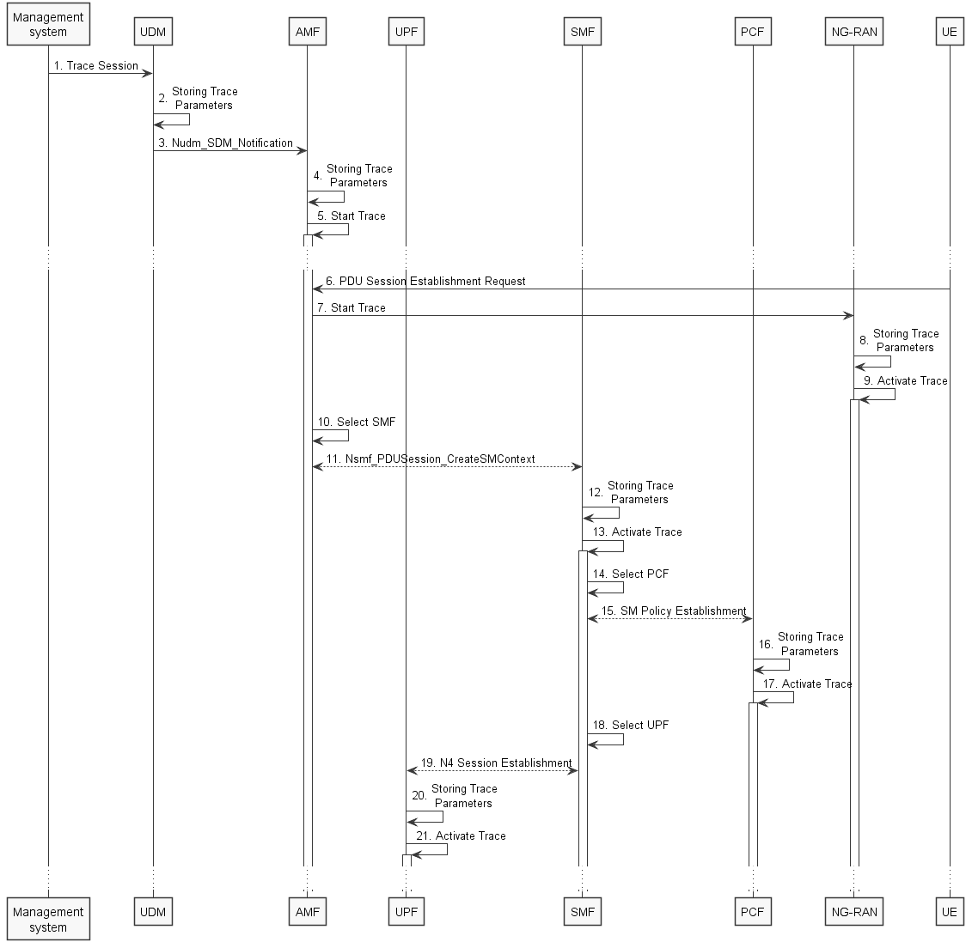
Figure 4.1.2.15.1.2: Trace activation in 5GC following the PDU Session Establishment procedure
The steps 6, 10, 11, 14 and 15 below are parts of the UE Requested PDU Session Establishment procedure - see 3GPP TS 23.502 [41] clause 4.3.2.2 for specific details. Present document does not attempt to re-define how UE Requested PDU Session Establishment procedure works, but rather illustrates the signaling Trace Activation aspects.
1. Management system activates Trace Session to the UDM. The following trace control and configuration parameters shall be included in the Trace Activation message:
- Trace Target: SUPI or IMEISV.
- Trace Reference.
- Triggering Events for AMF, SMF, UPF and PCF.
- Trace Depth.
- List of NE Types to trace.
- List of Interfaces for AMF, SMF, PCF, UPF and NG-RAN.
- Trace Collection Entity IP Address for the file-based trace reporting and Trace Reporting Consumer URI for the streaming trace reporting (if streaming based report is supported).
2. UDM stores the trace control and configuration parameters received from the management system.
3. UDM sends Nudm_SDM_Notification to AMF with the trace control and configuration parameters information (see clauses 4.5.1 and 5.2.3.3 of 3GPP TS 23.502 [41]).
4. AMF stores the trace control and configuration parameters received from the UDM.
5. AMF starts the Trace Session according to the received configuration.
6. UE sends PDU Session Establishment request to AMF
7. AMF sends the Start Trace message over NG interface (N2 interface from the 5GC perspective)
8. NG-RAN node stores the trace control and configuration parameters received from the AMF. This step is part of NG-RAN signaling trace activation - see clause 4.1.2.16 for more details.
9. NG-RAN node starts the Trace Session according to the received configuration. This step is part of NG-RAN signaling trace activation - see clause 4.1.2.16 for more details.
10. AMF selects an appropriate SMF
11. AMF sends the Nsmf_PDUSession_CreateSMContext request to the selected SMF with the trace control and configuration parameters.
12. SMF stores the trace control and configuration parameters received from the AMF.
13. SMF starts the Trace Session according to the received configuration.
14. SMF selects an approprite PCF
15. SMF establishes Session Management Policy Association with PCF (see step 7 in clause 4.3.2.2.1 of 3GPP TS 23.502 [x5]) and provides the trace control and configuration parameters information to the PCF.
16. PCF stores the trace control and configuration parameters received from the SMF as part of Policy Association.
17. PCF starts the Trace Session according to the received configuration.
18. SMF selects an approprite UPF
19. SMF performs N4 Session Establishment with UPF (see step 10 in clause 4.3.2.2.1 of 3GPP TS 23.502 [41]) and provides the trace control and configuration parameters information to the UPF.
20. UPF stores the trace control and configuration parameters received from the SMF as part of N4 Session Establishment.
21. UPF starts the Trace Session according to the received configuration.

Figure 4.1.2.15.1.3 illustrates the signaling Trace Session activation procedure in 5GC as part of the PDU Session Establishment procedure for the UE that has already been registered where SMF obtains trace control and configuration parameters from UDM via Nudm_UECM_Registration procedure:
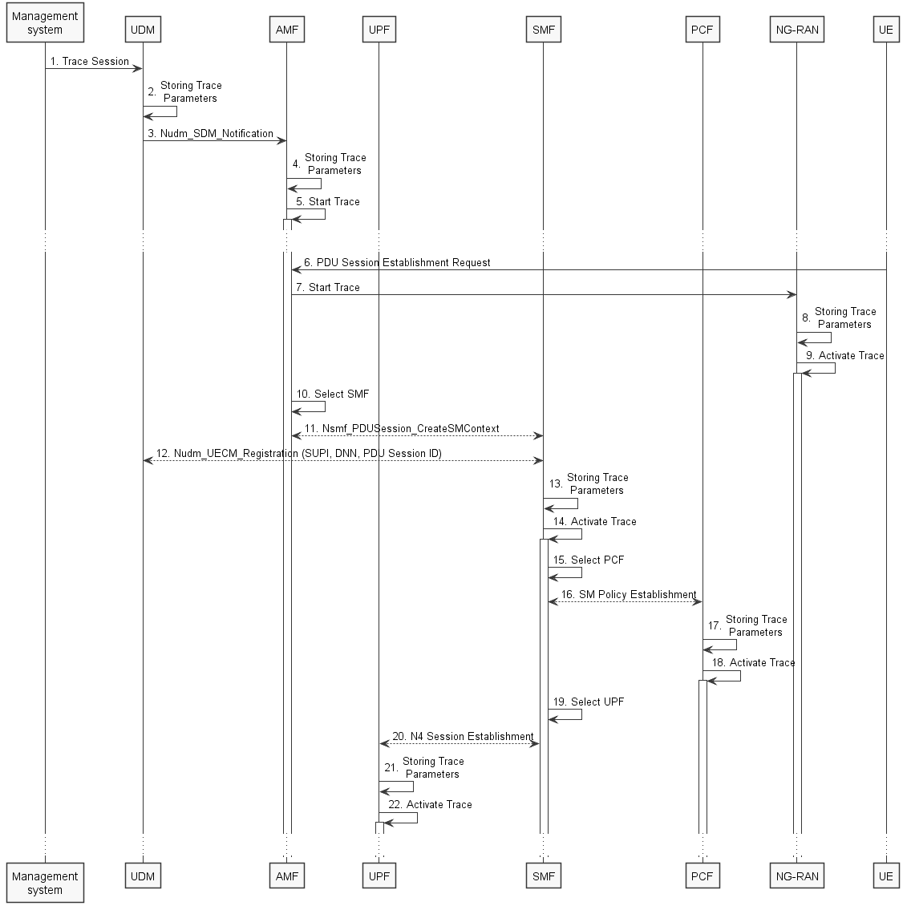
Figure 4.1.2.15.1.3: Trace activation in 5GC following the PDU Session Establishment procedure
The steps 6, 10, 11, 14 and 15 below are parts of the UE Requested PDU Session Establishment procedure - see 3GPP TS 23.502 [41] clause 4.3.2.2 for specific details. Present document does not attempt to re-define how UE Requested PDU Session Establishment procedure works, but rather illustrates the signaling Trace Activation aspects.
1. Management system activates Trace Session to the UDM. The following trace control and configuration parameters shall be included in the Trace Activation message:
- Trace Target: SUPI or IMEISV
- Trace Reference
- Triggering Events for AMF, SMF, UPF and PCF
- Trace Depth
- List of NE Types to trace
- List of Interfaces for AMF, SMF, UPF, PCF and NG-RAN
- Trace Collection Entity IP Address for the file-based trace reporting and Trace Reporting Consumer URI the streaming trace reporting (if streaming based report is supported)
2. UDM stores the trace control and configuration parameters received from the management system.
3. UDM sends Nudm_SDM_Notification to AMF with the trace control and configuration parameters information (see clauses 4.5.1 and 5.2.3.3 of 3GPP TS 23.502 [41]).
4. AMF stores the trace control and configuration parameters received from the UDM.
5. AMF starts the Trace Session according to the received configuration.
6. UE sends PDU Session Establishment request to AMF
7. AMF sends the Start Trace message over NG interface (N2 interface from the 5GC perspective)
8. NG-RAN node stores the trace control and configuration parameters received from the AMF. This step is part of NG-RAN signaling trace activation - see clause 4.1.2.16 for more details.
9. NG-RAN node starts the Trace Session according to the received configuration. This step is part of NG-RAN signaling trace activation - see clause 4.1.2.16 for more details.
10. AMF selects an appropriate SMF
11. AMF sends the Nsmf_PDUSession_CreateSMContext request to the selected SMF
12. SMF performs NuDM_UECM_Registration procedure with UDM and receives the trace control and configuration parameters from UDM
13. SMF stores the trace control and configuration parameters received from the UDM.
14. SMF starts the Trace Session according to the received configuration.
15. SMF selects an approprite PCF
16. SMF establishes Session Management Policy Association with PCF (see step 7 in clause 4.3.2.2.1 of 3GPP TS 23.502 [41]) and provides the trace control and configuration parameters information to the PCF.
17. PCF stores the trace control and configuration parameters received from the SMF as part of Policy Association.
18. PCF starts the Trace Session according to the received configuration.
19. SMF selects an approprite UPF
20. SMF performs N4 Session Establishment with UPF (see step 10 in clause 4.3.2.2.1 of 3GPP TS 23.502 [41]) and provides the trace control and configuration parameters information to the UPF.
21. UPF stores the trace control and configuration parameters received from the SMF as part of N4 Session Establishment.
22. UPF starts the Trace Session according to the received configuration.
Note: The specific scenarios where SMF receives trace control and configuration parameters either from UDM or from AMF are specified in 3GPP TS 23.502 [41].

Figure 4.1.2.15.1.4 illustrates the signaling Trace Session activation procedure in 5GC as part of the PDU Session Modification procedure for the UE that has already been registered and has an on-going PDU Session:
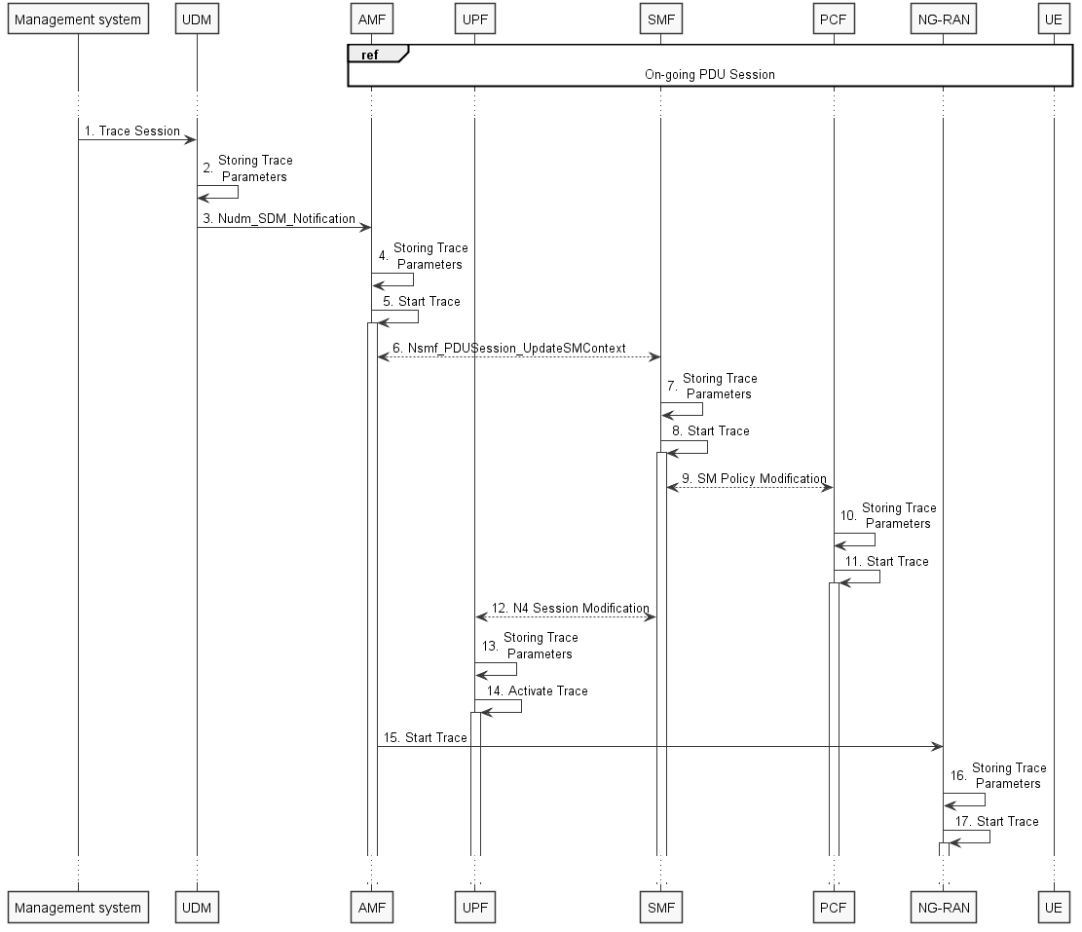
Figure 4.1.2.15.1.4: Trace activation in 5GC following the PDU Session Modification procedure
The steps 6 and 9 below are parts of the PDU Session Modification procedure - see 3GPP TS 23.502 [41] clause 4.3.3.2 for specific details. Present document does not attempt to re-define how PDU Session Modification procedure works, but rather illustrates the signaling Trace Activation aspects.
1. Management system activates Trace Session to the UDM. The following trace control and configuration parameters shall be included in the Trace Activation message:
- Trace Target:SUPI or IMEISV.
- Trace Reference.
- Triggering Events for AMF, SMF, UPF and PCF.
- Trace Depth.
- List of NE Types to trace.
- List of Interfaces for AMF, SMF, UPF, PCF and NG-RAN.
- Trace Collection Entity IP Address for the file-based trace reporting and Trace Reporting Consumer URI for the streaming trace reporting (if streaming based report is supported).
2. UDM stores the trace control and configuration parameters received from the management system.
3. UDM sends Nudm_SDM_Notification to AMF with the trace control and configuration parameters information (see clauses 4.5.1 and 5.2.3.3 of 3GPP TS 23.502 [41]).
4. AMF stores the trace control and configuration parameters received in step 9.
5. AMF starts the Trace Session according to the received configuration.
6. AMF sends Nsmf_PDUSession_UpdateSMContext request with the trace control and configuration parameters information to the SMF
7. SMF stores the trace control and configuration parameters received from the UDM.
8. SMF starts the Trace Session according to the received configuration.
9. SMF performs Session Management Policy Modification with PCF (see step 7 in clause 4.3.3.2 of 3GPP TS 23.502 [41]) and provides the trace control and configuration parameters information to the PCF.
10. PCF stores the trace control and configuration parameters received from the SMF as part of Policy Association.
11. PCF starts the Trace Session according to the received configuration.
12. SMF performs N4 Session Modification with UPF (see step 10 in clause 4.3.2.2.1 of 3GPP TS 23.502 [41]) and provides the trace control and configuration parameters information to the UPF.
13. UPF stores the trace control and configuration parameters received from the SMF as part of N4 Session Modification.
14. UPF starts the Trace Session according to the received configuration.
15. AMF sends the Start Trace message over NG interface (N2 interface from the 5GC perspective)
16. NG-RAN node stores the trace control and configuration parameters received from the AMF. This step is part of NG-RAN signaling trace activation - see clause 4.1.2.16 for more details.
17. NG-RAN node starts the Trace Session according to the received configuration. This step is part of NG-RAN signaling trace activation - see clause 4.1.2.16 for more details.

Figure 4.1.2.15.1.5 illustrates the signaling Trace Session activation procedure in 5GC as part of the PDU Session Modification procedure for the UE that has already been registered and has an on-going PDU Session where UDM notifies SMF about trace activation directly:
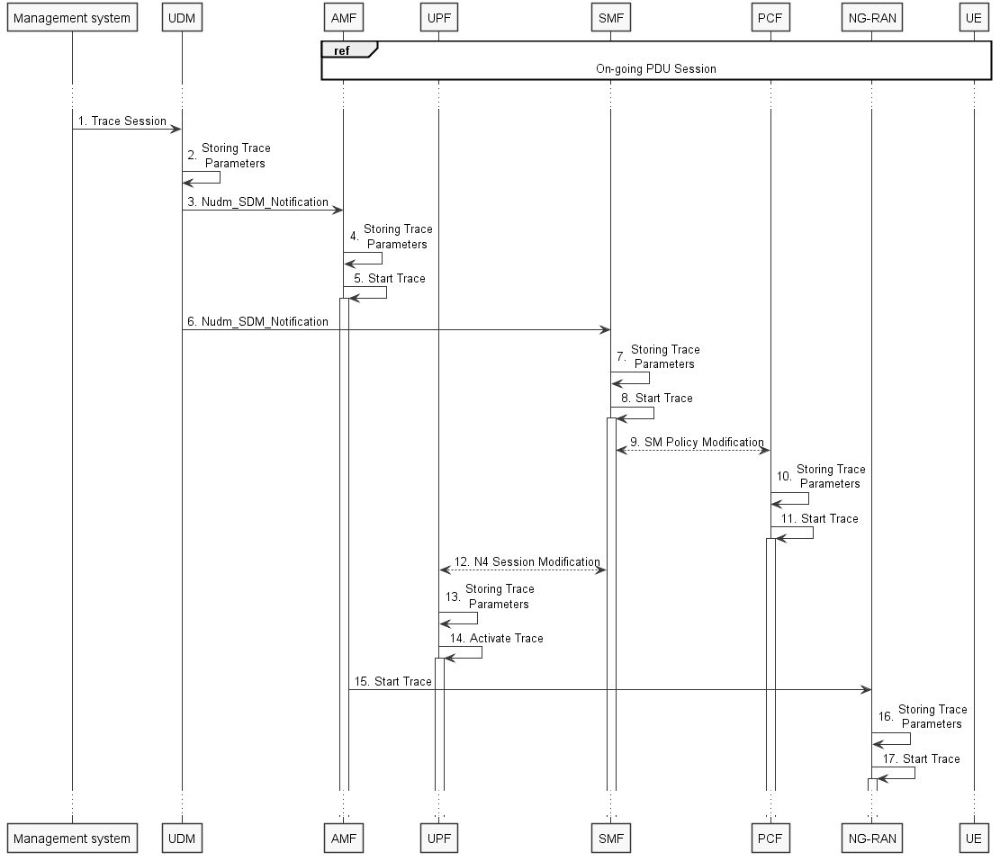
Figure 4.1.2.15.1.5: Trace activation in 5GC following the PDU Session Modification procedure (with UDM to SMF notification)
The steps 6 and 9 below are parts of the PDU Session Modification procedure - see 3GPP TS 23.502 [41] clause 4.3.3.2 for specific details. Present document does not attempt to re-define how PDU Session Modification procedure works, but rather illustrates the signaling Trace Activation aspects.
1. Management system activates Trace Session to the UDM. The following trace control and configuration parameters shall be included in the Trace Activation message:
- Trace Target: SUPI or IMEISV.
- Trace Reference.
- Triggering Events for AMF, SMF, UPF and PCF.
- Trace Depth.
- List of NE Types to trace.
- List of Interfaces for AMF, SMF, UPF, PCF and NG-RAN.
- Trace Collection Entity IP Address for the file-based trace reporting and Trace Reporting Consumer URI for the streaming trace reporting (if streaming based report is supported).
2. UDM stores the trace control and configuration parameters received from the management system.
3. UDM sends Nudm_SDM_Notification to AMF with the trace control and configuration parameters information (see clauses 4.5.1 and 5.2.3.3 of 3GPP TS 23.502 [41]).
4. AMF stores the trace control and configuration parameters received in step 9.
5. AMF starts the Trace Session according to the received configuration.
6. UDM sends Nudm_SDM_Notification to SMF with the trace control and configuration parameters information (see clauses 4.5.2 and 5.2.3.3 of 3GPP TS 23.502 [41]).
7. SMF stores the trace control and configuration parameters received from the UDM.
8. SMF starts the Trace Session according to the received configuration.
9. SMF performs Session Management Policy Modification with PCF (see step 7 in clause 4.3.3.2 of 3GPP TS 23.502 [41]) and provides the trace control and configuration parameters information to the PCF.
10. PCF stores the trace control and configuration parameters received from the SMF as part of Policy Association.
11. PCF starts the Trace Session according to the received configuration.
12. SMF performs N4 Session Modification with UPF (see step 10 in clause 4.3.2.2.1 of 3GPP TS 23.502 [41]) and provides the trace control and configuration parameters information to the UPF.
13. UPF stores the trace control and configuration parameters received from the SMF as part of N4 Session Modification.
14. UPF starts the Trace Session according to the received configuration.
15. AMF sends the Start Trace message over NG interface (N2 interface from the 5GC perspective)
16. NG-RAN node stores the trace control and configuration parameters received from the AMF. This step is part of NG-RAN signaling trace activation - see clause 4.1.2.16 for more details.
17. NG-RAN node starts the Trace Session according to the received configuration. This step is part of NG-RAN signaling trace activation - see clause 4.1.2.16 for more details.
Note: The specific scenarios where SMF receives trace control and configuration parameters either from UDM or from AMF are specified in 3GPP TS 23.502 [41].

*** START OF NEXT CHANGE ***

4.1.2.15.2 Inter-RAT handover between E-UTRAN and NG-RAN
The figure 4.1.2.15.2.1 below illustrates an example scenario when UE served by 5GC with ongoing PDU session and active Trace Session makes an inter-RAT handover from NG-RAN to the E-UTRAN and makes another handover back from E-UTRAN to NG-RAN illustrated in figure 4.1.2.15.2.2.
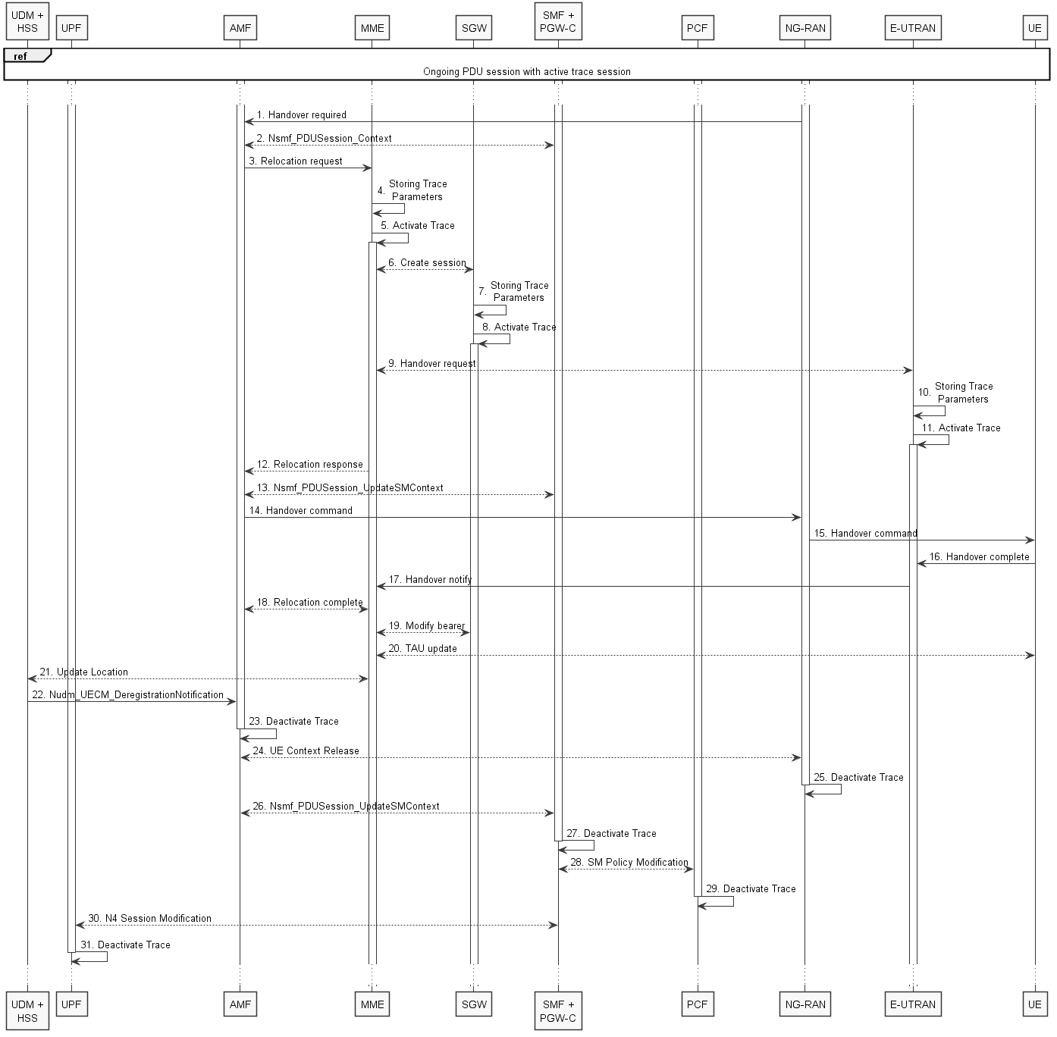
Figure 4.1.2.15.2.1: Signaling Trace Activation during Inter-RAT handover from NG-RAN to E-UTRAN
The steps 1 - 3, 6, 9, 12 - 22, 24, 26 and 28 on figure 4.1.2.15.2.1 are parts of the 5GS to EPS handover using N26 interface procedure - see 3GPP TS 23.502 [41] clause 4.11.1.2.1 for specific details. Present document does not attempt to re-define how 5GS to EPS handover using N26 interface procedure works, but rather illustrates the signaling Trace Activation aspects.
When AMF sends the Relocation Request to MME, AMF shall include the following trace control and configuration parameters for the Trace Activation:
- Trace Target:SUPI or IMEISV.
- Trace Reference.
- Triggering Events for MME, Serving GW, PDN GW, SGSN, GGSN.
- Trace Depth.
- List of NE Types to trace.
- List of Interfaces for MME, Serving GW, PDN GW, eNB, SGSN, GGSN, RNC.
- Trace Collection Entity IP Address for the file-based trace reporting.
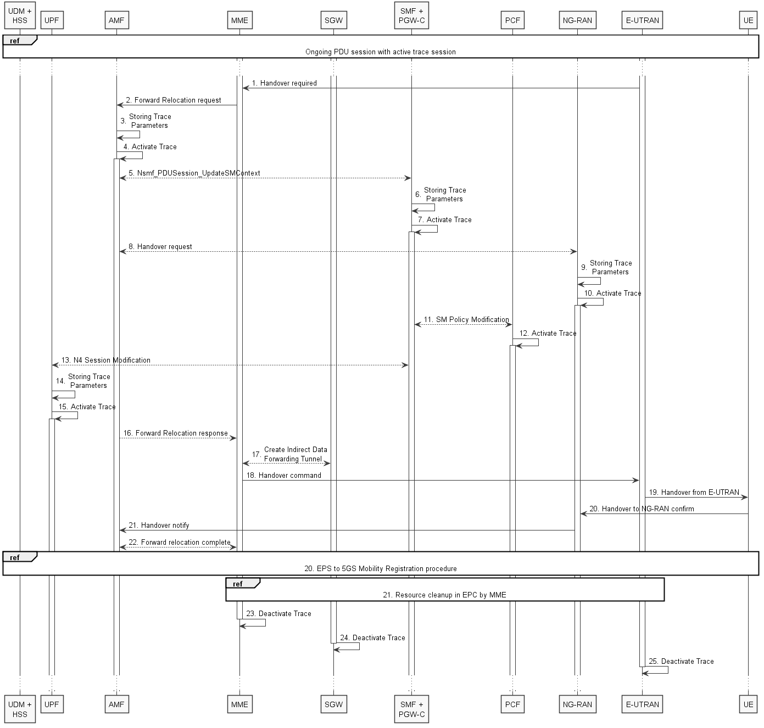
Figure 4.1.2.15.2.2: Signaling Trace Activation during Inter-RAT handover from E-UTRAN to NG-RAN
The steps 1, 2, 5, 8, 11 and 13 – 21 on figure 4.1.2.15.2.2 are parts of the EPS to 5GS handover using N26 interface procedure – see 3GPP TS 23.502 [41] clause 4.11.1.2.2 for specific details. Present document does not attempt to re-define how EPS to 5GS handover using N26 interface procedure works, but rather illustrates the signaling Trace Activation aspects.
When MME sends the Forward Relocation Request to AMF, MME shall include the following trace control and configuration parameters for the Trace Activation:
- Trace Target: SUPI or IMEISV.
- Trace Reference.
- Triggering Events for AMF, SMF, UPF and PCF.
- Trace Depth.
- List of NE Types to trace.
- List of Interfaces for AMF, SMF, UPF, PCF and NG-RAN.
- Trace Collection Entity IP Address.
*** START OF NEXT CHANGE ***

4.1.2.15.3 Non-3GPP access scenarios
Figure 4.1.2.15.3.1 illustrates the signaling Trace Session activation procedure in 5GC as part of the Registration via Untrusted non-3GPP Access procedure:
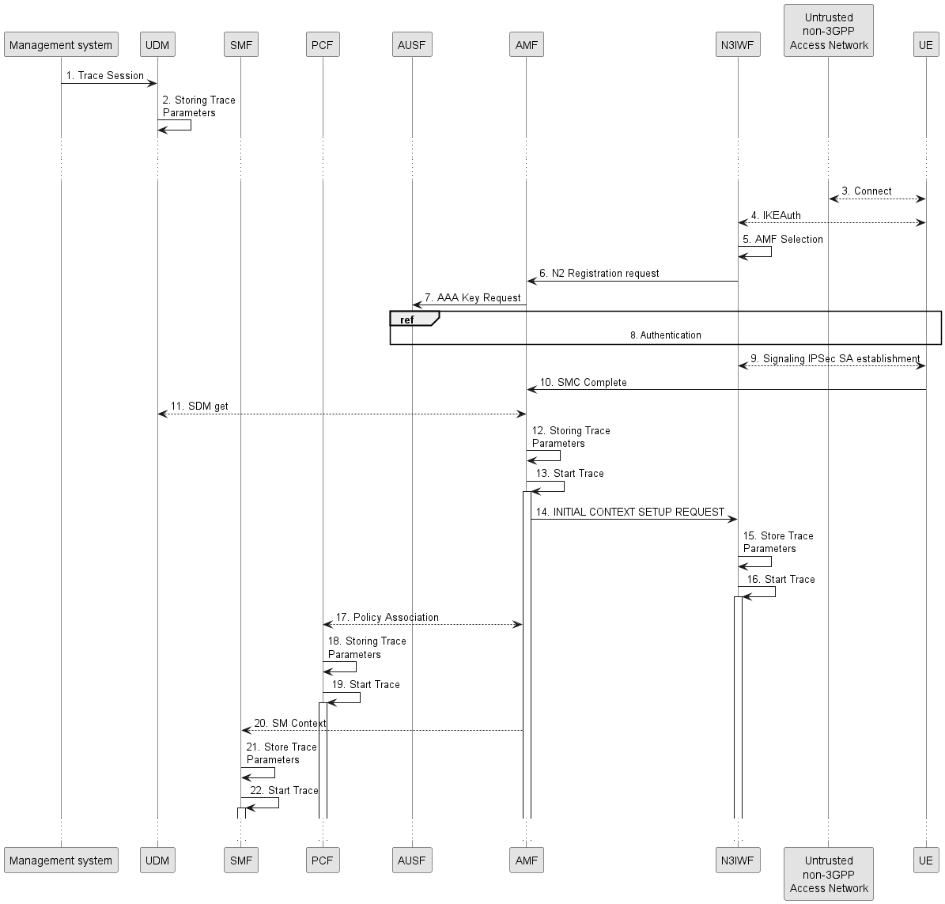
Figure 4.1.2.15.3.1: Trace activation in 5GC following the Registration via Untrusted non-3GPP Access procedure
The steps 3-11, 14 and 17 below are parts of the Registration via Untrusted non-3GPP Access procedure - see 3GPP TS 23.502 [41] clauses 4.12.2 and 4.2.2 for specific details. Present document does not attempt to re-define how Registration via Untrusted non-3GPP Access procedure works, but rather illustrates the signaling Trace Activation aspects.
1. Management system activates Trace Session to the UDM. The following trace control and configuration parameters shall be included in the Trace Activation message:
- Trace Target: SUPI or IMEISV.
- Trace Reference.
- Triggering Events for AMF, SMF, UPF and PCF.
- Trace Depth.
- List of NE Types to trace.
- List of Interfaces for AMF, SMF, UPF, PCF and N3IWF.
- Trace Collection Entity IP Address for the file-based trace reporting and Trace Reporting Consumer URI for the streaming trace reporting (if streaming based report is supported).
2. UDM stores the trace control and configuration parameters received from the management system.
3. UE connects to the Untrusted non-3GPP Access Network and obtains an IP address
4. UE performs IKE authentication with N3IWF
5. N3IWF selects appropriate AMF
6. N3IWF sends N2 Registration request to AMF
7. AMF requests AAA Key from AUSF
8. UE authenticates with AUSF via N3IWF and AMF
9. UE establishes Signaling IPsec SA with N3IWF
10. UE sends SMC Complete to AMF
11. AMF receives the trace control and configuration parameters information from UDM via Nudm_SDM_Get operation (see step 14 in clause 4.2.2.2.2 and clause 5.2.3.3 of 3GPP TS 23.502 [41]).
12. AMF stores the trace control and configuration parameters received from the UDM.
13. AMF starts the Trace Session according to the received configuration.
14. AMF sends INITIAL CONTEXT SETUP REQUEST (or START TRACE message as defined in TS 38.413 [49]) message to N3IWF containing the “Trace Activation” IE. (see clause 8.11.1 for information on TRACE START procedure, clause 8.3.1 for information on INITIAL CONTEXT SETUP REQUEST and clause 9.3.1.14 for details on Trace Activation IE of 3GPP TS 38.413 [49]).
15. N3IWF stores the trace control and configuration parameters received from AMF.
16. N3IWF starts the Trace Session according to the received configuration.
17. AMF establishes Policy Association with PCF (see step 16 in clause 4.2.2.2.2 of 3GPP TS 23.502 [41]) and provides the trace control and configuration parameters information to the PCF.
18. PCF stores the trace control and configuration parameters received from the AMF as part of Policy Association.
19. PCF starts the Trace Session according to the received configuration.
20. AMF provides the trace control and configuration parameters information to the SMF as part of the SM Context (see step 18 in clause 4.2.2.2.2 of 3GPP TS 23.502 [41]).
21. SMF stores the trace control and configuration parameters received from the AMF.
22. SMF starts the Trace Session according to the received configuration.

Figure 4.1.2.15.3.2 illustrates the signaling Trace Session activation procedure in 5GC as part of the PDU Session Establishment via Untrusted non-3GPP Access procedure for the UE that has already been registered:
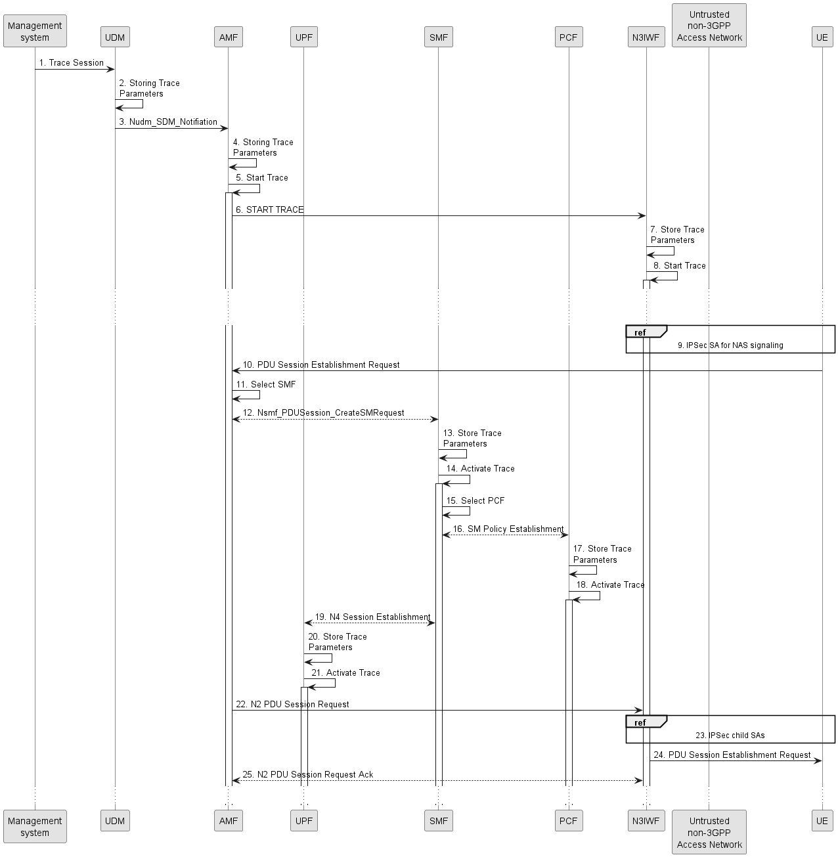
Figure 4.1.2.15.3.2: Trace activation in 5GC following the PDU Session Establishment via Untrusted non-3GPP Access procedure
The steps 6 - 9, 13 and 16 - 19 below are parts of the UE Requested PDU Session Establishment via Untrusted non-3GPP Access procedure - see 3GPP TS 23.502 [41] clause 4.12.5 for specific details. Present document does not attempt to re-define how UE Requested PDU Session Establishment via Untrusted non-3GPP Access procedure works, but rather illustrates the signaling Trace Activation aspects.
1. Management system activates Trace Session to the UDM. The following trace control and configuration parameters shall be included in the Trace Activation message:
- Trace Target: SUPI or IMEISV
- Trace Reference
- Triggering Events for AMF, SMF, UPF and PCF
- Trace Depth
- List of NE Types to trace
- List of Interfaces for AMF, SMF, UPF, PCF and N3IWF
- Trace Collection Entity IP Address for the file-based trace reporting and Trace Reporting Consumer URI for the streaming trace reporting (if streaming based report is supported).
2. UDM stores the trace control and configuration parameters received from the management system.
3. UDM sends Nudm_SDM_Notification to AMF with the trace control and configuration parameters information (see clauses 4.5.1 and 5.2.3.3 of 3GPP TS 23.502 [41]).
4. AMF stores the trace control and configuration parameters received from the UDM.
5. AMF starts the Trace Session according to the received configuration.
6. AMF sends START TRACE message or INITIAL CONTEXT SETUP REQUEST message to N3IWF containing the “Trace Activation” IE. (see clause 8.11.1 for information on TRACE START procedure, clause 8.3.1 for information on INITIAL CONTEXT SETUP REQUEST and clause 9.3.1.14 for details on Trace Activation IE of 3GPP TS 38.413 [49]).
7. N3IWF stores the trace control and configuration parameters received from AMF.
8. N3IWF starts the Trace Session according to the received configuration.
9. IPSec tunnel is established for NAS signalling established between UE and N3IWF as specified in clause 4.12.2 of 3GPP TS 23.502 [41].
10. UE sends PDU Session Establishment request to AMF
11. AMF selects an appropriate SMF
12. AMF sends the Nsmf_PDUSession_CreateSMContext request to the selected SMF
13. SMF stores the trace control and configuration parameters received from the AMF.
14. SMF starts the Trace Session according to the received configuration.
15. SMF selects an approprite PCF
16. SMF establishes Session Management Policy Association with PCF (see step 7 in clause 4.3.2.2.1 of 3GPP TS 23.502 [41]) and provides the trace control and configuration parameters information to the PCF.
17. PCF stores the trace control and configuration parameters received from the SMF as part of Policy Association.
18. PCF starts the Trace Session according to the received configuration.
19. SMF performs N4 Session Establishment with UPF (see step 10 in clause 4.3.2.2.1 of 3GPP TS 23.502 [41]) and provides the trace control and configuration parameters information to the UPF.
20. UPF stores the trace control and configuration parameters received from the SMF as part of N4 Session Establishment.
21. UPF starts the Trace Session according to the received configuration.
22. AMF sends N2 PDU Session Request to N3IWF
23. N3IWF determines the necessary number of IPsec child SAs and establishes them with UE
24. N3IWF sends PDU Session Establishment accept to UE
25. N3IWF sends N2 PDU Session Request Ack to AMF

Figure 4.1.2.15.3.3 illustrates the signaling Trace Session activation procedure in 5GC as part of the PDU Session Establishment via Untrusted non-3GPP Access procedure for the UE that has already been registered where SMF obtains trace control and configuration parameters from UDM via Nudm_UECM_Registration procedure:
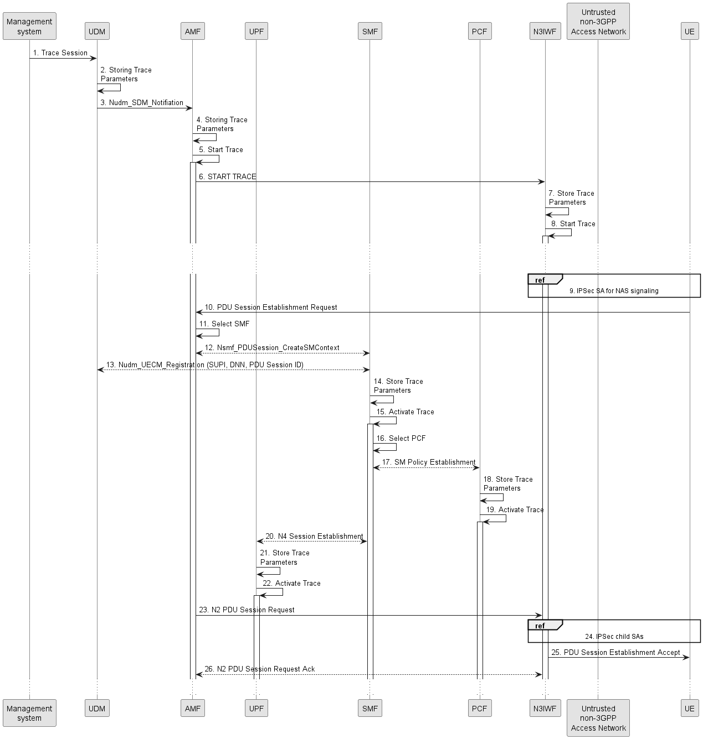
Figure 4.1.2.15.3.3: Trace activation in 5GC following the PDU Session Establishment via Untrusted non-3GPP Access procedure
The steps 6 - 9, 13 and 16 - 19 below are parts of the UE Requested PDU Session Establishment via Untrusted non-3GPP Access procedure - see 3GPP TS 23.502 [41] clause 4.12.5 for specific details. Present document does not attempt to re-define how UE Requested PDU Session Establishment via Untrusted non-3GPP Access procedure works, but rather illustrates the signaling Trace Activation aspects.
1. Management system activates Trace Session to the UDM. The following trace control and configuration parameters shall be included in the Trace Activation message:
- Trace Target: SUPI or IMEISV
- Trace Reference
- Triggering Events for AMF, SMF, UPF and PCF
- Trace Depth
- List of NE Types to trace
- List of Interfaces for AMF, SMF, UPF, PCF and N3IWF
- Trace Collection Entity IP Address for the file-based trace reporting and Trace Reporting Consumer URI for the streaming trace reporting (if streaming based report is supported).
2. UDM stores the trace control and configuration parameters received from the management system.
3. UDM sends Nudm_SDM_Notification to AMF with the trace control and configuration parameters information (see clauses 4.5.1 and 5.2.3.3 of 3GPP TS 23.502 [41]).
4. AMF stores the trace control and configuration parameters received from the UDM.
5. AMF starts the Trace Session according to the received configuration.
6. AMF sends START TRACE message or INITIAL CONTEXT SETUP REQUEST message to N3IWF containing the “Trace Activation” IE. (see clause 8.11.1 for information on TRACE START procedure, clause 8.3.1 for information on INITIAL CONTEXT SETUP REQUEST and clause 9.3.1.14 for details on Trace Activation IE of 3GPP TS 38.413 [49]).
7. N3IWF stores the trace control and configuration parameters received from AMF.
8. N3IWF starts the Trace Session according to the received configuration.
9. IPSec tunnel established for NAS signalling established between UE and N3IWF as specified in clause 4.12.2 of 3GPP TS 23.502 [41].
10. UE sends PDU Session Establishment request to AMF
11. AMF selects an appropriate SMF
12. AMF sends the Nsmf_PDUSession_CreateSMContext request to the selected SMF
13. SMF performs NuDM_UECM_Registration procedure with UDM and receives the trace control and configuration parameters from UDM
14. SMF stores the trace control and configuration parameters received from the UDM.
15. SMF starts the Trace Session according to the received configuration.
16. SMF selects an approprite PCF
17. SMF establishes Session Management Policy Association with PCF (see step 7 in clause 4.3.2.2.1 of 3GPP TS 23.502 [41]) and provides the trace control and configuration parameters information to the PCF.
18. PCF stores the trace control and configuration parameters received from the SMF as part of Policy Association.
19. PCF starts the Trace Session according to the received configuration.
20. SMF performs N4 Session Establishment with UPF (see step 10 in clause 4.3.2.2.1 of 3GPP TS 23.502 [41]) and provides the trace control and configuration parameters information to the UPF.
21. UPF stores the trace control and configuration parameters received from the SMF as part of N4 Session Establishment.
22. UPF starts the Trace Session according to the received configuration.
23. AMF sends N2 PDU Session Request to N3IWF
24. N3IWF determines the necessary number of IPsec child SAs and establishes them with UE
25. N3IWF sends PDU Session Establishment accept to UE
26. N3IWF sends N2 PDU Session Request Ack to AMF
NOTE: The specific scenarios where SMF receives trace control and configuration parameters either from UDM or from AMF are specified in 3GPP TS 23.502 [41].
*** START OF NEXT CHANGE ***

4.1.2.16 NG-RAN activation mechanisms
The Trace Session should be activated in in an NG-RAN node when the NG-RAN node receives the TRACE START, INITIAL CONTEXT SETUP REQUEST or HANDOVER REQUEST message with the IE Trace Activation from the AMF and if some activities have been started on the interfaces that have been requested to be traced.
If the subscriber or equipment which is traced makes a handover to a target NG-RAN node using the Xn interface, the source NG-RAN node should propagate the trace control and configuration parameters further to the target NG-RAN node by using the HANDOVER REQUEST message. When the target NG-RAN node receives the HANDOVER REQUEST message it should immediately start a Trace Session according to the trace control and configuration parameters received in the HANDOVER REQUEST message.
If the subscriber or equipment being traced at the old NG-RAN node has been sent to RRC_INCTIVE and then establishes RRC Connection to a new NG-RAN node, the new NG-RAN node initiates the Retrieve UE Context procedure using Xn interface. The old NG-RAN node should propagate the trace control and configuration parameters further to the new NG-RAN node by using the RETRIEVE UE CONTEXT RESPONSE message. When the new NG-RAN node receives the RETRIEVE UE CONTEXT RESPONSE message it should immediately start a Trace Session according to the trace control and configuration parameters received in the RETRIEVE UE CONTEXT RESPONSE message.
If the subscriber or equipment which is traced makes a handover to a target NG-RAN node using the NG interface, it is the AMF's responsibility to propagate the trace control and configuration parameters to the target NG-RAN node.
If the tracing shall continue also after the relocation has been performed, the 5GC Trace Start procedure shall be re-initiated from the 5GC towards the future NG-RAN node after the Relocation Resource Allocation procedure has been executed successfully.
The TRACE START, INITIAL CONTEXT SETUP REQUEST or HANDOVER REQUEST message that is received from the AMF contains the following information:
- Trace Reference and Trace Recording Session Reference.
- List of Interfaces for NG-RAN node.
- Trace Depth.
- Trace Collection Entity IP Address for the file-based trace reporting and Trace Reporting Consumer URI for the streaming trace reporting (if streaming based report is supported).
If the Trace Reference is the same as an existing Trace Session for the same subscriber or equipment, the NG-RAN node shall not activate a new Trace Session and the existing Trace Session will not be impacted. See clause 4.2.3.12 for the conditions on whether or not the Trace Recording Session should be started.
If the Trace Reference is the same as an existing Trace Session for different subscriber(s) or equipment(s), the NG-RAN node shall not activate a new Trace Session, and the NG-RAN node shall not start a new Trace Recording Session.
If the NG-RAN node is not able to activate the trace session due to ongoing handover of the UE to another NG-RAN node, the NG-RAN node shall inform the AMF with the TRACE FAILURE INDICATION message using NG interface.
*** START OF NEXT CHANGE ***

4.3.3 Trace session activation for RLF reporting in NG-RAN
RLF reporting is activated to the gNB as a special Trace Session where the Job Type indicates RLF reporting only. The detailed procedure is shown in figure 4.3.3.1 where one UE experiences an RLF event and the reestablishment is successful to the source gNB.
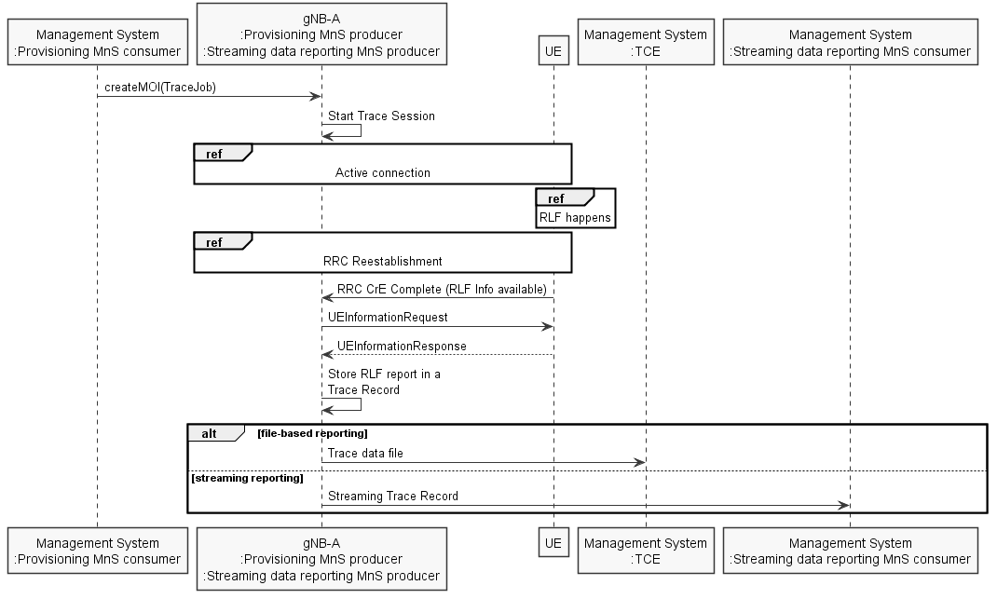
Figure 4.3.3.1 Example scenario for RLF reporting when UE reestablishment is successful at source gNB.
Upon Trace Session activation indicating RLF reporting only, the gNB shall start a Trace Session. This Trace Session shall collect only RLF reports received from the UE. The Trace Session activation information shall contain the following information:
- Trace Reference
- Job Type = RLF reporting only
- TCE IP Address for file based reporting and Trace Reporting Consumer URI for streaming reporting (if streaming based report is supported)
Figure 4.3.3.2 shows another example where the UE reestablishment is failed in the source gNB, but successful at a target gNB.
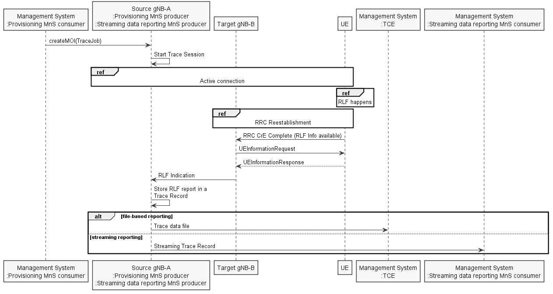
Figure 4.3.3.2 Example scenario for RLF reporting when the UE reestablishment is successful at target gNB when there is Xn Link between target gNB and source gNB
If the UE re-establishes the RRC connection successfully at the target gNB the RLF reports are fetched by the target gNB. When there is Xn link between target gNB and source gNB, the target gNB forwards the RLF report in the Xn RLF Indication message. The procedures to be used at gNB to forward the RLF reports towards the management system is the same as the reporting will be done by the source gNB in this case.
If the UE re-establishes the RRC connection successfully at the target gNB the RLF reports are fetched by the target gNB. When there is no Xn link between target gNB and source gNB, as shown in Figure 4.3.x.3, the RLF report can’t be forwared to source gNB. In this case the Trace Record containing the RLF reports shall be reported by the target gNB.
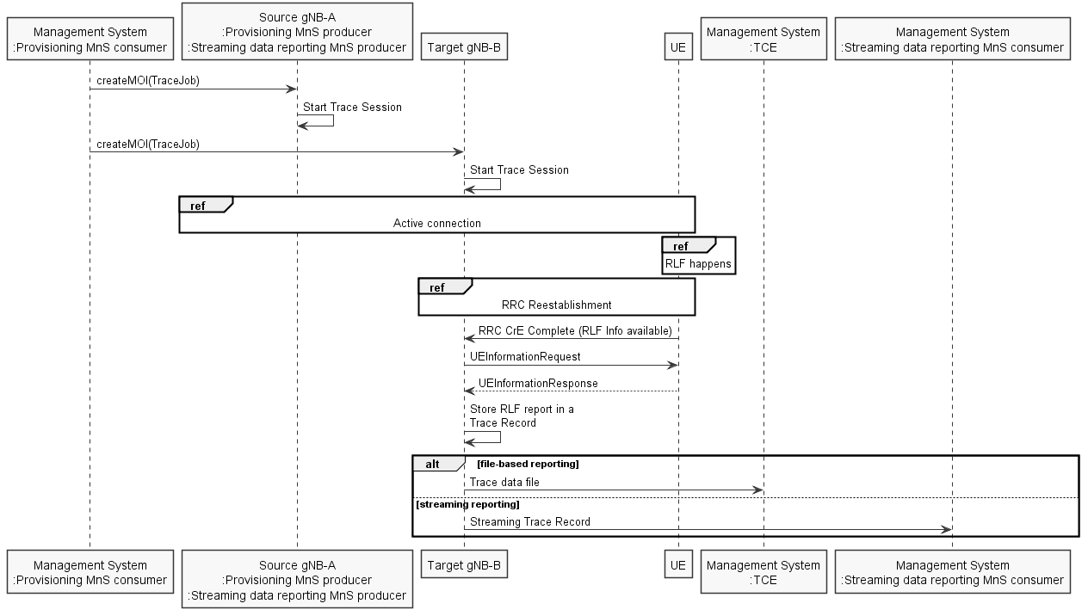
Figure 4.3.3.3 Example scenario for RLF reporting when there is no Xn Link between target gNB and source gNB
If a UE detects a Radio Link Failure event, it collects certain information as described in TS 38.300[42] and TS 38.331 [43]. Once the source gNB retrieved the RLF report from the UE or received it from the target gNB via Xn as defined in TS 38.300[42], or the target gNB retrieved the RLF report from the UE when there is no Xn link between target gNB and source gNB, gNB shall save the RLF report to the Trace Record. The Trace Record containing the RLF reports can be reported in the same mechanism as for normal subscriber and equipment trace or for MDT.
*** START OF NEXT CHANGE ***

4.8.3 Trace session activation for RCEF reporting in NG-RAN
RCEF reporting is activated to the gNB as a special Trace Session where the Job Type indicates RCEF reporting only. The detailed procedure is shown in figure 4.8.3.1 where a UE experiences an RCEF event and the RRC establishment is successful to the same gNB.
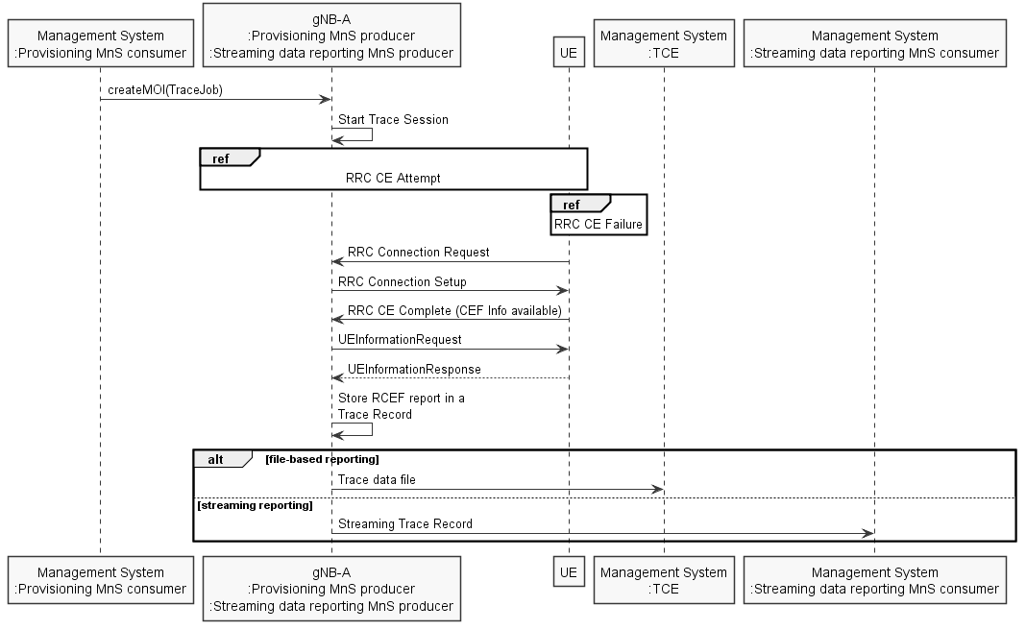
Figure 4.8.3.1 Example scenario for RCEF reporting when UE RRC establishment is successful to the same gNB.
Upon Trace Session activation indicating RCEF reporting only, the gNB shall start a Trace Session. This Trace Session shall collect only RCEF reports received from the UE. The Trace Session activation information shall contain the following information:
- Trace Reference
- Job Type = RCEF reporting only
- TCE IP Address for file based reporting and Trace Reporting Consumer URI for streaming reporting (if streaming based report is supported)
Figure 4.8.3.2 shows another example where the UE RRC Establishment is failed to one gNB, but successful to another gNB.
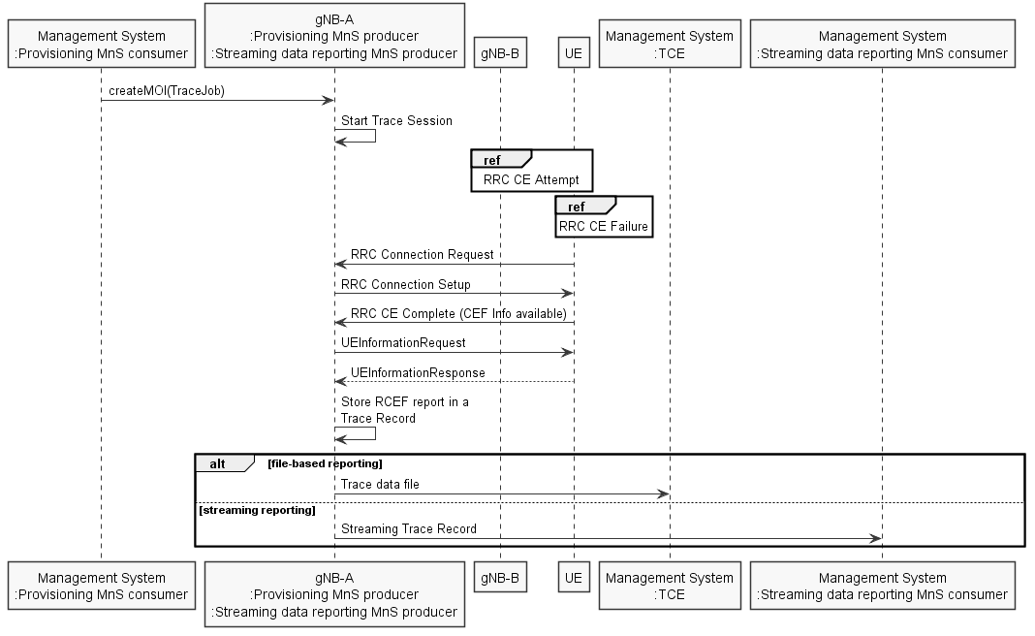
Figure 4.8.3.2 Example scenario for RCEF reporting when the UE RRC establishment is successful to a different gNB
If the UE establishes the RRC connection successfully the RCEF reports are fetched by the gNB. The procedures to be used at gNB to forward the RCEF reports towards the management system are the same regardless of whether RCEF occurred at this gNB or a different gNB.
If a UE detects a RRC Connection Establishment Failure event, it collects certain information as described in 3GPP TS 37.320 clause 5.1.6 [30]. Once the gNB retrieved the RCEF report from the UE, as defined in 3GPP TS 37.320 [30], it shall save it to the Trace Record. The Trace Record containing the RCEF reports can be transferred to the TCE for file-based trace reporting or to the Streaming data reporting MnS consumer for streaming reporting in the same mechanism as for normal subscriber and equipment trace or for MDT.
*** START OF NEXT CHANGE ***

5.9 Trace Collection Entity (TCE) IP Address (M,O)
For file-based reporting, this is a parameter which defines the IP address to which the Trace records shall be transferred. Either an IPv4 or an IPv6 address shall be signalled.
This parameter is mandatory in EPS or 5GS.
This parameter is optional in UMTS.

*** START OF NEXT CHANGE ***

5.9c Trace Reporting Consumer URI (CM)
For streaming reporting, this is a parameter which defines the URI of the Trace Reporting MnS consumer to which the Trace records shall be streamed.
The detailed URI structure is defined in clause 4.4 TS 32.158 [53].
This parameter is mandatory when streaming trace and/or MDT is supported.
This parameter shall have priority if both TCE IP address parameter and Trace Reporting Consumer URI parameter are present.

*** END OF CHANGE ***

