3GPP TSG-SA5 Meeting #155 S5-243397

Jeju, Korea (Republic Of), 27th May 2024 - 31st May 2024
CR-Form-v12.3
CHANGE REQUEST
 | 28.541 | CR | 1268 | rev | 1 | Current version: | 17.14.0
For HELP on using this form: comprehensive instructions can be found at
http://www.3gpp.org/Change-Requests.

Proposed change affects: | UICC apps |  | ME |  | Radio Access Network | X | Core Network

Title: | Rel-17 CR 28.541 Add missing NRNetwork and EUTraNetwork definitions
Source to WG: | Ericsson LM, Huawei
Source to TSG: | S5
Work item code: | TEI17 |  |  |  |  |  | Date: |  |  | 2024-05-17
Category: | F |  |  |  |  |  | Release: |  |  | Rel-17
 | Use one of the following categories:  F (correction)  A (mirror corresponding to a change in an earlier release)  B (addition of feature),  C (functional modification of feature)  D (editorial modification)  Detailed explanations of the above categories can  be found in 3GPP TR 21.900. |  |  |  |  |  |  |  | Use one of the following releases:  Rel-8 (Release 8)  Rel-9 (Release 9)  Rel-10 (Release 10)  Rel-11 (Release 11)  …  Rel-17 (Release 17)  Rel-18 (Release 18)  Rel-19 (Release 19)  Rel-20 (Release 20)
Reason for change: |  | NRNetwork and EUtraNetwork are referenced in a note and shown in Figure 4.2.1.1-5. These IOCs are not however defined in the NRM.
Summary of change: |  | Add definitions for the missing IOCs.
Consequences if not approved: |  | The IOCs are undefined which could lead to implementation errors and inconsistencies affecting interoperability
Clauses affected: |  | 4.2.1.1, 4.2.1.2, 4.3.x (new), 4.3.x (new)
 |  | Y | N
Other specs |  |  | X | Other core specifications |  |  |  | TS/TR ... CR ...
affected: |  |  | X | Test specifications |  |  |  | TS/TR ... CR ...
(show related CRs) |  |  | X | O&M Specifications |  |  |  | TS/TR ... CR ...
Other comments:
This CR's revision history:

1st Change

4.2 Class diagram

4.2.1 Class diagram for gNB and en-gNB

4.2.1.1 Relationships

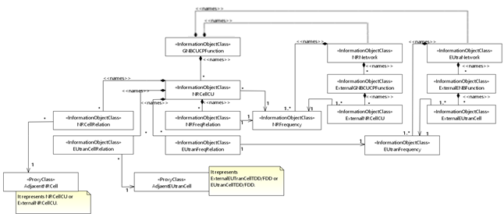
Figure 4.2.1.1-5: Cell Relation view for all deployment scenarios
NOTE 2: The above NRM fragment uses NRNetwork to hold NR external entities and frequency and using EUtraNetwork to hold LTE external entities and frequency.

2nd Change

4.2.1.2 Inheritance
This clause depicts the inheritance relationships.
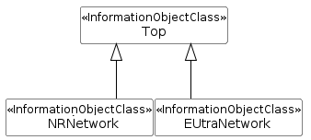
Figure 4.2.1.2-3: NRM fragment for NRNetwork and EUtraNetwork

3rd Change

4.3 Class definitions

4.3.x NRNetwork

4.3.x.1 Definition
This IOC represents a set of external NR entities. It contains only NR external entities and frequencies. This is used to differentiate these entities and frequencies from those in LTE.

4.3.x.2 Attributes
The NRNetwork IOC includes the attributes inherited from Top IOC (defined in TS 28.622 [30]). It contains no additional attributes.

4.3.x.3 Attribute constraints
None.

4.3.x.4 Notifications
The common notifications defined in clause 4.5 are valid for this IOC, without exceptions or additions.

4th Change

4.3.x EUtraNetwork

4.3.x.1 Definition
This IOC represents a set of external EUTran entities. It contains only LTE external entities and frequencies. This is used to differentiate these entities and frequencies from those in NR.

4.3.x.2 Attributes
The EUtraNetwork includes the attributes inherited from Top IOC (defined in TS 28.622 [30]). It contains no additional attributes.

4.3.x.3 Attribute constraints
None.

4.3.x.4 Notifications
The common notifications defined in clause 4.5 are valid for this IOC, without exceptions or additions.

