**3GPP TSG-SA5 Meeting #155 *S5-243374***

**Jeju, South Korea, 27 - 31 May 2024**

|  |  |  |  |  |  |  |  |  |
| --- | --- | --- | --- | --- | --- | --- | --- | --- |
| *CR-Form-v12.1* | | | | | | | | |
| **CHANGE REQUEST** | | | | | | | | |
|  | | | | | | | | |
|  | **538** | **CR** | **0079** | **rev** | **1** | **Current version:** |  |  |
|  | | | | | | | | |
| *For* [***HE******LP***](http://www.3gpp.org/3G_Specs/CRs.htm#_blank)*on using this form: comprehensive instructions can be found at* [*http://www.3gpp.org/Change-Requests*](http://www.3gpp.org/Change-Requests)*.* | | | | | | | | |
|  | | | | | | | | |

|  |  |  |  |  |  |  |  |  |
| --- | --- | --- | --- | --- | --- | --- | --- | --- |
| ***Proposed change affects:*** | UICC apps |  | ME |  | Radio Access Network | **x** | Core Network | **X** |

|  |  |  |  |  |  |  |  |  |  |  |
| --- | --- | --- | --- | --- | --- | --- | --- | --- | --- | --- |
|  | | | | | | | | | | |
| ***Title:*** | Rel-19 CR 28.538 UML diagram and other minor corrections | | | | | | | | | |
|  |  | | | | | | | | | |
| ***Source to WG:*** | Ericsson LM | | | | | | | | | |
| ***Source to TSG:*** | S5 | | | | | | | | | |
|  |  | | | | | | | | | |
| ***Work item code:*** | TEI19 | | | | |  | ***Date:*** | | | 2024-05-30 |
|  |  | | | |  | |  | | |  |
| ***Category:*** | F |  | | | | | ***Release:*** | | | Rel-19 |
|  | *Use one of the following categories:* ***F*** *(correction)* ***A*** *(mirror corresponding to a change in an earlier release)* ***B*** *(addition of feature),* ***C*** *(functional modification of feature)* ***D*** *(editorial modification)*  Detailed explanations of the above categories can be found in 3GPP [TR 21.900](http://www.3gpp.org/ftp/Specs/html-info/21900.htm). | | | | | | | | *Use one of the following releases: Rel-8 (Release 8) Rel-9 (Release 9) Rel-10 (Release 10) Rel-11 (Release 11) … Rel-15 (Release 15) Rel-16 (Release 16) Rel-17 (Release 17) Rel-18 (Release 18)* | |
|  |  | | | | | | | | | |
| ***Reason for change:*** | | 1. Some UML diagrams have misspelled “ObjetClass” 2. CR implementation error, missing Line feed before clause 6.2.2 3. Capitalization of <<Names>> in all diagrams, should be <<names>> 4. No need to refer to “TS 28.541” in the imported IOC boxes like EP_N3 as they are imported in 6.1.1 5. In Figure 6.2.1-6, the stereotypes for the IOCs are wrongly named as <<Instance Object Class>> 6. Typos in clauses 6.3.1, 6.3.2, 6.3.21 7. Headings of clause 6.3 and 6.4 do not follow the template in TS 32.160 8. There is no PlantUML code for the diagrams 9. There are no cardinality indications at the container class end of all containment diagrams. Required according to TS 32.156. | | | | | | | | |
|  | |  | | | | | | | | |
| ***Summary of change:*** | | 1. Misspelled “ObjetClass” corrected in fig. 6.2.1-3, 6.2.1-4, 6.2.1-5. 2. Adding Line feed before clause 6.2.2 3. Corrected Capitalization of <<Names>> to <<names>> 4. Removed ref. to “TS 28.541” in the imported IOC boxes 5. In Figure 6.2.1-6, corrected the stereotype for the IOCs to <<InformationObjectClass>> 6. Corrected typos in clauses 6.3.1, 6.3.2, 6.3.21 7. Corrected Headings of clause 6.3 and 6.4 8. PlantUML code for all diagrams added in new Annex 9. Add multiplicity cardinality at the container class end of all containment diagrams. | | | | | | | | |
|  | |  | | | | | | | | |
| ***Consequences if not approved:*** | | Misspelled class names in UML diagrams. No PlantUML code for diagram updates by any delegate. | | | | | | | | |
|  | |  | | | | | | | | |
| ***Clauses affected:*** | | 6.2.1, 6.2.2, 6.3, 6.3.1.1, 6.3.2.1, 6.3.13.1, 6.3.15.1, 6.3.21.1, 6.4, Annex X (new) | | | | | | | | |
|  | |  | | | | | | | | |
|  | | **Y** | **N** |  | | | |  | | |
| ***Other specs*** | |  | **x** | Other core specifications | | | | TS/TR ... CR ... | | |
| ***affected:*** | |  | **x** | Test specifications | | | | TS/TR ... CR ... | | |
| ***(show related CRs)*** | |  | **x** | O&M Specifications | | | | TS/TR ... CR ... | | |
|  | |  | | | | | | | | |
| ***Other comments:*** | |  | | | | | | | | |
|  | |  | | | | | | | | |
| ***This CR's revision history:*** | |  | | | | | | | | |

|  |
| --- |
| **1st Change** |

## 6.2 Class diagram

### 6.2.1 Relationships

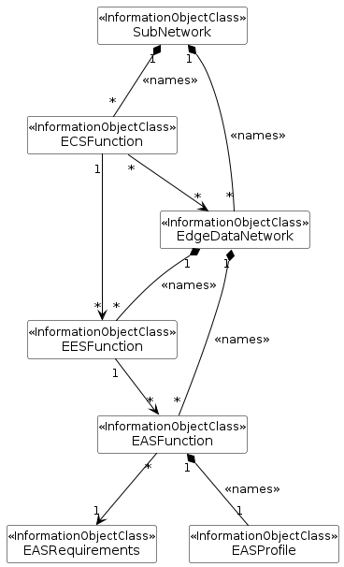

Figure 6.2.1-1: Edge NRM relationship diagram

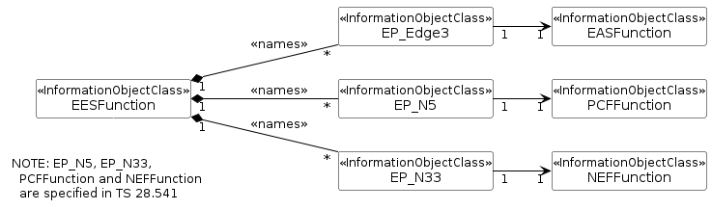

Figure 6.2.1-3: Transport view of EES NRM

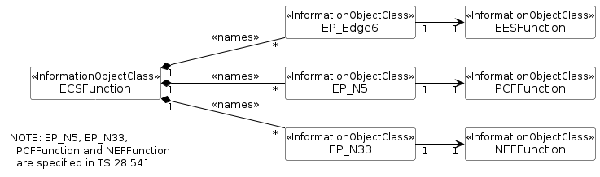

Figure 6.2.1-4: Transport view of ECS NRM

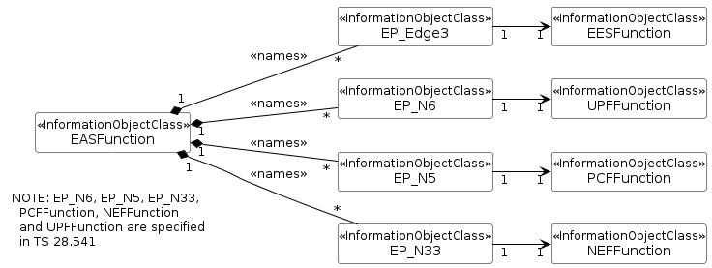

Figure 6.2.1-5: Transport view of EAS NRM

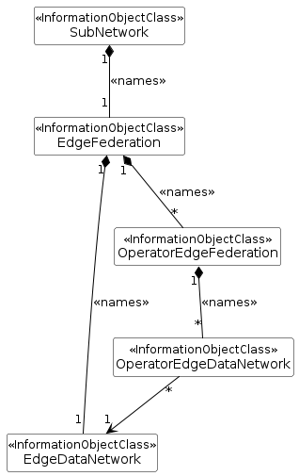

Figure 6.2.1-6: Edge Federation NRM

### 6.2.2 Inheritance

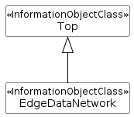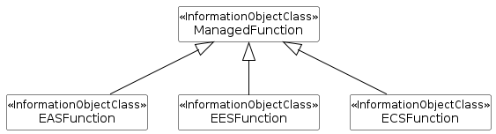

Figure 6.2.2-1: Edge Inheritance Relationship

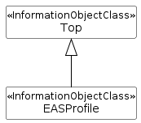

Figure 6.2.2-2: EASProfile Inheritance

|  |
| --- |
| **Next Change** |

## 6.3 Class definitions

### 6.3.1 EASFunction

#### 6.3.1.1 Definition

This IOC represents the properties of a EAS in a 3GPP network. For more information about EAS, see 3GPP TS 23.558 [2] and 3GPP TS 23.548 [16].

|  |
| --- |
| **Next Change** |

### 6.3.2 EASRequirements

#### 6.3.2.1 Definition

This IOC represents the requirements needed to deploy EAS(s) and the information of EAS(s) deployment process.

|  |
| --- |
| **Next Change** |

### 6.3.13 EESFunction

#### 6.3.13.1 Definition

This IOC represents the properties of a EES in a 3GPP network. For more information about EES, see 3GPP TS 23.558.

|  |
| --- |
| **Next Change** |

### 6.3.15 EASProfile

#### 6.3.15.1 Definition

This IOC represents an EASProfile, see TS 23.558[2]. This IOC will be instantiated with the instantiation of every EASFunction IOC.

|  |
| --- |
| **Next Change** |

### 6.3.21 EdgeFederation

#### 6.3.21.1 Definition

This IOC represents the set of federation relationships maintained by the PO and/or LO. This IOC when instantiated represents a set of available federations.

|  |
| --- |
| **Next Change** |

## 6.4 Attribute definitions

|  |
| --- |
| **Next Change** |

Annex X (informative):  
PlantUML source code

# X.1 ECM NRM UML diagrams

## X.1.1 Figure 6.2.1-1: Edge NRM relationship diagram

@startuml

skinparam backgroundColor white

skinparam classBackgroundColor white

skinparam classBorderColor black

skinparam Shadowing false

skinparam noteBackgroundColor white

skinparam noteBorderColor white

skinparam arrowColor black

skinparam ClassStereotypeFontStyle normal

hide circle

hide members

class SubNetwork  <<InformationObjectClass>>

class ECSFunction <<InformationObjectClass>>

class EdgeDataNetwork <<InformationObjectClass>>

class EASRequirements <<InformationObjectClass>>

class EASFunction <<InformationObjectClass>>

class EESFunction <<InformationObjectClass>>

class EASProfile <<InformationObjectClass>>

SubNetwork “1” *-- "*" EdgeDataNetwork: <<names>>

SubNetwork “1” *-- "*" ECSFunction: <<names>>

EdgeDataNetwork “1” *-- "*" EESFunction: <<names>>

EdgeDataNetwork “1” *-- "*" EASFunction: <<names>>

EASFunction “1” *-- "1" EASProfile: <<names>>

ECSFunction "*" --> "*" EdgeDataNetwork

ECSFunction "1" --> "*" EESFunction

EESFunction "1" --> "*" EASFunction

EASFunction "*" --> "1" EASRequirements

@enduml

## X.1.2 Figure 6.2.1-3: Transport view of EES NRM

@startuml

skinparam backgroundColor white

skinparam classBackgroundColor white

skinparam classBorderColor black

skinparam Shadowing false

skinparam noteBackgroundColor white

skinparam noteBorderColor white

skinparam arrowColor black

skinparam ClassStereotypeFontStyle normal

hide circle

hide members

left to right direction

class EESFunction <<InformationObjectClass>>

class EP_Edge3 <<InformationObjectClass>>

class EP_N5 <<InformationObjectClass>>

class EP_N33 <<InformationObjectClass>>

class EASFunction <<InformationObjectClass>>

class PCFFunction <<InformationObjectClass>>

class NEFFunction <<InformationObjectClass>>

EESFunction “1” *-- "*" EP_Edge3: <<names>>

EESFunction “1” *-- "*" EP_N5: <<names>>

EESFunction “1” *-- "*" EP_N33: <<names>>

EP_Edge3 "1" --> "1" EASFunction

EP_N5 "1" --> "1" PCFFunction

EP_N33 "1" --> "1" NEFFunction

note bottom of EESFunction

  NOTE: EP_N5, EP_N33,

    PCFFunction and NEFFunction

    are specified in TS 28.541

  end note

@enduml

## X.1.3 Figure 6.2.1-4: Transport view of ECS NRM

@startuml

skinparam backgroundColor white

skinparam classBackgroundColor white

skinparam classBorderColor black

skinparam Shadowing false

skinparam noteBackgroundColor white

skinparam noteBorderColor white

skinparam arrowColor black

skinparam ClassStereotypeFontStyle normal

hide circle

hide members

left to right direction

class ECSFunction <<InformationObjectClass>>

class EP_Edge6 <<InformationObjectClass>>

class EP_N5 <<InformationObjectClass>>

class EP_N33 <<InformationObjectClass>>

class EESFunction <<InformationObjectClass>>

class PCFFunction <<InformationObjectClass>>

class NEFFunction <<InformationObjectClass>>

ECSFunction “1” *-- "*" EP_Edge6: <<names>>

ECSFunction “1” *-- "*" EP_N5: <<names>>

ECSFunction “1” *-- "*" EP_N33: <<names>>

EP_Edge6 "1" --> "1" EESFunction

EP_N5 "1" --> "1" PCFFunction

EP_N33 "1" --> "1" NEFFunction

note bottom of ECSFunction

  NOTE: EP_N5, EP_N33,

    PCFFunction and NEFFunction

    are specified in TS 28.541

  end note

@enduml

## X.1.4 Figure 6.2.1-5: Transport view of EAS NRM

@startuml

skinparam backgroundColor white

skinparam classBackgroundColor white

skinparam classBorderColor black

skinparam Shadowing false

skinparam noteBackgroundColor white

skinparam noteBorderColor white

skinparam arrowColor black

skinparam ClassStereotypeFontStyle normal

hide circle

hide members

left to right direction

class EASFunction <<InformationObjectClass>>

class EP_Edge3 <<InformationObjectClass>>

class EP_N6 <<InformationObjectClass>>

class EP_N5 <<InformationObjectClass>>

class EP_N33 <<InformationObjectClass>>

class EESFunction <<InformationObjectClass>>

class UPFFunction <<InformationObjectClass>>

class PCFFunction <<InformationObjectClass>>

class NEFFunction <<InformationObjectClass>>

EASFunction “1” *-- "*" EP_Edge3: <<names>>

EASFunction “1” *-- "*" EP_N6: <<names>>

EASFunction “1” *-- "*" EP_N5: <<names>>

EASFunction “1” *-- "*" EP_N33: <<names>>

EP_Edge3 "1" --> "1" EESFunction

EP_N6 "1" --> "1" UPFFunction

EP_N5 "1" --> "1" PCFFunction

EP_N33 "1" --> "1" NEFFunction

note bottom of EASFunction

  NOTE: EP_N6, EP_N5, EP_N33,

    PCFFunction, NEFFunction

    and UPFFunction are specified

    in TS 28.541

  end note

@enduml

## X.1.5 Figure 6.2.1-6: Edge Federation NRM

@startuml

skinparam backgroundColor white

skinparam classBackgroundColor white

skinparam classBorderColor black

skinparam Shadowing false

skinparam noteBackgroundColor white

skinparam noteBorderColor white

skinparam arrowColor black

skinparam ClassStereotypeFontStyle normal

hide circle

hide members

class SubNetwork  <<InformationObjectClass>>

class EdgeFederation <<InformationObjectClass>>

class EdgeDataNetwork <<InformationObjectClass>>

class OperatorEdgeFederation <<InformationObjectClass>>

class OperatorEdgeDataNetwork <<InformationObjectClass>>

SubNetwork “1” *-- "1" EdgeFederation: <<names>>

EdgeFederation “1” *-- "1" EdgeDataNetwork: <<names>>

EdgeFederation “1” *-- "*" OperatorEdgeFederation: <<names>>

OperatorEdgeFederation “1” *-- "*" OperatorEdgeDataNetwork: <<names>>

OperatorEdgeDataNetwork "*" --> "1" EdgeDataNetwork

@enduml

## X.1.6 Figure 6.2.2-1: Edge Inheritance Relationship

@startuml

skinparam backgroundColor white

skinparam classBackgroundColor white

skinparam classBorderColor black

skinparam Shadowing false

skinparam noteBackgroundColor white

skinparam noteBorderColor white

skinparam arrowColor black

skinparam ClassStereotypeFontStyle normal

hide circle

hide members

class Top  <<InformationObjectClass>>

class EdgeDataNetwork <<InformationObjectClass>>

Top <|-- EdgeDataNetwork

@enduml

@startuml

skinparam backgroundColor white

skinparam classBackgroundColor white

skinparam classBorderColor black

skinparam Shadowing false

skinparam noteBackgroundColor white

skinparam noteBorderColor white

skinparam arrowColor black

skinparam ClassStereotypeFontStyle normal

hide circle

hide members

class ManagedFunction  <<InformationObjectClass>>

class EASFunction <<InformationObjectClass>>

class EESFunction <<InformationObjectClass>>

class ECSFunction <<InformationObjectClass>>

ManagedFunction <|-- EASFunction

ManagedFunction <|-- EESFunction

ManagedFunction <|-- ECSFunction

@enduml

## X.1.7 Figure 6.2.2-2: EASProfile Inheritance

@startuml

skinparam backgroundColor white

skinparam classBackgroundColor white

skinparam classBorderColor black

skinparam Shadowing false

skinparam noteBackgroundColor white

skinparam noteBorderColor white

skinparam arrowColor black

skinparam ClassStereotypeFontStyle normal

hide circle

hide members

class Top  <<InformationObjectClass>>

class EASProfile <<InformationObjectClass>>

Top <|-- EASProfile

@enduml

|  |
| --- |
| **End of changes** |