3GPP TSG-SA5 Meeting #155 S5-242969

Jeju, Korea (Republic Of), 27th May 2024 - 31st May 2024
CR-Form-v12.3
CHANGE REQUEST
 | 28.318 | CR | 0009 | rev | - | Current version: | 18.0.0
For HELP on using this form: comprehensive instructions can be found at
http://www.3gpp.org/Change-Requests.

Proposed change affects: | UICC apps |  | ME |  | Radio Access Network | X | Core Network

Title: | Rel-18 CR TS 28.318 Editorial modifications and essential corrections
Source to WG: | Harman GmbH
Source to TSG: | S5
Work item code: | TEI18 |  |  |  |  |  | Date: |  |  | 2024-05-17
Category: | F |  |  |  |  |  | Release: |  |  | Rel-18
 | Use one of the following categories:  F (correction)  A (mirror corresponding to a change in an earlier release)  B (addition of feature),  C (functional modification of feature)  D (editorial modification)  Detailed explanations of the above categories can  be found in 3GPP TR 21.900. |  |  |  |  |  |  |  | Use one of the following releases:  Rel-8 (Release 8)  Rel-9 (Release 9)  Rel-10 (Release 10)  Rel-11 (Release 11)  …  Rel-17 (Release 17)  Rel-18 (Release 18)  Rel-19 (Release 19)  Rel-20 (Release 20)
Reason for change: |  | As per last comments from edithelp,it was required to do some editorial modifications & essential corrections in some sections of the TS 28.318
Summary of change: |  | Editorial changes & corrections done as per Edithelp comments for clauses 2, 4, 5, 6, Annexure A, Annexure C, Annexure D, Annexure E to fix incorrect editorial text and issues like wrong references
Consequences if not approved: |  | There will be incorrect editorial text and issues like wrong references in TS 28.318.
Clauses affected: |  | 2, 4.1, 5.2.1,5.3.1, 6.3.2.4, A.1.1, A.2.2, C.3, D.2, D.4, E
 |  | Y | N
Other specs |  |  | X | Other core specifications |  |  |  | TS/TR ... CR ...
affected: |  |  | X | Test specifications |  |  |  | TS/TR ... CR ...
(show related CRs) |  |  | X | O&M Specifications |  |  |  | TS/TR ... CR ...
Other comments:
This CR's revision history:

First change

2 References
The following documents contain provisions which, through reference in this text, constitute provisions of the present document.
- References are either specific (identified by date of publication, edition number, version number, etc.) or non-specific.
- For a specific reference, subsequent revisions do not apply.
- For a non-specific reference, the latest version applies. In the case of a reference to a 3GPP document (including a GSM document), a non-specific reference implicitly refers to the latest version of that document in the same Release as the present document.
[1] 3GPP TR 21.905: "Vocabulary for 3GPP Specifications".
[2] DIRECTIVE (EU) 2019/ 944 OF THE EUROPEAN PARLIAMENT AND OF THE COUNCIL - of 5 June 2019 - on common rules for the internal market for electricity and amending Directive 2012/ 27/ EU (europa.eu)
https://eur-lex.europa.eu/legal-content/EN/TXT/PDF/?uri=CELEX:32019L0944&from=EN
[3] IEC TC 57 https://www.iec.ch/ords/f?p=103:7:511571509228708::::FSP_ORG_ID,FSP_LANG_ID:1273,25

[4] 3GPP TS 32.130: "Telecommunication management; Network sharing; Concepts and requirements"
[5] (Void)
[6] (Void)
[7] Sendin, A., Stafford, J., Grilli, A., "Utilities and Telecommunications in a Nutshell", EUTC, Ediciones Experiencia, 2022.
[8] 3GPP TS 22.104, "Service requirements for cyber-physical control applications in vertical domains; Stage 1".
[9] 3GPP TS 22.261, "Service requirements for the 5G system; Stage 1"
[10] IEC TR 61000-3-6 Electromagnetic compatibility (EMC) - Part 3-6: Limits - Assessment of emission limits for the connection of distorting installations to MV, HV and EHV power systems.
[11] IETF RFC 1628, "UPS Management Information Base", May 1994.
[12] ETSI ES 202 336-3: "Environmental Engineering (EE); Monitoring and Control Interface for Infrastructure Equipment (Power, Cooling and Building Environment Systems used in Telecommunication Networks); Part 3: AC UPS power system control and monitoring information model".
[13] (Void)
[14] 3GPP TS 28.552: "Management and orchestration; 5G performance measurements".
[15] 3GPP TS 28.554: "Management and orchestration; 5G end to end Key Performance Indicators (KPI)".
[16] (Void)
[17] 3GPP TS 38.473: "NG-RAN; F1 Application Protocol (F1AP)".
[18] 3GPP TS 23.003: "Numbering, addressing and identification".
[19] 3GPP TS 32.300: "Telecommunication management; Configuration Management (CM); Name convention for Managed Objects".
[20] 3GPP TS 28.622: "Telecommunication management; Generic Network Resource Model (NRM) Integration Reference Point (IRP); Information Service (IS)".
[21] 3GPP TS 28.541: " Management and orchestration; 5G Network Resource Model (NRM); Stage 2 and stage 3".
[22] ETSI ES 202 336-11: "Environmental Engineering (EE); Monitoring and control interface for infrastructure equipment (Power, Cooling and environment systems used in telecommunication networks); Part 11: Battery system with integrated control and monitoring information model".
[23] 3GPP TS 28.532: "Management and orchestration; Generic management services".

Second change

4 Overview

4.1 General
The present document specifies exposed management services that enable improved operation of energy utility networks used for energy distribution. Energy service can be logically considered as four components: generation, transmission, distribution and consumption points. In a typical energy system, there are few centralized generation facilities (e.g. nuclear, thermal and hydro plants), where nature's energy is converted into electricity. Then, there are a limited number of high power transmission lines covering great distance with the minimum of energy loss. Then, a great many sites are part of medium and low voltage distribution networks. The distribution system transforms and delivers energy to customers. Finally, there is an extremely large number of consumption points (i.e. every household, business, public infrastructure site such as traffic lights at an intersection.) This simple model of the energy service delivery system is depicted in Figure 4.1-1.
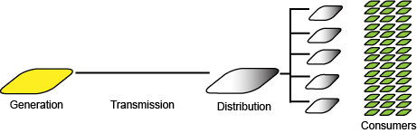
Figure 4.1-1: Energy service delivery system
Diverse standardized "smart grid" services are used to manage the energy system effectively - with high availability, safety and efficiency. IEC, IEEE and other organizations standardize these services. To support these services, diverse communication systems are employed, including optical fiber, mobile telecommunications, power line communications and others. The services are generally defined at the application layer, meaning that they can operate over any access. The choice of which access to employ is made by energy service operators, and is determined by many factors outside of the scope of the present document. In many deployments, the choice is to employ mobile telecommunications to support smart grid services. [7]
Since there are few energy generators and the requirements of transmission facilities are not changing that much over time, the focus for smart energy services and the communication systems that they rely on are mainly on distribution services. The distribution grid is the part of the energy system that is on the outer part of the system, the one closer to end-customers and, thus, the most extensive one. It is here that the energy system is changing fastest, as distributed energy generation, distributed energy storage and other trends disrupt the simpler top-down hierarchy of generation, transmission, distribution, consumption. Though there are smart grid services associated with consumption and distributed generation, these use cases and requirements have not been further developed as part of the present document.
Supporting the communication requirements of the distribution system is the focus of the present document. These networks, operated by Distribution System Operators (DSOs), aim at extremely high availability. The services employed in the distribution system include SCADA and DA [3], which can detect and correct abnormalities, reconfigure and restart services rapidly. If remote operations and monitoring is not available, when the electrical grid operations need it, it can result in service outages of much longer duration, sometimes requiring manual intervention by a service technician sent to the affected site.
An important form of 'fate sharing' exists between mobile telecommunications networks and the energy system. If energy service interruptions persist, the mobile telecommunications network will also become unavailable once the sites' independent energy storage and generation capacity are exhausted. If the mobile telecommunications service is interrupted, smart grid services will also be interrupted in a significant number of sites, leading to increasing risk of energy service outages over time. These scenarios are considered further in the present document.
Telecom management service exposure requirements, procedures and solution set details are specified to improve communication service availability to DSOs.

4.2 Background
The topics described in clause 4.1 have been considered in stage 1 standardization in 3GPP. Relevant requirements are specified in TS 22.104 [8] and TS 22.261 [9]. These stage 1 service requirements were considered to motivate and scope an investigation of stage 1 telecom management requirements.

Third change

5 Requirements

5.1 General
Subclauses of clause 5 of the present document include use case descriptions and the stage 1 requirements.

5.2 Exposing performance and prediction information for high availability

5.2.1 Description
To monitor and control its distribution grid (see clause 4), the DSO uses thousands of 3GPP compatible UEs (User Equipment, [7]). These UEs are spread across a wide geographical area, just like the distribution grid the UEs support. The DSO uses the UEs to provide connectivity to the monitor and control infrastructure of the distribution grid. This infrastructure and its operation are outside the scope of the present document. This infrastructure has very high availability service requirements. To fulfil these requirements, highly available communication is required. To achieve this highly available communication, the DSO monitors performance of communications services they use. If and when the DSO deems it necessary, the DSO proactively activates additional communication services.
It is currently possible for a DSO to gather the following information autonomously, with no support of the standard defined in the present document.
The DSO knows the location (lat/long) of each of its UEs.
Because of a UE’s connectivity to the 3GPP network, details of the 3GPP connection (available in the UE radio module) are available to each UE.
The DSO knows the received signal strength at each UE.
The DSO knows the cellID of each UE.
The DSO knows the radio access technology providing the connection to each UE.
In addition to using the UEs to provide internet connectivity to the monitor and control infrastructure, the DSO regularly sends "over the top” signals (e.g. ICMP ping messages) between the UEs, and collects performance information on this traffic. Example of this information include availability and latency in the entire data path connecting the UE with the DSO application server. This path may comprise other networks in addition to 3GPP networks, e.g. WAN networks.
The DSO is able to configure the frequency and granularity of the over-the-top data collection. Based on analysis of the collected over the top data, past and present, the DSO can determine, based on the current performance of the E2E connection, if a change to a backup communication system is merited.
Similar data is maintained by standards compliant 3GPP management systems. The DSO benefits from a means to supplement or replace the collected over-the-top data with information from the MNO 3GPP management system, as the data that is collected is more precise and specific to the 3GPP system instead of end-to-end. Using this data also benefits the DSO as they can more easily identify the root cause of problems, when they arise.
The use case is
- The DSO contacts the MNO 3GPP Management system.
- The DSO requests collection of performance measurements on specific cells or cells in a specific area, as described in Annex A.
- The DSO registers to receive reports of the performance measurements.
- The DSO can update or delete the configuration of the measurements or reports.
- Reports are generated according to the request.

5.2.2 Requirements
Requirement label | Description | Related use cases
REQ-5.2-1 | The 3GPP management system shall, subject to mobile network operator policy, regulatory requirements and contractual obligations, allow the DSO to request collection and reporting of the following PM data:  - Average delay DL air-interface  - Average delay UL on over-the-air interface  - Average DL UE throughput in gNB  - Average UL UE throughput in gNB  - Packet Uu Loss Rate in the DL per DRB per UE  - UL PDCP SDU Loss Rate  - Cell/network availability | Exposing performance and prediction information for high availability
REQ-5.2.2 | The 3GPP management system shall, subject to mobile network operator policy, regulatory requirements and contractual obligations, allow the DSO to specify the collection of performance information concerning specific cells or specific geographical area. | Exposing performance and prediction information for high availability

5.3 Exposed coordinated recovery requirements

5.3.1 Description
Energy system recovery of the distribution system is needed following both planned and unplanned interruptions of energy service. Annex C provides background information on the two supported use cases, corresponding the requirements listed in clause 5.3.2.
In summary, the following functionality is supported for both use cases described in Annex C.2 and C.3.
- The MNO can provide information regarding critical sites to the DSO, including their Energy Supply ID, UPS capacity of the site, base station ID if applicable. This information does not change often, but can be updated over time.
- The DSO can inform the MNO of the start and stop of energy outages, including the list of affected sites or locations.
- The DSO can request information from the MNO including the UPS capacity of the site, which may change over time.
The DSO can then perform remotely controlled operations to restore energy distribution service taking into account the UPS capacity of sites that are essential to telecommunication service and feasibility of MNO's intervention at a site. Specifically, DSOs will strive to restore energy distribution support to substations that rely on telecommunications for remote operations, while communication is still possible. This process is termed Rapid Recovery and is described in annex C.2. The process of recovery in these scenarios is termed Rapid Intervention.
The following functionality is supported for energy system recovery in scenarios in which there is no redundant energy distribution topology, as described in Annex C.3.
- The DSO can provide the MNO with the expected restoration time of energy distribution services affecting a specific set of MNO site, if the energy distribution service recovery were to proceed without the possibility of remote operations.
NOTE 1: This is the restoration time in cases that the DSO assumes that no telecommunication is possible to restore energy service. This is the 'normal situation' after roughly 15 minutes of energy outage throughout most of the world.
- The DSO can provide the MNO with the distribution lines restoration time i.e. expected beginning time of MNO’s Rapid Intervention to end an energy outage affecting a specific set of sites or locations.
NOTE 2: This is the time where electrical distribution service can be restored, e.g. after repairing a damaged distribution line.
- The DSO can provide the MNO with the expected duration of Rapid Intervention.
- The DSO can provide the MNO with the prioritised location or sites where the distribution energy services are more critical to be restored quickly.
NOTE 3: The DSO is aware of which base stations serve the UEs in their distribution substations, as each UE captures identifiers including the eNB-LCID. If the MNO is aware of both the timing of Rapid Intervention requirements (REQ-5.3-5 and REQ-5.3-6 below) and the priority locations, there is the possibility the MNO can arrange to support telecommunication services where and when they are essential.
- The MNO can provide the DSO with information regarding which MNO sites can provide Rapid Intervention service to the DSO at what time and for how long, so the DSO can restore energy service at an arranged time, in an arranged region, for the arranged duration.

5.3.2 Requirements
The following requirements apply to use cases with coordinated recovery with redundant topology (see Annex C.2).
Requirement label | Description | Related use cases
REQ-5.3-1 | The 3GPP management system should support, subject to operator policy, regulatory requirements and contractual obligations, for the DSO to obtain the following information from the MNO.  For each 'site' for which energy service is critical to the MNO's services the following information is provided:  - Energy Supply ID;  - UPS Capacity of the site (Total installed capacity and remaining capacity at the time at which this information is obtained) The units of remaining capacity in minutes of operation of the site;  - Base Station ID (if applicable. The site may not be a base station, e.g. it could be data centre or other facility.) | Energy service recovery with redundant energy distribution topology
REQ-5.3-2 | The 3GPP management system should support, subject to operator policy, regulatory requirements and contractual obligations, the capability to enable the DSO to provide the MNO with information concerning either the beginning time or end time, or both, of an energy service outage and the effected and or restored sites or locations, including at least:  - Beginning time of outage;  - Expected ending time of the outage. This applies only for redudant topology recovery, as described in Annex C.2.  - Energy Supply IDs of affected sites;  - Base Station IDs (if applicable. The site may not be a base station, e.g. it could be data centre or other facility.) | Energy service recovery with redundant energy distribution topology
REQ-5.3-3 | The 3GPP management system should support, subject to operator policy, regulatory requirements and contractual obligations, the capability to enable the DSO to obtain information from the MNO concerning the UPS capacity corresponding to a specific site including at least:  - UPS capacity (in some units of duration). | Energy service recovery with redundant energy distribution topology

The following requirements apply to use cases with coordinated recovery without redundant topology (see Annex C.3).
Requirement label | Description | Related use cases
REQ-5.3-5 | This requirement includes REQ-5.3-2, with the following extensions:  - the expected restoration time of energy distribution services, such as repair or replacement of interrupted distribution cables, etc. for effected sites;  - the expected start time, serving base stations and prioritized locations of Rapid Intervention;  - the expected duration and, serving base stations and location of Rapid Intervention. | Energy service recovery without redundant energy distribution topology
REQ-5.3-6 | The 3GPP management system should support, subject to operator policy, regulatory requirements and contractual obligations, the capability to enable the MNO to provide the DSO with information concerning:  - the time and duration for which MNO's communication service for DSO Rapid Recovery will be enabled for a particular site or location. | Energy service recovery without redundant energy distribution topology

Fourth change

6.3 Class definitions

6.3.1 OutageAndRecoveryInfo

6.3.1.1 Definition
This IOC represents the mutual information exchanged between DSO and MNO, for a particular instance of an energy outage at a particular location, to achieve Rapid Recovery of DSO’s energy service outage for a site/location which requires service restoration.
outageStartTime is used by the DSO to inform the MNO about the time when the outage of the energy service has occurred.
expectedOutageEndTime is used by the DSO to inform the MNO about the time when the service is expected to be restored through manual dispatch and processes, i.e. by not using rapid recovery mechanisms. In case the end of the outage cannot be estimated, the field is not filled.
dsoRapidInterventionTime is used by the DSO to inform the MNO about the start time from when the DSO expects that they will need telecommunication service to control devices in order to perform rapid intervention.
NOTE: Telecommunication service enable rapid intervention to start.
dsoRapidInterventionDuration is used by the DSO to inform the MNO about the duration for which the DSO requires telecommunication services from the MNO, beginning with dsoRapidInterventionTime.
mnoInterventionTime is used by the MNO to inform the DSO about the time when MNO will actually be able to provide telecommunication service to enable rapid intervention .

mnoInterventionDuration is used by the MNO to inform the DSO about the duration for which a MNO will actually be able to provide telecommunication service to enable rapid intervention, starting with mnoInterventionTime.
mnoMaxServiceDuration is used by the MNO to inform the DSO about the current estimated remaining time that the MNO is able to provide telecommunication service in the given “affectedArea”.
affectedArea is used by the DSO to inform the MNO about the area affected by the outage of the energy service. Different stakeholders are having different knowledge about the topology of the network and thus have different possibilities to identify objects in the network.
isAffectedAreaPriority indicates whether the location of DSO substation needs recovery on priority by using smart energy services or not.
actualOutageEndTime is used by the DSO to indicates the end of outage incident i.e the time at which DSO finally has restored its energy distribution services.

6.3.1.2 Attributes
Attribute name | Support Qualifier | isReadable | isWritable | isInvariant | isNotifyable
outageStartTime | M | T | T | F | T
expectedOutageEndTime | M | T | T | F | T
dsoRapidInterventionTime | M | T | T | F | T
dsoRapidInterventionDuration | M | T | T | F | T
mnoInterventionTime | M | T | F | F | T
mnoInterventionDuration | M | T | F | F | T
mnoMaxServiceDuration | M | T | F | F | T
affectedArea | M | T | T | F | T
isAffectedAreaPriority | M | T | T | F | T
actualOutageEndTime | M | T | T | F | T

6.3.1.3 Attribute constraints
None.

6.3.1.4 Notifications
The common notifications defined in clause 4.5 of [20] are valid for this IOC.

6.3.2 EnergyServiceLocation <<datatype>>

6.3.2.1 Definition
This <<datatype>> defines the area/location of the service outage.
This is defined as CGI and/or energySupplyId. This defines the regions/locations where the DSO subsystems are situated.
The attribute CGI is of type NrCellId , which provides the affected area by either a geographical area or a list of cell ids of the different RAN technologies.
The energySupplyId identifies the MNO facility that is using the DSO energy services. The energySupplyId is known between both the parties using out-of-band mechanisms hence not subject to standardisation.
Thise energySupplyId, used extensively in this class definition is known to both the MNO and DSO and is the means by which information is organized, essentially the 'key identifier' used to exchange information about specific sites, which is essential for most Rapid Recovery actions (see Annex C.2) and Rapid Intervention actions (see Annex C.3).

6.3.2.2 Attributes
Attribute name | S | isReadable | isWritable | isInvariant | isNotifyable
CGI | M | T | T | F | T
energySupplyId | M | T | T | F | T

6.3.2.3 Attribute constraints
None.

6.3.2.4 Notifications
The subclause 6.3.1.4 of the <<IOC>> using this <<dataType>> as one of its attributes, shall be applicable.

6.3.3 DsoThresholdMonitor
This IOC includes information which DSO shares with MNO for network performance monitoring.
The attribute targetThresholdLocation specifies the location of the object instances that are to be monitored. This may require to instantiate a PerfMetricJob, as appropriate.
This IOC includes attributes inherited from ThresholdMonitor IOC (defined in TS 28.622[21]) and the following attribute:

6.3.3.1 Attributes
Attribute name | S | isReadable | isWritable | isInvariant | isNotifyable
targetThresholdLocation | M | T | T | F | T

Fifth change

Annex A (informative):
Procedures

A.1 Exposing performance and prediction information for high availability

A.1.1 DSO is trusted and supported by network operator, non-split gNB

A.1.1.1 General
In this scenario the DSO consumer, is recognized by the network operator as a trusted entity that is allowed to read from and write to selected producers and corresponding MOIs in one or more MIBs controlled by the network operator. In this basic scenario, the network operator supports the DSO consumer by providing specific necessary information such as a Distinguished Name of producer(s) and MOI(s), by some means not described in this TS. This scenario is specific to a non-split gNB.

A.1.1.2 Signal flow
The DSO making use of a DSO managed service consumer (DSO consumer) wants to receive performance metric reports from one or more specific cell sites. These reports are provided continuously over the monitoring interval with the requested granularity. The DSO consumer is in possession of the following information:
the identity of the cell site: base station ID, or
the estimated location of the cell site antenna
NOTE: Based upon the identity of the cell site, the location of the cell site, or both, the MNO supplies to the DSO the DN and any required scoping parameters for PerfMetricJob MOI(s), ThresholdMonitor MOI(s) and NtfSubscriptionControl MOI(s).
The MNO exposes a MnS producer (termed in this clause 'network operator producer').

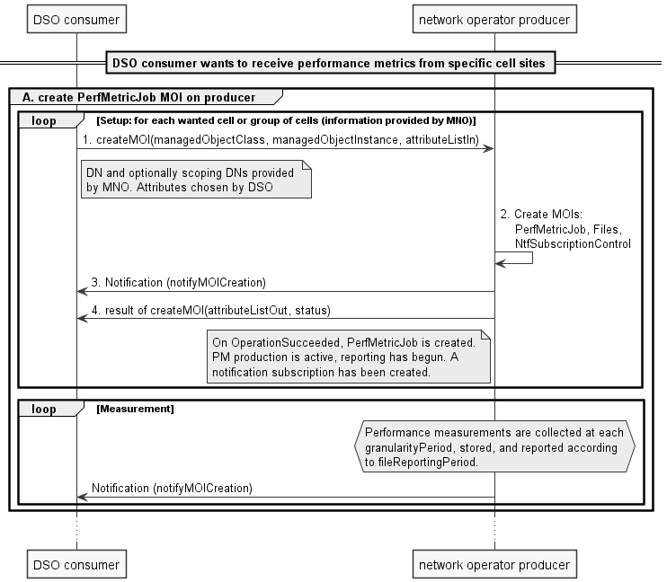
Figure A.1.1.2-1 Create PerfMetricJob

- PerfMetricJob
1. The DSO consumer sends createMOI to the producer with the following parameters: managedObjectClass = PerfMetricJob, managedObjectInstance = {DN supplied by the MNO}, attributeListIn as defined in the following table:
Attribute name | Value
administrativeState | -
operationalState | -
jobId | pmj_group_0001
performanceMetrics | DRB.AirIfDelayDL_PLMN, DRB.AirlffDelayUl_PLMN,  DRB.UEThpDL.PLMN,  DRB.UEThpUL.PLMN,  CellAvailability_{NRCellDU}
granularityPeriod | 60
objectInstances | included if supplied by the MNO
rootObjectInstances | included if supplied by the MNO
reportingCtrl | fileReportingPeriod = 3  notificationRecipientAddress = URL
_linkToFiles | -

jobID is chosen by the DSO, this example uses jobID = pmj_group_0001 to identify the performance measurements from one cell or group of cells as identified by the MNO-supplied DN and optionally objectInstances & rootObjectInstances.
PLMN used to specify the performance metrics. It is supplied by MNO.
granularityPeriod is chosen by the DSO, this example uses 60 seconds.
reportingCtrl uses implicit notification subscription. The fileReportingPeriod is chosen by the DSO, this example uses 3 minutes. The notificationRecipientAddress is chosen by the DSO, in this example it is the URL where the notifyMOICreation and notifyMOIDeletion notification types shall be sent.
2. The network operator producer creates “PerfMetricJob” data collection job, Files and NtfSubscriptionControl MOIs.
3. The network operator producer sends notifyMOICreation to the notificationRecipientAddress included in reportingCtrl.
4. The producer sends createMOI response to the DSO consumer with output parameters as defined in the following table:
Attribute name | Value
attributeListOut | name / value pairs of the attributes of the new object
status | OperationSucceeded | OperationFailed

The DSO consumer stores the attribute name/value pairs.
On OperationSucceeded, metric production is now active on the in-scope object instances whose object class matches the object class associated to the specified performance metrics. A notification subscription has been created.
Repeat steps 1 - 4 for each cell site (or group of cell sites as determined by DN information provided by MNO) where performance metric information is wanted.
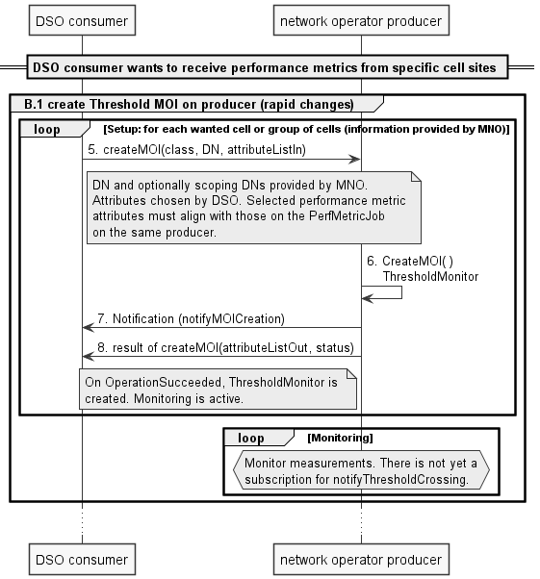
Figure A.1.1.2-2 Create ThresholdMonitor (rapid)
B.1 ThresholdMonitor for rapidly changing PMs
5. The DSO consumer sends createMOI for ThresholdMonitor to monitor the performance measurements for rapidly changing PMs including measurement for latency, packet loss and throughput , using the following parameters: managedObjectClass = ThresholdMonitor, managedObjectInstance = {DN supplied by MNO}, attributeListIn as defined in the following table:
Attribute name | Value
administrativeState | -
operationalState | -
thresholdInfoList | ThresholdInfo  performanceMetrics=DRB.AirIfDelayDl_PLMN  thresholdDirection=UP_AND_DOWN  thresholdValue=70.0  hysteresis=20.0  ThresholdInfo  performanceMetrics=DRB.AirIfDelayUl_PLMN  thresholdDirection=UP_AND_DOWN  thresholdValue=70.0  hysteresis=20.0  ThresholdInfo  performanceMetrics=DRB.UEThpDl.PLMN (kbit/s)  thresholdDirection= UP_AND_DOWN  thresholdValue=100000.0  Hysteresis=10000.0  ThresholdInfo  performanceMetrics=DRB.UEThpUl.PLMN (kbit/s)  thresholdDirection= UP_AND_DOWN  thresholdValue=10000.0  Hysteresis=1000.0
monitorGranularityPeriod | 180
objectInstances | included if supplied by the MNO
rootObjectInstances | included if supplied by the MNO

In this example, a ThresholdInfo datatype will be included for each performance metric that was included in the creation of the corresponding PerfMetricJob MOI where rapidly threshold monitoring is desired.
A threshold monitor is created for delay at the air interface in both DL and UL. In this example, the threshold is set at 7 ms with hysteresis of 2 ms in both the DL and UL. PLMN is provided by the MNO.
A threshold monitor is created for UE throughput in both the DL and UL. In this example, the threshold is set at 100 Mbps with hysteresis of 20 Mbps in the DL and at 10 Mbps with hysteresis of 1 Mbps in the UL.
monitorGranularityPeriod = 180 seconds, multiple of 3 X granularityPeriod established in the PerfMetricJob above.
scope information is included if provided by the MNO.
[ThresholdInfo will also contain an attribute for the location (Lat/long, TAC, cellid). This is used to scope the object instance to be monitored.]
6. The network operator producer creates “ThresholdMonitor” MOI.
7. The network operator producer sends notifyMOICreation to the notificationRecipientAddress in step 1.
8. The producer sends createMOI response to the DSO consumer with output parameters as defined in the following table:
Attribute name | Value
attributeListOut | name / value pairs of the attributes of the new object
status | OperationSucceeded | OperationFailed

The DSO consumer stores the attribute name/value pairs.
Repeat steps 5 - 8 for cell site (or group of cell sites as determined by DN information provided by MNO) where rapidly changing threshold monitoring is required.
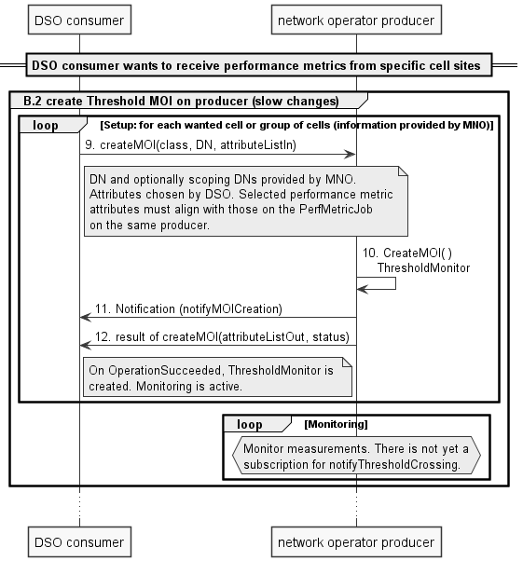
Figure A.1.1.2-3 Create ThresholdMonitor (slow)

B.2 ThresholdMonitor for slowly changing PMs
9. The DSO consumer sends createMOI for a second ThresholdMonitor to monitor the performance measurements for slowly changing PMs like cell availability, using the following parameters: managedObjectClass = ThresholdMonitor, managedObjectInstance = {DN supplied by MNO}, attributeListIn as defined in the following table:
Attribute name | Value
administrativeState | -
operationalState | -
thresholdInfoList | ThresholdInfo  performanceMetrics=CellAvailability_{NRCellDU}  thresholdDirection=UP_AND_DOWN  thresholdValue=99.0  hysteresis=0.5
monitorGranularityPeriod | 3,600
objectInstances | included if supplied by the MNO
rootObjectInstances | included if supplied by the MNO

In this example, a ThresholdInfo datatype will be included for each performance metric that was included in the creation of the corresponding PerfMetricJob MOI where slowly changing threshold monitoring is desired.
A threshold monitor is created for cell availability. In this example, the threshold is set at 99.0% with hysteresis of 0.5%.
monitorGranularityPeriod = 3,600 seconds (1 hour), multiple of 3 X granularityPeriod established in the PerfMetricJob above.
scope information is included if provided by the MNO.
[ThresholdInfo will also contain an attribute for the location (Lat/long, TAC, cellid). This is used to scope the object instance to be monitored.]
10. The network operator producer creates “ThresholdMonitor” MOI.
11. The network operator producer sends notifyMOICreation to the notificationRecipientAddress in step 1.
12. The producer sends createMOI response to the DSO consumer with output parameters as defined in the following table:
Attribute name | Value
attributeListOut | name / value pairs of the attributes of the new object
status | OperationSucceeded | OperationFailed

The DSO consumer stores the attribute name/value pairs.
Repeat steps 9 – 12 for each cell site (or group of cell sites as determined by DN information provided by MNO) where slowly changing threshold monitoring is required.
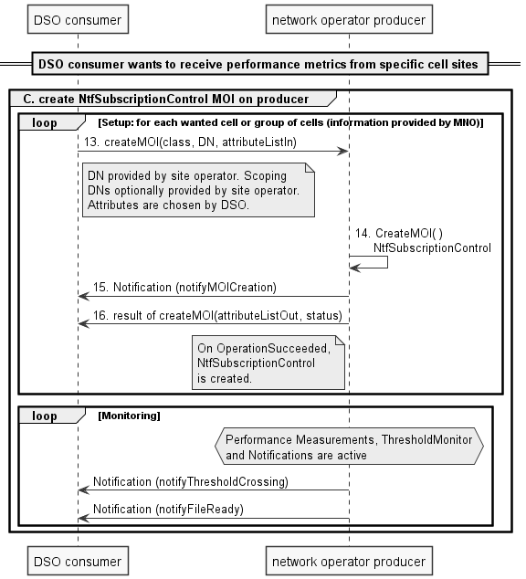
Figure A.1.1.2-4 Create NtfSuscriptionControl
C. NtfSubscriptionControl
13. The DSO consumer sends createMOI for NtfSubscriptionControl to subscribe for the required notifications with the following parameters: managedObjectClass = NtfSubscriptionControl, managedObjectInstance = {DN supplied by the MNO}, attributeListIn as defined in the following table:
Attribute name | Value
notificationRecipientAddress | URL
notificationTypes | notifyFileReady, notifyFilePreparationError, notifyThresholdCrossing
scope | included if supplied by the MNO
notificationFilter | -

notificationRecipientAddress is specified by the DSO and is the URL where the notifications shall be sent. In this example it is the same URL as provided to PerfMetricJob in step 1 above, although the DSO consumer may select a different URL in this current step.
notificationTypes = notifyFileReady, notifyFilePreparationError, notifyThresholdCrossing
scope information is included if provided by the MNO.
14. The network operator producer creates “NtfSubscriptionControl” job.
15. The network operator producer sends notifyMOICreation to the notificationRecipientAddress in step 1.
16. The producer sends createMOI response to the DSO consumer with output parameters as defined in the following table:
Attribute name | Value
attributeListOut | name / value pairs of the attributes of the new object
status | OperationSucceeded | OperationFailed

The DSO consumer stores the attribute name/value pairs.
Repeat steps 13 - 16 for each cell site (or group of cell sites as determined by DN information provided by MNO)where threshold monitoring and file notification are required.

A.1.1.3 Signal flow – completion
The DSO, making use of a DSO managed service consumer (DSO consumer) wants to end performance metric reports from one or more specific cell sites which were previously setup for performance metric reporting. For ultimate deactivation of metric production and threshold monitoring the MnS consumer should delete the job and monitor to free up resources on the MnS producer.
NOTE: dMNO, making use of a MnS producer (termed in this clause ‘network operator producer’) provides to the DSO the DN and any required scoping parameters for PerfMetricJob MOI (s), ThresholdMonitor MOI(s) and NtfSubscriptionControl MOI(s).
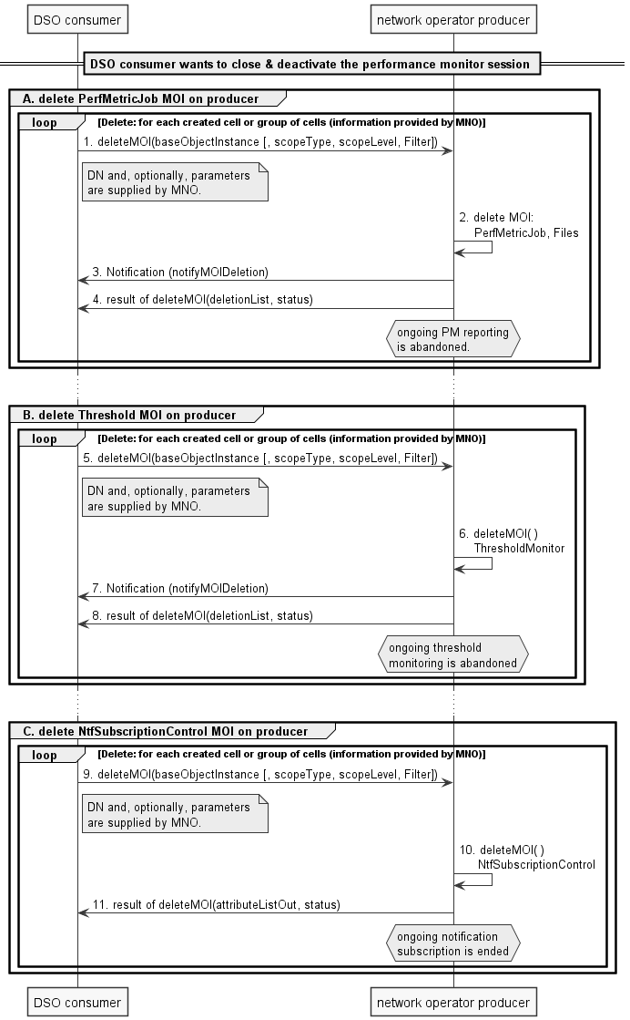
Figure A.1.1.3-1
- PerfMetricJob
- The DSO consumer sends deleteMOI to the producer with the following parameters: baseObjectInstance = {DN supplied by the MNO}, scopeType, scopeLevel and Filter are optional and shall be included if supplied by the MNO.
- The network operator producer deletes “PerfMetricJob” data collection job.
- The network operator producer sends notifyMOIDeletion to the notificationRecipientAddress in section C, step 9 above.
- The network operator producr sends deleteMOI response to the DSO consumer with output parameters as defined in the following table:
Attribute name | Value
deletionList | LIST OF SEQUENCE <ManageedEntity DN, ManagedEntity class name>
status | OperationSucceeded | OperationFailed | OperationPartiallySucceeded

Best effort synchronization applies; all managed objects selected for this operation will perform the operation if possible regardless of whether some managed objects fail to perform it. The managed objects selected for this operation are specified by information provided by the MNO.
When the "PerfMetricJob" is deleted, the ongoing reporting period shall be aborted.
- ThresholdMonitor
- The DSO consumer sends deleteMOI to the producer with the following parameters: baseObjectInstance = {DN supplied by the MNO}, scopeType, scopeLevel and Filter are optional and shall be included if supplied by the MNO.
- The network operator producer deletes “ThresholdMonitor” data collection job.
- The network operator producer sends notifyMOIDeletion to the notificationRecipientAddress in section C, step 9 above.
- The network operator producr sends deleteMOI response to the DSO consumer with output parameters as defined in the following table:
Attribute name | Value
deletionList | LIST OF SEQUENCE <ManageedEntity DN, ManagedEntity class name>
status | OperationSucceeded | OperationFailed | OperationPartiallySucceeded

Best effort synchronization applies; all managed objects selected for this operation will perform the operation if possible regardless of whether some managed objects fail to perform it.

- NtfSubscriptionControl
- When the DSO consumer does not wish to receive notifications any more, it shall delete the corresponding NtfSubscriptionControl instance. The DSO consumer sends deleteMOI to the producer with the following parameters: baseObjectInstance = {DN supplied by the MNO}, scopeType, scopeLevel and Filter are optional and shall be included if supplied by the MNO.
- The network operator producer deletes “NtfSubscriptionControl” job.
- The network operator producr sends deleteMOI response to the DSO consumer with output parameters as defined in the following table:
Attribute name | Value
deletionList | LIST OF SEQUENCE <ManageedEntity DN, ManagedEntity class name>
status | OperationSucceeded | OperationFailed | OperationPartiallySucceeded

A.1.2 DSO is trusted and supported by network operator, split gNB

A.1.2.1 General
In this scenario the DSO consumer, is recognized by the network operator as a trusted entity that is allowed to read from and write to selected producers and corresponding MOIs in one or more MIBs controlled by the network operator. In this basic scenario, the network operator supports the DSO consumer by providing specific necessary information such as a Distinguished Name of producer(s) and MOI(s), by some means not described in this TS. This scenario is specific to a split gNB.

A.1.2.2 Signal flow
The DSO, making use of a DSO managed service consumer (DSO consumer) wants to receive performance metric reports from one or more specific cell sites. These reports are provided continuously over the monitoring interval with the requested granularity. The DSO consumer is in possession of the following information:
the identity of the cell site: base station ID, or
the estimated location of the cell site antenna
NOTE: Based upon the identity of the cell site, the location of the cell site, or both, the MNO supplies to the DSO the DN and any required scoping parameters for PerfMetricJob MOI(s), ThresholdMonitor MOI(s) and NtfSubscriptionControl MOI(s).
The MNO exposes a MnS producer (termed in this clause 'network operator producer').
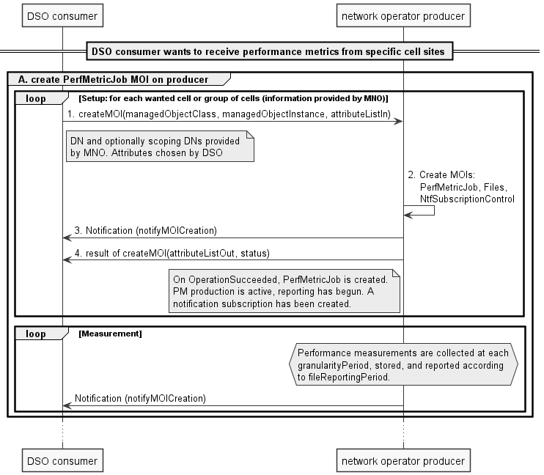
Figure A.1.2.2-1 Create PerfMetricJob

A. PerfMetricJob
- The DSO consumer sends createMOI to the network operator producer with the following parameters: managedObjectClass = PerfMetricJob, managedObjectInstance = {DN supplied by the MNO}, attributeListIn as defined in the following table:
Attribute name | Value
administrativeState | -
operationalState | -
jobId | pmj_group_0001
performanceMetrics | DRB.AirIfDelayDL_PLMN, DRB.AirIfDelayUl_PLMN,  DRB.UEThpDL.PLMN,  DRB.UEThpUL.PLMN,  DRB.PacketLossRateUL  SO.CellInServiceTotal.NCGI  SO.CellOOSTimeTotal.NCGI  SO.CellOOSTimeAverage.NCGI  CellAvailAvg_{TimeCU}  NwAvailAvg_{TimeRAN}
granularityPeriod | 7200
objectInstances | included if supplied by the MNO
rootObjectInstances | included if supplied by the MNO
reportingCtrl | fileReportingPeriod = 120  notificationRecipientAddress = URL
_linkToFiles | -

jobID is chosen by the DSO, this example uses jobID = pmj_group_0001 to identify the performance measurements from one cell or group of cells as identified by the MNO-supplied DN and optionally objectInstances & rootObjectInstances.
PLMN used to specify the performance metrics. It is supplied by MNO.
granularityPeriod is chosen by the DSO, this example uses 7200 seconds (2 hours).
reportingCtrl uses implicit notification subscription. The fileReportingPeriod is chosen by the DSO, this example uses 120 minutes. The notificationRecipientAddress is chosen by the DSO, in this example it is the URL where the notifyMOICreation and notifyMOIDeletion notification types shall be sent.
2. The network operator producer creates “PerfMetricJob” data collection job, Files and NtfSubscriptionControl MOIs.
3. The network operator producer sends notifyMOICreation to the notificationRecipientAddress included in reportingCtrl.
4. The network operator producer sends createMOI response to the DSO consumer with output parameters as defined in the following table:
Attribute name | Value
attributeListOut | name / value pairs of the attributes of the new object
status | OperationSucceeded | OperationFailed

The DSO consumer stores the attribute name/value pairs.
On OperationSucceeded, metric production is now active on the in-scope object instances whose object class matches the object class associated to the specified performance metrics. A notification subscription has been created.
Repeat steps 1 - 4 for each cell site (or group of cell sites as determined by DN information provided by MNO) where performance metric information is wanted.

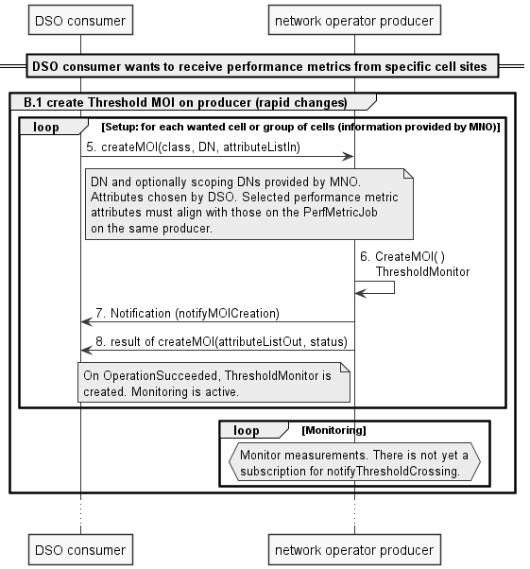
Figure A.1.2.2-2 Create ThresholdMonitor (rapid)
B.1 ThresholdMonitor for rapidly changing PMs
5. The DSO consumer sends createMOI for ThresholdMonitor to monitor the performance measurements for rapidly changing PMs including measurement for latency, packet loss and throughput, using the following parameters: managedObjectClass = ThresholdMonitor, managedObjectInstance = {DN supplied by MNO}, attributeListIn as defined in the following table:
Attribute name | Value
administrativeState | -
operationalState | -
thresholdInfoList | ThresholdInfo  performanceMetrics=DRB.AirIfDelayDl_PLMN  thresholdDirection=UP_AND_DOWN  thresholdValue=70.0  hysteresis=20.0  ThresholdInfo  performanceMetrics=DRB.AirIfDelayUl_PLMN  thresholdDirection=UP_AND_DOWN  thresholdValue=70.0  hysteresis=20.0  ThresholdInfo  performanceMetrics=DRB.UEThpDl.PLMN (kbit/s)  thresholdDirection= UP_AND_DOWN  thresholdValue=100000.0  Hysteresis=10000.0  ThresholdInfo  performanceMetrics=DRB.UEThpUl.PLMN (kbit/s)  thresholdDirection= UP_AND_DOWN  thresholdValue=10000.0  Hysteresis=1000.0  ThresholdInfo  performanceMetrics=DRB.PacketLossRateUl (1 ~ 1E6)  thresholdDirection=UP  thresholdValue=20000  Hysteresis=_
monitorGranularityPeriod | 14400
objectInstances | included if supplied by the MNO
rootObjectInstances | included if supplied by the MNO

In this example, a ThresholdInfo datatype will be included for each performance metric that was included in the creation of the corresponding PerfMetricJob MOI where rapidly threshold monitoring is desired.
A threshold monitor is created for delay at the air interface in both DL and UL. In this example, the threshold is set at 7 ms with hysteresis of 2 ms in both the DL and UL. PLMN is provided by the MNO.
A threshold monitor is created for UE throughput in both the DL and UL. In this example, the threshold is set at 100 Mbps with hysteresis of 20 Mbps in the DL and at 10 Mbps with hysteresis of 1 Mbps in the UL.
A threshold monitor is created for UL PacketLoss. In this example, the threshold is set at 0.02% packetloss.
monitorGranularityPeriod = 14400 seconds, multiple of 2 X granularityPeriod established in the PerfMetricJob above.
scope information is included if provided by the MNO.
[ThresholdInfo will also contain an attribute for the location (Lat/long, TAC, cellid). This is used to scope the object instance to be monitored.]
6. The network operator producer creates “ThresholdMonitor” MOI.
7. The network operator producer sends notifyMOICreation to the notificationRecipientAddress in step 1.
8. The network operator producer sends createMOI response to the DSO consumer with output parameters as defined in the following table:
Attribute name | Value
attributeListOut | name / value pairs of the attributes of the new object
status | OperationSucceeded | OperationFailed

The DSO consumer stores the attribute name/value pairs.
Repeat steps 5 - 8 for each cell site (or group of cell sites as determined by DN information provided by MNO) where rapidly changing threshold monitoring is required.
Figure A.1.2.2-3 Create ThresholdMonitor (slow)

B.2 ThresholdMonitor for slowly changing PMs
9. The DSO consumer sends createMOI for a second ThresholdMonitor to monitor the performance measurements for slowly changing PMs like cell availability, using the following parameters: managedObjectClass = ThresholdMonitor, managedObjectInstance = {DN supplied by MNO}, attributeListIn as defined in the following table:
Attribute name | Value
administrativeState | -
operationalState | -
thresholdInfoList | ThresholdInfo  performanceMetrics= SO.CellOOSTimeAverage.NCGI  thresholdDirection=UP_AND_DOWN  thresholdValue=1800  ThresholdInfo  performanceMetrics= CellAvailAvg_{TimeCU}  thresholdDirection=UP_AND_DOWN  thresholdValue=600  ThresholdInfo  performanceMetrics= NwAvailAvg_{TimeRAN}  thresholdDirection=UP_AND_DOWN  thresholdValue=300
monitorGranularityPeriod | 43200
objectInstances | included if supplied by the MNO
rootObjectInstances | included if supplied by the MNO

In this example, a ThresholdInfo datatype will be included for each performance metric that was included in the creation of the corresponding PerfMetricJob MOI where slowly changing threshold monitoring is desired.
Three threshold monitors are created for cell availability. In this example, the threshold is set at 1800 seconds (30 minutes) for metric SO.CellOOSTimeAverage.NCGI.
monitorGranularityPeriod = 43200 seconds (12 hours), multiple of 6 X granularityPeriod established in the PerfMetricJob above.
scope information is included if provided by the MNO.
[ThresholdInfo will also contain an attribute for the location (Lat/long, TAC, cellid). This is used to scope the object instance to be monitored.]
10. The network operator producer creates “ThresholdMonitor” MOI.
11. The network operator producer sends notifyMOICreation to the notificationRecipientAddress in step 1.
12. The network operator producer sends createMOI response to the DSO consumer with output parameters as defined in the following table:
Attribute name | Value
attributeListOut | name / value pairs of the attributes of the new object
status | OperationSucceeded | OperationFailed

The DSO consumer stores the attribute name/value pairs.
Repeat steps 9 – 12 for each cell site (or group of cell sites as determined by DN information provided by MNO) where slowly changing threshold monitoring is required.

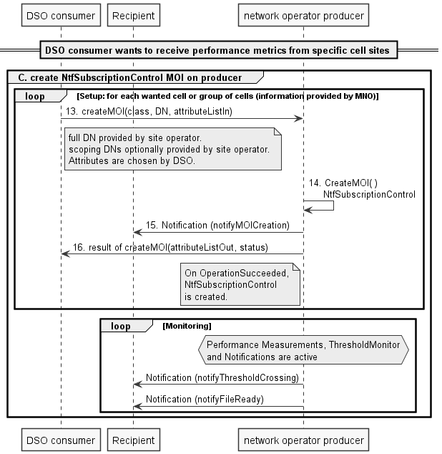
Figure A.1.2.2-4 Create NtfSuscriptionControl
C. NtfSubscriptionControl
13. The DSO consumer sends createMOI for NtfSubscriptionControl to subscribe for the required notifications with the following parameters: managedObjectClass = NtfSubscriptionControl, managedObjectInstance = {DN supplied by the MNO}, attributeListIn as defined in the following table:
Attribute name | Value
notificationRecipientAddress | URL
notificationTypes | notifyFileReady, notifyFilePreparationError, notifyThresholdCrossing
scope | included if supplied by the MNO
notificationFilter | -

notificationRecipientAddress is specified by the DSO and is the URL where the notifications shall be sent. In this example it is the same URL as provided to PerfMetricJob in step 1 above, although the DSO consumer may select a different URL in this current step.
notificationTypes = notifyFileReady, notifyFilePreparationError, notifyThresholdCrossing
scope information is included if provided by the MNO.
14. The network operator producer creates “NtfSubscriptionControl” job.
15. The network operator producer sends notifyMOICreation to the notificationRecipientAddress in step 1.
16. The network operator producer sends createMOI response to the DSO consumer with output parameters as defined in the following table:
Attribute name | Value
attributeListOut | name / value pairs of the attributes of the new object
status | OperationSucceeded | OperationFailed

The DSO consumer stores the attribute name/value pairs.
Repeat steps 13 - 16 for each cell site (or group of cell sites as determined by DN information provided by MNO) where threshold monitoring and file notification are required.

A.1.2.3 Signal flow – completion
The DSO, making use of a DSO managed service consumer (DSO consumer) wants to end performance metric reports from one or more specific cell sites which were previously setup for performance metric reporting. For ultimate deactivation of metric production and threshold monitoring the MnS consumer should delete the job and monitor to free up resources on the MnS producer.
NOTE: MNO, making use of a MnS producer (termed in this clause ‘network operator producer’) provides to the DSO the DN and any required scoping parameters for PerfMetricJob MOI(s), ThresholdMonitor MOI(s) and NtfSubscriptionControl MOI(s).

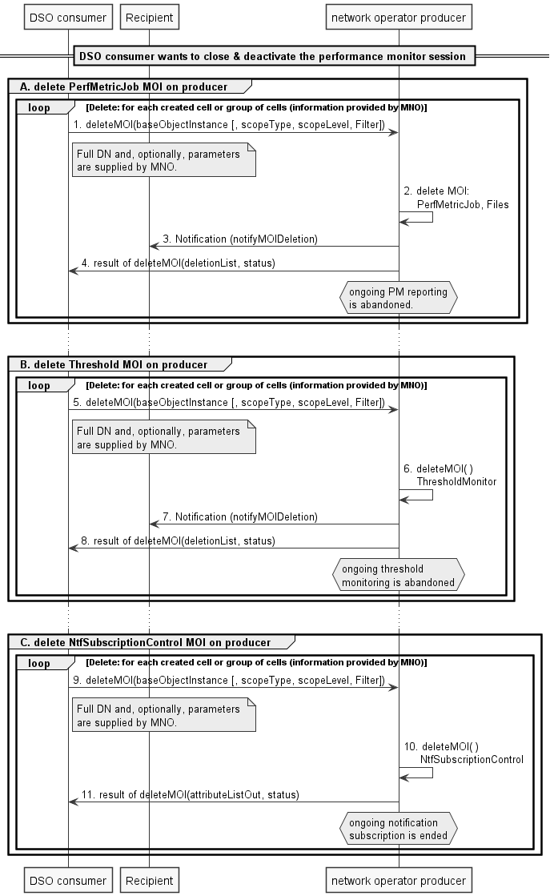
Figure A.1.2.3-1
- PerfMetricJob
- The DSO consumer sends deleteMOI to the producer with the following parameters: baseObjectInstance = {DN supplied by the MNO}, scopeType, scopeLevel and Filter are optional and shall be included if supplied by the MNO.
- The network operator producer deletes “PerfMetricJob” data collection job.
- The network operator producer sends notifyMOIDeletion to the notificationRecipientAddress in section C, step 9 above.
- The producr sends deleteMOI response to the DSO consumer with output parameters as defined in the following table:
Attribute name | Value
deletionList | LIST OF SEQUENCE <ManageedEntity DN, ManagedEntity class name>
status | OperationSucceeded | OperationFailed | OperationPartiallySucceeded

Best effort synchronization applies; all managed objects selected for this operation will perform the operation if possible regardless of whether some managed objects fail to perform it. The managed objects selected for this operation are specified by information provided by the MNO.
When the "PerfMetricJob" is deleted, the ongoing reporting period shall be aborted.
- ThresholdMonitor
- The DSO consumer sends deleteMOI to the network operator producer with the following parameters: baseObjectInstance = {DN supplied by the MNO}, scopeType, scopeLevel and Filter are optional and shall be included if supplied by the MNO.
- The network operator producer deletes “ThresholdMonitor” data collection job.
- The network operator producer sends notifyMOIDeletion to the notificationRecipientAddress in section C, step 9 above.
- The producr sends deleteMOI response to the DSO consumer with output parameters as defined in the following table:
Attribute name | Value
deletionList | LIST OF SEQUENCE <ManageedEntity DN, ManagedEntity class name>
status | OperationSucceeded | OperationFailed | OperationPartiallySucceeded

Best effort synchronization applies; all managed objects selected for this operation will perform the operation if possible regardless of whether some managed objects fail to perform it.

- NtfSubscriptionControl
- When the DSO consumer does not wish to receive notifications any more, it shall delete the corresponding NtfSubscriptionControl instance. The DSO consumer sends deleteMOI to the network operator producer with the following parameters: baseObjectInstance = {DN supplied by the MNO}, scopeType, scopeLevel and Filter are optional and shall be included if supplied by the MNO.
- The network operator producer deletes “NtfSubscriptionControl” job.
- The network operator producr sends deleteMOI response to the DSO consumer with output parameters as defined in the following table:
Attribute name | Value
deletionList | LIST OF SEQUENCE <ManageedEntity DN, ManagedEntity class name>
status | OperationSucceeded | OperationFailed | OperationPartiallySucceeded

A.2 Energy utility and telecommunication coordinated rapid recovery of energy service procedure

A.2.1 General
Coordinated energy service recovery requirements are given in clause 5.3. The use cases supported are described in Annex C.
The functionality supported by the signalling flow is:
- A: Inititialization (to initialize the rest of the defined operations). As interaction between MnSs involves creation of a MOI the listed operations precede the other operations listed below.
- B: MNO informs DSO of changes (e.g. to update the list of essential sites and their related information).
- C: DSO updates the information (e.g. to update the expected end of an energy outage).
- D: DSO retrieves the changes (e.g. to query the UPS available time for a site from the MNO).

A.2.2 Signal flow
In the procedure below A occurs before B, C and D are possible. B, C and D can occur at any time after A completes, in any order.
Figure A.2.2-1: Coordinated Rapid Recovery and strategic outage plan Procedure
1. In order to be able to provide energy service outage and recovery related information for MNO, DSO sends createMOI request for OutageAndRecovery IOC which contains information attributes for outage and rapid recovery by DSO.
2. MnS producer in MNO creates the OutageAndRecovery MOI that contains this information for the applicable site. Which site is applicable depends on the attribute affectedArea that is sent in the createMOI request in step 1. createMOI response is sent by MNO MnS producer to DSO.
3. In order to be able to get automatically notified of the creation of the MOIs or any changes in the attribute information in the MOIs, DSO sends createMOI request for NtfSubscriptionControl IOC to MNO. The notification that can be subscribed for is defined using notificationTypes attributes. See clause 4.4.1 of TS 28.622.
4. The MnS Producer in MNO sends the response.
5. MnS producer in MNO instantiate the OutageAndRecovery IOC. This is name-contained by OutageAndRecovery IOC created in step 1.
NOTE 1: In step 6, if done, a subscription is created such that, subject to parameters in the NtfSubscriptionControl IOC, notifications are sent from the MNO to the DSO. This allows, for example, the MNO to notify the DSO of changes in the maxServiceDuration over time. This step is shown as step 6 below.
6. If there is a change in the attribute values, the MNO sends a notifyMOIAttributeValueChanges notification to inform DSO about the changes. The example of the change can include change of the maxServiceDuration.
NOTE 2: In steps 7 and 8 below, there is a change in an attribute of the MOI. This is done by DSO to inform MNO on the changes, e.g. information about an expected outage for a specific site.
7. DSO can modify/update any information like outage start time stamp by sending a modifyMOIAttributes request to MNO. DSO can create/read/update/delete (CRUD operations) the information in the MOI by using provisioning MnS (defined in TS 28.532 [23]).
8. MNO MnS producer provides the modify response to the DSO.
NOTE 3: In steps 9 and 10 below, the DSO requests and receives respectively the current value of one or more attribute(s).
9. DSO can also query the maxServiceDuration as and when required by using the getMOIAttributes operation. For example the information could include identity of DSO energy supply meter, MNO base station, remaining MaxServiceDuration of a particular site, etc. DSO requests the required information from the MNO by using getMOIAttributes operation.
10. MNO provides the required information in the response to the DSO.

Sixth change

C.3 Scenario #2: Energy service recovery without redundant energy distribution topology
This use case is a variation on clause C.2 above.
In C.3, a redundant topology offers the opportunity to adjust the switching of medium voltage lines for energy distribution. When there is a failure of one of these lines, it is possible to adjust the topology to re-establish energy supply to all distribution substations.
This possibility exists only if there is a redundant topology. There are scenarios in which there is no redundant topology, either because a substation is remotely located or because the redundant topology is sufficiently damaged that a sufficient network cannot be re-established. This use case addresses these scenarios.
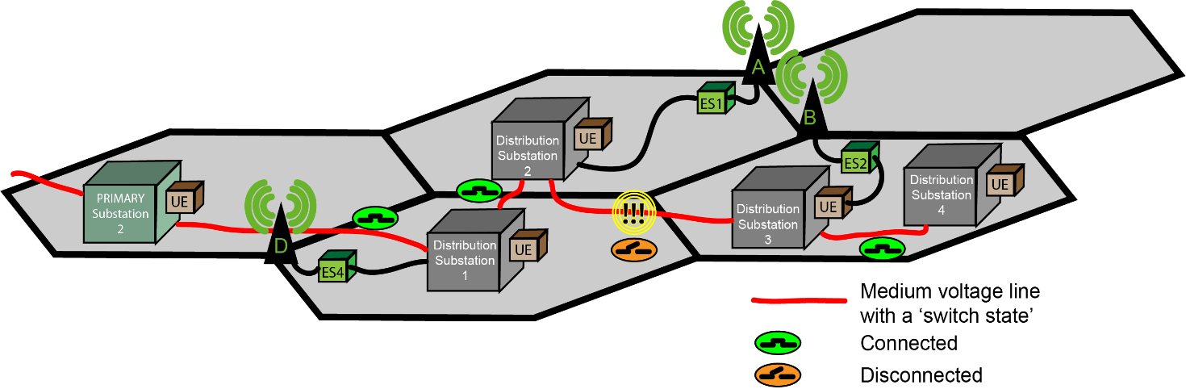
Figure C.3-1: Local Failure Event of feeder of Distribution Substations without Redundant Topology
In figure C.3-1, there is a failure in the distribution line between Distribution Substation 2 and Distribution substation 3. This will result in a failure to supply energy to ES2, and thereby base station B.
In this use case, it is necessary to re-establish the energy supply between substation 2 and substation 3 prior to resuming service in substation 3 and 4.
Once this has been re-established the topology is restored as shown in Figure C.3-2.
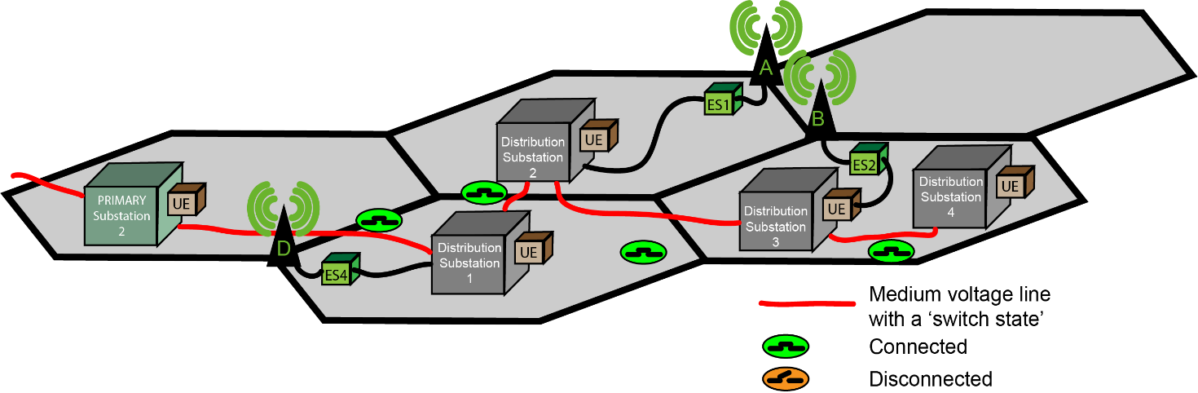
Figure C.3-2: Restored Energy feeder to Distribution Substations
At the point when the distribution is again possible, it is necessary to resume service at distribution substation 3 and 4. However, as some time has elapsed, the UPS capacity of B will be exhausted. This will mean that any smart energy automated operations to distribution substation 3 and 4 will be impossible. Manual intervention to restart service will require substantially more time than automated response.
For this reason, this use case suggests a new operational capability to achieve rapid coordinated recovery. In this approach the DSO informs the MNO to reserve UPS capacity in certain sites, so that it will be possible to resume telecom operations subsequent to the resumption of energy distribution service. If energy distribution service does not resume, after the UPS capacity becomes exhausted, telecom operations will become impossible.
Use case actors
DSO network operations centre 'management system'
The DSO network operations centre management system (DSO-MS) maintains operational information used for DSO network operations. The DSO-MS supports interfaces defined in this use case. All other aspects of the DSO-MS are out of scope of 3GPP specification. The DSO-MS is a consumer of the 3GPP management system.
MNO operations centre 'management system'
The MNO operations centre management system (MNO-MS) has and can expose operational information to DSOs concerning the network's configuration and status. The -MS as discussed in this use case can be considered a producer of management interfaces consumed by the DSO-MS. The MNO-MS is effectively a standardized subset of interfaces and semantics of the 3GPP management system. The MNO-MS is a 3GPP management system for 5G and the DSO-MS is not a 3GPP management system, however it supports mechanisms that are defined by 3GPP standards (e.g. it uses 'northbound interfaces' exposed by the 5G network management system.)
Sites that are not managed by the MNO, e.g. for shared network operations, can be included in the exposed information and capabilities by means that are out of scope of 3GPP standardization.
Use case service flow
Preconditions:
The purpose of the following description is to explain the scenario in which the energy utility operates a network by means of diverse accesses. It is important to mention that other access systems are used to access the energy utility site networks as well, but only access via the mobile telecommunication system is in of scope of this use case.
An energy utility maintains many energy distribution substations. Each is an energy utility infrastructure site that is responsible for distribution of energy to customer sites. This energy utility infrastructure site's operation requires smart energy services. The smart energy services are used to manage and control DSO equipment. This equipment is present on a local area network in the energy utility infrastructure site, which is accessed (e.g. as a VLAN) over any access. In this use case, the access that is used is 3GPP access. A UE is used effectively to carry DSO energy utility infrastructure site communication opaquely (that is, as encrypted traffic) to the Utility Service Provider Network.
The DSO can obtain information from each UE that is used to provide access to the DSO networks. The DSO is, by means of this information obtained from UEs in the DSO network, aware of the Base station ID of the serving base station for each UE.
NOTE 1: The MNO exposed information regarding the base station ID and its associated Energy Supply ID and UPS status enables the DSO to determine which of the UEs deployed in their network will eventually be affected if the supply is out of service.
On a regular basis, e.g. daily, the DSO-MS reads information from the MNO-MS exposed 3GPP management system MnS Producer's exposed interfaces. The DSO-MS is aware which base stations each of the DSO's UE camp on. The DSO-MS is also aware of which base stations rely on which Distribution Substation.
Service Flow:
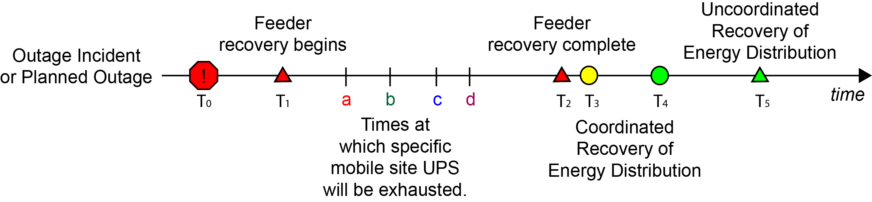
Figure C.3-3: Timeline for Restoration of a Distribution Substation
1. At some time (T₀) there is an outage incident either a planned or unplanned incident.
2. The DSO-MS uses the standardized mechanism to request information from the MNO-MS, to identify the UPS capacity, including remaining time of operation, of the base stations in the vicinity of the outage, where the distribution substations will need to be switched on and off.
This request may be done repeatedly, over time, so that the DSO-MS can track the status of the MNO-MS. The MNO-MS should inform the DSO-MS of the current UPS status for a specific Energy Supply ID.
NOTE 2: It is especially important for the MNO-MS to inform the DSO-MS of the UPS status of sites that are Base Stations.
3. At some subsequent time (T₁), the energy utility begins restoration of energy feeder lines or other affected infrastructure.
4. The period of time that will elapse before the restoration of energy service from some set of distribution substations will be longer than the UPS capacity of the mobile infrastructure sites. This use case assumes that the MNO knows or can estimate the remaining time of operation after T₀ given the UPS capacity of different mobile infrastructure sites, as received in step 2, shown as a, b, c, d in Figure C.3-3. That is, T₂ occurs after the UPS capacity is exhausted in the sites affected by the energy outage. This use case assumes that the DSO knows or can estimate time at which energy distribution service can resume, shown as T₂ in figure C.3-3. This may not be the exact time at which resumption of energy service can resume, which is shown as T₃. T₂ is an estimate when the energy feeder will have recovered, while T₃ represents the time at which energy feeder service resumes and restoration of distribution is possible.
5. The energy feeder for one or more energy distribution substations is now complete. At this point, it will be possible to restore energy distribution. However, operations are required at the distribution substation. This can be performed by smart energy services remotely if there is network coverage. The starting time, when the MNO provides service with remaining UPS capacity, is shown in Figure C.3-3 as T₃. The smart energy services to restore energy distribution services to all customers, including the MNO, is shown as T₄.
There are two alternatives for how the restoration can occur. Manually, as described in 6a, or with remote intervention, as described in 6b.
6a. Without prior arrangement, there will be no UPS capacity remaining in the infrastructure that serves the distribution substations that have restored power. In this case, manual intervention is required to restore energy distribution. This will be complete after a substantial period of time (T₅).
6b. Alternatively, prior arrangement can be made so UPS capacity will remain in the infrastructure at the time it is needed to restore energy distribution service. This prior arrangement is described in the steps below, and consists of operations between the DSO-MS and MNO-MS.
This Rapid Recovery process enables the situation that, at time (T₃), the MNO is able to use remaining UPS capacity to offer telecommunication service at the time at which the DSO will perform remote operations by means of data communications to restore service in the sites affected by the outage, and operates them until the outage concludes.
6.b.1. In this use case, the DSO-MS communicates to the MNO-MS:
- the affected sites (identified by the associated Energy Supply IDs) by the outage
- the time X after which recovery is possible
- the time Y (that is a certain interval of time after X) that the recovery is expected to complete (a small number of minutes)
The MNO (or the site operator of a site essential to the MNO that is operated by a third party, see annex B), knowing this, has the opportunity to manage the use of the UPS in the affected sites so that they do not exhaust at time (a, b, c, d, etc.). Rather, capacity sufficient for operation of the base station between time X and Y is reserved. Figure C.3-4 below shows a concrete example of this interaction.
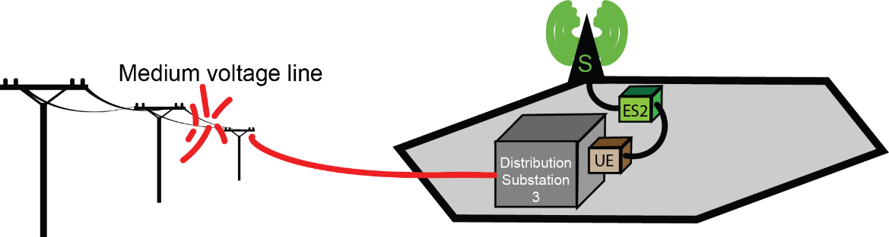
Figure C.3-4: Example of Restoration Scenario of a Distribution Substation
Table C.3-1: Example Sequence of Restoration of a Distribution Substation
Time | Event
00:34 | A storm rages and causes power lines to collapse in the mountain province. Energy distribution service by Distribution Substation 3 is no longer possible!
00:36 | The DSO informs the MNO that there has been an energy distribution incident that will affect site S. The DSO expects to repair the medium voltage line by 02:45, and if telecommunications service permits it, remote control (using Distribution Automation and SCADA controls) of all sites served by Distribution Substation 3 can be restored - by 02:50.  In terms of the procedure step 5a, X=0:2:45, Y = 5 minutes.
00:40 | The MNO conserves energy as appropriate to conserve 5 minutes of operating capacity of their UPS reserve.
02:38 | The DSO informs the MNO that the feeder line is restored. Remote control restoration of service can begin now. This is T₂ in Figure C.3-3.
02:43 | The MNO resumes operation at site S. The DSO is informed that the service has resumed.
02:47 | The DSO completes distribution automation. Site S now has energy service. This is T₄ in Figure C.3-3.

6.b.2. The DSO, after time (T₃), employs smart energy services such as distribution automation or specific SCADA operations to restore service to customers rapidly.
6.b.3. The incident concludes (T₄). Energy distribution service has been restored to the MNO site(s) as well as other energy service customers.
6.b.4 The DSO-MS notifies the MNO-MS that the restore operation is complete.
Service flow result
T₄ occurs before manual uncoordinated recovery of service would be successful (T₅ in Figure C.3-3) Thus, alternative 6.b is superior to 6.a for both the MNO and the DSO.
Service is restored to distribution substation 3 and 4 at T₄, within minutes of the restoration of the medium voltage line between distribution substation 2 and 3 T₃. This is substantially faster than service could be restored if a technician had to visit distribution substation 2 and 3 - represented on Figure C.3-3 as T₅. As a result, service is restored to the MNO sites affected more rapidly than in an uncoordinated incident.

Seventh change

Annex D (informative):
Unspecified needed configuration and functionality

D.1 General
The present document provides a specification for management services to support the use cases corresponding to requirements in clause 5.
Some aspects needed to support a DSO deploying a MnS consumer for functionality defined in clause 6 and annex A are not defined in the present document. These aspects are described in this annex.

D.2 Service reachability configuration
In order for a MnS consumer deployed by a DSO to communicate with a MnS producer deployed by an MNO, the DSO needs configuration information. Specifically the network address and port number to access the MnS producer should be known.
For example, the MNO could provide the DSO with a DNS name to obtain the MnS producer service address, as well as a port number.

D.3 Service security management
While authentication and authorization of the MNO by the DSO and the DSO by the MNO are needed, the means by which this is achieved is not specified in the present document.
Further, the communication between the MNO and DSO needs to be secure, including protecting confidentiality and the integrity of the data communicated. The means by which this is achieved is not specified in the present document.
This could be achieved for example by means of an exchange (by some secure means) of credentials between trusted parties and use of a secure communication layer such as TLS.

D.4 Service configuration
The procedures defined in annex A require configuration information before they can be used.
For performance monitoring aspects, the MNO should provide the full DN (corresponding to each cell id) to the DSO to obtain the associated performance metrics. The correspondence between DN [19] and Cell ID [18] is, in the present document, required configuration. This format of this configuration is not specified, nor is the method by which the MNO provides it to the DSO. Not all cell ids are relevant to DSO, so the mapping will be restricted to only those that serve the DSO equipment.
Minimum configuration elements for performance monitoring are as follows:
- DN; as specified in 3GPP TS 32.300 [19].
- Cell ID; as specified in 3GPP TS 23.003 [18].
For coordinated energy service recovery, the DSO needs to know the list of Energy Supply IDs that correspond to critical sites of the MNO. The location is also needed, so that it is possible to identify the critical sites affected when there are energy outages that affect a particular region. The present document does not specify the form of the list of Energy Supply IDs and associated locations, or the means by which it is provided by the MNO to the DSO.
Typical configuration elements for coordinated recovery are as follows:
- Energy Supply ID; As defined by the DSO and known to the MNO.
- Cell ID; as specified in 3GPP TS 23.003 [18].
- Latitude; The latitude of the site.
- Longitude; The longitude of the site.

Eighth change

Annex E (normative): UML source code

Figure A.1.1.2-1

'S5-240924 Figure A.1.1.2-1 Create PerfMetricJob
@startuml
skinparam Shadowing false
skinparam Monochrome true
participant "DSO consumer" as Cons
participant "network operator producer" as Prod

== DSO consumer wants to receive performance metrics from specific cell sites ==

group A. create PerfMetricJob MOI on producer

loop Setup: for each wanted cell or group of cells (information provided by MNO)

Cons -> Prod: 1. createMOI(managedObjectClass, managedObjectInstance, attributeListIn)
Note right Cons
DN and optionally scoping DNs provided
by MNO. Attributes chosen by DSO
End Note

Prod -> Prod: 2. Create MOIs:\n PerfMetricJob, Files,\n NtfSubscriptionControl

Cons <- Prod: 3. Notification (notifyMOICreation)

Cons <- Prod: 4. result of createMOI(attributeListOut, status)

Note left Prod
On OperationSucceeded, PerfMetricJob is created.
PM production is active, reporting has begun. A
notification subscription has been created.
End Note

end loop for each wanted MOI

loop Measurement
hnote over Prod
Performance measurements are collected at each
granularityPeriod, stored, and reported according
to fileReportingPeriod.
end note

Cons <- Prod: Notification (notifyMOICreation)
end loop

end group A.
...

@enduml

Figure A.1.1.2-2

'S5-240924 Figure A.1.1.2-2 Create ThresholdMonitor (rapid)
@startuml
skinparam Shadowing false
skinparam Monochrome true
participant "DSO consumer" as Cons
participant "network operator producer" as Prod

== DSO consumer wants to receive performance metrics from specific cell sites ==

group B.1 create Threshold MOI on producer (rapid changes)

loop Setup: for each wanted cell or group of cells (information provided by MNO)

Cons -> Prod: 5. createMOI(class, DN, attributeListIn)
Note right Cons
DN and optionally scoping DNs provided by MNO.
Attributes chosen by DSO. Selected performance metric
attributes must align with those on the PerfMetricJob
on the same producer.
End Note

Prod -> Prod: 6. CreateMOI( )\n ThresholdMonitor
Cons <- Prod: 7. Notification (notifyMOICreation)

Cons <- Prod: 8. result of createMOI(attributeListOut, status)
Note left Prod
On OperationSucceeded, ThresholdMonitor is
created. Monitoring is active.
End Note

end loop

loop Monitoring
hnote over Prod
Monitor measurements. There is not yet a
subscription for notifyThresholdCrossing.
end note

end loop

end group B

...
@enduml

Figure A.1.1.2-3

'S5-240924 Figure A.1.1.2-3 Create ThresholdMonitor (slow)
@startuml
skinparam Shadowing false
skinparam Monochrome true
participant "DSO consumer" as Cons
'participant "Recipient" as Recip
participant "network operator producer" as Prod

== DSO consumer wants to receive performance metrics from specific cell sites ==

group B.2 create Threshold MOI on producer (slow changes)

loop Setup: for each wanted cell or group of cells (information provided by MNO)

Cons -> Prod: 9. createMOI(class, DN, attributeListIn)
Note right Cons
DN and optionally scoping DNs provided by MNO.
Attributes chosen by DSO. Selected performance metric
attributes must align with those on the PerfMetricJob
on the same producer.
End Note

Prod -> Prod: 10. CreateMOI( )\n ThresholdMonitor
Cons <- Prod: 11. Notification (notifyMOICreation)

Cons <- Prod: 12. result of createMOI(attributeListOut, status)
Note left Prod
On OperationSucceeded, ThresholdMonitor is
created. Monitoring is active.
End Note

end loop

loop Monitoring
hnote over Prod
Monitor measurements. There is not yet a
subscription for notifyThresholdCrossing.
end note

end loop

end group B

...

@enduml

Figure A.1.1.2-4

'S5-240924 Figure A.1.1.2-4 Create NtfSuscriptionControl
@startuml
skinparam Shadowing false
skinparam Monochrome true
participant "DSO consumer" as Cons
participant "network operator producer" as Prod

== DSO consumer wants to receive performance metrics from specific cell sites ==

group C. create NtfSubscriptionControl MOI on producer

loop Setup: for each wanted cell or group of cells (information provided by MNO)

Cons -> Prod: 13. createMOI(class, DN, attributeListIn)
Note right Cons
DN provided by site operator. Scoping
DNs optionally provided by site operator.
Attributes are chosen by DSO.
End Note

Prod -> Prod: 14. CreateMOI( )\n NtfSubscriptionControl
Cons <- Prod: 15. Notification (notifyMOICreation)

Cons <- Prod: 16. result of createMOI(attributeListOut, status)
Note left Prod
On OperationSucceeded,
NtfSubscriptionControl
is created.
End Note
end loop

loop Monitoring
hnote over Prod
Performance Measurements, ThresholdMonitor
and Notifications are active
end note

Cons <- Prod: Notification (notifyThresholdCrossing)
Cons <- Prod: Notification (notifyFileReady)

end loop
end group

@enduml

Figure A.1.1.3-1

'S5-240924 Figure A.1.1.3-1
@startuml
skinparam Shadowing false
skinparam Monochrome true
participant "DSO consumer" as Cons
participant "network operator producer" as Prod

== DSO consumer wants to close & deactivate the performance monitor session ==

group A. delete PerfMetricJob MOI on producer

loop Delete: for each created cell or group of cells (information provided by MNO)

Cons -> Prod: 1. deleteMOI(baseObjectInstance [, scopeType, scopeLevel, Filter])
Note right Cons
DN and, optionally, parameters
are supplied by MNO.
End Note

Prod -> Prod: 2. delete MOI:\n PerfMetricJob, Files

Cons <- Prod: 3. Notification (notifyMOIDeletion)

Cons <- Prod: 4. result of deleteMOI(deletionList, status)

hnote over Prod
ongoing PM reporting
is abandoned.
end note

end loop for each wanted MOI

end group A.
...

group B. delete Threshold MOI on producer

loop Delete: for each created cell or group of cells (information provided by MNO)

Cons -> Prod: 5. deleteMOI(baseObjectInstance [, scopeType, scopeLevel, Filter])
Note right Cons
DN and, optionally, parameters
are supplied by MNO.
End Note

Prod -> Prod: 6. deleteMOI( )\n ThresholdMonitor
Cons <- Prod: 7. Notification (notifyMOIDeletion)

Cons <- Prod: 8. result of deleteMOI(deletionList, status)

hnote over Prod
ongoing threshold
monitoring is abandoned
end Note

end loop

end group B

...

group C. delete NtfSubscriptionControl MOI on producer

loop Delete: for each created cell or group of cells (information provided by MNO)

Cons -> Prod: 9. deleteMOI(baseObjectInstance [, scopeType, scopeLevel, Filter])
Note right Cons
DN and, optionally, parameters
are supplied by MNO.
End Note

Prod -> Prod: 10. deleteMOI( )\n NtfSubscriptionControl

Cons <- Prod: 11. result of deleteMOI(attributeListOut, status)

hnote over Prod
ongoing notification
subscription is ended
End Note
end loop

end group

@enduml

Figure A.1.2.2-1

'S5-240924 Figure A.1.2.2-1 Create PerfMetricJob
@startuml
skinparam Shadowing false
skinparam Monochrome true
participant "DSO consumer" as Cons
participant "network operator producer" as Prod

== DSO consumer wants to receive performance metrics from specific cell sites ==

group A. create PerfMetricJob MOI on producer

loop Setup: for each wanted cell or group of cells (information provided by MNO)

Cons -> Prod: 1. createMOI(managedObjectClass, managedObjectInstance, attributeListIn)
Note right Cons
DN and optionally scoping DNs provided
by MNO. Attributes chosen by DSO
End Note

Prod -> Prod: 2. Create MOIs:\n PerfMetricJob, Files,\n NtfSubscriptionControl

Cons <- Prod: 3. Notification (notifyMOICreation)

Cons <- Prod: 4. result of createMOI(attributeListOut, status)

Note left Prod
On OperationSucceeded, PerfMetricJob is created.
PM production is active, reporting has begun. A
notification subscription has been created.
End Note

end loop for each wanted MOI

loop Measurement
hnote over Prod
Performance measurements are collected at each
granularityPeriod, stored, and reported according
to fileReportingPeriod.
end note

Cons <- Prod: Notification (notifyMOICreation)
end loop

end group A.
...
@enduml

Figure A.1.2.2-2

'S5-240924 Figure A.1.2.2-2 Create ThresholdMonitor (rapid)
@startuml
skinparam Shadowing false
skinparam Monochrome true
participant "DSO consumer" as Cons
participant "network operator producer" as Prod

== DSO consumer wants to receive performance metrics from specific cell sites ==

group B.1 create Threshold MOI on producer (rapid changes)

loop Setup: for each wanted cell or group of cells (information provided by MNO)

Cons -> Prod: 5. createMOI(class, DN, attributeListIn)
Note right Cons
DN and optionally scoping DNs provided by MNO.
Attributes chosen by DSO. Selected performance metric
attributes must align with those on the PerfMetricJob
on the same producer.
End Note

Prod -> Prod: 6. CreateMOI( )\n ThresholdMonitor
Cons <- Prod: 7. Notification (notifyMOICreation)

Cons <- Prod: 8. result of createMOI(attributeListOut, status)
Note left Prod
On OperationSucceeded, ThresholdMonitor is
created. Monitoring is active.
End Note

end loop

loop Monitoring
hnote over Prod
Monitor measurements. There is not yet a
subscription for notifyThresholdCrossing.
end note

end loop

end group B

...

@enduml

Figure A.1.2.2-3

'S5-240924 Figure A.1.2.2-3 Create ThresholdMonitor (slow)
@startuml
skinparam Shadowing false
skinparam Monochrome true
participant "DSO consumer" as Cons
'participant "Recipient" as Recip
participant "network operator producer" as Prod

== DSO consumer wants to receive performance metrics from specific cell sites ==

group B.2 create Threshold MOI on producer (slow changes)

loop Setup: for each wanted cell or group of cells (information provided by MNO)

Cons -> Prod: 9. createMOI(class, DN, attributeListIn)
Note right Cons
DN and optionally scoping DNs provided by MNO.
Attributes chosen by DSO. Selected performance metric
attributes must align with those on the PerfMetricJob
on the same producer.
End Note

Prod -> Prod: 10. CreateMOI( )\n ThresholdMonitor
Cons <- Prod: 11. Notification (notifyMOICreation)

Cons <- Prod: 12. result of createMOI(attributeListOut, status)
Note left Prod
On OperationSucceeded, ThresholdMonitor is
created. Monitoring is active.
End Note

end loop

loop Monitoring
hnote over Prod
Monitor measurements. There is not yet a
subscription for notifyThresholdCrossing.
end note

end loop

end group B

...

@enduml

Figure A.1.2.2-4

'S5-240924 Figure A.1.2.2-4 Create NtfSuscriptionControl
@startuml
skinparam Shadowing false
skinparam Monochrome true
participant "DSO consumer" as Cons
participant "network operator producer" as Prod

== DSO consumer wants to receive performance metrics from specific cell sites ==

group C. create NtfSubscriptionControl MOI on producer

loop Setup: for each wanted cell or group of cells (information provided by MNO)

Cons -> Prod: 13. createMOI(class, DN, attributeListIn)
Note right Cons
DN provided by site operator.
scoping DNs optionally provided by site operator.
Attributes are chosen by DSO.
End Note

Prod -> Prod: 14. CreateMOI( )\n NtfSubscriptionControl
Cons <- Prod: 15. Notification (notifyMOICreation)

Cons <- Prod: 16. result of createMOI(attributeListOut, status)
Note left Prod
On OperationSucceeded,
NtfSubscriptionControl
is created.
End Note
end loop

loop Monitoring
hnote over Prod
Performance Measurements, ThresholdMonitor
and Notifications are active
end note

Cons <- Prod: Notification (notifyThresholdCrossing)
Cons <- Prod: Notification (notifyFileReady)

end loop
end group

@enduml

Figure A.1.2.3-1

'S5-240924 Figure A.1.2.3-1
@startuml
skinparam Shadowing false
skinparam Monochrome true
participant "DSO consumer" as Cons
'participant "Recipient" as Recip
participant "network operator producer" as Prod

== DSO consumer wants to close & deactivate the performance monitor session ==

group A. delete PerfMetricJob MOI on producer

loop Delete: for each created cell or group of cells (information provided by MNO)

Cons -> Prod: 1. deleteMOI(baseObjectInstance [, scopeType, scopeLevel, Filter])
Note right Cons
DN and, optionally, parameters
are supplied by MNO.
End Note

Prod -> Prod: 2. delete MOI:\n PerfMetricJob, Files

Cons <- Prod: 3. Notification (notifyMOIDeletion)

Cons <- Prod: 4. result of deleteMOI(deletionList, status)

hnote over Prod
ongoing PM reporting
is abandoned.
end note

end loop for each wanted MOI

end group A.
...

group B. delete Threshold MOI on producer

loop Delete: for each created cell or group of cells (information provided by MNO)

Cons -> Prod: 5. deleteMOI(baseObjectInstance [, scopeType, scopeLevel, Filter])
Note right Cons
DN and, optionally, parameters
are supplied by MNO.
End Note

Prod -> Prod: 6. deleteMOI( )\n ThresholdMonitor
Cons <- Prod: 7. Notification (notifyMOIDeletion)

Cons <- Prod: 8. result of deleteMOI(deletionList, status)

hnote over Prod
ongoing threshold
monitoring is abandoned
end Note

end loop

end group B

...

group C. delete NtfSubscriptionControl MOI on producer

loop Delete: for each created cell or group of cells (information provided by MNO)

Cons -> Prod: 9. deleteMOI(baseObjectInstance [, scopeType, scopeLevel, Filter])
Note right Cons
DN and, optionally, parameters
are supplied by MNO.
End Note

Prod -> Prod: 10. deleteMOI( )\n NtfSubscriptionControl

Cons <- Prod: 11. result of deleteMOI(attributeListOut, status)

hnote over Prod
ongoing notification
subscription is ended
End Note
end loop

end group

@enduml

End of changes

