3GPP TSG-SA5 Meeting #155 S5-243357

Jeju, South Korea, 27 - 31 May 2024
CR-Form-v12.1
CHANGE REQUEST
 | 28.405 | CR | 0033 | rev | 1 | Current version: | 18.6.0
For HELP on using this form: comprehensive instructions can be found at
http://www.3gpp.org/Change-Requests.

Proposed change affects: | UICC apps |  | ME |  | Radio Access Network | X | Core Network | X

Title: | Rel-18 CR TS 28.405 revision of S5-242206 with the updated procedure for QMC activation
Source to WG: | Huawei, Ericsson, CATT
Source to TSG: | S5
Work item code: | eQoE |  |  |  |  |  | Date: |  |  | 2024-04-30
Category: | F |  |  |  |  |  | Release: |  |  | Rel-18
 | Use one of the following categories:  F (correction)  A (mirror corresponding to a change in an earlier release)  B (addition of feature),  C (functional modification of feature)  D (editorial modification)  Detailed explanations of the above categories can  be found in 3GPP TR 21.900. |  |  |  |  |  |  |  | Use one of the following releases:  Rel-8 (Release 8)  Rel-9 (Release 9)  Rel-10 (Release 10)  Rel-11 (Release 11)  …  Rel-15 (Release 15)  Rel-16 (Release 16)  Rel-17 (Release 17)  Rel-18 (Release 18)
Reason for change: |  | - The revision of S5-242206 use the wrong baseline for the Figure 4.6.1.2-1.  - The S5-242206 to add areascope is agreed in SA5 154# meetting, the description of areascope is missing in the clause 4.6.2.1. For the figure Figure 4.6.2.1-1, the attributes of slicescope is inconsistent with the statements of step1. The sliceSupportListQMC should be transmitted between the gNB and AMF according to RAN TS 38.314 definition. Therefore, the description of “sliceScope” in the figure should be corrected.
Summary of change: |  | - Correct the Figure 4.6.1.2-1  - Add the areascope statements in clause 4.6.2.1 and step1 in Figure 4.6.2.1-1  - Correct “slicescope” to “sliceSupportListQMC” in the step1 in the figure 4.6.2.1-1  - Add the appendix for plant uml source code.
Consequences if not approved: |  | Inconsistent descriptions will make wrong implementation.
Clauses affected: |  | 4.6.1.1, 4.6.1.2，4.6.2.1, 5.4，Annex A，A.1，A.2，A.3
 |  | Y | N
Other specs |  |  | X | Other core specifications |  |  |  | TS/TR ... CR ...
affected: |  |  | X | Test specifications |  |  |  | TS/TR ... CR ...
(show related CRs) |  |  | X | O&M Specifications |  |  |  | TS/TR ... CR ...
Other comments:
This CR's revision history:

1st change

4.6 Signalling based activation in NR

4.6.1 Activation of measurement collection for a UE in NR

4.6.1.0 General
Activation of measurement collection for a UE can be done after UE is registered or before UE Registration procedure.

4.6.1.1 Activation of QoE measurement task after completion of UE registration procedure
Figure 4.6.1.1-1 and the text below describe the activation of QoE measurement collection after completion of UE registration procedure.

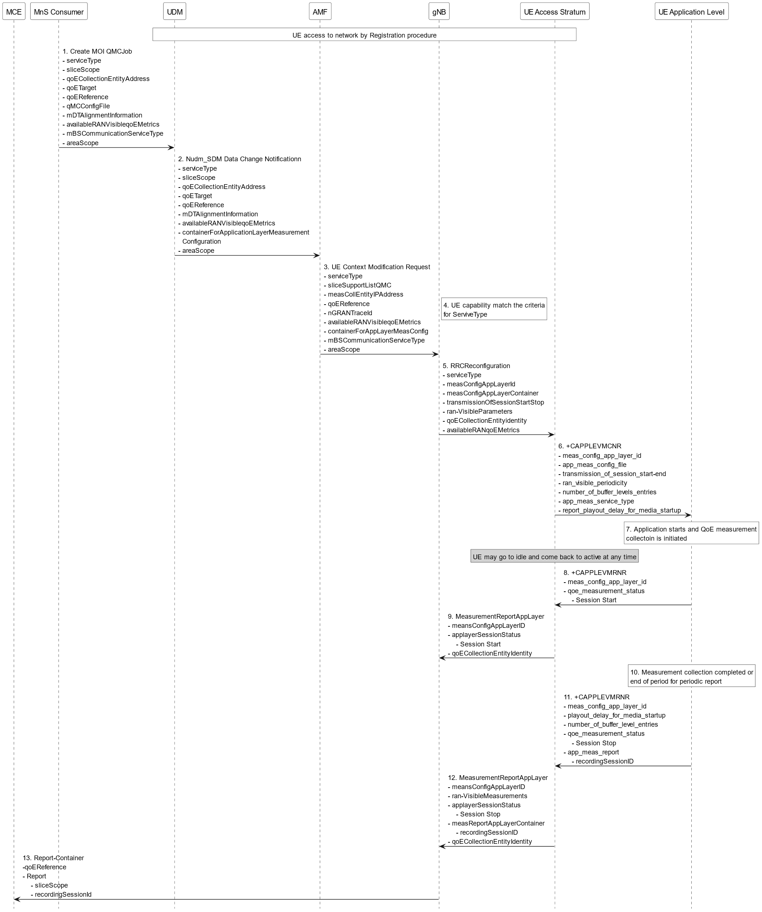
Figure 4.6.1.1-1: QMC activation and reporting example in NR after UE is registered

1. The MnS Consumer sends createMOI request for QMCJob to UDM that controls the impacted gNB(s), and includes the parameters: serviceType, sliceScope,areaScope, qoECollectionEntityAddress, qoETarget, qoEReference, mDTAlignmentInformation, availableRANqoEMetrics and qMCConfigFile.
2. The UDM inserts subscriber related data and forwards it to the AMF.
3. The AMF forwards the configuration parameters serviceType, areaScope,sliceSupportListQMC, measCollEntityIPAddress, qoEReference, nGRANTraceId, availablerANqoEMetrics and containerForAppLayerMeasConfig in message UE Context Modification Request to the impacted gNB.
4. The gNB checks if the UE capability matches the criteria for serviceType in the QoE measurement configuration information.
5. If the UE has the wanted UE capability, the gNB starts a UE request session and stores the associated qoECollectionEntityAddress, sends the message RRCReconfiguration to the UE including serviceType, measConfigAppLayerId, transmissionOfSessionStartStop, ran-VisibleParameters and measConfigAppLayerContainer.
If QoE measurement configuration pertains to MBS communication service, the gNB translates the qoECollectionEntityAddress into qoECollectionEntityIdentity and includes qoECollectionEntityIdentity in the RRCReconfiguration.
NOTE: The IE measConfigAppLayerId indicates the identity of the application layer measurement configuration, see [11].
6. The access stratum in the UE sends an unsolicited response to the application level including app-meas_service_type, meas_config_app_layer_id, transmission_of_session_start-end, ran_visible_periodicity, number_of_buffer_level_entries, report_playout_delay_for_media_startup, and app-meas_config_file. The unsolicited response is for the AT command +CAPPLEVMCNR which is sent from UE Application Level to UE Access Stratum during Registration procedure.
7. When the application for the specified serviceType starts, the QMC is initiated. To specify the session which is started, the application generates a recordingSessionId.
8. The application layer sends the AT command +CAPPLEVMRNR [7] including meas_config_app_layer_id and qoe_measurement_status that indicates that a session is started to the access stratum.
9. The UE sends the message MeasurementReportAppLayer including measConfigAppLayerId, appLayerSessionStatus and qoECollectionEntityIdentity to the gNB.
10. When the QMC is completed or at the end of period for periodic report, the recorded information is collected in a QMC report, see [6], [7] or [13].
11. The application layer sends the AT command +CAPPLEVMRNR [7] including meas_config_app_layer_id, playout_delay_for_media_startup, number_of_buffer_level_entries, qoe_measurement_status indicating that session has ended and app-meas_report including recordingSessionId to the access stratum.
12. The UE sends the message MeasurementReportAppLayer including measConfigAppLayerId, appLayerSessionStatus, ran-VisibleMeasurements and measReportAppLayerContainer including recordingSessionId and qoECollectionEntityIdentity to the gNB.
13. The gNB translates the qoECollectionEntityIdentity to the qoECollectionEntityAddress, if it is needed, and sends the QMC report to the MCE associated to the qoEReference. The report contains the qoEReference and the RAN transparent container including the recordingSessionId and sliceScope, which contains only the S-NSSAI used. Note that the qoEReference is mapped to the measConfigAppLayerId at gNB on the previous step and is included in QMC report.
Next modified section

4.6.1.2 Activation of QoE measurement task before UE Registration procedure to the network
Figure 4.6.1.2-1 and the text below describe the activation of QoE measurement collection before UE registration procedure to the network.
The AMF receives and stores QoE measurement collection job as part of API: Nudm_SDM. Then the same procedure for activation of measurement collection job is applied as after completion of UE registration procedure, except that instead of UE Context Modification Request the message Initial Context Setup Request is sent, see 4.6.1.1.

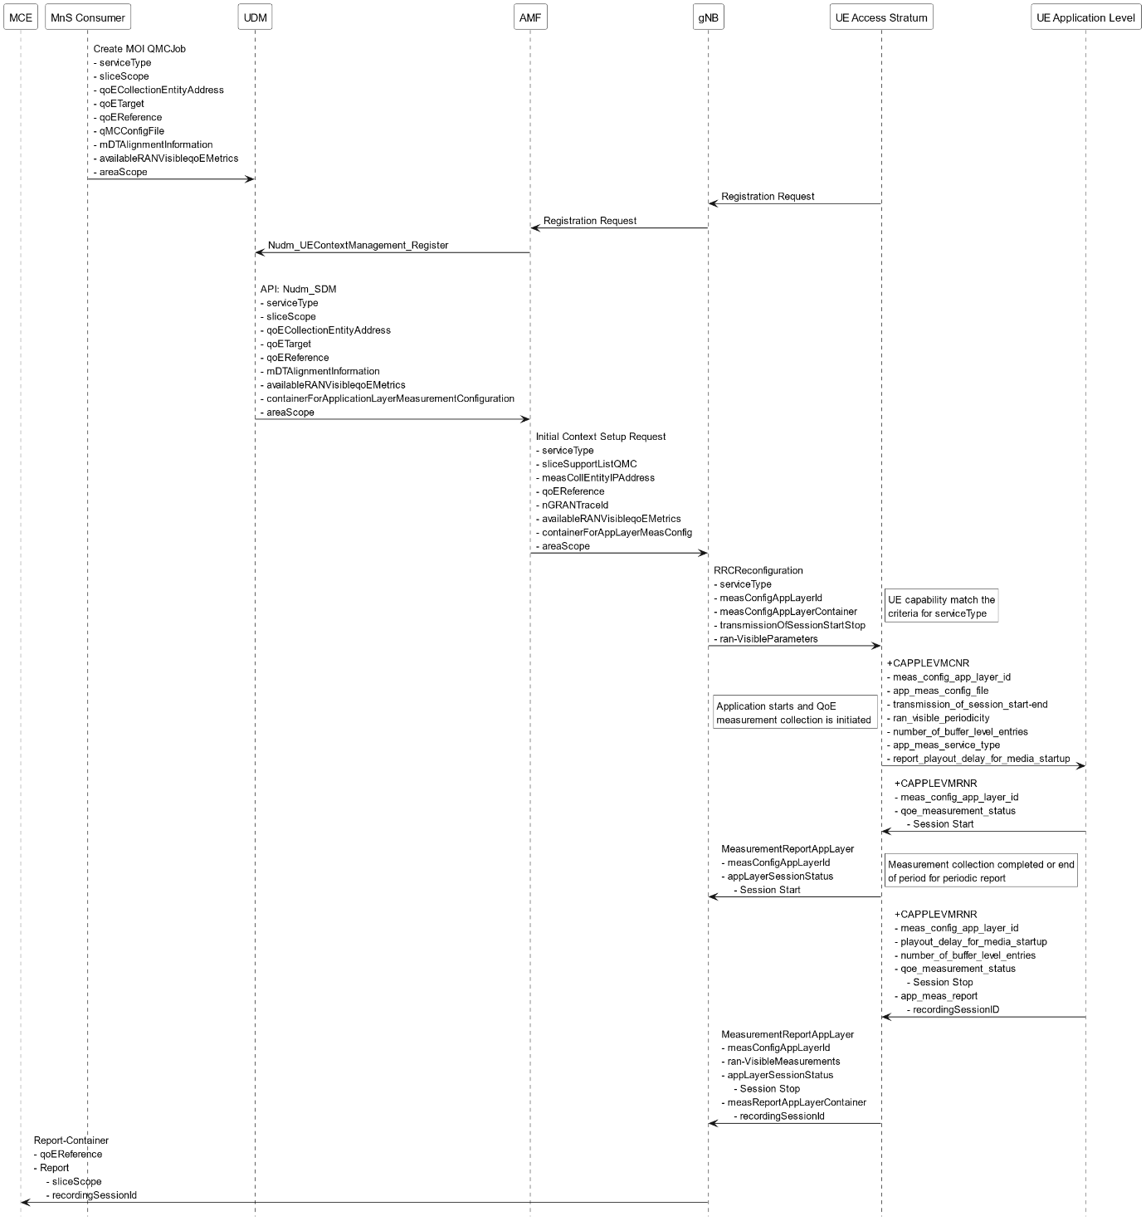
Figure 4.6.1.2-1: QMC activation and reporting example in NR before UE Registration procedure to the network
Next modified section

4.6.2 Handling of measurement collection at handover in NR

4.6.2.1 NG Based Handover for Signalling Based Activation
The figure 4.6.2.1-1 and the text below describe the handling at NG Based handover between gNBs for Signalling Based Activation case.

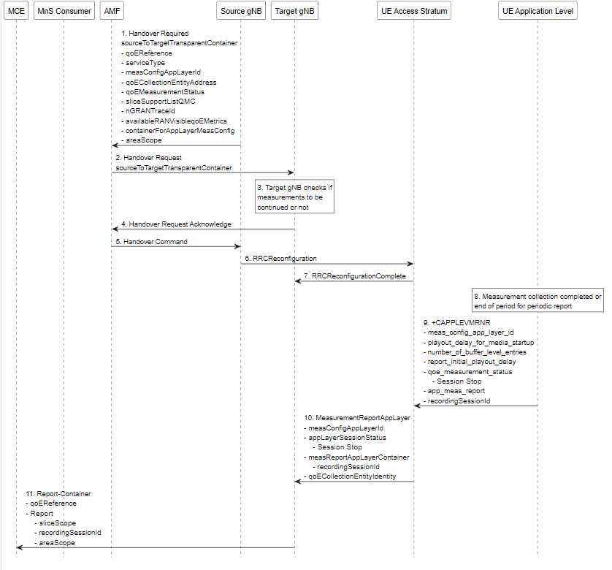
Figure 4.6.2.1-1: Handling of QMC activation example in case of NG Based handover in NR for Signalling Based Activation
1. Source gNB sends the message HANDOVER REQUIRED to AMF. The message includes the Source to Target Transparent Container which contains qoEReference, serviceType, measConfigAppLayerId,areaScope, measCollEntityIPAddress, qoEMeasurementStatus, sliceSupportListQMC, nGRANTraceId, availableRANVisibleqoEMetrics and containerForAppLayerMeasConfig.
2. AMF sends the message HANDOVER REQUEST to the Target gNB. The message includes the Source to Target Transparent Container which contains the same parameters as in step 1.
3. The target gNB checks if the measurements will be continued or not.
4. The target gNB sends the message HANDOVER REQUEST ACKNOWLEDGE to the AMF.
5. The AMF sends the message HANDOVER COMMAND to the source gNB.
6. The source gNB sends the message RRCReconfiguration to the UE.
7. The UE sends the message RRCReconfigurationComplete to the gNB.
8. When the ongoing QMC is completed or end of periodic reporting is reached, the recorded information is collected in a QMC report, see [6], [7] or [13], at UE Application Level.
9. The application layer sends the AT command +CAPPLEVMRNR including meas_config_app_layer_id, qoe_measurement_status playout_delay_for_media_startup, number_of_buffer_level_entries, report_initial_playout_delay, and the app-meas_report to the access stratum.
10. The UE sends the message MeasurementReportAppLayer including measConfigAppLayerId, appLayerSessionStatus, measReportAppLayerContainer, and qoECollectionEntityIdentity to the gNB.
11. The gNB translates the qoECollectionEntityIdentity into qoECollectionEntityAddress and sends the QMC report to the MCE associated to the qoEReference. The report contains the qoEReference and the RAN transparent container including the recordingSessionId and sliceScope (which contains only S-NSSAI that is used). Note that the qoEReference is mapped to the measConfigAppLayerId at gNB on the previous step and is included in QMC report.

Next modified section

5.4 Area scope (CM)
The area scope parameter defines the area in terms or cells or Tracking Area/Routing Area/Location Area where the QMC shall take place. If the parameter is not present the QMC shall be done throughout the PLMN specified in PLMN target.
The area scope parameter in UMTS is either:
- List of cells, identified by CGI. Maximum 32 CGI can be defined.
- List of Routing Area, identified by RAI. Maximum of 8 RAIs can be defined.
- List of Location Area, identified by LAI. Maximum of 8 LAIs can be defined.
The area scope parameter in LTE is either:
- list of cells, identified by E-UTRAN-CGI. Maximum 32 CGI can be defined.
- List of Tracking Area, identified by TAC. Maximum of 8 TAC can be defined.
The area scope parameter in NR is either:
- list of cells, identified by N-CGI. Maximum 32 NCGI can be defined.
- List of Tracking Area, identified by TAC. Maximum of 8 TAC can be defined.
- List of Tracking Area Identity, identified by TAC with associated plmn-Identity. Maximum of 8 TAI can be defined. For further details see also TS 38.331[8].
The parameter is mandatory if area based QMC is requested.
Next modified section

Annex A (informative):
Plant UML source code

A.1 QMC activation and reporting example in NR after UE is registered
The following PlantUML source code is used to describe QMC activation and reporting example in NR after UE is registered. As depicted by Figure 4.6.1.1-1:
@startuml
hide footbox

participant "MCE" #white
participant "MnS Consumer" #white
participant "UDM" #white
participant "AMF" #white
participant "gNB" #white
participant "UE Access Stratum" #white
participant "UE Application Level" #white

rnote over UDM, "UE Access Stratum"#white
UE access to network by Registration procedure
endnote
"MnS Consumer" -> "UDM" :1. Create MOI QMCJob\n- serviceType\n- sliceScope\n- qoECollectionEntityAddress\n- qoETarget\n- qoEReference\n- qMCConfigFile\n- mDTAlignmentInformation\n- availableRANVisibleqoEMetrics\n- mBSCommunicationServiceType\n- areaScope
"UDM" -> "AMF" :2. Nudm_SDM Data Change Notificationn\n- serviceType\n- sliceScope\n- qoECollectionEntityAddress\n- qoETarget\n- qoEReference\n- mDTAlignmentInformation\n- availableRANVisibleqoEMetrics\n- containerForApplicationLayerMeasurement\n Configuration\n- areaScope
"AMF" -> "gNB": 3. UE Context Modification Request\n- serviceType\n- sliceSupportListQMC\n- measCollEntityIPAddress\n- qoEReference\n- nGRANTraceId\n- availableRANVisibleqoEMetrics\n- containerForAppLayerMeasConfig\n- mBSCommunicationServiceType\n- areaScope
rnote right #white
4. UE capability match the criteria
for ServiveType
end note
"gNB" -> "UE Access Stratum" :5. RRCReconfiguration\n- serviceType\n- measConfigAppLayerId\n- measConfigAppLayerContainer\n- transmissionOfSessionStartStop\n- ran-VisibleParameters\n- qoECollectionEntityidentity\n- availableRANqoEMetrics
"UE Access Stratum" -> "UE Application Level": 6. +CAPPLEVMCNR\n- meas_config_app_layer_id\n- app_meas_config_file\n- transmission_of_session_start-end\n- ran_visible_periodicity\n- number_of_buffer_levels_entries\n- app_meas_service_type\n- report_playout_delay_for_media_startup
rnote over "UE Application Level" #white
7. Application starts and QoE measurement
collectoin is initiated
end note
rnote over "UE Access Stratum", "UE Access Stratum" #lightgray
UE may go to idle and come back to active at any time
end note
"UE Application Level" -> "UE Access Stratum": 8. +CAPPLEVMRNR\n- meas_config_app_layer_id\n- qoe_measurement_status\n - Session Start
"UE Access Stratum" -> "gNB": 9. MeasurementReportAppLayer\n- meansConfigAppLayerID\n- applayerSessionStatus\n - Session Start\n- qoECollectionEntityIdentity
rnote over "UE Application Level" #white
10. Measurement collection completed or
end of period for periodic report
end note
"UE Application Level" -> "UE Access Stratum": 11. +CAPPLEVMRNR\n- meas_config_app_layer_id\n- playout_delay_for_media_startup\n- number_of_buffer_level_entries\n- qoe_measurement_status\n - Session Stop\n- app_meas_report\n - recordingSessionID
"UE Access Stratum" -> "gNB": 12. MeasurementReportAppLayer\n- meansConfigAppLayerID\n- ran-VisibleMeasurements\n- applayerSessionStatus\n - Session Stop\n- measReportAppLayerContainer\n - recordingSessionID\n- qoECollectionEntityIdentity
"gNB" -> "MCE": 13. Report-Container\n-qoEReference\n- Report\n - sliceScope\n - recordingSessionId

@enduml

A.2 QMC activation and reporting example in NR before UE Registration procedure to the network
The following PlantUML source code is used to describe QMC activation and reporting example in NR before UE Registration procedure to the network. As depicted by Figure 4.6.1.1-1:

@startuml
hide footbox

participant "MCE" #white
participant "MnS Consumer" #white
participant "UDM" #white
participant "AMF" #white
participant "gNB" #white
participant "UE Access Stratum" #white
participant "UE Application Level" #white

"MnS Consumer" -> "UDM" :Create MOI QMCJob\n- serviceType\n- sliceScope\n- qoECollectionEntityAddress\n- qoETarget\n- qoEReference\n- qMCConfigFile\n- mDTAlignmentInformation\n- availableRANVisibleqoEMetrics\n- areaScope
"UE Access Stratum" -> "gNB" :Registration Request
"gNB" -> "AMF":Registration Request
"AMF" -> "UDM":Nudm_UEContextManagement_Register
|||
"UDM" -> "AMF" :API: Nudm_SDM\n- serviceType\n- sliceScope\n- qoECollectionEntityAddress\n- qoETarget\n- qoEReference\n- mDTAlignmentInformation\n- availableRANVisibleqoEMetrics\n- containerForApplicationLayerMeasurementConfiguration\n- areaScope
"AMF" -> "gNB" :Initial Context Setup Request\n- serviceType\n- sliceSupportListQMC\n- measCollEntityIPAddress\n- qoEReference\n- nGRANTraceId\n- availableRANVisibleqoEMetrics\n- containerForAppLayerMeasConfig\n- areaScope
"gNB" -> "UE Access Stratum" :RRCReconfiguration\n- serviceType\n- measConfigAppLayerId\n- measConfigAppLayerContainer\n- transmissionOfSessionStartStop\n- ran-VisibleParameters
rnote right #white
UE capability match the
criteria for serviceType
end note
"UE Access Stratum" ->"UE Application Level":+CAPPLEVMCNR\n- meas_config_app_layer_id\n- app_meas_config_file\n- transmission_of_session_start-end\n- ran_visible_periodicity\n- number_of_buffer_level_entries\n- app_meas_service_type\n- report_playout_delay_for_media_startup
rnote left#white
Application starts and QoE
measurement collection is initiated
end note
"UE Application Level" ->"UE Access Stratum":+CAPPLEVMRNR\n- meas_config_app_layer_id\n- qoe_measurement_status\n - Session Start
"UE Access Stratum" -> "gNB": MeasurementReportAppLayer\n- measConfigAppLayerId\n- appLayerSessionStatus\n - Session Start
rnote right#white
Measurement collection completed or end
of period for periodic report
end note
"UE Application Level" ->"UE Access Stratum":+CAPPLEVMRNR\n- meas_config_app_layer_id\n- playout_delay_for_media_startup\n- number_of_buffer_level_entries\n- qoe_measurement_status\n - Session Stop\n- app_meas_report\n - recordingSessionID
"UE Access Stratum" -> "gNB": MeasurementReportAppLayer\n- measConfigAppLayerId\n- ran-VisibleMeasurements\n- appLayerSessionStatus\n - Session Stop\n- measReportAppLayerContainer\n - recordingSessionId
"gNB" -> "MCE":Report-Container\n- qoEReference\n- Report\n - sliceScope\n - recordingSessionId
@enduml

A.3 Handling of QMC activation example in case of NG Based handover in NR for Signalling Based Activation
The following PlantUML source code is used to describe the procedure for SNPN provisioning with 3GPP segments only, as depicted by Figure 4.6.2.1-1:

@startuml
hide footbox

participant "MCE" #white
participant "MnS Consumer" #white
participant "AMF" #white
participant "Source gNB" #white
participant "Target gNB" #white
participant "UE Access Stratum" #white
participant "UE Application Level" #white

"Source gNB" -> "AMF":1. Handover Required\nsourceToTargetTransparentContainer\n- qoEReference\n- serviceType\n- measConfigAppLayerId\n- qoECollectionEntityAddress\n- qoEMeasurementStatus\n- sliceSupportListQMC\n- nGRANTraceId\n- availableRANVisibleqoEMetrics\n- containerForAppLayerMeasConfig\n- areaScope

"AMF" -> "Target gNB":2. Handover Request\nsourceToTargetTransparentContainer
rnote over "Target gNB" #white
3. Target gNB checks if
measurements to be
continued or not
end note
"Target gNB" -> "AMF":4. Handover Request Acknowledge
"AMF" -> "Source gNB":5. Handover Command
"Source gNB" -> "UE Access Stratum":6. RRCReconfiguration
"UE Access Stratum" -> "Target gNB":7. RRCReconfigurationComplete
rnote over "UE Application Level" #white
8. Measurement collection completed or
end of period for periodic report
end note

"UE Application Level" -> "UE Access Stratum":9. +CAPPLEVMRNR\n- meas_config_app_layer_id\n- playout_delay_for_media_startup\n- number_of_buffer_level_entries\n- report_initial_playout_delay\n- qoe_measurement_status\n - Session Stop\n- app_meas_report\n- recordingSessionId

"UE Access Stratum" -> "Target gNB":10. MeasurementReportAppLayer\n- measConfigAppLayerId\n- appLayerSessionStatus\n - Session Stop\n- measReportAppLayerContainer\n - recordingSessionId\n- qoECollectionEntityIdentity
"Target gNB" -> "MCE":11. Report-Container\n- qoEReference\n- Report\n - sliceScope\n - recordingSessionId\n - areaScope

@enduml
End of change

