3GPP TSG-SA5 Meeting #155 S5-243304d1
Jeju, South Korea, 27 - 31 May 2024

Source: China Unicom

Title: Add potential solution for metric of RedCap RRC connection number

Document for: Approval
Agenda Item: 6.19.17

1 Decision/action requested
The group is asked to approve the proposal.

2 References
[1] 3GPP TR 28.876: “Management aspects of RedCap feature”
[2] 3GPP TS 28.552: “Management and orchestration;5G performance measurements”
[3] 3GPP TS 28.554: "Management and orchestration; 5G end to end Key Performance Indicators (KPI)"

3 Rationale
It was approved in SP-231734 to study the management of aspects of RedCap features. One of the working taks is to investigate the measurements and KPIs to evaluate the performance of NR networks delivering communication services for RedCap UEs. A use case and requirement on metric of RedCap RRC connection number evaluation are approved in the last meeting. In order to satisfy the requirement mentioned above, a potential solution on metric of RedCap RRC connection number is proposed in this contribution.

4 Detailed proposal
This contribution proposes to make the following changes in [1].
1st Change

5.3 Use case #3: Metric of RedCap RRC connection number

5.3.1 Description
Industry sensors scenario is a typical use case of RedCap technology. It’s desirable in this scenario to connect different kinds of sensors to 5G network as mentioned in TR 38.875 [6]. According to TS 22.104 [8] and TR 22.804 [9], this use case has a requirement on UE density to ensure enough number of devices enjoying communication service.
RRC connection number is an indispensable performance metric for 5G NR, indicating the number of UEs connected to gNB simultaneously. lt can reflect NR performances to operators.
The current measurements related to RRC connection number specified in TS 28.552 [10] are all performed without recognizing the UE type. Therefore, it’s difficult to accurately determine the number of RedCap UEs connected to NR, especially when different type of UEs co-exist. Consequently, it is important to investigate how to define metric for RRC connection number of RedCap UEs. It will assist operators in understanding the resource load brought by RedCap and enable dynamic resource allocation.

5.3.2 Potential requirements
REQ-RedCap_Perf_RRCNum: The MnS shall have capability to provide measurements or KPIs related to RedCap RRC connection number in NR network.

5.3.3 Potential Solutions

5.3.3.1 Potential solution #1
This solution proposes to reuse and enhance the exsiting measurements related to RRC connection number defined in TS28.552 [10] for this use case.
Current measurements about RRC connection number includes Mean number of RRC Connections, Max number of RRC Connections, Mean number of stored inactive RRC Connections, Max number of stored inactive RRC Connections, etc. In order to achieve the requirement in clause 5.3.2, most aspects of the existing measurments can be reused and some enhancements also need to be introduced.
In radio access procedure in 5G system, UEs (no matter legacy UEs or RedCap UEs) need to report to gNB about the NR UE Radio Access Capability Parameter using UE-NR-Capability IE, which is specified in clause 6.3.3 in TS 38.331 [2]. RedCapParameters is part of UE-NR-Capability IE which can be deliverd by the UE capability inquiry process. The detailed descprition about RedCapParameters is shown as follows,
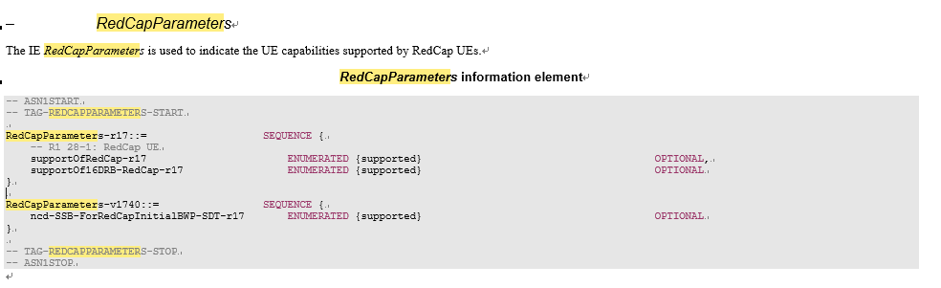
Based on the procedures above, gNB can be aware of whether the UE is RedCap or not when a UE tries to access to NG-RAN. Consequestly, the measurements that performed after the inquiry of UE capability can be seperated for different types of UEs.
When there is more than one type of UEs (e.g. RedCap UEs, eMBB UEs) covered by a cell, the filter needs to be enhanced to optionally separate the measurement into subcounters to represent the RedCap RRC connection number.
Take the Mean number of RRC Connection as an example:
- Introduce a new filter which can be named as NewFilter, then RRC.ConnMean can be optionally separate as RRC.ConnMean.NewFilter to represent RedCap RRC connection number when the value of NewFilter is RedCap.
The subcounters filtered by the new filter with the value of RedCap can be used as metrics of RedCap RRC connection number.

5.3.4 Evaluation of potential solutions
TBD

End of changes

