3GPP TSG-SA5 Meeting #155 S5-243295
Jeju, South Korea, 27 - 31 May 2024

Source: China Telecom

Title: potential solution for Management of connections between RAN node on-board satellite and AMF (regenerative mode)

Document for: Approval
Agenda Item: 6.19.15

1 Decision/action requested
The group is asked to discuss and agree on the proposal.

2 References
[1] 3GPP TS 38.300: "NR; Overall description; Stage-2".
[2] 3GPP TR 23.700-29: " Study on integration of satellite components in the 5G architecture Phase 3".

3 Rationale
The NTN gateway provides IP connectivity between the network elements on-board satellites and terrestrial network. The definition of NTN gateway is as follows.
--- Start of quote from TS 38.300 ---
NTN Gateway: an earth station located at the surface of the earth, providing connectivity to the NTN payload using the feeder link. An NTN Gateway is a TNL node.
Feeder link: wireless link between the NTN Gateway and the NTN payload.
NTN payload: a network node, embarked on board a satellite or high altitude platform station, providing connectivity functions, between the service link and the feeder link. In the current version of this specification, the NTN payload is a TNL node.
---End quote---
For the scenario in the Rel-19 study that considers gNB/eNB on-board satellites, the NTN gateway will provide the IP connectivity between the gNB/eNB and AMF/MME.
It is important to note that due to gNB/eNB mobility, when LEO/MEO satellites leave the source NTN gateway coverage area, this may result in the feeder link switchover from the source NTN gateway to the target NTN gateway. The feeder link switchover has been specified in TS 38.300.
--- Start of quote from TS 38.300 ---
A feeder link switchover is the procedure where the feeder link is changed from a source NTN Gateway to a target NTN Gateway for a specific NTN payload. The feeder link switchover is a Transport Network Layer procedure.
---End quote---
In this case, the IP connection between the gNB/eNB and the AMF/MME will change regularly.
Observation 1: The switchover of the feeder link between the NTN gateways will result in the IP connection between the gNB/eNB and the AMF/MME changing regularly.
The connectivity between the network elements on-board satellites and NTN gateways has been specified in TS 38.300 [1].
--- Start of quote from TS 38.300---
The following connectivity is supported by the NTN payload:
- An NTN gateway may serve multiple NTN payloads;
- An NTN payload may be served by multiple NTN gateways.
For soft feeder link switch over, an NTN payload is able to connect to more than one NTN Gateway during a given period, i.e. a temporary overlap can be ensured during the transition between the feeder links.
For hard feeder link switch over, an NTN payload connects to only one NTN Gateway at any given time, i.e. a radio link interruption may occur during the transition between the feeder links.
Both hard and soft feeder link switchover are supported in NTN.
---End quote---
The connection relationship among gNB/eNB, gateway, and AMF/MME is as described in TR 23.700-29 [2].
--- Start of quote from TR 23.700-29---
gNB connects to the same AMF via a different gateway (e.g. Annex A, Figure A-3).
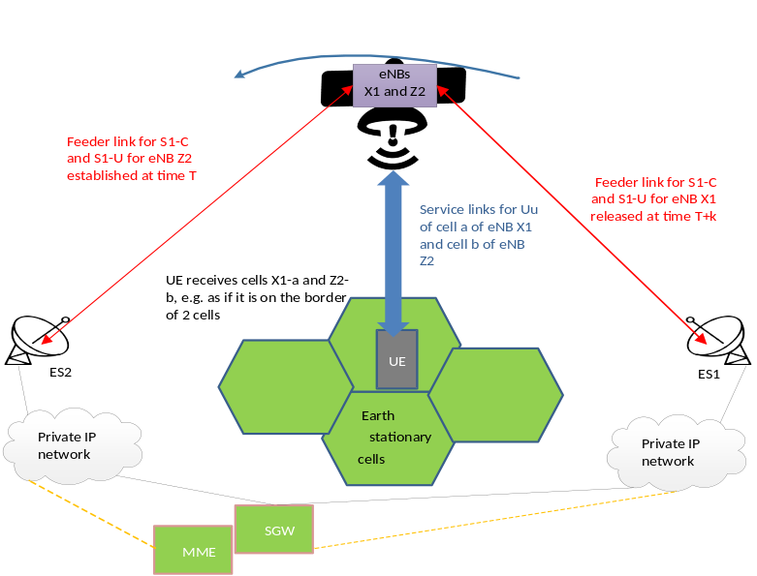
gNB connects to a different AMF via a different gateway (e.g. Annex A, Figure A-4)
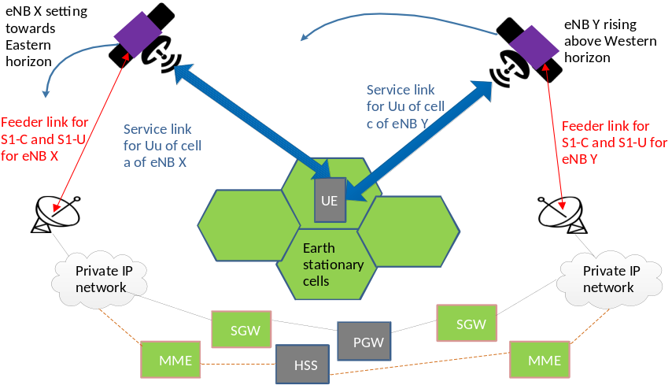
---End quote---
Observation 2: The gNB/eNB on-board satellites connect/disconnect the AMF/MME via the same gateway or different gateways.
Based on the above observations, we find that the IP connectivity between the gNB/eNB and the AMF/MME changes depending on whether the feeder link is connected or disconnected.
Proposal: 3GPP management system configures the gNB/eNB and AMF/MME when a feeder link is connected or disconnected.

4 Detailed proposal
Start of 1st Change

5.1.1 Use case #1: Connections between RAN node on-board satellite and CN (regenerative mode)

5.1.1.1 Description
When non-geo synchronized objects like LEO and MEO satellites are used for the NTN system, the satellites will not always be at the same position relative the earth’s surface, and the coverage area on the earth surface for one satellite varies over time.
One consequence of non-geosynchronous satellites is that the associations between the entities on ground segment and entities in space segment are changing frequently, typically with a period of one to several minutes.

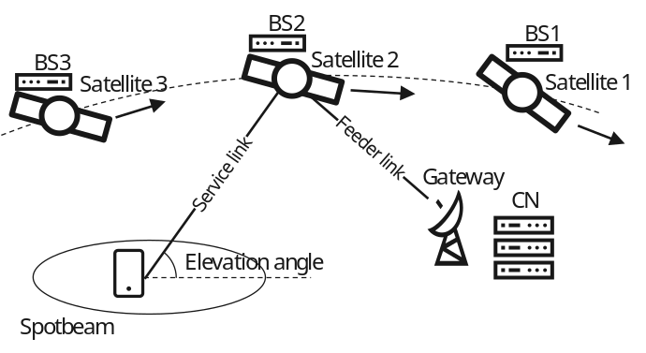
Figure 5.1.1.1-1 Non-geosynchronous satellites in NTN with regenerative gNB processed satellite payload
Fig. 5.1.1.1-1 illustrates this association change in an NTN system with regenerative gNB satellite payload. In this case, the ground segment Core Network (CN) will serve the same spotbeams all the time, while the space segment gNB on different satellites (satellite 1, 2 and 3) will serve the spotbeam in different time period as the satellites are approaching and leaving the coverage of the spotbeam over time. From management point of view, it will e.g. impact the association between GNBCUCPFunction and AMFFunction.
Another issue is the topology between space segment Managed Element (MnS producer) and the ground based Management System (MnS consumer): With long distances in between, disturbances (e.g. bad weather conditions), and partial reachability issues (when satellites fly over oceans with no gateway coverage), the latency, availability and reliability of the interface between them (feeder link + Inter-satellite link) are impacted.
Summary:
For the deployment scenario of RAN nodes on-board satellites, this would result in the following scenario: a LEO or MEO satellite with an onboard RAN node leaves the coverage area of a CN and then returns to the coverage area of that CN after cycling around the Earth.
From the operator’s perspective, it’s necessary to investigate how to efficiently manage the connections between RAN nodes and CN to avoid errors in CN due to stale connections, e.g. AMF/MME sending paging requests or AMF configuration updates to an unavailable RAN node. For example, 3GPP management system configures AMF/MME and/or gNB/eNB to add necessary information to support their awareness of when connectivity between a RAN node and a CN NF is available or unavailable.

5.1.1.2 Potential requirements
REQ-NTN-REGCON-1：3GPP MnS producer should have the capability to configure the connections between RAN nodes on-board satellite and 5GC on an unreliable management interface.

5.1.1.3 Potential solutions

5.1.1.3.x Potential solution #<x>: <Pre-configuration of the gNB/eNB and AMF/MME before connections between them are established or lost >
This is a candidate solution for Use case #1: Connections between RAN node on-board satellite and CN (regenerative mode).
As described in Use case #1, the connections between gNB/eNB on-board satellite and AMF/MME on the ground changes frequently, typically because the periodic connecting/disconnecting of the gNB/eNB on-board satellite to the gateways. Therefore, this solution proposes to take the connecting/disconnecting of the gNB/eNB on-board satellite to the gateways as an event that triggers the 3GPP management to perform configuration operations on the gNB/eNB and AMF/MME.
The solution addresses the scenario where the gNB/eNB on-board satellite is connected to one or more gateways simultaneously during a given period, and the AMF/MME on the ground associated with the gateway can be different or the same. Figure 5.1.1.3.x-1 shows an example deployment scenario.
- Case I: gNB/eNB connects to the same AMF/MME via a different gateway (e.g. gNB/eNB connects AMF/MME 3 via Gateway 2 or Gateway 3).
- Case II: gNB/eNB connects to a different AMF/MME via a different gateway (e.g. gNB/eNB connects AMF/MME 2 via Gateway 2).
The attribute localAddress in EP_NgC/EP_RP_EPS instances will have the different value if the connection between gNB/eNB and AMF/MME is via the different gateway.
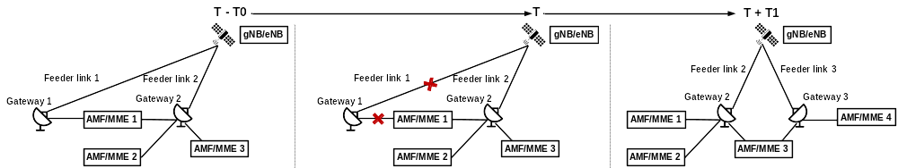
Figure 5.1.1.3.x-1 Example scenario of connections between RAN node on-board satellite and CN.
hhe cect on-board satelliteaway is st system creates multiple EP_N)/EP_RP_EPS (one eNB side) and EP_N2 (on AMF side)/ EP_RP_EPS (on MME side) instances to handle the multiple connectivity links between gNB/eNB on-board satellite and AMF/MME on the ground, and adds new attributes representing creates/modifies the connection availability duration information in EP_NgC, EP_N2 aon the gNB/eNB and/or AMF/MME.
Before the connection between gNB/eNB on-board satellite and gateway is lost, the 3GPP management system may removes/modifies the EP_NgC /EP_RP_EPS and EP_N2/ EP_RP_EPS instances and removes/modifies the relevant connection availability duration information.
The connection availability duration information is a list that provides the time when the gNB/eNB has a connection to a AMF/MME and the time when the connection is disconnected.
hatnfigurationRP_EPS and EP_P_RPollowsting princ:- Attribute localAddress in EP_NgC/EP_RP_EPS instances will have the same value if the connection between gNB/eNB and AMF/MME is via the same gateway, otherwise the values will be different.
AtrmoteAddrsEP_RP_EPS intes ave th the gNB/ame AMF/MME, otherwise es wilAttribute remoteAddress in EP_N2/EP_RP_EPS instances will have the same value if the connection between gNB/eNB and AMF/MME is via the same gateway, otherwise the values will be different.

