3GPP TSG-SA5 Meeting #155 S5-243279
Jeju, South Korea, 27 - 31 May 2024

Source: Huawei, Nokia, Nokia Shanghai Bell, ZTE

Title: Discussion on the issues for ManagedNFService in generic model in TS 28.622 and TS 28.623

Document for: Endorsement
Agenda Item: 6.19.13

1 Decision/action requested
The group is asked to discuss and approval.

2 References
[1] 3GPP TS 28.622: "Telecommunication management; Generic Network Resource Model (NRM) Integration Reference Point (IRP); Information Service (IS) "
[2] 3GPP TS 28.623: "Telecommunication management; Generic Network Resource Model (NRM) Integration Reference Point (IRP); Solution Set (SS) definitions"
[3] 3GPP TS 28.541: "Management and orchestration; 5G Network Resource Model (NRM); Stage 2 and stage 3"

3 Rationale

3.1 Background
The ManagedNFService IOC is defined in TS 28.622 [1] as follows:
/***********************Abstract from TS 28.622 [1]***************************/

4.2.1 Relationships
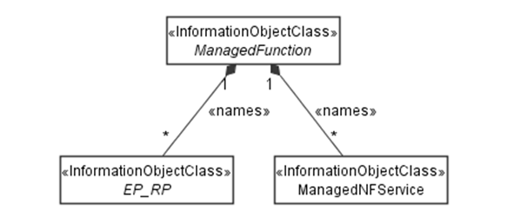

4.3.17 ManagedNFService

4.3.17.1 Definition
A ManagedNFService represents a Network Function (NF) service as defined in clause 7 of 3GPP TS 23.501[22].

4.3.17.2 Attributes
The ManagedNFService IOC includes attributes inherited from Top IOC (defined in clause 4.3.29) and the following attributes:
Attribute Name | S | isReadable | isWritable | isInvariant | isNotifyable
administrativeState | M | T | T | F | T
operationalState | M | T | F | F | T
userLabel | O | T | T | F | T
nFServiceType | M | T | F | T | F
sAP | M | T | T | F | T
operations | M | T | T | F | T
usageState | M | T | F | F | T
registrationState | CM | T | F | F | T

4.3.17.3 Attribute constraints
Attribute constraint for registrationState: The attribute registrationState should be supported by instance of a ManagedNFService if the service is designed for being published and discovered by other NFs, and need to be registered to a repository function. E.g. Authentication service provided by AUSF should include this attribute. NF management services provided by NRF don’t include this attribute.

4.3.17.4 Notifications
The common notifications defined in clause 4.5 are valid for this IOC, without exceptions or additions

4.4.1 Attribute properties
The following table defines the properties of attributes specified in the present document.

……
nFServiceType | The parameter defines the type of the managed NF service instance  allowedValues: See clause 7.2 of TS 23.501[22]  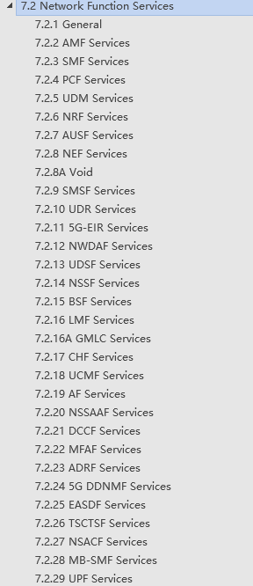 | type: ENUM  multiplicity: 1  isOrdered: N/A  isUnique: N/A  defaultValue: None  isNullable: False
operations | This parameter defines set of operations supported by the managed NF service instance.  allowedValues: See TS 23.502[23] for supporting operations | type: Operation  multiplicity: 1..*  isOrdered: False  isUnique: True  defaultValue: None  isNullable: False
Operation.name | This parameter defines the name of the operation of the managed NF service instance.  allowedValues: N/A | type: String  multiplicity: 1  isOrdered: N/A  isUnique: N/A  defaultValue: None  isNullable: True
allowedNFTypes | This parameter identifies the type of network functions allowed to access the operation of the managed NF service instance.  allowedValues: See TS 23.501[22] for NF types  - NRF  - UDM  - AMF  - SMF  - AUSF  - NEF  - PCF  - SMSF  - NSSF  - UDR  - LMF  - GMLC  - 5G_EIR  - SEPP  - UPF  - N3IWF  - AF  - UDSF  - DN  - BSF  - CHF  - NWDAF  - PCSCF  - CBCF  - HSS  - UCMF  - SOR_AF  - SPAF  - MME  - SCSAS  - SCEF  - SCP  - NSSAAF  - ICSCF  - SCSCF  - DRA  - IMS_AS  - AANF  - 5G_DDNMF  - NSACF  - MFAF  - EASDF  - DCCF  - MB_SMF  - TSCTSF  - ADRF  - GBA_BSF  - CEF  - MB_UPF  - NSWOF  - PKMF  - MNPF  - SMS_GMSC  - SMS_IWMSC  - MBSF  - MBSTF  - PANF  - TNGF  - W_AGF  - TWIF  - TSN_AF | type: ENUM  multiplicity: 1..*  isOrdered: False  isUnique: True  defaultValue: None  isNullable: False
operationSemantics | This paramerter identifies the semantics type of the operation. See TS 23.502[23]  allowedValues: “Request/Response”, “Subscribe/Notify”. | type: ENUM  multiplicity: 1  isOrdered: N/A  isUnique: N/A  defaultValue: None  isNullable: False
……

/***********************Abstract from TS 28.622 [1]***************************/

3.2 Observations
Based on the analysis of above yellow highlighted text, it is clear that ManagedNFService IOC is only applicable for the management of 5GC NFs defined in TS 23.501.

3.3 Issues
Issue#1: From specification view, TS 28.622 defines the generic model which is agnostic to generation and domains, however, the ManagedNFService IOC is 5GC specific.
Issue#2: ManagedNFService is name-contained by ManagedFunction which is also inherited by NG-RAN ManagedFunction (e.g. GNBCUCPFunction), it gives impression that GNBCUCPFunction also name contained ManagedFunctionService. See below:
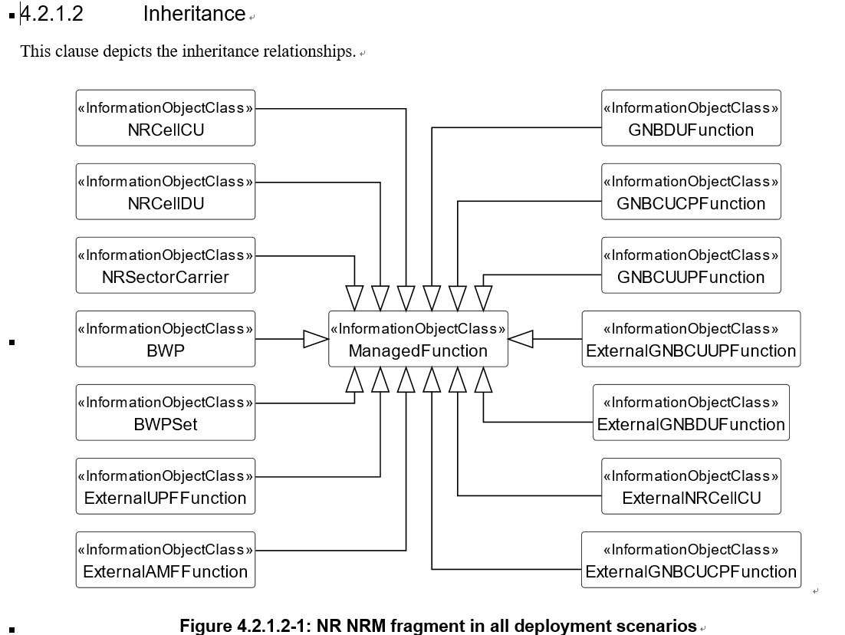
Following is one example in stage3:
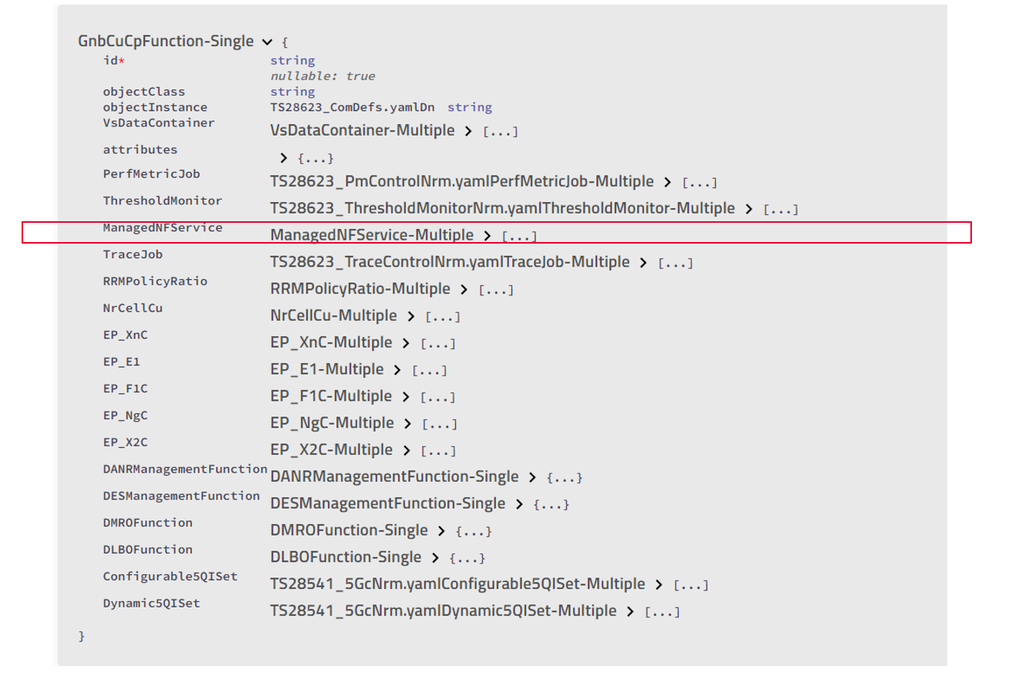

Following are the detailed proposals to address above issues:
Proposal#1: Move NRM Fragment definition for ManagedNFService from generic information model definitions in TS 28.622/623 to 5GC NRM information model definitions in TS 28.541.
Proposal#2: Add statement in TS 28.541 to describe the name containment relationship (ManagedFunction name containing ManagedNFService) only applied for 5GC NRM.

4 Detailed proposal
Following are the detailed proposals to address above issues:
Proposal#1: Move NRM Fragment definition for ManagedNFService from generic information model definitions in TS 28.622/623 to 5GC NRM information model definitions in TS 28.541.
Proposal#2: Add statement in TS 28.541 to describe the name containment relationship (ManagedFunction name containing ManagedNFService) only applied for 5GC NRM..

