3GPP TSG-SA5 Meeting #155 S5-243251
Jeju, South Korea, 27 - 31 May 2024

Source: Huawei

Title: Add exposure roles and concepts

Document for: Approval
Agenda Item: 6.19.21

1 Decision/action requested
Group is asked to approve this proposal.

2 References
[1] 3GPP TS 28.879 Study on OAM for service management and exposure to external consumers

3 Rationale
There are multiple concepts and solutions focusing on exposure, the group needs to align the understanding on the following issues:
- Roles related to exposure of management services: means who may contribute and get involved into the exposure discussion.
- Concept of potential consumer: whether it’s necessary to differentiate the external consumer and internal consumer.
- What information/services to be exposed to serve management purpose: exposure with management services (i.e. by means of using component A/B/C) or abstraction information of management services with other interface format (e.g. openAPI etc.).
- Relation between SA5 exposure mechanism with the exposure solutions in other working groups: mainly SA6 and TM forum, need to have an integrated view on the relations with other groups.

4 Detailed proposal
It’s proposed to make the following change to TR 28.879.

4 Concepts and Background

4.0 Roles related to exposure of management services
The role concepts CSP, CSC and NOP as defined in TS 28.530 clause 4.8 apply here in the context of exposure of management services.

4.1 Exposure of management services

4.1.0 Background of existing solutions
A MnS can be available (i.e., instantiated, and ready to be exposed) and hence discoverable by internal and external MnS consumers. An available MnS is described by the MnsInfo IOC (see clause 4.3.42 of TS 28.622 [3]). The available MnSs in the 3GPP management system can be found in the MnSRegistry IOC (see clause 4.3.41 of TS 28.622 [3]) and the use case procedures for discovery are described clause 5 in TS 28.537 [4]. In the study, we will focus on how the external MnS consumer can leverage external exposure frameworks (e.g., the CAPIF framework [5]) to access and consume management services with regards to all the stages involved: publishing, discovery and access control.

4.1.1 Overview

4.1.2 Exposure of management service
The present document studies a generic approach to expose management services to MnS consumers. A management service (MnS) is identified by different component types, i.e., MnS component type A (management operations or notifications), MnS component type B (managed objects), and MnS component type C (performance and fault information) (as defined in clause 4.2 of TS 28.533[2]). In order for the MnS consumer to consume management services, the access rights have to be configured for the MnS consumer accordingly. The access rights determine what MnS managed objects and related information (i.e. component type B or C and their associated information) of the MnS they can access. In addition, the access rights also determine what operations (i.e. MnS component A) the MnS consumer can or cannot perform.
For example, considering Figure 4.1.1-1, the MnS A producer produces MnS A that is directly consumed by the internal MnS consumer and the external MnS consumers 1 and 2 respectively. Depending on the different access rights assigned to the MnS consumers, it’s possible that:
- The internal MnS Consumer and external MnS Consumer 1 and 2 can access the same or different managed objects under the management scope of MnS A producer.
- The operations (i.e., CRUD) or notifications that internal MnS Consumer and external MnS Consumer 1 and 2 can perform on the accessed managed objects are the same or different.
- The internal MnS Consumer and external MnS Consumer 1 and 2 can or cannot access the same or different performance and fault information associated with the accessible managed objects of MnS A.

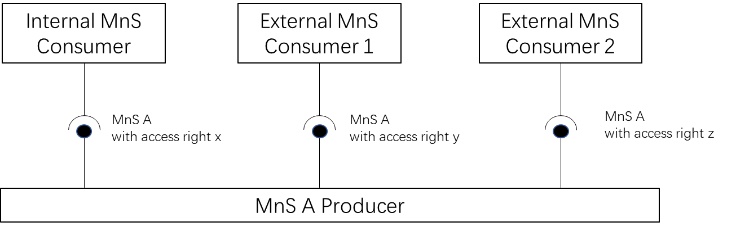

Figure 4.1.1-1: Example of Exposing Management Services concept.
To provide a MnS to be consumed, it first needs to be published to the MnS discovery producer entity. After it’s published, the MnS will be available to be discovered by the MnS consumers. Following discovery, authentication and authorization mechanisms need to be applied to ensure that the MnS consumers only have access to the allowed MnS component type A, B, or C for the MnS.

