3GPP TSG-SA5 Meeting #155 S5-242980
Jeju, South Korea, 27 May - 31 May 2024

Source: Samsung

Title: Energy Saving by adaptable QoS Service

Document for: Approval
Agenda Item: 6.19.20

1 Decision/action requested
In this box give a very clear / short /concise statement of what is wanted.

2 References
[1] 3GPP TR 28.880: "Study on energy efficiency and energy saving aspects of 5G networks and services"

3 Rationale
This provides the new use case of energy saving by adapting some of the UE services QoS parameters as per a pre-agreement between subscriber and the operator. By using such adaptable service the performance requirements on the network can be reduced in order to achieve energy saving.

4 Detailed proposal
The following changes are proposed for TR 28.880[1].
First Change

5.X Use case #X: Energy saving by conversion to adaptable QoS service

5.X.1 Description
5G system architecture characterise the 5G services with the QoS model. 5G QoS model is based on QoS flows. A QoS flow ID (QFI) identifies a QoS flow in the 5G system where same traffic forwarding treatment is applied to the user plane traffic with the same QFI. Each QoS flow is specified by a set of QoS parameters and QoS characteristics in 3GPP TS 23.501. Adaptable QoS service can be defined by lowering some of the QoS requirements for each service. For example, any service identified by 5QI=X1 requiring high throughput can be reconfigured into a adaptable service by adjusting the QoS parameters such as guaranteed flow bit rate (GFBR) and maximum flow bit rate (MFBR) to lower down throughput requirements for the network. Alternatively, a service’s QoS criteria can be removed all together turning that service into a best-effort traffic [TS 22.261]. This modification of QoS criteria will result in reduced performance requirements for the network and hence, resulting in reduced energy consumption. Energy saving method can be based on defining an environmentally friendly adaptable QoS serviceand dynamically switch users to such service when a significant energy saving is predicted in network. Adaptable QoS service will only be utilised when a much larger energy saving is predicted by the network, so only during limited time intervals.
This may also be used in extending the time for which a network node remain in energy saving mode. A cell energy saving mode time is depicted in figure below where a capacity cell is put to energy saving mode when the load is lower than the energy saving mode threshold. A adaptable QoS load threshold is also defined which will specify a load threshold at which service(s) can be converted into adaptable QoS service. When cell load is above the energy saving mode threshold but lower than adaptable QoS load threshold, userss services QoS parameters can be reconfigured so that they utilise less resources in the cell. Consequently, cell load is expected to reduce down to the energy saving mode threshold earlier and the cell is put to energy saving mode earlier to further increase energy saving. Figure below illustrates the cell load reduction due to adaptable QoS reconfiguration and the extended time of energy saving mode for a cell.

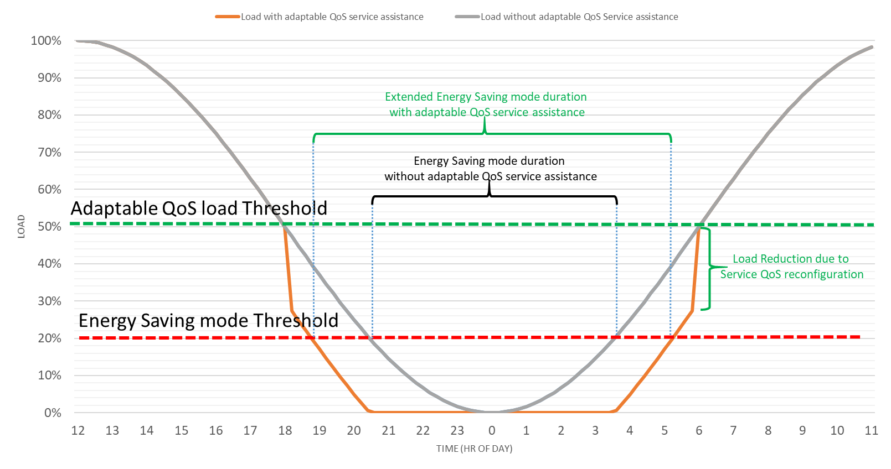

5.X.2 Potential requirements
REQ-Energy_Saving_AdaptQoS-ES-1: The 3GPP management system should have capability enabling authorized consumers to request for modification of an existing service into a adaptable QoS Service.
Note: A existing service can be modified to save energy by lowering some of its QoS parameters. For example, any service identified by 5QI=X1 requiring high throughput can be reconfigured by adjusting its QoS parameters such as guaranteed flow bit rate (GFBR) and maximum flow bit rate (MFBR) in order to reduce performance requirements on the network. Alternatively, a service’s QoS criteria can be removed all together turning that service flow into a best-effort traffic
REQ-Energy_Saving_AdaptQoS-ES-2: The 3GPP management system should have capability enabling authorized consumers to configure a load based threshold which when crossed the QoS parameter values of a service can be reduced. .

End of Changes

