3GPP TSG-SA5 Meeting #155 S5-242980
Jeju, South Korea, 27 May - 31 May 2024

Source: Samsung

Title: Energy Saving by Green Service

Document for: Approval
Agenda Item: 6.19.20

1 Decision/action requested
In this box give a very clear / short /concise statement of what is wanted.

2 References
[1] 3GPP TR 28.880: "Study on energy efficiency and energy saving aspects of 5G networks and services"

3 Rationale
This provides the new use case of energy saving by converting some of the UE services to Green Service i.e the service with adaptable QoS and might be as per some pre-agreement between user and operator.

4 Detailed proposal
The following changes are proposed for TR 28.880[1].
First Change

5.X Use case #X: Energy saving by conversion to green service

5.X.1 Description
5G system architecture characterise the 5G services with the QoS model. 5G QoS model is based on QoS flows. A QoS flow ID (QFI) identifies a QoS flow in the 5G system where same traffic forwarding treatment is applied to the user plane traffic with the same QFI. Each QoS flow is specified by a set of QoS parameters and QoS characteristics in 3GPP TS 23.501. The green equivalent of each service i.e the Green Service (GS) can be defined by lowering some of the QoS requirements for each service. For example, any service identified by 5QI=X1 requiring high throughput can be reconfigured into a GS by adjusting the QoS parameters such as guaranteed flow bit rate (GFBR) and maximum flow bit rate (MFBR) to lower down throughput requirements for the network. Alternatively, a service’s QoS criteria can be removed all together turning that service into a best-effort traffic [TS 22.261]. This modification of QoS criteria will result in reduced performance requirements for the network and hence, resulting in reduced energy consumption. Energy saving method can be based on defining an environmentally friendly GS and dynamically switch users to GS when a significant energy saving is predicted in network. GS will only be utilised when a much larger energy saving is predicted by the network, so only during limited time intervals.
This may also be used in extending the time for which a network node remain in energy saving mode. A cell energy saving mode time is depicted in figure below where a capacity cell is put to energy saving mode when the load is lower than the energy saving mode threshold. A green service load threshold is also defined which will specify a load threshold at which service(s) can be converted into GS. When cell load is above the energy saving mode threshold but lower than green service load threshold, users’s services can be reconfigured to GS where they utilise less resources in the cell. Consequently, cell load is expected to reduce down to the energy saving mode threshold earlier and the cell is put to energy saving mode earlier to increase energy saving. Figure below illustrates the cell load reduction due to GS reconfiguration and the extended time of energy saving mode for a cell using GS reconfiguration.
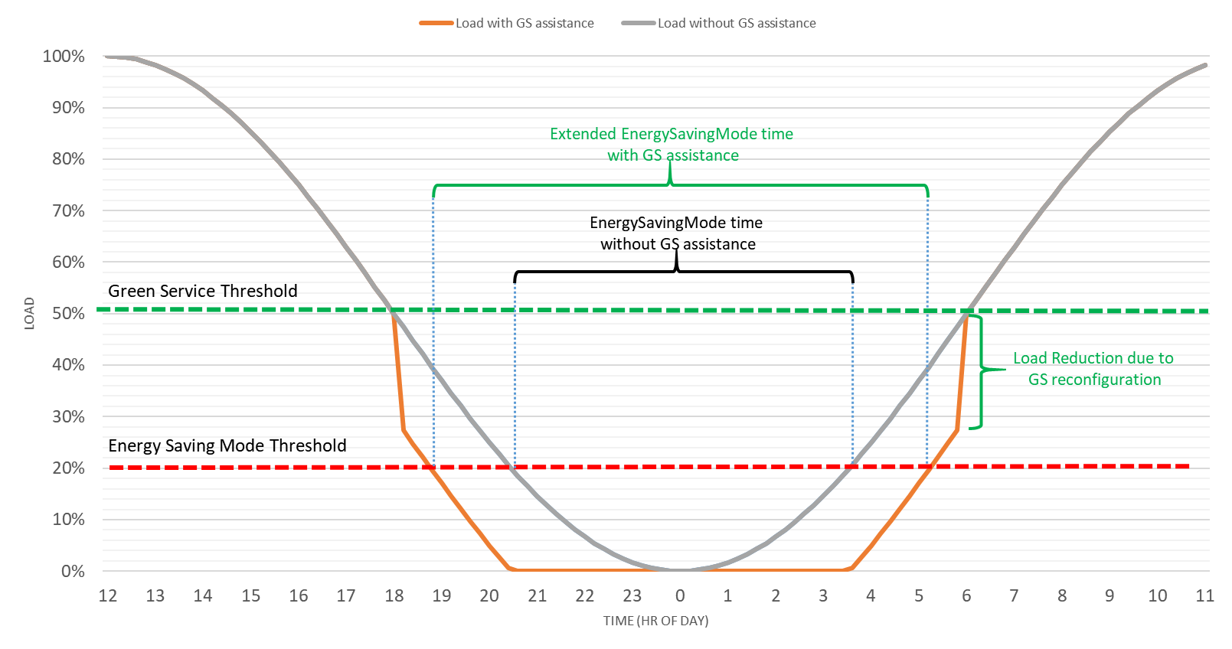

5.X.2 Potential requirements
REQ-Energy_Saving_GreenService-ES-1: The 3GPP management system should have capability enabling authorized consumers to request for modification of an existing service into a Green Service.
Note: A existing service can be modified to a Green Service (GS) by lowering some of its QoS parameters. For example, any service identified by 5QI=X1 requiring high throughput can be reconfigured into a GS by adjusting the QoS parameters such as guaranteed flow bit rate (GFBR) and maximum flow bit rate (MFBR) to lower down throughput performance requirements on the network. Alternatively, a service’s QoS criteria can be removed all together turning that service into a best-effort traffic
REQ-Energy_Saving_GreenService-ES-2: The 3GPP management system should have capability enabling authorized consumers to configure a load based threshold which when crossed the service can be changed to a green service.

End of Changes

