**3GPP TSG-SA5 Meeting #155 *S5-243230***

Jeju, South Korea, 27 – 31 May 2024

**Source: Ericsson**

**Title: pCR TR 28.873 Job identity generator**

**Document for: Approval**

**Agenda Item: 6.19.11**

# 1 Decision/action requested

***For agreement and approval***

# 2 References

[1] TR 28.873 " Study on data management, subscriptions and reporting"

[2] SP-231732 "Study on data management regarding subscriptions and reporting"

# 3 Rationale

As discussed and agreed in pCR S5-242096, the identity used in a measurement job shall be globally unique.

# 4 Detailed proposals

*** START OF NEXT CHANGE ***

# 6 Potential solutions

## 6.X Potential solution #X: Job identity generator

### 6.X.1 Description

As discussed in subclause 5.1 that the identity used in a measurement job needs to be globally unique between consumers and producers.

This solution introduces a new function, named ID generator, in the network which has the responsibility to generate a global unique identity for use case 1 defined in section 5.1.

One option is that at PM/Trace/MDT/QoE activation, all requests are going to be sent to the ID generator without a global unique identity. Upon receiving this request, the ID generator

* generates a globally unique identity,
* inserts it into the PM/Trace/MDT/QoE activation request, and sends to the producer, and
* responses to the consumer with the generated globally unique identity

In any subsequent PM/Trace/MDT/QoE message, the globally unique identity is going to be used as Job ID, Trace Reference, or QoE Reference.

Alternative is that before sending a PM/Trace/MDT/QoE activation request, the consumer sends an ID request to this ID generator. Upon receiving this request, the ID generator generates a globally unique identity, and responses to the consumer. The consumer inserts the received globally unique identity into the PM/Trace/MDT/QoE activation request and use it in any subsequent PM/Trace/MDT/QoE message, as Job ID, Trace Reference, or QoE Reference.

Editor’s Note: The feasibility of this potential solution needs further consideration, especially for the concern of complexity

Figure 6.x.1-1 example one of PM/Trace/MDT/QoE with ID generator

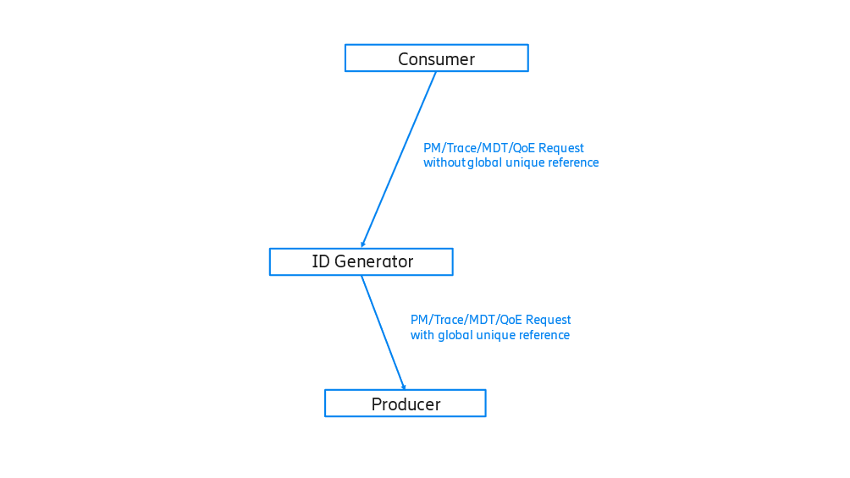

Figure 6.x.1-2 example two of PM/Trace/MDT/QoE with generator

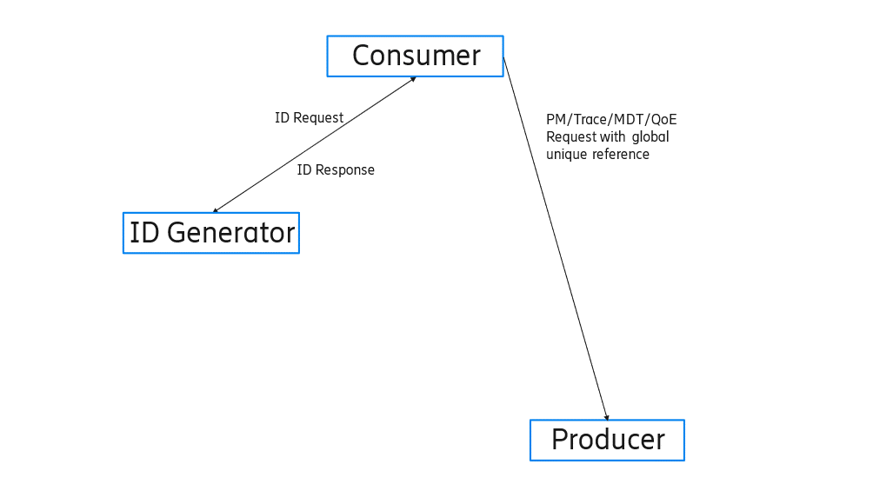

*** END OF CHANGE ***