3GPP TSG-SA5 Meeting #155 S5-243230
Jeju, South Korea, 27 – 31 May 2024

Source: Ericsson

Title: pCR TR 28.873 Job identity generator

Document for: Approval
Agenda Item: 6.19.11

1 Decision/action requested
For agreement and approval

2 References
[1] TR 28.873 " Study on data management, subscriptions and reporting"
[2] SP-231732 "Study on data management regarding subscriptions and reporting"

3 Rationale
As discussed and agreed in pCR S5-242096, the identity used in a measurement job shall be globally unique.

4 Detailed proposals
*** START OF NEXT CHANGE ***

6 Potential solutions

6.X Potential solution #X: Job identity generator

6.X.1 Description
As discussed in subclause 5.1 that the identity used in a measurement job needs to be globally unique between consumers and producers.
This solution introduces a new function, named ID generator, in the network which has the responsibility to generate a global unique identity for use case 1 defined in section 5.1.
One option is that at PM/Trace/MDT/QoE activation, all requests are going to be sent to the ID generator without a global unique identity. Upon receiving this request, the ID generator
- generates a globally unique identity,
- inserts it into the PM/Trace/MDT/QoE activation request, and sends to the producer, and
- responses to the consumer with the generated globally unique identity
In any subsequent PM/Trace/MDT/QoE message, the globally unique identity is going to be used as Job ID, Trace Reference, or QoE Reference.
Alternative is that before sending a PM/Trace/MDT/QoE activation request, the consumer sends an ID request to this ID generator. Upon receiving this request, the ID generator generates a globally unique identity, and responses to the consumer. The consumer inserts the received globally unique identity into the PM/Trace/MDT/QoE activation request and use it in any subsequent PM/Trace/MDT/QoE message, as Job ID, Trace Reference, or QoE Reference.

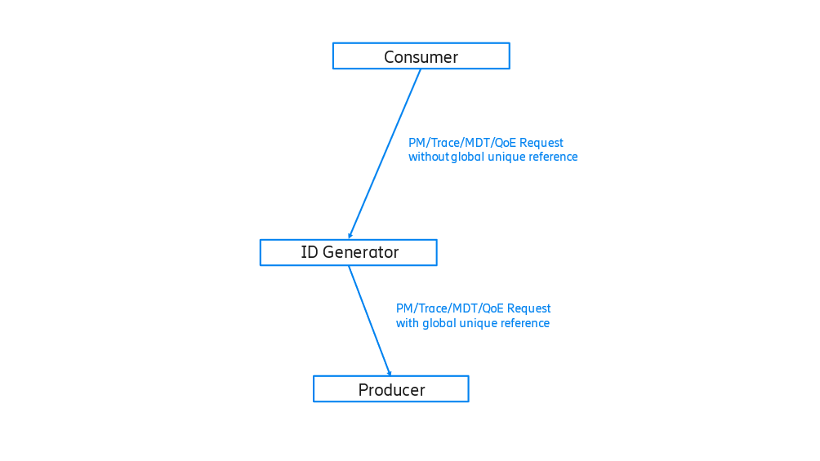Figure 6.x.1-1 example one of PM/Trace/MDT/QoE with ID generator
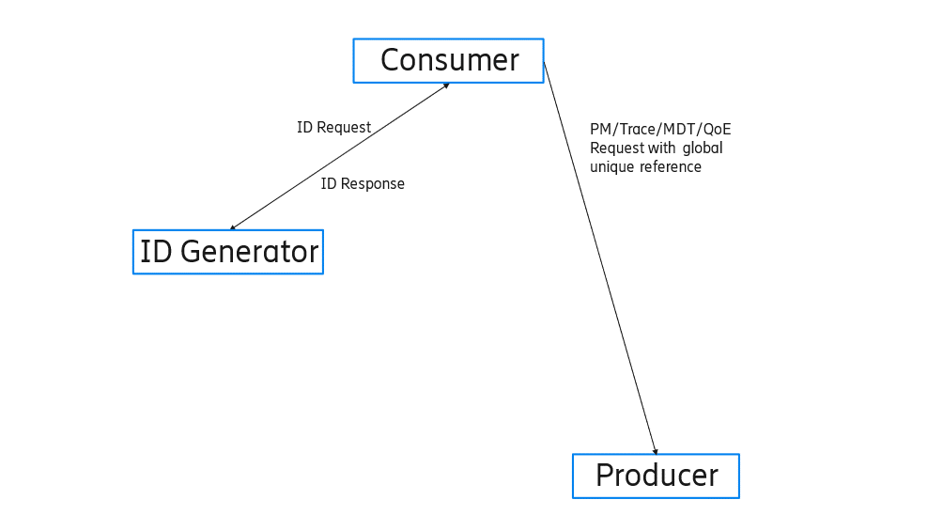 Figure 6.x.1-2 example two of PM/Trace/MDT/QoE with generator
*** END OF CHANGE ***

