3GPP TSG-SA5 Meeting #155 S5-243224

Jeju, South Korea, 27 - 31 May 2024
CR-Form-v12.1
CHANGE REQUEST
 | 28.537 | CR | Input to draftCR | rev | - | Current version: | 18.0.0
For HELP on using this form: comprehensive instructions can be found at
http://www.3gpp.org/Change-Requests.

Proposed change affects: | UICC apps |  | ME |  | Radio Access Network | X | Core Network | X

Title: | Rel-19 input to draftCR TS 28.537 Update clause 6.4 Managing external management data
Source to WG: | Huawei, Deutsche Telekom
Source to TSG: | S5
Work item code: | MADCOL_ph2 |  |  |  |  |  | Date: |  |  | 2024-04-01
Category: | B |  |  |  |  |  | Release: |  |  | Rel-19
 | Use one of the following categories:  F (correction)  A (mirror corresponding to a change in an earlier release)  B (addition of feature),  C (functional modification of feature)  D (editorial modification)  Detailed explanations of the above categories can  be found in 3GPP TR 21.900. |  |  |  |  |  |  |  | Use one of the following releases:  Rel-8 (Release 8)  Rel-9 (Release 9)  Rel-10 (Release 10)  Rel-11 (Release 11)  …  Rel-15 (Release 15)  Rel-16 (Release 16)  Rel-17 (Release 17)  Rel-18 (Release 18)
Reason for change: |  | For the description for managing data in clause 6.4.1, it needs more description and example to elaborate how the managing external management data functionality can be used. The solution to elaborate how the managing external management data functionality can be used is discussed in TR 28.842 and recommended to be used as the basis of the normative work.
Summary of change: |  | Add description and example to elaborate how the managing external management data functionality can be used
Consequences if not approved:
Clauses affected: |  | 6.4.1
 |  | Y | N
Other specs |  |  | X | Other core specifications |  |  |  | TS/TR ... CR ...
affected: |  |  | X | Test specifications |  |  |  | TS/TR ... CR ...
(show related CRs) |  |  | X | O&M Specifications |  |  |  | TS/TR ... CR ...
Other comments:
This CR's revision history: |  | S5-242441 is the revision of S5-241420

1st Change

6.4 Managing external management data

6.4.1 Description
Management data which is specified by 3GPP (clause 6.1.1) can be enriched by additional data not specified by 3GPP. This so-called external management data can be produced by data sources of different nature (e.g. sensors) with different formats.
External management data can be used for example as additional input for network optimization and prediction.
The management system should be able to manage this kind of data. That means data consumers should be able to discover external management data and request external management data to be produced and reported. The management system should provide support for storing it.
The definition of external data sources and the data formats they use is out of scope of this specification.
This functionality is supported based on the assumption that the connection between the 3GPP external entities and 3GPP management system is set up enabling the 3GPP management system to obtain and store the external management data. The mechanism for setting up the connection between the 3GPP management system and external data sources and collection of the external management data is out of scope of this specification. This functionality focuses on the external management data discovery, request and delivery between MnS producer and MnS consumer. Following is an example to illustrate the framework for managing external management data.
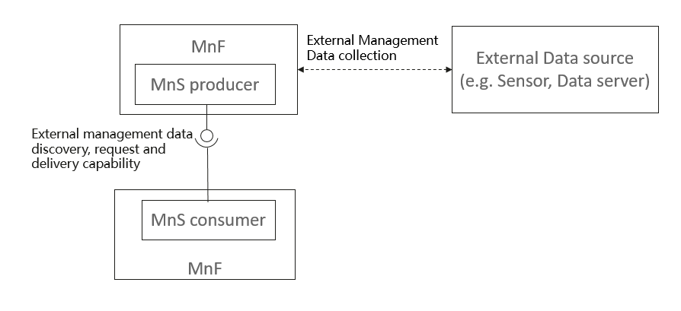
Figure 6.4.1-1 Example to illustrate the framework for managing external management data.
The present document defines generic management mechanisms for external management data discovery, request and delivery, which can cope with any kind of external data sources and data formats.
End of Changes

