3GPP TSG-SA5 Meeting #155 S5-243173
Jeju, South Korea, 27 - 31 May 2024 Merged of S5-242387/S5-242765

Source: China Mobile, ZTE

Title: Add solution of Signaling storm analysis for TR 28.915

Document for: Approval
Agenda Item: 6.19.5

1 Decision/action requested
In this box give a very clear / short /concise statement of what is wanted.

2 References
[1] 3GPP draft TR 28.915: “Management and orchestration; Study on management aspects of Network Digital Twin v0.1.0”.
[2] SP-231727 "New Study on management aspects of Network Digital Twin"

3 Rationale
This contribution proposes to add solution of signaling storm analysis for TR 28.915 based on SP-231727 [2]

4 Detailed proposal
First Change

5.2 Use case 2: Signaling storm analysis

5.2.1 Description
Signaling storm refers to the situation where a large number of signaling messages suddenly surge in the mobile communication network, resulting in the network processing capacity overload, thus affecting the network performance and stability. Signaling storm may be caused because of big event happened that too many users request service at the same time, or by network failure, configuration error or malicious attacks. During this period, users will repeatedly try to establish the connection until reconnected, thus generating a large number of signaling messages surge suddenly, causing signaling storm.
To prevent potential signaling storm risks, the operator needs to effectively control the flow of each signaling control node on the network to avoid nodes working improperly caused by signaling storm. For example, as depicted in figure 1, AMF, SMF, and UDM in the 5G NDT might be all potential signaling storm impact points when network signaling storm happens. the signaling storm scenarios need to perform simulation and evaluation using NDT to find the optimal flow control parameters of each signaling impact point to avoid serious damage to the 5G network when it is affected by signaling storm.
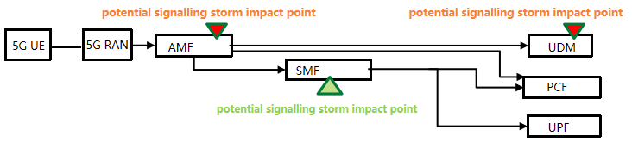
Figure 1
By simulating various network scenarios such as network failure or large amount of user subscribes at the same time the network operator can determine whether the current network can defend against if signaling storm happened.

5.2.2 Potential requirements
REQ-SIMULATION_NDT-01: NDT should have the capability to simulate the behaviour ofsignaling storm.
REQ-SIMULATION_NDT-02: NDT should have the capability to report the results for signaling storm analysis.

5.2.3 Potential solutions
This solution addresses the following issues of use case 2. Signaling storm simulation should be made by using NDT. The NDT utilizes network related information on signaling storms from the MnS producer to generate a report of simulation and validation results for defending against signaling storms with the following approach:

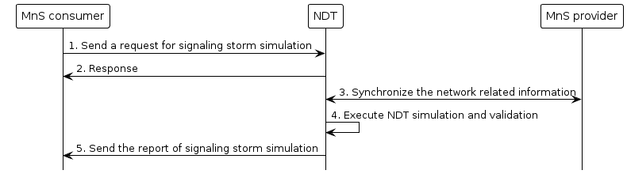
Figure 5.2.3: NDT for signaling storm simulation and validation
- The MnS consumer sends a request to NDT as the MnS provider for signaling storm simulation, including the simulated network objects(e.g., network functions, S-NSSAI, etc) and optional optimization actions(e.g. setting the maximum rate of traffic received at a network node, flow control rules).
- The NDT as the MnS provider provides a response to MnS consumer indicating the status of the request based on a feasibility check (success or failure).
- The NDT as the MnS consumer synchronizes the network related information from MnS providers for network simulation and validation. The network related information may include network capability related information, network slicing information regarding the resource aspects and/or other relevant data (e.g., the number of current subscribers,traffic collected in recent and historical periods) for simulation and validationof the behaviour of signaling storm.
- The NDT executes the network simulation and validation for signaling storm, and generates the report.
- The NDT as the MnS provider sends the report including the resultssignaling storm to MnS consumer. The report can include:
- Simulated behavior: Use of network simulation to analyse the behavior and impacts of signaling storms based on current and historical data.
- Validation of optimization actions: Upon forecasting, for example, the maximum growth of terminal re-connections, optimization actions can be triggered based on local operator policy or MnS consumer's request.
- Validation Results: Based on the behavior of optimization actions, report the evaluation results, such as whether signaling storm faults will occur or not.

End of Changes

