3GPP TSG-SA5 Meeting #155 S5-242337

27 - 31 May 2024, Jeju, South Korea

Source: Nokia

Title: Rel-19 pCR 28.914 Intent handling capability exposure

Document for: Approval

Agenda Item: 6.19.3

1 Decision/action requested
The group is asked to discuss and agree on the proposal.

2 References
[1] 3GPP TR 28.914: " Study on intent driven management service for mobile network phase 3 v0.2.0"

3 Rationale
TS28.312 supports intent handling and exposure of handling capability as a list of supported expectationTargets but is incomplete since it does not enable the MnS producer to indicate the specific values ranges that they support. This pCR is to propose an extension to intent handling capability exposure to allow the supported values to be exposed.

4 Detailed proposal

First Change

5. Use Cases
5.X Use case X: Extension of Intent handling capability
5.X.1 Description
TS28.312 supports intent handling and exposure of handling capability as a list of supported expectationTargets.
The specification does not show the supported value ranges for the targets or the sets of targets that are supported. E.g. for service management intents, the intent handler may want to expose the description of services that they can offer, i,e., to expose that they support intents or intent expectations having a specific set of features and a specific set of values for those features as illustrated by Table 5.X.1-1. The IDMS should support expose of such capabilities.
Table 5.X.1-1: An example of a service offer description indicating the possible characteristics of services that can exposed via an intent handling capability as the service characteristic offered by an intent handler for service emanagement intents.
Object Type |  |  |  |  | RAN Services
Feature | Units | Value Options
End-to-end latency | ms | 0.5 | 1 | 2 |  | 5 | 10 | 25 | 50 | 100
Jitter | ms | .001 | 0.01 | 0.1 |  | 1 | 2 | 5 | 10 | 20
Survival Time | ms | 0 | 1 | 2 |  | 5 | 10 | 25 | 50 | 100
Availability |  | 99% | 99.5%. | 99.9% |  | 99.995% | 99.999% | 99.9995% | 99.9999% | .99999%
Reliability |  | 99% | 99.5%. | 99.9% |  | 99.995% | 99.999% | 99.9995% | 99.9999% | .99999%
End user Data rate | ≥ x Mbps | 0.1 | 0.2 | 0.5 |  | 1.0 | 2.0 | 5.0 | 10.0 | 20.0
Payload | ≈. x Bytes | 1 | 2 | 5 |  | 10 | 20 | 100 | 500 | 1000
Traffic density | Gbps/km² | 1 | 2 | 5 |  | 10 | 20 | 50 | 100 | 1000
Connection density | ‘000/km² | 0.1 | 0.5 | 1 |  | 5 | 10 | 20 | 50 | 100
Service area size | A x B km | 0.1x10 | 0.1x100 | 0.1x500 |  | 0.1 x 0.1 | 1 x1 | 10 x10 | 50 x50 | 100x100
Policies | Policy 1 | Policy 1 value 1 |  | Policy 1 value 2 |  |  | … |  | …
 | Policy 2 | Policy 2 value 1 |  | Policy 2 value 2 |  |  | … |  | …
 | : | : |  | : |  |  | … |  | …

5.X.2 use cases
5.X.2.1 Intent handling capability exposure
The IDMS may be used on the north of the RAN Service Management Intent handler to enable the design of a RAN service between the MnS producer and the MnS consumer.

The RAN service intent-driven MnS consumer generates an artefact, say called a service-offer description that describes the different candidate characteristics of the desired RAN service from the MnS consumer’s point of view.,. The MnS consumer provides service-offer description to the Service Management Intent handler for validation. The service-offer description may be viewed as a RAN service management intent that contains a list of candidate intent expectations, i.e. the expectations are candidates that may be separately submitted by the MnS consumer for fulfilment.

On receiving the service-offer description, The Service Management Intent handler validates the service-offer description and confirms to what extent the RAN service as described by the service-offer description can be supported. For that, the Service Management Intent handler returns the service-offer description but indicating only the supported combinations of service features and values withcontxts (e.g., policies and conditions) under which the service many be offered..
Intent handler for service management intents
May iterate
Intent with multiple potential expectations indicating Service Descriptor describing candidate desired features sets.

Intent handling capability detailing the Service Descriptor describing candidate features that are supported.
intent consumer providing Service management intent
Figure 5.X.2.1-1: Example interaction between an MnS producer and MnS consumer on the exposure of capabilities for service management intents

5.1.2 Potential Requirements
INT_NEGOT_REQ 1: The MnS producer should support a capability to provide to a intent driven MnS consumer a description of the supported scenario specific intents.

INT_NEGOT_REQ 1: The MnS producer should support a capability enabling an MnS consumer to provide a listing the set of potential alternative expectations that the MnS consumer would like to be evaluated for whether it is feasible or fulfillable.

5.1.3 Potential Solutions
5.1.3.1 solution for consumer to indicate alternatives:
- Extend the intent IOC to allow for expectationSelectivity when the intent is being provided for feasibility checking. This enables a consumer to submit a set of candidate expectations to get feedback on which expectations are supported or not. For example, a service management design function can submit the set of potential RAN service descriptions to see which set can be supported by the RAN service intent handler.

5.1.3.2 solutions for MnS producer to indicate supported targets:
- Introduce in the IntentHandlingCapability <<dataType>>
  - an attribute (and corresponding data Type) representing the details on information about expectationTargets that are supported by the intent handler. The information indicates the supported expectationTargets as
    - a list of names of supported expectation targets
    - a list of names of supported expectation targets and the value ranges for which they are supported
    - a set expressing the combination of expectation targets and value ranges that can be jointly supported.
The respective changes may be as below

To be revised: IntentHandlingCapability <<dataType>>
The IntentHandlingCapability includes the following attributes (new attributes are in bold).
Attribute Name | Support Qualifier | isReadable | isWritable | isInvariant | isNotifyable
intentHandlingCapabilityId | M | T | F | F | T
supportedExpectationObjectType | M | T | F | F | T
supportedExpectationTaregtName | M | T | F | F | T
supportedExpectationTargetInfo | M | T | F | F | T

To be added: 6.2.1.3.X. supportedExpectationTargetInfo <<dataType>>

6.2.1.3.X.1 Definition
The supportedExpectationTargetInfo indicates the detailed information about what the intent handler supports for a given supportedExpectationObjectType. It allows the intent handler to indicate the support in any one of the three ways below as illustrated by Figure 6.2.1.3.X.1-1:
- as a list of names of supported expectation targets
- as a list of names of supported expectation targets and the value ranges within which they are supported
- as a set expressing the combination of expectation targets and value ranges that can be jointly supported.
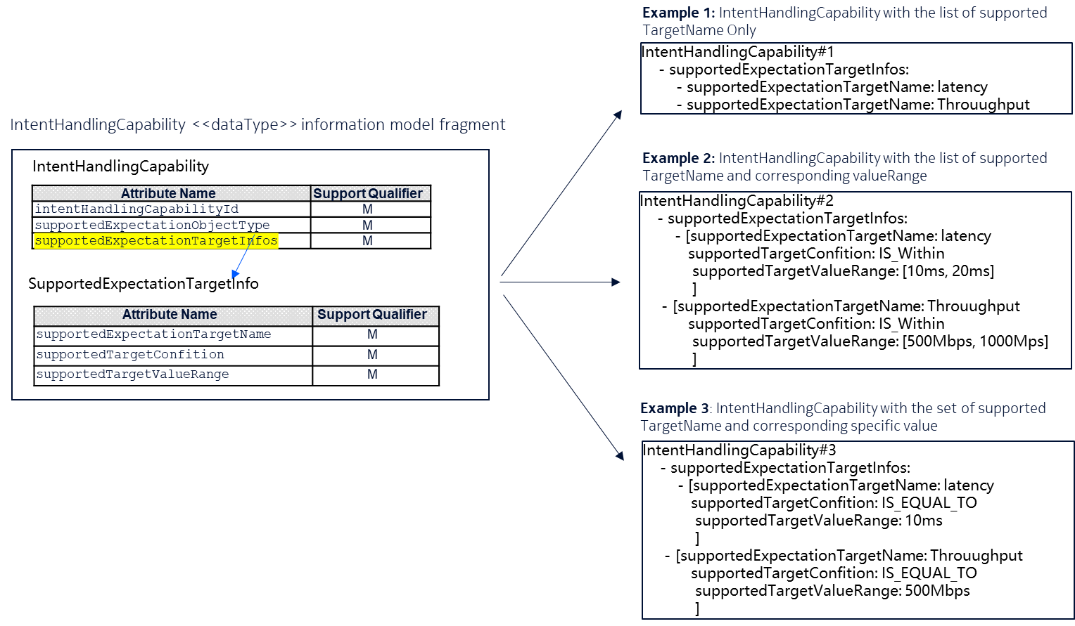
Figure 6.2.1.3.X.1-1: MnS producer can express supported capabilities in any of the 3 possible ways.

6.2.1.3.X.2 Attributes
The supportedExpectationTargetInfo includes the following attributes.
Attribute Name | Support Qualifier | isReadable | isWritable | isInvariant | isNotifyable
supportedTargetName | M | T | F | F | T
supportedTargetCondition | M | T | F | F | T
SupportedTargetValueRange | M | T | F | F | T

To be added: Attribute definitions
Name | Description
supportedExpectationTargetInfo | It describes the supported expectation targets for the supported expectation object type. | type: SupportedExpectationTargetInfo  multiplicity: 1 … *  isOrdered: N/A  isUnique: N/A  defaultValue: None  isNullable: False
supportedExpectationTargetName | It indicates the name or identifier of the supported expectation targets for the supported expectation object type.  allowedValues: depends on ExpectationObject in the IntentExpectation | type: String  multiplicity: 1  isOrdered: N/A  isUnique: N/A  defaultValue: None  isNullable: True
supportedTargetCondition | It expresses the limits within which the supportedExpectationTargetName shall be suppoprted.  allowedValues: targetCondition defined in clause 6.2.1.3.3 | type: Enum  multiplicity: 1  isOrdered: N/A  isUnique: N/A  defaultValue: "IS_EQUAL_TO"  isNullable: False
SupportedTargetValueRange | It describes the range of values that applicable to the supportedExpectationTargetName and the supportedTargetCondition.  allowedValues: targetValueRange defined in clause 6.2.1.3.3 | type: ValueRangeType  multiplicity: 1..*  isOrdered: False  isUnique: True  defaultValue: None  isNullable: True

5.1.4 Evaluation of solutions
TBD

