**3GPP TSG-SA5 Meeting #155S5-242337**

**27 - 31 May 2024, Jeju, South Korea**

**Source: Nokia**

**Title: Rel-19 pCR 28.914 Intent handling capability exposure**

**Document for: Approval**

**Agenda Item: 6.19.3**

# 1 Decision/action requested

***The group is asked to discuss and agree on the proposal.***

# 2 References

[1] 3GPP TR 28.914: " Study on intent driven management service for mobile network phase 3 v0.2.0"

# 3 Rationale

TS28.312 supports intent handling and exposure of handling capability as a list of supported expectationTargets but is incomplete since it does not enable the MnS producer to indicate the specific values ranges that they support. This pCR is to propose an extension to intent handling capability exposure to allow the supported values to be exposed.

# 4 Detailed proposal

|  |
| --- |
| **First Change** |

# 5. Use Cases

5.X Use case X: Extension of Intent handling capability

5.X.1 Description

TS28.312 supports intent handling and exposure of handling capability as a list of supported expectationTargets.

The specification does not show the supported value ranges for the targets or the sets of targets that are supported. E.g. for a service management service, the intent handler may want to expose that they support intents having a specific set of features and a specific set of values for those features as illustrated by Table 5.X.1-1. The IDMS should support expose of such capabilities.

Table 5.X.1-1: An example of a possible description of characteristics of services that can exposed via an intent handling capability as the service characteristic offered by service management intent handler.

|  |  |  |  |  |  |  |  |  |  |  |
| --- | --- | --- | --- | --- | --- | --- | --- | --- | --- | --- |
| **Service Offer Descriptor** | | | | | | | | | | |
| **Object Type** | | | | | **RAN Services** | | | | | |
| Feature | Units | Value Options | | | | | | | | |
| End-to-end latency | ms | 0.5 | 1 | 2 | | 5 | 10 | 25 | 50 | 100 |
| Jitter | ms | .001 | 0.01 | 0.1 | | 1 | 2 | 5 | 10 | 20 |
| Survival Time | ms | 0 | 1 | 2 | | 5 | 10 | 25 | 50 | 100 |
| Availability |  | 99% | 99.5%. | 99.9% | | 99.995% | 99.999% | 99.9995% | 99.9999% | .99999% |
| Reliability |  | 99% | 99.5%. | 99.9% | | 99.995% | 99.999% | 99.9995% | 99.9999% | .99999% |
| End user Data rate | ≥ x Mbps | 0.1 | 0.2 | 0.5 | | 1.0 | 2.0 | 5.0 | 10.0 | 20.0 |
| Payload | ≈. x Bytes | 1 | 2 | 5 | | 10 | 20 | 100 | 500 | 1000 |
| Traffic density | Gbps/km2 | 1 | 2 | 5 | | 10 | 20 | 50 | 100 | 1000 |
| Connection density | ‘000/km2 | 0.1 | 0.5 | 1 | | 5 | 10 | 20 | 50 | 100 |
| Service area size | A x B km | 0.1x10 | 0.1x100 | 0.1x500 | | 0.1 x 0.1 | 1 x1 | 10 x10 | 50 x50 | 100x100 |
| **Policies** | **Policy 1** | **Policy 1 value 1** | | **Policy 1 value 2** | | | **…** | | **…** | |
|  | **Policy 2** | **Policy 2 value 1** | | **Policy 2 value 2** | | | **…** | | **…** | |
|  | **:** | : | | : | | | **…** | | **…** | |

5.X.2 use cases

5.X.2.1 Intent handling capability exposure

The IDMS may be used on the north of the RAN Service Management Intent handler to enable service design between the Service Management Intent handler and its RAN Service intent driven MnS consumer.

The Service intent driven MnS consumer generates an artefact that describes the desired service from consumer point of view, say call it a Service Descriptor and provides it to the Service Management Intent handler for validation. The Service Descriptor is a service management intent involving a list of intent expectations but where any of the expectations can be separately submitted for fulfilment.

On receiving the Service Descriptor, The Service Management Intent handler validates the Service Offer Descriptor and confirms to what extent the service as described by the Service Offer Descriptor can be supported. For that, the Service Management Intent handler returns the Service Offer Descriptor but indicating only the supported combinations of service features and values. The returned Service Offer Descriptor includes policies and conditions with which the service many be offered. The Service intent driven MnS consumer may then return with a revised Service Offer Descriptor.

Service Management Intent handler

May iterate

Intent with multiple potential expectations indicating Service Descriptor describing candidate desired features sets.

Intent handling capability detailing the Service Descriptor describing candidate features that are supported.

Service management intent consumer

Note: the above capabilities may be achieved in a single step in which the Service Management Intent handler exposes the supported Service Descriptor, e.g. like in Table 5.X.1-1. The Service intent driven MnS consumer can then submit intents involving expectations that match any one of the exposed sets of supported expectation targets.

5.1.2 Potential Requirements

**INT_NEGOT_REQ 1:** The MnS producer should support a capability to provide to a intent driven MnS consumer a description of the supported scenario specific intents.

**INT_NEGOT_REQ 1:** The MnS producer should support a capability enabling an MnS consumer to provide a listing the set of potential alternative expectations that the MnS consumer would like to be evaluated for feasibility.

5.1.3 Potential Solutions

5.1.3.1 solution for consumer to indicate alternatives:

* Extend the intent IOC to allow for expectationSelectivity when the intent is being provided for feasibility checking. This enables a consumer to submit a set of candidate expectations to get feedback on which expectations are supported or not. For example, a service management design function can submit the set of potential RAN service descriptions to see which set can be supported by the RAN service intent handler.

5.1.3.2 solutions for MnS producer to indicate supported targets:

* Introduce in the IntentHandlingCapability <<dataType>>
  + an attribute (and corresponding data Type) representing the details on information about expectationTargets that are supported by the intent handler. The information indicates the supported expectationTargets as
    - a list of names of supported expectation targets
    - a list of names of supported expectation targets and the value ranges for which they are supported
    - a set expressing the combination of expectation targets and value ranges that can be jointly supported.

The respective changes may be as below

##### **To be revised:** IntentHandlingCapability <<dataType>>

The IntentHandlingCapability includes the following attributes (new attributes are in bold).

|  |  |  |  |  |  |
| --- | --- | --- | --- | --- | --- |
| Attribute Name | Support Qualifier | isReadable | isWritable | isInvariant | isNotifyable |
| intentHandlingCapabilityId | M | T | F | F | T |
| supportedExpectationObjectType | M | T | F | F | T |
| **~~supportedExpectationTaregtName~~** | **~~M~~** | **~~T~~** | **~~F~~** | **~~F~~** | **~~T~~** |
| **supportedExpectationTargetInfo** | **M** | **T** | **F** | **F** | **T** |

##### To be added: 6.2.1.3.X. supportedExpectationTargetInfo <<dataType>>

###### 6.2.1.3.X.1 Definition

The supportedExpectationTargetInfo indicates the detailed information about what the intent handler supports for a given supportedExpectationObjectType. It allows the intent handler to indicate the support in any one of the three ways below as illustrated by Figure 6.2.1.3.X.1-1:

1. as a list of names of supported expectation targets
2. as a list of names of supported expectation targets and the value ranges within which they are supported
3. as a set expressing the combination of expectation targets and value ranges that can be jointly supported.

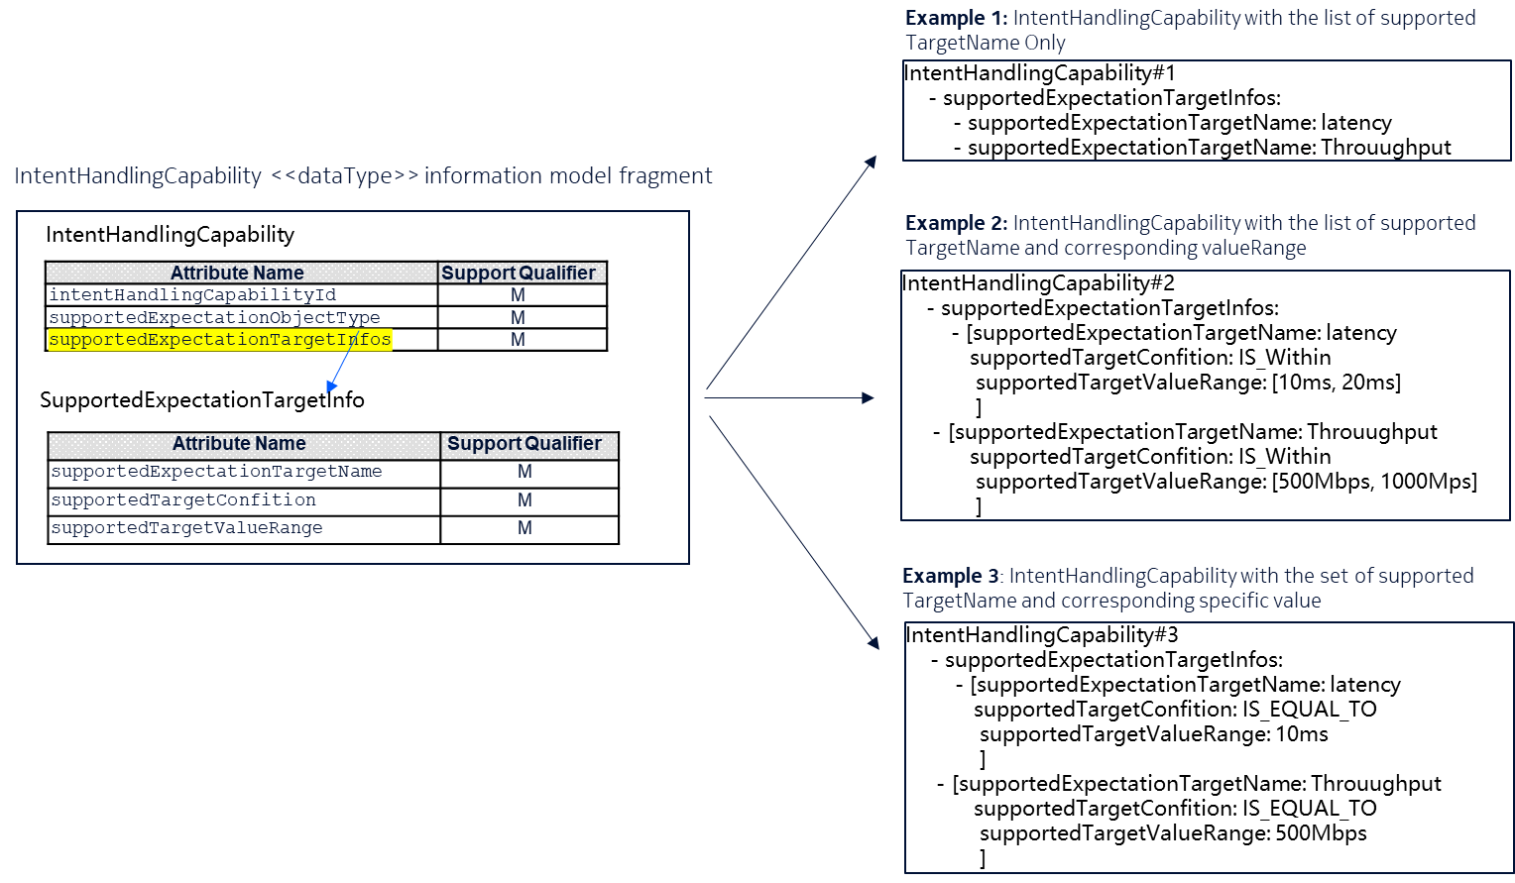

Figure 6.2.1.3.X.1-1: MnS producer can express supported capabilities in any of the 3 possible ways.

###### 6.2.1.3.X.2 Attributes

The supportedExpectationTargetInfo includes the following attributes.

|  |  |  |  |  |  |
| --- | --- | --- | --- | --- | --- |
| Attribute Name | Support Qualifier | isReadable | isWritable | isInvariant | isNotifyable |
| supportedTargetName | M | T | F | F | T |
| supportedTargetCondition | M | T | F | F | T |
| SupportedTargetValueRange | M | T | F | F | T |

**To be added:** Attribute definitions

|  |  |  |
| --- | --- | --- |
| Name | Description |  |
| supportedExpectationTargetInfo | It describes the supported expectation targets for the supported expectation object type. | type: SupportedExpectationTargetInfo  multiplicity: 1 … *  isOrdered: N/A  isUnique: N/A  defaultValue: None  isNullable: False |
| supportedExpectationTargetName | It **indicates the name or identifier of** the supported expectation targets for the supported expectation object type.  allowedValues: depends on ExpectationObject in the IntentExpectation | type: String  multiplicity: 1  isOrdered: N/A  isUnique: N/A  defaultValue: None  isNullable: True |
| supportedTargetCondition | It expresses the limits within which the **supportedExpectationTarget**Name shall be suppoprted.  allowedValues: targetCondition defined in clause 6.2.1.3.3 | type: Enum  multiplicity: 1  isOrdered: N/A  isUnique: N/A  defaultValue: "IS_EQUAL_TO"  isNullable: False |
| SupportedTargetValueRange | It describes the range of values that applicable to the **supportedExpectationTarget**Name and the supportedTargetCondition.  allowedValues: targetValueRange defined in clause 6.2.1.3.3 | type: ValueRangeType  multiplicity: 1..*  isOrdered: False  isUnique: True  defaultValue: None  isNullable: True |
|  |  |  |

5.1.4 Evaluation of solutions

TBD