3GPP TSG-SA5 Meeting #155 S5-24xxxx

27 - 31 May 2024, Jeju, South Korea

Source: Nokia

Title: Rel-19 pCR 28.914 Negotiation on intent fulfilment

Document for: Approval

Agenda Item: 6.19.3

1 Decision/action requested
The group is asked to discuss and agree on the proposal.

2 References
[1] 3GPP TR 28.914: " Study on intent driven management service for mobile network phase 3 v0.2.0"

3 Rationale
Some intent feasibility has been agreed in R18. However intent feasibility is related to other intent related negotiations. This pCR provides a key issue on intent negotiation with the complete set of negotiations.

4 Detailed proposal

First Change

5. Use Cases
5.X Use case X: Negotiation on fulfilment of intents
5.X.1 Description
There are multiple negotiations that can happen for an intent that is feasible, many of them employing interaction that are similar.
Note: although some of these may be applicable during the feasibility check process, they are considered part of intent negotiations and not part of feasibility checking.
3.2.1 Checking for achievable outcomes
The MnS consumer wants to know the possible achievable outcomes for a given intent . The MnS consumer creates an intent that should be evaluated by the MnS producer be see what the MnS producer can deliver.
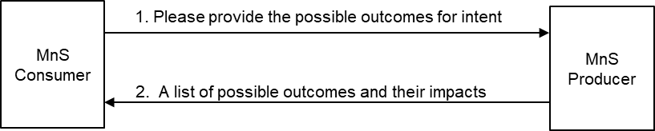
Figure 3.1.2-1: MnS consumer requests and receives a list of achievable outcomes on an intent.
Subsequently, the MnS producer provides a report indicating what is achievable for each intent aspect (intentExpectation and expectationTarget) within that intent. Since different achievable outcomes may have different impacts, the report should include the relative impacts of each outcomes.

3.2.2 Checking for best possible outcome on an intent, intent expectation, or expectation target
The MnS consumer wants to know the best possible outcome for a given intent or intent expectation or expectation target. This could be prior to or during fulfilment.
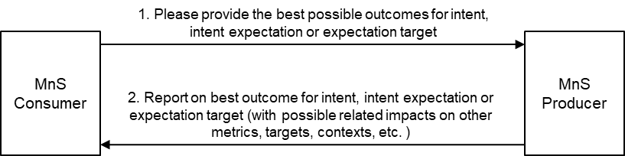
Figure 3.1.3-1: Checking for best possible outcome on intent or intent expectation or expectation target,
The MnS consumer creates an intent that should be evaluated by the MnS producer with a request to provide the best possible outcome. Subsequently, the MnS producer provides a report indicating that best possible outcome. The best possible outcome is defined as follows:
- The request is to evaluate an intent with only 1 expectation target: The best possible outcome is the best value on that expectation target that does not adversely affect other aspects of the network.
- The request is to evaluate expectation target in an intent with multiple expectation targets (e.g. multiple expectations or one expectation with multiple expectation targets): The best possible outcome is the best value on that expectation target that maintains the other expectation targets to within the ranges specified in the intent and does not adversely affect other expectation targets or aspects of the network.
- The request is to evaluate all expectation targets in an intent with multiple expectation targets (e.g. multiple expectations or one expectation with multiple expectation targets): The best possible outcome is the best value on each expectation target that maintains the other expectation targets to within the ranges specified in the intent and does not adversely affect other aspects of the network.
The MnS producer should support an achievable outcomes report that lists the achievable outcomes for any of the three scenarios, the report including the related impact on other targets in the intent or on other metrics and contexts.

3.2.3 MnS producer to recommend realizable intent targets and contexts
The MnS consumer wants to know what the MnS producer recommends what to be applied for particular intent characteristics. The MnS consumer creates an intent and asks the MnS producer to recommend what changes could be made to the intent or other intents to make the intent fulfillable (Figure 3.2.1-1). Alternatively, the MnS producer has attempted to fulfil the intent and indicated that it cannot be fulfilled, so the MnS consumer asks the MnS producer to recommend what changes could be made to the intent or other intents to make the intent fulfillable.
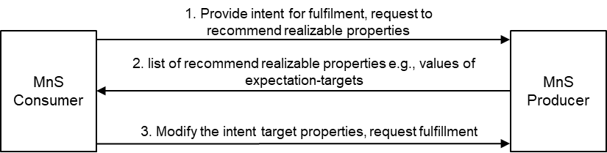
Figure 3.2.1-1: Enabling the MnS consumer to request and receive a recommendation on the realizable intent properties prior to fulfilment.
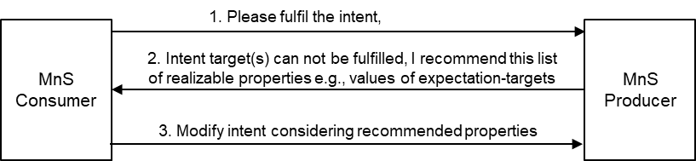
Figure 3.2.1-2: Enabling the MnS producer to recommend to the MnS consumer a set of realizable intent properties in case of inability to fulfil an intent.
Subsequently, the MnS producer provides a (intent modification recommendation) report indicating the changes to be applied to the intent to make the intent fulfillable. The MnS producer should support a recommended-changes report that lists the proposed candidate changes to each unfulfillable target within an unfulfillable expectation.
Note: the nature of the report and what can be included if FFS

3.2.4 MnS consumer advises on preferred alternatives
The MnS consumer wants an intent fulfilled. The intent is feasible, but the MnS producer has multiple alternatives related to fulfilling the intent. The MnS producer wants the MnS consumer to advise on their (the MnS consumer’s) preference among these alternatives.
Note 1: An alternative is the combination a set of expectation target values that the MnS producer can achieve together with their (expected) impacts on the network (objects). E.g. for an expectation target on energy consumption, the impact may include which cells could be deactivated, or which other intents (e.g. coverage related intents) could be affected.
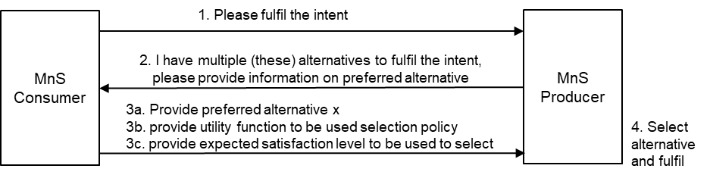
Figure 3.2.2-1: MnS consumer advises the MnS producer on the preferences among alternatives at the MnS producer.
After the MnS consumer creates an intent to be fulfilled, the MnS producer determines that there are multiple alternatives, so the MnS producer and provides a report to the MnS consumer so that the MnS consumer may help chose the best alternative.

The report to the MnS consumer may include:
- the list of available/achievable expectation target values that the MnS producer is able to apply/achieve.
- The expected relative impacts of the different alternatives – on aspects of the submitted intent or other intents and intent expectations.
- A request to the MnS consumer to select one among the alternatives.
Given the alternatives, the MnS consumer takes one or both of the two actions,
- Chooses and indicates the preferred alternative.
- Defines the relative importance of their expectation Targets so that the MnS producer may consider these in deciding upon the solution/ solution approach/ closed loops/ action/ outcome to be applied/deployed/achieved.

3.2.5 MnS producer requests for extra information to be used to select another alternative post initial fulfilment
The MnS consumer wants an intent fulfilled and the MnS producer has multiple alternatives related to fulfilling the intent. After the MnS consumer creates an intent to be fulfilled, the MnS producer independently choses the alternative to be applied. But on realizing that they cannot achieve better outcomes, MnS producer allows the MnS consumer to provide extra information that guarantee better satisfaction (see Figure 3.2.5-2). The MnS producer reports the fulfillment outcomes (imperfect fulfillment) and indicates to the MnS consumer that if the MnS consumer is unsatisfied with the outcomes, the MnS consumer should provide extra information to help select a better alternative.
The report to the MnS consumer may include one or more of the following:
- The list of available/ achievable expectation target values which can guide the MnS consumer when providing the preference policy.
- The relative impacts of the different alternatives – on the submitted intent or on other intents and intent expectations or on the network.
- A request to evaluate the fulfilment and provide information that could help improve fulfilment.
The extra information provided by the MnS consumer may be one or more of the following:
- A Binary indication that they accept the provided fulfillment or that they do not accept, and another alternative should be tried.
- A utility function indicating the MnS consumer’s relative benefits of their expectation Targets. The utility function is the MnS consumer’s policy for evaluating of the extent to which they are satisfied with the selected alternative
- MnS consumer’s level of satisfaction which is the evaluation of the extent to which the achieved outcomes match the MnS consumer’s expectation as computed from the utility function.
- changes to the expectation Targets or the relative importance of the expectation Targets to the MnS consumer’s objectives
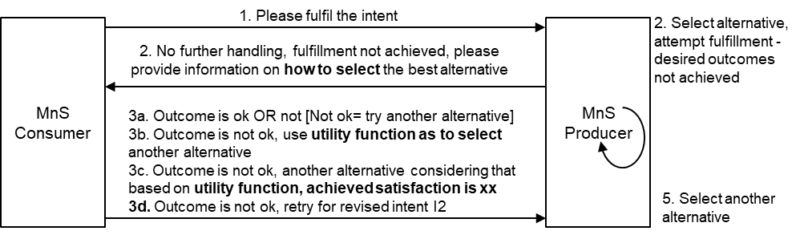
Figure 3.2.4-1: MnS producer requests MnS consumer to provide information to help select (better) alternative

5.1.2 Potential Requirements
INT_NEGOT_REQ 1: The MnS producer should support a capability enabling an MnS consumer to provide an intent with a request for the MnS producer to provide information on the alternative achievable outcomes for an intent.

Note: An alternative is the combination of a set of expectation target values that the MnS producer can achieve together with their (expected) impacts on the network (objects). E.g. for an expectation target on energy consumption, the impact may include which cells could be deactivated, or which other intents (e.g. coverage related intents) could be affected.
INT_NEGOT_REQ 2: The MnS producer should support a capability to provide an intent report including information on what is achievable for each intent aspect (intentExpectation and expectationTarget) within that intent and the relative cost/impact of achieving that outcome.
INT_NEGOT_REQ 3: The MnS producer should support a capability enabling an MnS consumer to provide an intent with a request for the MnS producer to provide the best possible outcome on an intent or intent expectation or expectation target.
INT_NEGOT_REQ 4: The MnS producer should support a capability to provide an intent report including information on the best possible outcome on intent or intent expectation or expectation target.
Note: In the cases where the intent includes multiple targets, this would imply multiple back and forth interactions where the consumer checks each individual target
INT_NEGOT_REQ-5: The MnS producer should support a capability enabling an MnS consumer to provide an intent with a request for the MnS producer to provide information on what changes could be made to the intent properties or to properties of other intents to make the intent fulfillable .
INT_NEGOT_REQ-6 The MnS producer may support a capability to provide a report indicating what changes could be applied to the intent (i.e.,) to make the intent fulfillable
Note 2: example changes could include: omitting certain intentExpectations and/or expectationTarget(s) or changing the properties of intentExpectations and/or expectationTarget(s)
INT_NEGOT_REQ-7: The MnS producer should support a capability to provide to an MnS consumer an intent report indicating the alternatives that the MnS producer can support for the provided intent, intent expectations, or expectation Targets and the expected relative impacts of the different alternatives
INT_NEGOT_REQ-8: The MnS producer should support a capability to request an MnS consumer to indicate its preference among a set of alternatives that the MnS producer can support for the provided intent, intent expectations, or expectation Targets.
INT_NEGOT_REQ-9: The MnS producer should support a capability enabling an MnS consumer to provide to the MnS producer information indicating the MnS consumer’s preference among alternatives that the MnS producer can support for the provided intent, intent expectations, or expectation Targets.
INT_NEGOT_REQ-10 The MnS producer should support a capability enabling an authorized MnS consumer to provide information on a policy that should be used by the be used by the MnS producer to select among the alternatives available at the MnS producer.
Note: The policy may be provided in form of a utility function
INT_NEGOT_REQ-11 The MnS producer should support a capability to request the MS consumer to provide an evaluation of the MnS producer’s alternatives based on the expected relative impacts of the different alternatives.
INT_NEGOT_REQ-12 The MnS producer should support a capability enabling an MnS consumer to provide an evaluation of the MnS producer’s alternatives to then be used to select among the alternatives.
INT_NEGOT_REQ-13 The MnS producer should support a capability to inform an authorized MnS consumer that an alternative among multiple alternatives has been selected and (will be/has been) applied for the submitted intent.
INT_NEGOT_REQ-14 The MnS producer should support a capability to inform an authorized MnS consumer that since no more improvement to intent fulfillment shall be possible the MnS consumer should evaluate the extent to which the applied alternative satisfies the MnS consumer’s objectives or provide extra information which can help improve satisfaction.
INT_NEGOT_REQ-15 The MnS producer should support a capability enabling an authorized consumer to inform the producer that the alternative selected by the MnS producer was not satisfactory and another alternative should be applied.
INT_NEGOT_REQ-16 The MnS producer should support a capability enabling an authorized MnS consumer to provide information on the level of fulfillment which the MnS producer can use to differently attempt the fulfillment.
INT_NEGOT_REQ-17(already supported) The MnS producer should support a capability enabling an authorized MnS consumer to revise the properties of an intent as the means to improve the chances of the intent being fulfillable.

5.1.3 Potential Solutions
TBD
5.1.4 Evaluation of solutions
- introduce in the intent IOC a container to hold the MnS consumer’s information on the desired action (feasibility check, evaluation or fulfilment) to be taken by the MnS producer. It may be called requiredIntentAction.
  - The attribute is an ENUM with the values FEASIBILITY_CHECK, POTENTIALOUTCOMES_CHECK, BESTOUTCOMES_CHECK, RECOMMENDATION_REQUEST, FULFILMENT
- introduce a dataType to contain the MnS producer’s information on the negotiations. It may indicate what is achievable for an intent, what the MnS producer recommends for an intent or the MnS producer’s alternatives from which the MnS consumer may chose. It may be called intentFeedbackInfo.
  - The intentFeedbackInfo data type includes what is achievable for each intent aspect (intentExpectation and expectationTarget) within that intent and the relative cost/impact of achieving that outcome
  - The intentFeedbackInfo data type includes an attribute for what the information indicates, i.e. either the achievableOutcomes, the recommended changes,
  - Introduce the related attributes in the intent report IOC, i.e. achievableOutcomesReport, recommendedChangesreport, SupportedAlternativesReport. These are all elements of type intentFeedbackInfo.
  - Inclusion of a SupportedAlternativesReport inherently asks theMnS consumer to chose one alternative among those in the SupportedAlternativesReport.
  - The intentFeedbackInfo data type optionally includes an ENUM attribute indicating need for extra information. The values representing the type of extra information needed could include: SELECT_FROM_OPTIONS, IS_SELECTED_OPTION_OK; PROVIDE_EXTRA_INFO_
- Introduce an dataType representing the container for the MnS consumer’s response to the MnS producer. It may be called IntentFeedback
  - It may contain an attribute for a specific alternative among those indicated by the Mns producer.
  - It may contain a policy that should be used by the be used by the MnS producer to select among the alternatives. The policy may for example be MnS consumer’s utility function.
  - It may contain an attribute indicating the MnS consumer’s satisfaction from a deployed fulfillment as computed form the MnS consumer’s utility function
  - It may contain a list indicating the MnS consumer’s expected satisfaction from the different alternatives e.g. as evaluated form the MnS consumer’s utility function. This may be a key-value pair where the key is an identifier of the alternative and the value’s the MnS consumer’s expected satisfaction.
    - It may also be used to indicate the true MnS consumer’s satisfaction as evaluated for an alternative that has been applied
  - The IntentFeedback dataType optionally includes an ENUM attribute indicating the type of extra information being provided. The values representing the type of extra information could include: IS_SELECTED_OPTION_NOT_OK, SELECTED_OPTION, SATISAFACTION_POLICY

