3GPP TSG-SA5 Meeting #155 S5-242330

27 - 31 May 2024, Jeju, South Korea

Source: Nokia

Title: Rel-19 DP 28.914 Intent Negotiations

Document for: Approval

Agenda Item: 6.19.3

1 Decision/action requested
The group is asked to discuss and agree on the proposal.

2 References
None

3 Discussion
Some intent feasibility has been agreed in R18. However intent feasibility is related to other intent related negotiations. For an intent that is desired by the MnS consumer, there is no guarantee that the MnS producer can deliver it the way the consumer desires. It could be that the producer does not fully understand the intent or that the MnS producer has multiple alternatives on how to realize the intent. Intent negotiation includes all interactions that enable the MnS consumer and producer to agree on the details of the intent, its fulfillment, or its results. There can be many cases that are related although can in general be grouped into 2 categories – those related to the evaluation of an intent and those related to the fulfilment of an intent.
- OAM Requirement-1 The MnS producer should support a capability enabling an MnS authorized consumer to provide an intent with an indication whether the intent is for feasibility checking or for fulfillment.

These use cases cover the study objectives for WT-3.1 Intent negotiation functionalities.

3.1 Use cases, Procedures and OAM requirements related to the evaluation of an intent
3.1.1 Feasibility Checking
The MnS consumer has an intent and would like to confirm if the intent is feasible, and in case it is infeasible, what causes it to be infeasible or what changes could be made to make the intent feasible.
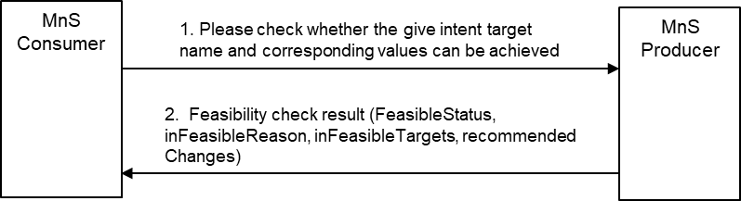
Figure 3.1.1-1: enabling the consumer to check if the intent is feasible, and in case it is infeasible, what causes it to be infeasible or what changes could be made to make the intent feasible.
The MnS consumer creates an intent indicating that it should be checked for feasibility.
If the intent is infeasible, the MnS producer may provide a feasibility check report containing one of the following:
- a binary result that the intent infeasible or not – this is already supported in TS28.312
  - The MnS producer should provide a reason for why the intent is infeasible – this is already supported in TS28.312, with the current reasons as conflict, invalid expression/syntax.
- a detailed report indicating what causes the intent to be infeasible – indicating which intentExpectation or expectationTarget is feasible or not -say using a binary flag for each aspect (intentExpectation and expectationTarget).
  - The MnS producer should support an infeasibility report that lists infeasible expectations and infeasible targets with the infeasible expectations.
  - The MnS producer may support new infeasibility reasons to infeasible targets/expectations, e.g., conflict, invalid expression, etc.
- a report indicating what is achievable for each intent aspect (intentExpectation and expectationTarget) that is infeasible.
  - The MnS producer should support an achievable outcomes report that lists the achievable outcomes for each infeasible targets within an infeasible expectation.
OAM Requirements:
- INT_ FEASIB_REQ 1 The MnS producer should support a capability to provide an infeasibility report that lists infeasible expectations and infeasible targets within the infeasible expectations.
- INT_ FEASIB_REQ 2 The MnS producer may support a capability to provide information on infeasibility reasons for any infeasible targets/expectations, e.g., conflict, invalid expression, etc.
- INT_ FEASIB_REQ 4 The MnS producer should support a capability to provide an achievable outcome report that lists the alternative (achievable outcomes) for each infeasible targets within an infeasible expectation.
- INT_ FEASIB_REQ 5 The MnS producer should support a capability to provide an achievable outcome report that lists the alternative changes to the infeasible targets that would guarantee to make the targets feasible.
- INT_ FEASIB_REQ 6 The MnS producer should support a capability enabling an MnS consumer to provide an intent with an indication for the type of feasibility check report to be provided.
This use case addresses aspects on three study objectives:
- WT-3.1.1 Management capability to enable MnS producer to ask the MnS consumer to decide which out of many possible outcomes is preferred from the MnS consumer’s perspective.
- WT-3.1.2 Management capability to enable MnS consumer to verify or check the feasibility if proposed intent expectation is possible for an MnS producer.
- WT-3.1.3 Management capability to enable MnS consumer to explore the best value that can be achieved from an specific intent expectation or target.

3.2 Use cases, Procedures and OAM requirements on Negotiation on fulfilment of intents
3.2.1 Overview
There are multiple negotiations that can happen for an intent that is feasible, many of them employing interaction that are similar.
Note: although some of these may be applicable during the feasibility check process, they are considered part of intent negotiations and not part of feasibility checking.
3.2.1 Checking for achievable outcomes
The MnS consumer wants to know the possible achievable outcomes for a given intent regardless of whether the intent. The MnS consumer creates an intent that should be evaluated by the MnS producer be see what the MnS producer can deliver.
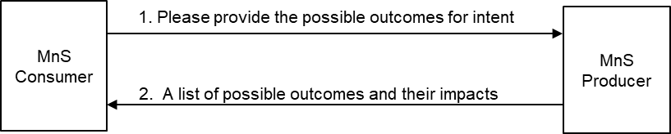
Figure 3.1.2-1: MnS consumer requests and receives a list of achievable outcomes on an intent.
Subsequently, the MnS producer provides a report indicating what is achievable for each intent aspect (intentExpectation and expectationTarget) within that intent. Since different achievable outcomes may have different impacts, the report should include the relative impacts of each outcomes.
OAM Requirements:
- INT_NEGOT_REQ 1: The MnS producer should support a capability enabling an MnS consumer to provide an intent with a request for the MnS producer to provide information on the alternative achievable outcomes for an intent.
- INT_NEGOT_REQ 2: The MnS producer should support a capability to provide an intent report including information on what is achievable for each intent aspect (intentExpectation and expectationTarget) within that intent and the relative cost/impact of achieving that outcome.

This use case addresses aspects on this study objective:
- WT-3.1.3 Management capability to enable MnS consumer to explore the best value that can be achieved from an specific intent expectation or target.

3.2.2 Checking for best possible outcome on an intent, intent expectation, or expectation target
The MnS consumer wants to know the best possible outcome for a given intent or intent expectation or expectation target. This could be prior to or during fulfilment.
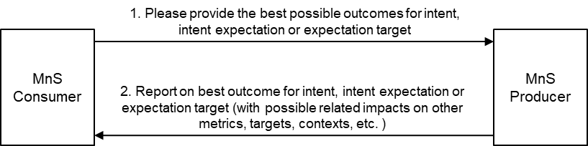
Figure 3.1.3-1: Checking for best possible outcome on intent or intent expectation or expectation target,
The MnS consumer creates an intent that should be evaluated by the MnS producer with a request to provide the best possible outcome. Subsequently, the MnS producer provides a report indicating that best possible outcome. The best possible outcome is defined as follows:
- The request is to evaluate an intent with only 1 expectation target: The best possible outcome is the best value on that expectation target that does not adversely affect other aspects of the network.
- The request is to evaluate expectation target in an intent with multiple expectation targets (e.g. multiple expectations or one expectation with multiple expectation targets): The best possible outcome is the best value on that expectation target that maintains the other expectation targets to within the ranges specified in the intent and does not adversely affect other expectation targets or aspects of the network.
- The request is to evaluate all expectation targets in an intent with multiple expectation targets (e.g. multiple expectations or one expectation with multiple expectation targets): The best possible outcome is the best value on each expectation target that maintains the other expectation targets to within the ranges specified in the intent and does not adversely affect other aspects of the network.
The MnS producer should support an achievable outcomes report that lists the achievable outcomes for any of the three scenarios, the report including the related impact on other targets in the intent or on other metrics and contexts.
OAM Requirements:
- INT_NEGOT_REQ 3: The MnS producer should support a capability enabling an MnS consumer to provide an intent with a request for the MnS producer to provide the best possible outcome on an intent or intent expectation or expectation target.
- INT_NEGOT_REQ 4: The MnS producer should support a capability to provide an intent report including information on on the best possible outcome on intent or intent expectation or expectation target.
Note: In the cases where the intent includes multiple targets, this would imply multiple back and forth interactions where the consumer checks each individual target
This use case addresses aspects on three study objectives:
- WT-3.1.3 Management capability to enable MnS consumer to explore the best value that can be achieved from an specific intent expectation or target.

3.2.3 MnS producer to recommend realizable intent properties
The MnS consumer wants to know what the MnS producer recommends what to be applied for particular intent characteristics. The MnS consumer creates an intent and asks the MnS producer to recommend what changes could be made to the intent or other intents to make the intent fulfillable (Figure 3.2.1-1). Alternatively, the MnS producer has attempted to fulfil the intent and indicated that it cannot be fulfilled, so the MnS consumer creates asks the MnS producer to recommend what changes could be made to the intent or other intents to make the intent fulfillable.
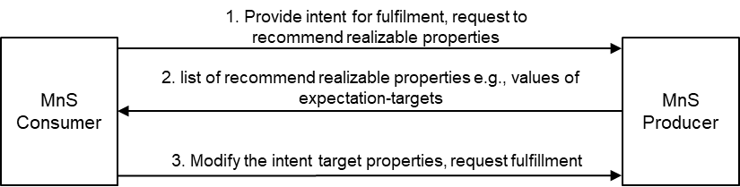
Figure 3.2.1-1: Enabling the MnS consumer to request and receive a recommendation on the realizable intent properties prior to fulfilment.
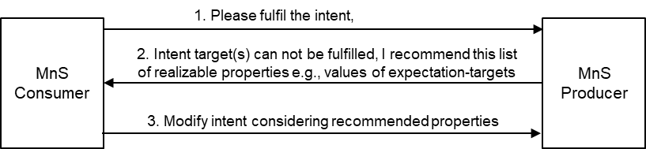
Figure 3.2.1-2: Enabling the MnS producer to recommend to the MnS consumer a set of realizable intent properties in case of inability to fulfil an intent.
Subsequently, the MnS producer provides a (intent modification recommendation) report indicating the changes to be applied to the intent to make the intent fulfillable. The MnS producer should support a recommended-changes report that lists the proposed candidate changes to each unfulfillable target within an unfulfillable expectation.
Note: the nature of the report and what can be included if FFS
OAM Requirements:
- INT_NEGOT_REQ-5: The MnS producer should support a capability enabling an MnS consumer to provide an intent with a request for the MnS producer to provide information on what changes could be made to the intent properties or to properties of other intents to make the intent fulfillable .
- INT_NEGOT_REQ-6 The MnS producer may support a capability to provide a report indicating what changes could be applied to the intent (i.e., deleting some of the intentExpectations and/or expectationTarget(s) or the changing the properties of intentExpectations and/or expectationTarget(s)) to make the intent fulfillable .
This use case addresses aspects on two study objectives:
- WT-3.1.2 Management capability to enable MnS consumer to verify or check the feasibility if proposed intent expectation is possible for an MnS producer.
- WT-3.1.3 Management capability to enable MnS consumer to explore the best value that can be achieved from an specific intent expectation or target.

3.2.4 MnS consumer advises on preferred alternatives prior to fulfilment
The MnS consumer wants an intent fulfilled. The intent is feasible, but the MnS producer has multiple alternatives for how to realize the intent. The MnS producer wants the MnS consumer to advise on their (the MnS consumer’s) preference among these alternatives.
Note 1: The nature of alternatives, whether intent target values, approaches, DNs (e.g. of affected functions or / closed loops), actions e.g. a set of recommended actions if FFS
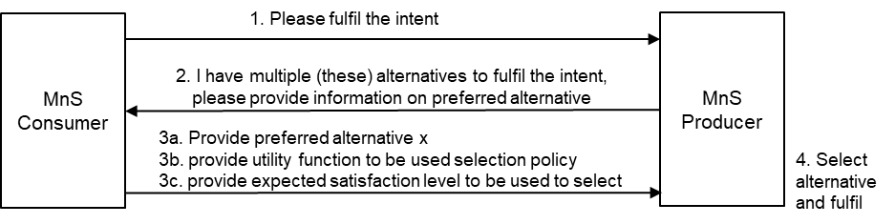
Figure 3.2.2-1: MnS consumer advises the MnS producer on the preferences among alternatives at the MnS producer.
After the MnS consumer creates an intent to be fulfilled, the MnS producer determines that there are multiple alternatives, so the MnS producer and provides a report to the MnS consumer so that the MnS consumer may help chose the best alternative.

The report to the MnS consumer may include:
- the list of available alternatives that the MnS producer is able to apply/achieve.
- The expected relative impacts of the different alternatives – on aspects of the submitted intent or other intents and intent expectations.
- A request to the MnS consumer to select one among the alternatives.
Given the alternatives, the MnS consumer takes one or both of the two actions,
- Chooses and indicates the preferred alternative.
- Defines the relative importance of their expectation Targets so that the MnS producer may consider these in deciding upon the solution/ solution approach/ closed loops/ action/ outcome to be applied/deployed/achieved.
OAM Requirements:
- INT_NEGOT_REQ-7: The MnS producer should support a capability to provide to an MnS consumer an intent report indicating the alternatives that the MnS producer can support for the provided intent, intent expectations, or expectation Targets and the expected relative impacts of the different alternatives
- INT_NEGOT_REQ-8: The MnS producer should support a capability to request an MnS consumer to indicate its preference among a set of alternatives that the MnS producer can support for the provided intent, intent expectations, or expectation Targets.
- INT_NEGOT_REQ-9: The MnS producer should support a capability enabling an MnS consumer to provide to the MnS producer information indicating the MnS consumer’s preference among alternatives that the MnS producer can support for the provided intent, intent expectations, or expectation Targets.
- INT_NEGOT_REQ-10 The MnS producer should support a capability enabling an authorized MnS consumer to provide information on a policy that should be used by the be used by the MnS producer to select among the alternatives available at the MnS producer.
Note: The policy may be provided in form of a utility function
- INT_NEGOT_REQ-11 The MnS producer should support a capability to request the MS consumer to provide an evaluation of the MnS producer’s alternatives based on the expected relative impacts of the different alternatives.
- INT_NEGOT_REQ-12 The MnS producer should support a capability enabling an MnS consumer to provide an evaluation of the MnS producer’s alternatives to then be used to select among the alternatives.
This use case addresses aspects on two study objectives:
- WT-3.1.1 Management capability to enable MnS producer to ask the MnS consumer to decide which out of many possible outcomes is preferred from the MnS consumer’s perspective.
WT-4 Study how Intent Utility Function can be used to allow Intent driven MnS consumer to improve priority handling by assigning relative preferences to Expectations. Study whether utility may impact existing use cases.
3.2.5 MnS producer requests for extra information to be used to select another alternative post initial fulfilment
The MnS consumer wants an intent fulfilled and the MnS producer has multiple alternatives for how to realize the intent. After the MnS consumer creates an intent to be fulfilled, the MnS producer independently choses the alternative to be applied. But on realizing that they cannot achieve better outcomes, MnS producer allows the MnS consumer to provide extra information that guarantee better satisfaction (see Figure 3.2.5-2). The MnS producer reports the fulfillment outcomes (imperfect fulfillment) and indicates to the MnS consumer that if the MnS consumer is unsatisfied with the outcomes, the MnS consumer should provide extra information to help select a better alternative.
The report to the MnS consumer may include one or more of the following:
- The list of available alternatives which can guide the MnS consumer when providing the preference policy.
- The relative impacts of the different alternatives – on aspects of the submitted intent or other intents and intent expectations.
- A request to evaluate the fulfilment and provide information that could help improve fulfilment.
The extra information provided by the MnS consumer may be one or more of the following:
- A Binary indication that they accept the provided fulfillment or that they do not accept, and another alternative should be tried.
- A utility function indicating the MnS consumer’s relative benefits of their expectation Targets. The utility function is the MnS consumer’s policy for evaluating of the extent to which they are satisfied with the selected approach
- MnS consumer’s level of satisfaction which is the evaluation of the extent to which the achieved outcomes match the MnS consumer’s expectation as computed from the utility function.
- changes to the expectation Targets or the relative importance of the expectation Targets to the MnS consumer’s objectives
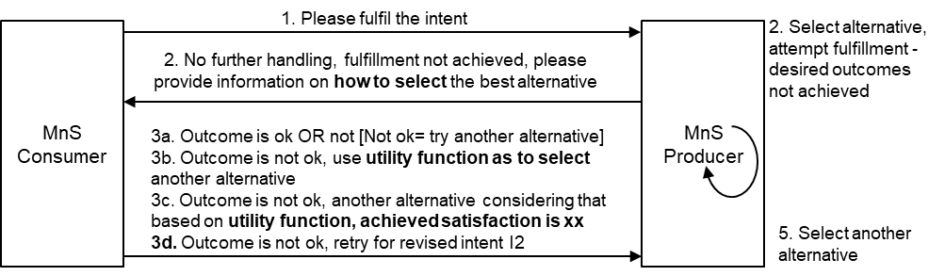
Figure 3.2.4-1: MnS producer requests MnS consumer to provide information to help select (better) alternative.
OAM Requirements:
- INT_NEGOT_REQ-7 (restated) The MnS producer should support a capability to provide to an MnS consumer an intent report indicating the alternatives that the MnS producer can support for the provided intent, intent expectations, or expectation Targets and the expected relative impacts of the different alternatives
- INT_NEGOT_REQ-13 The MnS producer should support a capability to inform an authorized MnS consumer that an alternative among multiple alternatives has been selected and (will be/has been) applied for the submitted intent.
- INT_NEGOT_REQ-14 The MnS producer should support a capability to inform an authorized MnS consumer that since no more improvement to intent fulfillment shall be possible the MnS consumer should evaluate the extent to which the applied alternative satisfies the MnS consumer’s objectives or provide extra information which can help improve satisfaction.
- INT_NEGOT_REQ-15 The MnS producer should support a capability enabling an authorized consumer to inform the producer that the alternative selected by the MnS producer was not satisfactory and another alternative should be applied.
- INT_NEGOT_REQ-10(restated) The MnS producer should support a capability enabling an authorized MnS consumer to provide (information on) a policy that should be used by the be used by the MnS producer to select among the alternatives available at the MnS producer.
- INT_NEGOT_REQ-16 The MnS producer should support a capability enabling an authorized MnS consumer to provide information on the level of fulfillment which the MnS producer can use to differently attempt the fulfillment.
- INT_NEGOT_REQ-17(already supported) The MnS producer should support a capability enabling an authorized MnS consumer to revise the properties of an intent as the means to improve the chances of the intent being fulfillable.
This use case addresses aspects on two study objectives :
- WT-3.1.1 Management capability to enable MnS producer to ask the MnS consumer to decide which out of many possible outcomes is preferred from the MnS consumer’s perspective.
- WT-4 Study how Intent Utility Function can be used to allow Intent driven MnS consumer to improve priority handling by assigning relative preferences to Expectations. Study whether utility may impact existing use cases.

3.3 Proposed way forward for SA5
It is proposed to capture new OAM use case descriptions and requirements (from above section 3.1 and 3.2) in TR 28.914 on the following use cases:
- Feasibility Checking
- Checking achievable outcomes
- Checking for best possible outcome on an intent, intent expectation or expectation
- MnS producer to recommend realizable intent properties.
- MnS consumer advises on preferred alternatives prior to fulfilment.
- MnS producer requests for extra information to be used to select another alternative post initial fulfilment.
It is proposed to extend the solutions on intent feasibility in TS28.312

4 Detailed proposal
It is requested to investigate the following functionalities in TR 28.914:

- Feasibility Checking
- Explore achievable outcomes
- Explore the best possible outcome on an intent, intent expectation or expectation
- MnS producer to recommend realizable intent target and context for the unfulfilled targets and contexts
- MnS consumer advises on preferred alternatives (including the outcomes and/or solutions) for fulfilment
- MnS producer requests for extra information to be used to select alternative for fulfilment.

