3GPP TSG-SA5 Meeting #155 S5-243121

27 - 31 May 2024, Jeju, South Korea revision of S5-242334

Source: Nokia, Nokia Shanghai Bell

Title: pCR 28.867 CCL Coordination capabilities

Document for: Approval

Agenda Item: 6.19.4

1 Decision/action requested
Discuss and agree on the text

2 References
[1] 3GPP TR 28.867-010 “Closed control loop management”.

3 Rationale
Multiple CCLs acting along each other in the same environment are expected to affect one another i.e., there may be conflicts which need to be detected and the necessary resolutions executed. The operation of these CCLs needs to be coordinated. This pCR introduces the set of capabilities that may be needed for coordination of Closed Control Loops as well as the alternative approaches on how to handle any such conflict detection and resolution.

4 Detailed proposal

Start of First change

4 Concepts and background
4.X Closed Control Loop conflicts management
4.X.1 CCL conflict scenarios
Multiple CCLs could co-exist and concurrently act within the same environment. The CCLs can affect one another, in the worst cases leading to conflicts. The conflicts may occur among goals, , control scopes or actions of the CCLs. The control scopes of a CCL are the set of managed entities and controlled parameters on those managed entities for which a CCL instance takes responsibility. Actions of the CCL are changes that a CCL can perform over a managed entity such as configuring an attribute. The possible conflict scenarios include:
- Conflicts among the targets within the goals of the individual CCLs sharing a given scope, i.e., (where applicable) that a target network configuration parameter is only part of the goals of one CCL in the given scope
Note: the scope is the set of managed objects and their properties which the CCL measures or is responsible to configure.
- Conflicts among the performance metrics even where there are no goal conflicts, i.e., that for two CCLs which have different goals or targets within their goals but share a given scope, one CCL will not affect the metrics of another CCL. For example, a conflict could occur among the metrics if a CCL that optimizes energy consumption affects handover performance metrics which are supposed to be optimized by another CCL.
- Conflicts among the scopes of the CCLs, e.g. where the measurement scope of CCL is the control scope of another CCL, so (where applicable) the spaces should be allocated such that that two CCLs will not control/adjust the same set of parameters on the same set of managed objects.
- Conflicts on when the CCLs may be triggered for execution, for example, where 2 CCLs have a related scope, to ensure that one CCL (CCL A) does not influence a scope that is used as input/measurement scope by another CCL (CCL B). In that case CCLA and CCL B need to be triggered in different times.
To address the conflicts, coordination interactions are required between the CCLs and one or more higher hierarchy coordination functions to avoid or detect and resolve the conflicts.

Note: the descriptions of the conflict scenarios may need to be improved after detailed descriptions of the conflict detection and resolution use cases.

Next change

5. Use Cases

5.A. Use case X5 CCL conflicts resolution and coordination rinteractions
The coordination of CCLs includes the management services needed to detect, resolve, or avoid conflicts among goals and their targets, , control scopes or actions of the CCLs. To address the different conflict situations, coordination capabilities could be required for the following scenarios:
- Capabilities to identify different interaction types between CCLs such as cooperation (positive interaction), conflict (negative interaction) or dependency (neutral interaction).
- Capabilities to align targets among the goals of individual CCLs sharing a given scope.
- Capabilities to identify different types of conflicts between CCLs such as parameters conflict, metrics conflict, or any others.
- Capabilities to address the different interactions between CCLs with adequate mechanisms, such as conflict resolution mechanisms.
- Capabilities to identify before the execution of a proposed action of CCL that such an action could cause undesired effects to other CCLs or to managed entities (e.g., pre-execution and post-execution coordination, concurrency coordination, etc.).
- Capabilities to evaluate the impact and effectiveness of CCLs actions after their execution (e.g., impact assessment).

The coordination of CCLs could be required at different execution points of the CCL translating into different CCL coordination use cases with corresponding CCL coordination services required at those points as illustrated by example Figure 5.A.1-1. The coordination of CCLs could be achieved via direct interaction among the CCLs or via a third-party entity, say called the CCLs coordination Function (or simply CCL Coordinator).

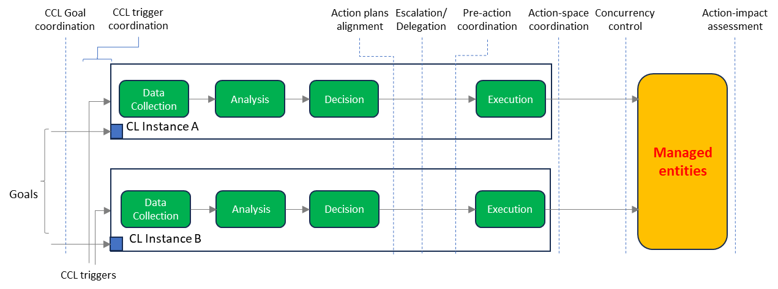
Figure 5.A.1-1: Exemplary Closed Control Loop Coordination coordination interaction points
Note: the terms at the top indicate general naming of the groupings of coordination interactions at the different execution points during the execution the CCL. Action-space coordination implies coordinating the sets of actions that the different CCL can apply. Concurrency control implies coordinating the times at which different CCLs can execute actions. action-impact assessment indicates interactions and processes on the evaluation of the impacts of the different CCLs.

End of modifications

