3GPP TSG-SA5 Meeting #155 S5-242954

Jeju, Korea (Republic Of), 27th May 2024 - 31st May 2024

Source: Samsung

Title: MDAS assisted topology mapping for edge network

Document for: Approval
Agenda Item: 6.19.2

1 Decision/action requested
In this box give a very clear / short /concise statement of what is wanted.

2 References
None

3 Rationale
This provides the new use case of MDAS.

4 Detailed proposal

First Change

5.x Edge Network topology mapping
5.x.1 Description
This use case assumes that the 5GC nodes are deployed on the edge of the network to provide better and reliable services to the end users. With edge network deployment, we can guarantee the latency and reliability for critical applications such as factory automation, automation vehicles, remote control and virtual/augmented reality.
As depicted in the following figure multiple instances of the 5GC nodes may be deployed on the edge network to mitigate the load. Selecting the set of nodes and their instances to be deployed in the edge site is crucial for better performance.

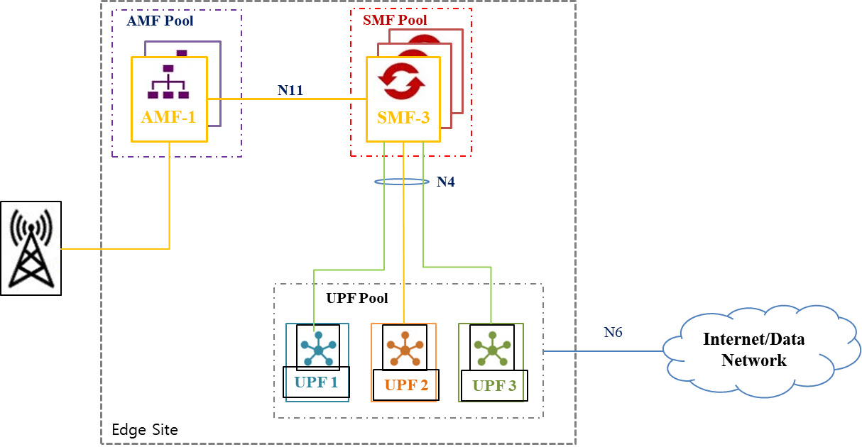

5.x.2 Potential Requirements
REQ-FUN-EdgePM-01: It should be possible for MDA analytics to suggest the components of an edge site.
5.x.3 Potential solutions
The solution involves performing heuristics learnings on measurement data related with RTT and Packet Loss on various interfaces including N3 (gNB UPF), N4 (SMF UPF), N10 (SMF UDM), N11(AMF SMF) and N7 (SMF PCF). Thereafter, deploying automation functionalities (e.g AI/ML Time Series Methods) to analyse the above parameters and subsequently chooses the best components to be part of an edge site. The analytics will provide projected RTT and Packet Loss information, as peer information, for each related interface. Based on the peer information the best possible components can be decide.
The solution proposes a new MDA type for edge network topology mapping.
The analytics scope of this MDA type would indicate the following:
- The DNs of the interface (EP_N3, EP_N11) for which the peer information is requested.
The enabling data for this MDA type would include the following:
- The average round-trip delay on a N3 interface of this gNB on PDU Session Anchor (PSA) for available instances of core UPF. This measurement is split into sub-counters per DSCP (Differentiated Services Code Point). See clause 5.4 of TS 28.552.
- Number of GTP data packets of this gNB which are not successfully received at UPF. See clause 5.4 of TS 28.552.
- Number of GTP data packets of this gNB which are not successfully received at gNB over N3. See clause 5.4 of TS 28.552
The analytics output for this MDA type would include the following:
- Member NF: The DN of the selected VNF to be deployed on the edge.

