3GPP TSG-SA5 Meeting #155 S5-243071
Jeju, South Korea, 27 - 31 May 2024

Title: LS on update of 3GPP SA5 Rel-18 progress and Rel-19 work plan
Response to: -
Release: Rel-18/Rel-19
Work Item: -

Source: 3GPP SA5
To: GSMA, NGMN, TM Forum, ITU-T SG13, ITU-T SG5, ITU-T SG2, ETSI ISG ZSM, ETSI ISG NFV, ETSI TC EE, ONAP, O-RAN
Cc: 3GPP SA

Contact person: Zou Lan (3GPP SA5 Chair)
(zoulan<at>huawei<dot>com)

Send any reply LS to: 3GPP Liaisons Coordinator, mailto:3GPPLiaison@etsi.org

Attachments: None

1 Overall description
SA5 would like to thank you for your continuous interest to SA5 technical discussion. We would like to inform you about 3GPP SA5 Rel-18 progress and Rel-19 work plan.
The Rel-18 standardization work is completed. In Rel-18, the following aspects are extensively addressed. Summary of 3GPP Rel-18 features are described in TR 21.918 https://portal.3gpp.org/desktopmodules/Specifications/SpecificationDetails.aspx?specificationId=4229 “Release 18 Description; Summary of Rel-18 Work Items”. The corresponding management OpenAPI and YANG solution sets are captured in 3GPP forge: https://forge.3gpp.org/rep/sa5/MnS

- Intelligence and automation
- Management architecture and mechanisms
- Support of new services
- Charging management

Management and Orchestration including intelligence and automation, management architecture and mechanisms, support of new services.

The latest 5G management and orchestration features are captured in specifications listed in following diagram (more details can be found in TS 28.533 Annex E):
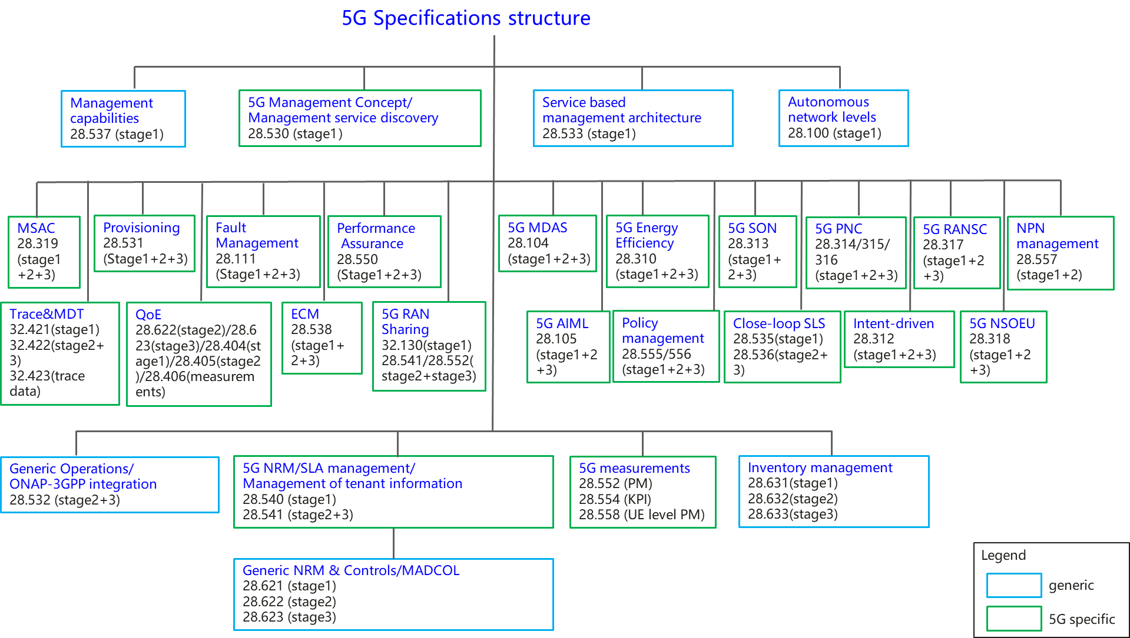

3GPP SA5 has started Rel-19 management and orchestration study and standardization work from Jan.2024. In the scope of Rel-19, SA5 standardization work includes management and orchestration requirements, management stage 2 and interaction procedures, and stage 3 OpenAPI and YANG solution sets to provide complete management interoperability capabilities for 5G network in multi-vendor environment.
There are 21 Rel-19 management and orchestration topics currently under discussion, the detail information of the topics in captured in https://forge.3gpp.org/rep/sa5/MnS/-/wikis/pages
- Study on AI/ML management - phase 2
- Study on Management Data Analytics (MDA) – Phase 3
- Study on intent driven management services for mobile network phase 3
- Study on closed control loop management
- Study on management aspects of Network Digital Twin
- Study on Cloud Aspects of Management and Orchestration
- Study on Enablers for Security Monitoring
- Study on Service Based Management Architecture enhancement phase 3
- Study on Management of planned configurations
- Data management phase 2
- Study on data management regarding subscriptions and reporting
- 5G performance measurements and KPIs phase 4
- 5G Advanced NRM features phase 3
- Subscriber and Equipment Trace and QoE collection management
- Study on Management Aspects of NTN Phase 2
- Study on management of IAB nodes
- Study on management aspects of RedCap feature
- Study on Enhancement of Management Aspects related to NWDAF Phase 2
- Study on Management of Network Sharing Phase 3
- Study on energy efficiency and energy saving aspects of 5G networks and services
- Study on Enhanced OAM for management exposure to external consumers

Charging management include 5G Charging for Local breakout roaming of data connectivity,
Network Slice Charging
, Charging aspects for 5G LAN VN Group, CIoT, Edge Computing.
The complete set of 5G Charging service support are captured in the following diagram (TS 32.240):
There are 5 Rel-19 charging topics currently under discussion:
- Charging Aspects of Ranging and Sidelink Positioning
- CHF Segmentation
- Study on charging aspects of satellite access Phase 3
- Study on Charging Aspects of Common API Framework
- Study on Charging aspects of next generation real time communication services phase 2
SA5 would like to thank you for your interest in Rel-18 progress and is looking forward for future cooperation on Rel-19 topics.

2 Actions
To GSMA, NGMN, TM Forum, ITU-T SG13, ITU-T SG5, ITU-T SG2, ETSI ISG ZSM, ETSI ISG NFV, ETSI TC EE, ONAP, O-RAN
ACTION:
SA5 kindly asks to take the above information into account.

3 Dates of next TSG SA WG 5 meetings
SA5#156 19 August - 23 August 2024 Maastricht, Netherlands
SA5#157 14 October - 18 October 2024 Hyderabad, India

