3GPP TSG-SA5 Meeting #155 S5-242629

Jeju, South Korea, 27 - 31 May 2024
CR-Form-v12.1
CHANGE REQUEST
 | 28.105 | CR | 0145 | rev | - | Current version: | 18.3.0
For HELP on using this form: comprehensive instructions can be found at
http://www.3gpp.org/Change-Requests.

Proposed change affects: | UICC apps |  | ME |  | Radio Access Network | X | Core Network | X

Title: | Rel-18 Input to DraftCR 28.105 correct AIML function management scenario for NWDAF
Source to WG: | Asiainfo
Source to TSG: | S5
Work item code: | AIML_MGT |  |  |  |  |  | Date: |  |  | 2024-05-13
Category: | F |  |  |  |  |  | Release: |  |  | Rel-18
 | Use one of the following categories:  F (correction)  A (mirror corresponding to a change in an earlier release)  B (addition of feature),  C (functional modification of feature)  D (editorial modification)  Detailed explanations of the above categories can  be found in 3GPP TR 21.900. |  |  |  |  |  |  |  | Use one of the following releases:  Rel-8 (Release 8)  Rel-9 (Release 9)  Rel-10 (Release 10)  Rel-11 (Release 11)  …  Rel-15 (Release 15)  Rel-16 (Release 16)  Rel-17 (Release 17)  Rel-18 (Release 18)
Reason for change: |  | In clause 4a.2, it is missing the senario where the ML training function is located in the CN domain manament function, the ML inference function is located in the NWDAF.
Summary of change: |  | Adding the AI/ML functionalities management secenario that where the ML training is located in CN domain management function and AI/ML inference is located in NWDAF
Consequences if not approved: |  | It may cause the senario missed
Clauses affected: |  | 4a.2
 |  | Y | N
Other specs |  |  |  | Other core specifications |  |  |  | TS/TR ... CR ...
affected: |  |  |  | Test specifications |  |  |  | TS/TR ... CR ...
(show related CRs) |  |  |  | O&M Specifications |  |  |  | TS/TR ... CR ...
Other comments:
This CR's revision history:

First Change

4a.2 AI/ML functionalities management scenarios (relation with managed AI/ML features)
The ML training function and/or AI/ML inference function can be located in the RAN domain MnS consumer (e.g. cross-domain management system) or the domain-specific management system (i.e. a management function for RAN or CN), or Network Function.
For MDA, the ML training function can be located inside or outside the MDAF. The AI/ML inference function is in the MDAF.
For NWDAF, the ML training function can be located in the MTLF of the NWDAF or the management system, the AI/ML inference function is in the AnLF of NWDAF.
For RAN, the ML training function and AI/ML inference function can both be located in the gNB, or the ML training function can be located in the management system and AI/ML inference function is located in the gNB.
Therefore, there might exist several location scenarios for ML training function and AI/ML inference function.
Scenario 1:
The ML training function and AI/ML inference function are both located in the 3GPP management system (e.g. RAN domain management function). For instance, for RAN domain-specific MDA, the ML training function and AI/ML inference functions for MDA can be located in the RAN domain-specific MDAF. As depicted in figure 4a.2-1.

Figure 4a.2-1: Management for RAN domain specific MDAF
Similarly, for CN domain-specific MDA the ML training function and AI/ML inference function can be located in CN domain-specific MDAF.

Scenario 2:
For RAN AI/ML capabilities, the ML training function is located in the 3GPP RAN domain-specific management function while the AI/ML inference function is located in gNB. See figure 4a.2-2.
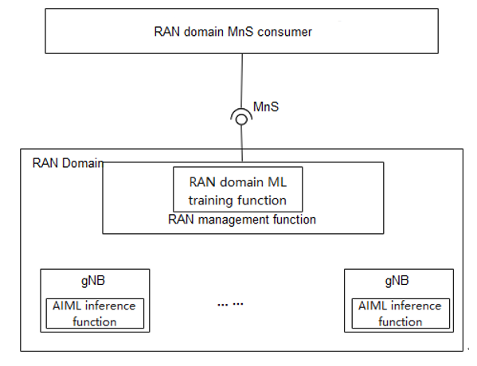
Figure 4a.2-2: Management where the ML training is located in RAN domain management function and AI/ML inference is located in gNB
Scenario 3:
For RAN AI/ML capabilities, the ML training function and AI/ML inference function are both located in the gNB. See figure 4a.2-3.
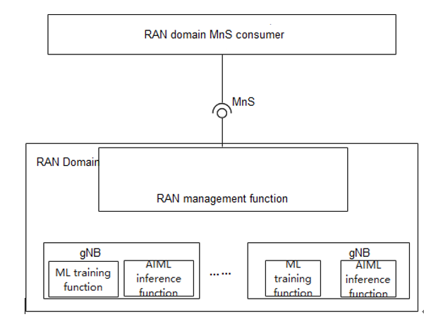
Figure 4a.2-3: Management where the ML training and AI/ML inference are both located in gNB
Scenario 4:
For NWDAF, the ML training function and AI/ML inference function are both located in the NWDAF. See figure 4a.2-4.

Figure 4a.2-4: Management where the ML training and AI/ML inference are both located in CN

Scenario 5:
For NWDAF, the ML training function is located in the CN domain manament function, the ML inference function is located in the NWDAF. See figure 4a.2-5.

Figure 4a.2-5: Management where the ML training is located in CN domain management function and AI/ML inference is located in NWDAF
End Change

