3GPP TSG-SA5 Meeting #155 S5-242615

Jeju, South Korea, 27 - 31 May 2024
CR-Form-v12.1
CHANGE REQUEST
 | 28.536 | CR | 0083 | rev | - | Current version: | 18.0.0
For HELP on using this form: comprehensive instructions can be found at
http://www.3gpp.org/Change-Requests.

Proposed change affects: | UICC apps |  | ME |  | Radio Access Network | X | Core Network | X

Title: | Clarify assurance procedure
Source to WG: | Ericsson
Source to TSG: | S5
Work item code: | TEI16 |  |  |  |  |  | Date: |  |  | 2024-05-15
Category: | A |  |  |  |  |  | Release: |  |  | Rel-18
 | Use one of the following categories:  F (correction)  A (mirror corresponding to a change in an earlier release)  B (addition of feature),  C (functional modification of feature)  D (editorial modification)  Detailed explanations of the above categories can  be found in 3GPP TR 21.900. |  |  |  |  |  |  |  | Use one of the following releases:  Rel-8 (Release 8)  Rel-9 (Release 9)  Rel-10 (Release 10)  Rel-11 (Release 11)  …  Rel-15 (Release 15)  Rel-16 (Release 16)  Rel-17 (Release 17)  Rel-18 (Release 18)
Reason for change: |  | The procedure for SLS assurance is described in clause 4.1.3.1. According to the diagram the consumer is informed about the fulfilment of the assurance goal after the second loop (with cycle time of the observation period) is completed. However the consumer should be informed after each cycle as the loop is continuosly operational.  After the SLS assurance is not required any longer i.e. the second loop has completed the last cycle, the data which was subscribed to is no longer needed and can be unsubscribed, this part of the procedure is missing.
Summary of change: |  | - update Figure 4.1.3.1.1 SLS assurance procedure bring last step into the loop  - update Figure 4.1.3.1.1 adding unscribe from Fault and Performance MnS providers  - update Figure 4.1.3.1.1 adding unscribe from the Analytic data providers  - add new steps 12 and13 reflecting the unsubscribe from providers
Consequences if not approved: |  | Incorrect procedure not aligned with stage 2 model for SLS assurance.
Clauses affected: |  | 4.1.3.1, Annex X (new)
 |  | Y | N
Other specs |  |  | X | Other core specifications |  |  |  | TS/TR ... CR ...
affected: |  |  | X | Test specifications |  |  |  | TS/TR ... CR ...
(show related CRs) |  |  | X | O&M Specifications |  |  |  | TS/TR ... CR ...
Other comments: |  | No stage 3 impacts
This CR's revision history:

First change

4.1.3 Procedures

4.1.3.1 SLS Assurance Procedure

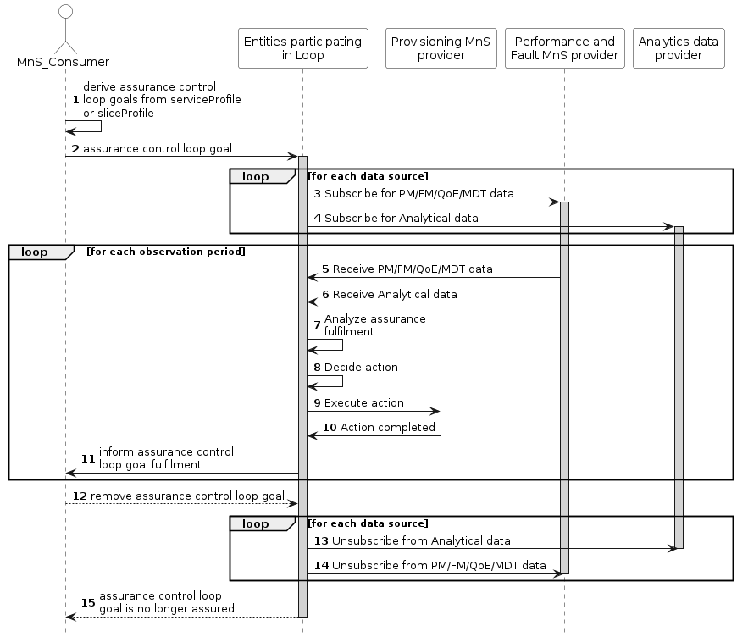
Figure 4.1.3.1.1 SLS assurance procedure
For the purpose of the procedure shown in Figure 4.1.3.1.1 "entities participating in the loop" refers to any entity in the 3GPP management system responsible for the functioning of an ACCL to ensure the AssuranceControlLoopGoal required by an AssuranceControlLoop_Consumer.
1. AssuranceControlLoop_consumer derives AssuranceControlLoopGoal from the ServiceProfile or SliceProfile.
2. AssuranceControlLoop_consumer provides the AssuranceControlLoopGoal to Entities_Participating_in_loop by utilizing the provision management services defined in as defined in clause 11.1.1.3 of TS 28.532 [7].
NOTE 1: In case the Entities_Participating_in_loop represents CrossDomain_Entities_Participating_in_loop, the AssuranceControlLoopGoal is the attribute(s) of the ServiceProfile. In case the Entities_Participating_in_loop represents Domain_Entities_Participating_in_loop, the AssuranceControlLoopGoal is the attribute(s) of the SliceProfile.
3. Entities_Participating_in_loop subscribes the related performance data (e.g., the packet delay related measurements), fault data, QoE data (e.g., buffer level) and MDT data from respective sources by utilizing the Operation establishStreamingConnection as defined in clause 6.2.1 of TS 28.550 [3].
4. Entities_Participating_in_loop, optionally, subscribes the related analytical data from MDAS producer or network functions, e.g., NWDAF. In case of NWDAF as a provider, Nnwdaf_EventsSubscription Service as defined in clause 4.2 of TS 29.520 [11] is used.
5. Entities_Participating_in_loop collects the related performance, fault, QoE and MDT data (e.g., the packet delay related measurements), fault data, QoE data (e.g., buffer level) and MDT data from respective sources by utilizing the Operation establishStreamingConnection as defined in clause 6.2.1 of TS 28.550 [3].
6. Entities_Participating_in_loop, optionally, collects the related analytical data from MDAS producer or network functions, e.g., NWDAF. In case of NWDAF as a provider, Nnwdaf_EventsSubscription Service as defined in clause 4.2 of TS 29.520 [11] is used.
7. Entities_Participating_in_loop assesses if the AssuranceControlLoopGoal has been fulfilled.
8. Entities_Participating_in_loop assesses if and which action to take in case the AssuranceControlLoopGoal has not been fulfilled.
9. As per the mitigation action (e.g., scale out) resources are changed, the generic provisioning management service as defined in clause 11.1 of TS 28.532 [7] is utilized for the same.
10. Action completed.
NOTE 2: The Entities_Participating_in_loop continues to monitor and analyse the performance and perform the adjustment if needed after an observation period.
11. AssuranceControlLoop_consumer receives assurance fulfilment information from Entities_Participating_in_loop by utilizing the provision management services defined in clause 11.1.1.3 of TS 28.532 [7].
12. AssuranceControlLoop_consumer removes the AssuranceControlLoopGoal
13. Entities_Participating_in_loop, (if subscribed), unsubscribes from receiving the related analytical data from MDAS producer or network functions, e.g., NWDAF.
14. Entities_Participating_in_loop unsubscribe from receiving he related performance data (e.g., the packet delay related measurements), fault data, QoE data (e.g., buffer level) and MDT data from respective sources.
15. Entities_Participating_in_loop informs the MnS consumer the AssuranceControlLoopGoal is no longer assured

Second change

Annex X (informative):
Appendix with UML code for the procedure diagram

@startuml
actor MnS_Consumer #White
participant Ent_PiL as "Entities participating\nin Loop" #White
participant Prov as "Provisioning MnS\nprovider" #White
participant PmFm as "Performance and\nFault MnS provider" #White
participant ADP as "Analytics data\nprovider" #White
autonumber
MnS_Consumer -> MnS_Consumer: derive assurance control\nloop goals from serviceProfile\nor sliceProfile
MnS_Consumer -> Ent_PiL: assurance control loop goal
activate Ent_PiL #lightgrey
loop for each data source
Ent_PiL -> PmFm: Subscribe for PM/FM/QoE/MDT data
activate PmFm #lightgrey
Ent_PiL -> ADP: Subscribe for Analytical data
activate ADP #lightgrey
end loop
loop for each observation period
PmFm -> Ent_PiL: Receive PM/FM/QoE/MDT data
ADP -> Ent_PiL: Receive Analytical data
Ent_PiL -> Ent_PiL:Analyze assurance\nfulfilment
Ent_PiL -> Ent_PiL:Decide action
Ent_PiL -> Prov:Execute action
Ent_PiL <- Prov:Action completed
Ent_PiL -> MnS_Consumer: inform assurance control\nloop goal fulfilment
end loop
MnS_Consumer --> Ent_PiL: remove assurance control loop goal
loop for each data source
Ent_PiL -> ADP: Unsubscribe from Analytical data
deactivate ADP #lightgrey
Ent_PiL -> PmFm: Unsubscribe from PM/FM/QoE/MDT data
deactivate PmFm #lightgrey
end loop
Ent_PiL --> MnS_Consumer:assurance control loop\ngoal is no longer assured
deactivate Ent_PiL
hide footbox
@enduml

End of changes

