3GPP TSG-SA5 Meeting #155 S5-242608

Jeju, South Korea, 27 - 31 May 2024
CR-Form-v12.1
CHANGE REQUEST
 | 28.536 | CR | 0078 | rev | - | Current version: | 18.0.0
For HELP on using this form: comprehensive instructions can be found at
http://www.3gpp.org/Change-Requests.

Proposed change affects: | UICC apps |  | ME |  | Radio Access Network | X | Core Network | X

Title: | Correct dataType name in Figure 4.1.2.2.1.1
Source to WG: | Ericsson, Deutsche Telekom
Source to TSG: | S5
Work item code: | TEI17 |  |  |  |  |  | Date: |  |  | 2024-05-15
Category: | A |  |  |  |  |  | Release: |  |  | Rel-18
 | Use one of the following categories:  F (correction)  A (mirror corresponding to a change in an earlier release)  B (addition of feature),  C (functional modification of feature)  D (editorial modification)  Detailed explanations of the above categories can  be found in 3GPP TR 21.900. |  |  |  |  |  |  |  | Use one of the following releases:  Rel-8 (Release 8)  Rel-9 (Release 9)  Rel-10 (Release 10)  Rel-11 (Release 11)  …  Rel-15 (Release 15)  Rel-16 (Release 16)  Rel-17 (Release 17)  Rel-18 (Release 18)
Reason for change: |  | The dataType name in Figure 4.1.2.2.1.1 is wrong  Plantuml code in Annex D is not reflecting the model in Figure 4.1.2.2.1.1, and 4.1.2.2.2.1
Summary of change: |  | Change dataType name in Figure 4.1.2.2.1.1  Remove the grey from Figure 4.1.2.2.2.1  Update plantuml code in Annex D.1  Update plantuml code in Annex D.2
Consequences if not approved: |  | Figures are not aligned with the description which may lead to interoperability issues
Clauses affected: |  | 4.1.2.2.1, 4.1.2.2.2, Annex D.1, Annex D.2
 |  | Y | N
Other specs |  |  | X | Other core specifications |  |  |  | TS/TR ... CR ...
affected: |  |  | X | Test specifications |  |  |  | TS/TR ... CR ...
(show related CRs) |  |  | X | O&M Specifications |  |  |  | TS/TR ... CR ...
Other comments:
This CR's revision history:

First change

4.1.2.2.1 Relationships
This clause depicts the set of classes that encapsulates the information relevant for this MnS. This clause provides an overview of the relationships between relevant classes in UML. This clause provides an overview of the relationships between relevant classes in UML. Subsequent clauses provide more detailed specification of various aspects of these classes.
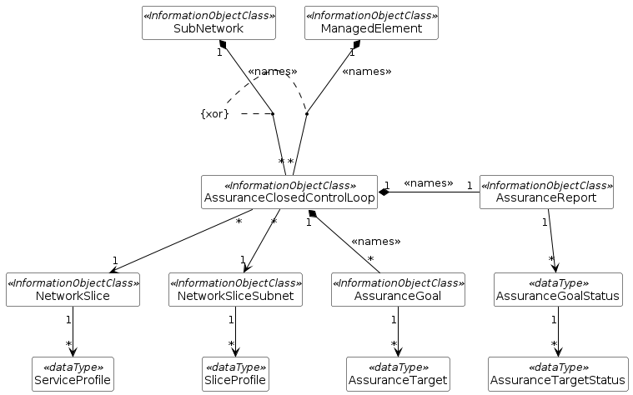
Figure 4.1.2.2.1.1: Assurance management NRM fragment

4.1.2.2.2 Inheritance
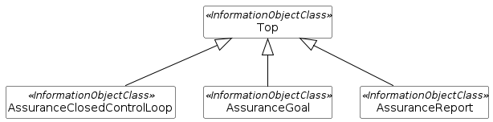
Figure 4.1.2.2.2.1: Assurance management inheritance relationships

Second change

Annex D (informative):
Appendix with UML code for model diagrams

D.1 UML code for Figure 4.1.2.2.1.1
@startuml
skinparam backgroundColor white
skinparam classBackgroundColor white
skinparam classBorderColor black
skinparam Shadowing false
skinparam noteBackgroundColor white
skinparam noteBorderColor white
skinparam arrowColor black
hide circle
hide members

class SubNetwork <<InformationObjectClass>>
class ManagedElement <<InformationObjectClass>>
class AssuranceClosedControlLoop <<InformationObjectClass>>
class AssuranceReport <<InformationObjectClass>>
class AssuranceGoal <<InformationObjectClass>>
class NetworkSlice <<InformationObjectClass>>
class NetworkSliceSubnet <<InformationObjectClass>>
class ServiceProfile <<dataType>>
class SliceProfile <<dataType>>
class AssuranceTarget <<dataType>>
class AssuranceGoalStatus <<dataType>>
class AssuranceTargetStatus <<dataType>>

SubNetwork "1" *-- "*" AssuranceClosedControlLoop: <<names>>
ManagedElement "1" *-- "*" AssuranceClosedControlLoop: <<names>>
AssuranceClosedControlLoop "1" *-- "*" AssuranceGoal: <<names>>
AssuranceReport "1" -left-* "1" AssuranceClosedControlLoop: <<names>>
AssuranceReport "1" --> "*" AssuranceGoalStatus
AssuranceGoalStatus "1" --> "*" AssuranceTargetStatus
AssuranceGoal "1" --> "*" AssuranceTarget
AssuranceClosedControlLoop "*" --> "1" NetworkSlice
NetworkSlice "1" --> "*" ServiceProfile
AssuranceClosedControlLoop "*" --> "1" NetworkSliceSubnet
NetworkSliceSubnet "1" --> "*" SliceProfile

note "{xor}" as Note1
Note1 .. (SubNetwork, AssuranceClosedControlLoop)
Note1 .. (ManagedElement, AssuranceClosedControlLoop)

@enduml

D.2 UML code for Figure 4.1.2.2.2.1
@startuml
skinparam backgroundColor white
skinparam classBackgroundColor white
skinparam classBorderColor black
skinparam Shadowing false
skinparam noteBackgroundColor white
skinparam noteBorderColor black
skinparam Note1BorderColor red
skinparam arrowColor black
hide circle
hide members

class Top <<InformationObjectClass>>
class AssuranceClosedControlLoop <<InformationObjectClass>>
class AssuranceGoal <<InformationObjectClass>>
class AssuranceReport <<InformationObjectClass>>

Top <|-- AssuranceClosedControlLoop
Top <|-- AssuranceGoal
Top <|-- AssuranceReport

@enduml

End of changes

