3GPP TSG-SA5 Meeting #155 S5-242358
Jeju, South Korea, 27 - 31 May 2024

Source: ZTE Corporation
Title: pCR TR 28.914 add alternative solutions for implicit intent report subscription
Document for: Approval
Agenda Item: 6.19.3

1 Decision/action requested
The group is asked to discuss and agree on the proposal.

2 References
[1] Study on intent driven management service for mobile network phase 3 v0.0.0
[2] SP-231737 "Study on intent driven management services for mobile network phase 3"

3 Rationale
When MnS Consumer expresses the intent expectation to MnS Producer, the MnS Consumer may have some requirements on Intent report (e.g., receive periodical and automated intent reports on a specific expectation target). It proposes to add key issue for introducing the MnS capability to enable MnS consumer to customize the content of intent report.
This contribution is related to WT-3 of the FS_IDMS_MN_Ph3 SID [2], which is to investigate new requirements for additional intent driven management functionalities.

4 Detailed proposal
Start of First change

5.3 Use case #3: Implicit intent report subscription

5.3.1 Description
In TS 28.312 [2], NtfSubscriptionControl IOC is used for MnS consumer to subscribe the intent report information explicitly. MnS consumer needs to request to create a NtfSubscriptionControl instance to subscribe the intent report information for a specified intent instance after such intent instance is created.
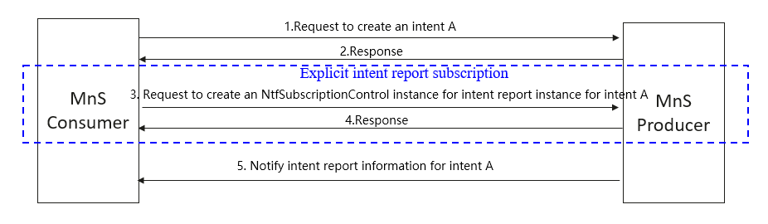
Figure 5.X.1-1 Explicit intent report subscription
However, in some scenarios, MnS consumer who expresses the intent may want to obtain the intent report by default, instead of triggering separate subscription action (i.e. request to create a NtfSubscriptionControl instance) to subscribe intent report information (especially intent fulfilment information).
So, the capability to support for implicit intent report subscription is important for the MnS consumer who express the intent.

5.3.2 Potential requirements
REQ-Intent_Driven_MnS-CON-1: The intent driven MnS producer should have the capability enabling MnS consumer who expresses the intent to specify intent report control information in the intent when creating or modifying the intent.
The existing REQ-Intent_Driven_MnS_Report-1,2,3,4,5,6,7 defined in TS 28.312 [2] also applied for implicit intent report subscription

5.3.3 Potential solutions

5.3.3.1 Potential solution #1
It proposes to add an attribute "reportRecipientAddress" in Intent <<IOC>> to represent the address of notification recipient for MnS consumer to receive the notification (i.e. notifyMOIAttributeValueChanges notification) with intent report information. If present, this attribute instructs the MnS producer to create, on behalf of the MnS consumer, a subscription for attribute value change notifications for IntentReport instance of the corresponding intent instance. Then MnS consumer does not need to request to create a NtfSubscriptionControl instance to receive the notification with intent report information.
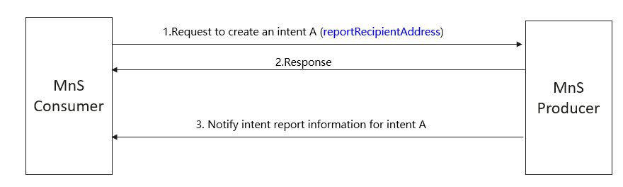
Figure 5.X.3-1 Implicit intent report subscription
In addition, the existing attribute “observationPeriod” in Intent <<IOC>> can be used to allow the MnS consumer who expresses the intent to configure the frequency of the intent reporting.
In case MnS consumer who expresses the intent does not want to subscribe to the intent report content, a new attribute “expectedReportTypes” can be added as an optional attribute of Intent <<IOC>> to allow the MnS consumer who expresses the intent to specify the content of the intent report. The allowed values for attribute “expectedReportType” can be intentFulfilmentReport, intentConflictReport or intentFeasibilityCheckReport.

5.3.3.2 Potential solution #2
The existing Intent IOC can be extended to support customized intent report.
Enhancement Aspect: Add a new IntentReportControl <<datatype>> to the Intent IOC and one Intent instance can have multiple IntentReportControl. IntentReportControl <<datatype>> includes following attributes:
- “expectedReportTypes”, represents the type of IntentReports, which can be one/any/all of “IntentFulfilmentReport”, “IntentConflictReport”, and “IntentFeasibilityCheckReport”.
- “reportingTime”, represents the specified time condition for intent reporting. For example, it can be an interval, a specific time, or a time window.
- “reportingTargets”, represents the specified targets needed to be reported and corresponding conditions. This attribute can be a <<dataType>>, including targetName, targetCondition, and targetValueRange that are already defined in TS 28.312.

- “observationPeriod”, represents the frequency of the intent reporting.
- “reportRecipientAddress”, represent the address of notification recipient for MnS consumer.
- “intentReportReference”, indicates the associated intent report instance(s).
Note: The MnS Producer should configure the “intentReportReference” to the Intent IOC when the IntentReport instance is created.

5.3.4 Evaluation of potential solutions
TBD
End of First change

