3GPP TSG-SA3 Meeting #116 S3-242543-r1

Jeju, South Korea, 20th - 24th May 2024 revision of S3-241989

Source: Huawei, HiSilicon

Title: New solution for mitigating UE privacy risks using temporary UE ID

Document for: Approval
Agenda Item: 5.7

1 Decision/action requested
Approve the pCR on new solution on key issue #2 in 33.700-29

References
- S. Xia, Q. Jiang, C. Zou and G. Li, "Beam Coverage Comparison of LEO Satellite Systems Based on User Diversification," in IEEE Access, vol. 7, pp. 181656-181667, 2019, doi: 10.1109/ACCESS.2019.2959824.
- Inigo del Portillo, Bruce G. Cameron, Edward F. Crawley, A technical comparison of three low earth orbit satellite constellation systems to provide global broadband, Acta Astronautica, Volume 159, 2019, Pages 123-135, ISSN 0094-5765, https://doi.org/10.1016/j.actaastro.2019.03.040.

3 Rationale
This contribution proposes a new solution for KI#2. In satellite scenario, the downlink coverage of the satellite beam is much larger than the uplink coverage of the UE beam. The downlink beam coverage is about 1000 km² even for some LEO (low-earth orbit) satellites[1][2]. Therefore, it is more difficult to intercept the uplink message for the passive attacker in the ground. Based on the above assumption, interim UE IDs are proposed to be provided by UE in this solution, which mitigates the security threat of UE traceability and linkability.

4 Detailed proposal
*** Start of Change ***

6.Y Solution #Y: Mitigating UE privacy risks using temporary UE ID

6.Y.1 Introduction
This solution addresses the KI#2.
In TR 23.700-29 [2], some solutions need to assign an interim GUTI to a UE before NAS security is established. However, the interim GUTI is sent in clear text and reused multiple times. Thus, it is possible thatthe UE can be tracked based on the interim GUTI.
In this solution, it is proposed to use one interim GUTI only once. Besides, the interim GUTI is generated based on the UE’s input in the uplink. The rationale of the solution is as follows.
In a satellite scenario, the downlink traffic is transmitted from the satellite to the UE on the ground whereas the uplink traffic is directed to the satellite. Therefore, it is easier to eavesdrop the downlink messages instead of uplink messages for a passive attacker on the ground.

6.Y.2 Solution details
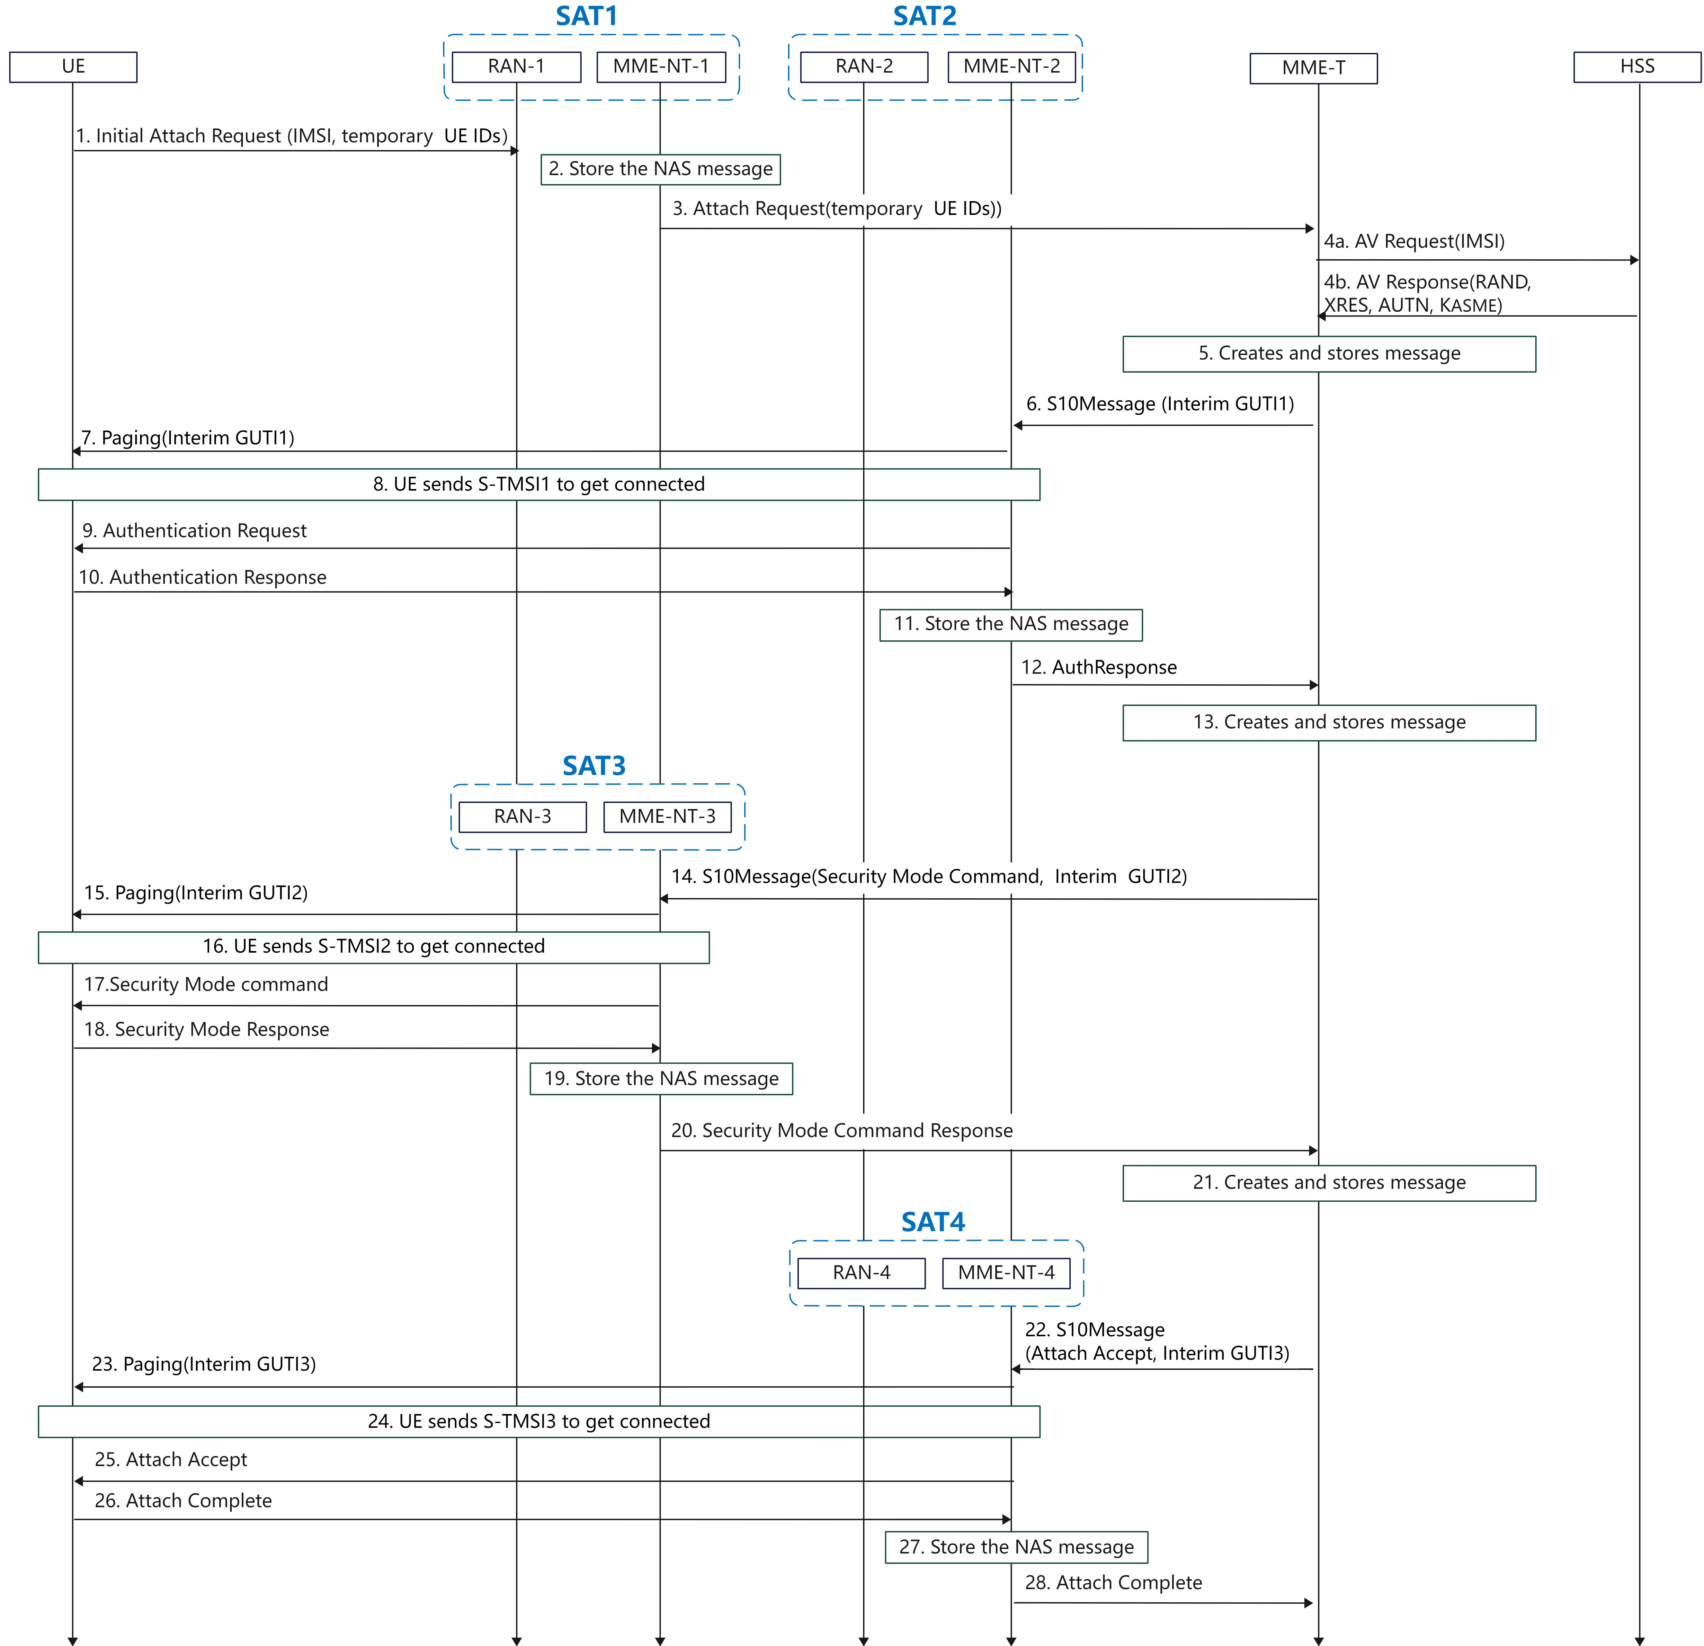
Figure 6.Y.2-1 interim GUTI assignment procedure in S&F, 4G
The attach procedure is based on the Solution #11 in TR 23.700-29[2]. The main difference is that in this solution UE provides temporary UE IDs in the initial attach request for the network to generate interim GUTIs.
Step1: The UE randomly generates one or multiple temporary UE IDs. The UE sends the initial Attach Request (IMSI, temporary UE IDs) to the SAT1. If the interim UE IDs are duplicated, the satellite shall require the UE to send new interim UE IDs. So the interim UE ID for the same MME-NT is unique.
Editor’s Note: The impact and potential abuse of UE ID duplication checks is FFS.
Step2-5: These steps are the same as corresponding steps in the Solution#11 of TR 23.700-29[2]. In addtion, the GUTIs are formed based on the temporary UE IDs.
Step6: When the next satellite available, the MME-T creates the Authentication NAS payload and forwards it to the SAT2 with the interim GUTI1.
Step7: The SAT2 pages the UE using the interim GUTI1.
Step8: The UE extracts the temporary UE ID from the received interim GUTI1 and compares it with the stored temporary UE IDs. If success, the UE generates and sends S-TMSI1 to get connected.
Step9-13: These steps are the same as the corresponding steps in the Solution#11 of TR 23.700-29[2].
Step14: When the next satellite available, the MME-T shall relay the Security mode command with the interim GUTI2 to the SAT3.
Step15-16: These steps are similar to the steps 10-11, with the SAT2 replaced with the SAT3.
Step17-21: These steps are the same as the corresponding steps in the the Solution#11 of TR 23.700-29[2].
Step22: When the next satellite available, the MME-T shall send the Attach accept along with the interim GUTI3 to the SAT4.
Step23-24: These steps are similar to step 10-11 with the SAT2 replaced with the SAT4.
Step25-28: These steps are the same as corresponding steps in the Solution#11 of TR 23.700-29[2].
Editor’s Note: how to generate the interim GUTI from the temporary UE ID is FFS.
NOTE: This solution is also applicable to the 5G systems, with the MME replaced with the AMF and the attach procedure with the registration procedure.

6.Y.3 Evaluation
The solution is addressing the KI#2.
The solution is based on the SA2’s solution #11 with security enhancement. The temporary UE IDs are provided by the UE for the network to generate the interim GUTI so that only the intreim GUTI is not reused to prevent traceability and linkability.

*** End of Change ***

