3GPP TSG-WG SA2 Meeting #164 S2-2409088

Maastricht, Netherlands, 19th Aug 2024 - 23rd Aug 2024 revision of S2-2408406
CR-Form-v12.2
CHANGE REQUEST
 | 23.288 | CR | 1171 | rev | 1 | Current version: | 18.6.0
For HELP on using this form: comprehensive instructions can be found at
http://www.3gpp.org/Change-Requests.

Proposed change affects: | UICC apps |  | ME |  | Radio Access Network |  | Core Network | X

Title: | Registration and Discovery procedure for Vertical Federated Learning among NWDAF(s) and/or AF(s) with NWDAF as the VFL server
Source to WG: | ICS, OPPO, InterDigital
Source to TSG: | SA2
Work item code: | AIML_CN |  |  |  |  |  | Date: |  |  | 2024-08-09
Category: | B |  |  |  |  |  | Release: |  |  | Rel-19
 | Use one of the following categories:  F (correction)  A (mirror corresponding to a change in an earlier release)  B (addition of feature),  C (functional modification of feature)  D (editorial modification)  Detailed explanations of the above categories can  be found in 3GPP TR 21.900. |  |  |  |  |  |  |  | Use one of the following releases:  Rel-8 (Release 8)  Rel-9 (Release 9)  Rel-10 (Release 10)  Rel-11 (Release 11)  …  Rel-16 (Release 16)  Rel-17 (Release 17)  Rel-18 (Release 18)  Rel-19 (Release 19)
Reason for change: |  | Introducing a new FL variant (i.e. Vertical Federated Learning) in 5GC.
Summary of change: |  | [1st Change] Adding a new subsection to describe required procedures to perform VFL Registration and Discovery when NWDAF(s) and/or AF(s) are the VFL client with a VFL Server NWDAF.
Consequences if not approved: |  | The new feature that was concluded in the study phase will not be adopted in the related specs.
Clauses affected: |  | 5.2, 6.2X (new)
 |  | Y | N
Other specs |  | X |  | Other core specifications |  |  |  | TS 23.501, TS 23.502
affected: |  |  | X | Test specifications |  |  |  | TS/TR ... CR ...
(show related CRs) |  |  | X | O&M Specifications |  |  |  | TS/TR ... CR ...
Other comments:
This CR's revision history:

* * * * 1st change * * * *

6.2X.X.X Registration and Discovery procedure for Vertical Federated Learning among NWDAF(s) and/or AF(s) with NWDAF as the VFL server

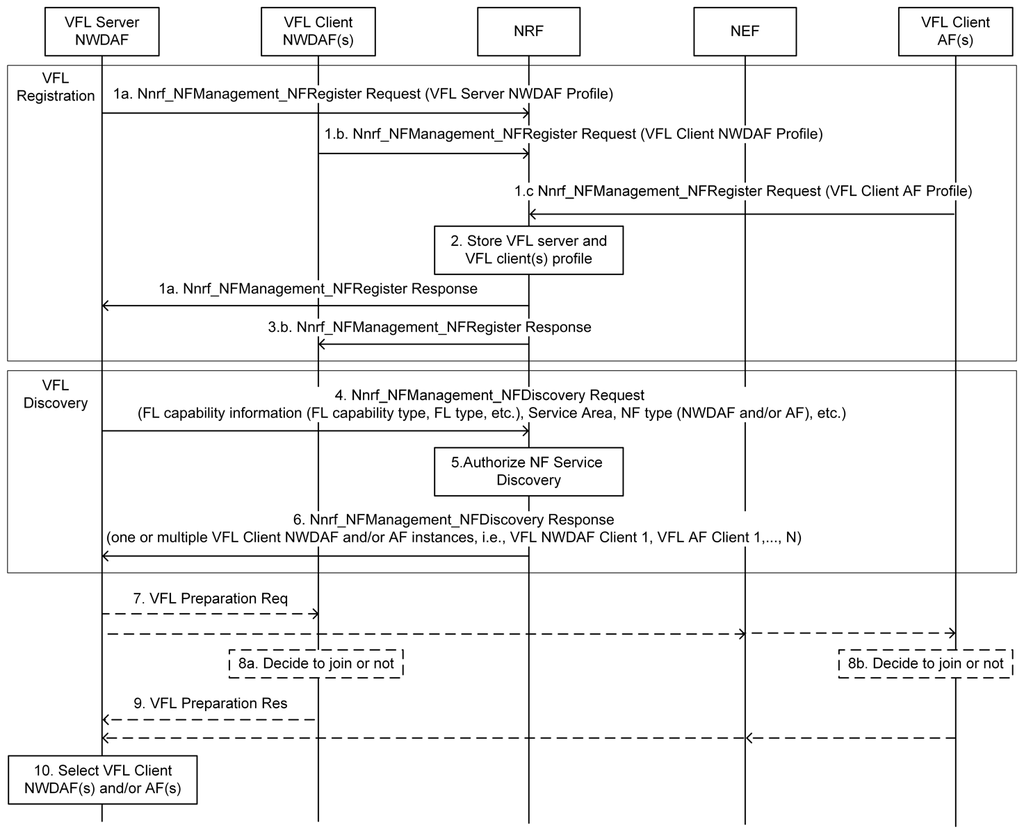
Figure 6.2X.X.X-X: Registration and Discovery procedure for Vertical Federated Learning when NWDAF is the VFL server and NWDAF(s) and/or AF(s) are the VFL client.
Steps 1 to 3 are the NWDAF and AF Registration procedures when the VFL server is NWDAF.
1-3. VFL Server/Client NWDAF (containing MTLF) and VFL Server/Client AF (containing model training capability) register to NRF with its NF profile, which includes NF Type (see clause 5.2.7.2.2 of TS 23.502 [X]), Analytics ID(s), Address information of NWDAF/AF, Service Area, FL capability information which includes FL capability type (i.e. FL server and/or FL client), FL type (i.e.VFL), optional Vendor ID(s), and Time interval supporting FL as described in clause 5.2.
Editor’s note: Whether and how to use Vendor ID(s) for untrusted AF is FFS.
For an untrusted AF, the NEF registers based on the configuration at the NRF within its NF profile information about the AF as specified in clause 6.2.2.3 and includes other information related to the AF capability, including FL capability information, which includes FL capability type (i.e. FL server and/or FL client), FL type (i.e. VFL), optional Vendor ID(s)).

Steps 4 to 6 are the NWDAF and AF Discovery procedures when the VFL server is NWDAF.
4-6. NWDAF containing MTLF (as the VFL server) determines that the ML Model requires VFL based on operator policy (e.g., a pre-configured list of ML Models), Analytic ID, Service Area/DNAI, data can not be obtained directly from data producer NF (e.g., due to privacy reasons).
NOTE: Step 4 in Figure 6.2X.X.X-X may be triggered at the VFL Server NWDAF by VFL server NWDAF itself or a request from an analytics consumer.
If the NWDAF containing MTLF can not perform as VFL Server NWDAF, the MTLF first discovers and selects VFL Server NWDAF from NRF by invoking the Nnrf_NFDiscovery_Request service operation. The following criteria might be used: Analytic ID of the VFL ML Model required, ML Model filter information as defined in clause 6.2A.2, Time Period of Interest, Service Area, FL capability information (FL capability Type (i.e. FL server and/or FL client), FL type (i.e. VFL), and optional Vendor ID(s)).
Once the VFL Server NWDAF is determined, the VFL Server NWDAF discovers other NWDAF(s) containing MTLF and/or AF(s) as VFL Client from NRF by invoking the Nnrf_NFDiscovery_Request service operation. The following criteria might be used: Analytic ID of the ML Model required, FL capability information (FL capability Type (i.e. FL client), FL type (i.e. VFL), optional Vendor ID(s)), Service Area, NF type(s) of data sources from which the VFL Client NWDAF is able to collect data for local ML Model training, and Time Period of Interest.

7. VFL Server NWDAF sends Federated Learning preparation request to the VFL NWDAF Client(s), using Nnwdaf_MLModelTraining_Subscribe or Nnwdaf_MLModelTrainingInfo_Request service, and/or the VFL AF Client(s), using Naf_MLModelTraining_Subscribe or Naf_MLModelTrainingInfo_Request service, with the ML Preparation Flag, to check if the VFL Client NWDAF(s) and VFL Client AF(s) can meet the ML Model training requirement (e.g. Analytics ID, Data Availability requirement, FL Availability time requirement (time span needed for the FL process), etc.). Data Availability requirement includes a list of Event IDs of the local data for training, and may also include the dataset statistical properties, the time window of the data samples and the minimum number of data samples. In the case of untrusted AF Client(s), the Nnef _MLModelTraining_Subscribe or NnefMLModelTrainingInfo_Request service can be used by the VFL NWDAF Server with the ML Preparation Flag.
Editor’s note: Whether to use new service operations in Step 8 is FFS.

8. VFL Client NWDAF(s) and/or VFL Client AF(s) checks if it can meet the ML Model training requirement and decide whether to join the Federated Learning process based on operator policy (e.g., pre-configured list of ML Models) and/or implementation. Example criteria used by VFL Client NWDAF(s) may be based on its data availability and time availability, computation and communication capability, etc.
9. VFL Client NWDAF(s) invokes Nnwdaf_MLModelTraining_Notify or Nnwdaf_MLModelTraining_Subscribe response or Nnwdaf_MLModelTrainingInfo_Request response service operation, and/or the VFL Client AF(s) invokes Naf_MLModelTraining_Subscribe response, Naf_MLModelTraining_Subscribe response, to indicate to the VFL Server NWDAF whether it will join the VFL procedure and may include the reason in the response message if it cannot join the VFL process. The untrusted VFL Client AF(s) invokes Nnef_MLModelTraining_Notify or Nnef_MLModelTraining_Subscribe response or Nnef_MLModelTrainingInfo_Request response service operation.
10. VFL Server NWDAF determines the VFL Client NWDAF(s) and/or VFL Client AF(s) to be involved in the VFL procedures based on the information received in step 6 and other information received in step 10 (if available).
Editor's note: Steps 7-10 may be further updated depending on agreements on how the sample and feature alignment procedure should be implemented.

* * * * End of changes * * *

