**3GPP TSG-RAN WG4 Meeting #112 R4-241xxxx**

**Maastricht, Netherlands, August 19th – August 23rd, 2024**

**Agenda item:** 6.2.3

**Source:** Moderator (vivo)

**Title:** Ad-hoc meeting minutes for [112][331] NR_FR1_TRP_TRS_enh

**Document for:** Information

# Introduction

This is ad-hoc meeting minutes for Rel-18 FR1 TRP TRS WI.

# Topic #1: Test methodology related issues

### Sub-topic 1-1 test method issues

**Issue 1-1-1: Clarification of voltage environmental requirement**

* Proposals
  + **CR R4-2411243 agreeable or not?**
* Recommended WF
  + TBD

*Agreements:*

*CR R4-2411243 is agreeable.*

**Issue 1-1-2: adding RC lab alignment results and update the outcome**

* Proposals
  + **Proposal 1: It is proposed to update the RC lab alignment and RC harmonization outcome by taking Samsung RC lab’s results into account. (Samsung)**
* Recommended WF
  + TBD.

**Issue 1-1-3: Whether the updated RC lab alignment and harmonization outcome agreeable?**

* Proposals
  + **CR R4-2412051 agreeable or not?**
* Recommended WF
  + TBD.

*Agreements:*

CR R4-2412051 is agreeable.

**Issue 1-1-4: How to treat RC harmonization activity for low bands (in Rel-18 or Rel-19)?**

* Proposals
  + **Proposal 1: RAN4 to further study RC lab alignment and RC harmonization at FR1 low band especially for TRS. (Samsung)**
* Recommended WF
  + TBD.

*Agreements:*

*RAN4 recommend RAN plenary to consider the RC lab alignment and harmonization at FR1 low band as scope in Rel-19 OTA WI.*

# Topic #2: Rel-18 TRP TRS requirements

### Sub-topic 2-1 Rel-18 TRP TRS requirements work

***Moderator:*** *the background information review of Rel-17 requirements based on the data pool in R4-2212818:*

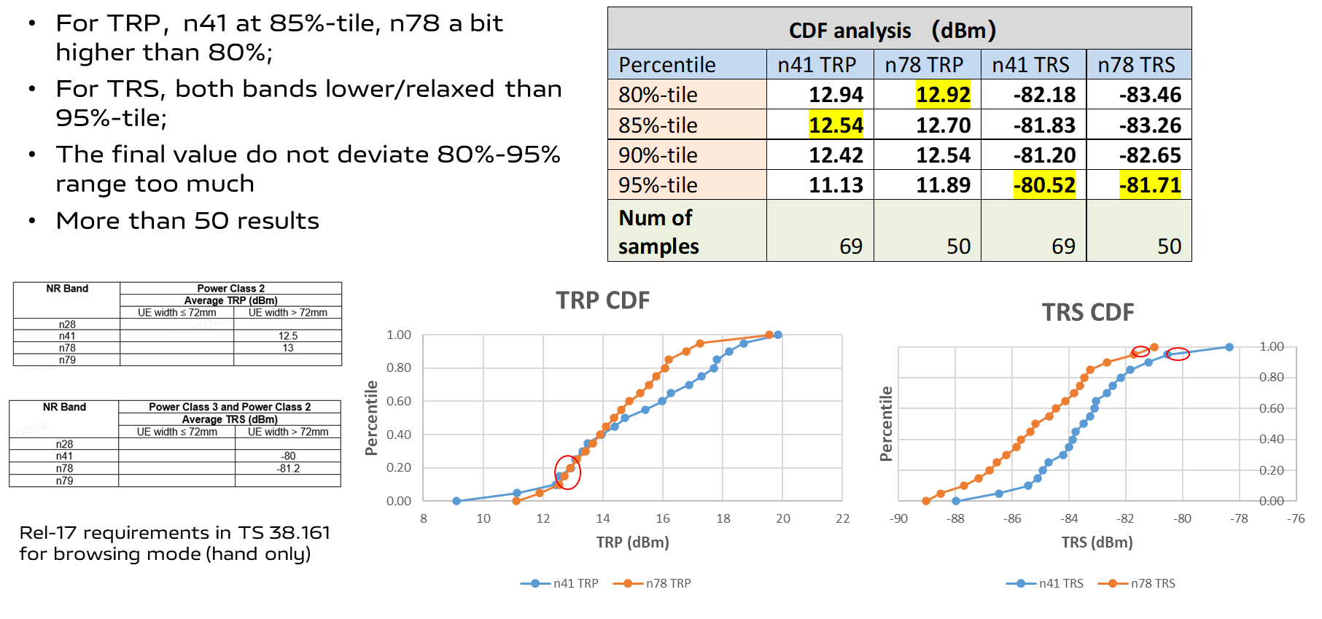

*The analysis of Rel-18 data pool CDF and passing rate in R4-2408098:*



***Moderator:*** *It should be emphasized that the group stick to the agreed per-band CDF discussion approach. The overall passing rate is just for information.*

***Moderator:*** *The LTE BHH requirements defined in other SDOs outside are listed in Annex part of this summary, which is just for sharing industry information. RAN4 will not specify NR requirements based on LTE offset approach.*

**Issue 2-1-1: Requirements for Rel-18 TRP TRS based on measurement campaign data pool**

* Proposals
  + 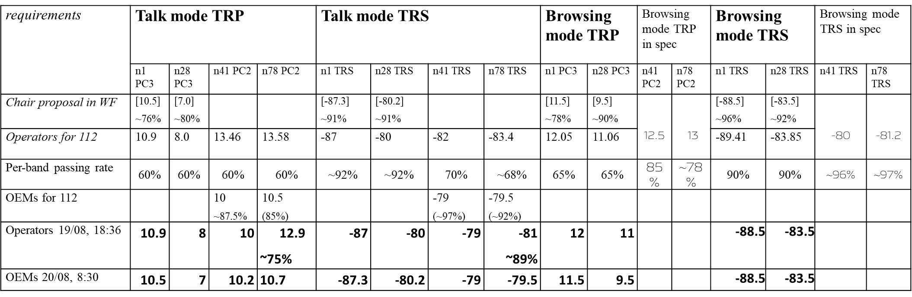**Discuss the updated proposals from companies**
* Recommended WF
  + Discuss and agree TRP/TRS requirements

**Discussions in ad-hoc:**

Keysight: whether 0dB TT is assumed?

Moderator: this is RAN4 core requirements discussion without TT.

VDF: we are OK with regional approach and timeline-based approach.

Apple: RAN4 define min requirements for global bands, regional requirements was not even in LTE phase. Other SDOs can define their regional requirements on top of RAN4 requirements. Timeline-based two sets requirements can be further discussed.

TIM: we are OK to consider both regional approach and timeline-based approach. If no single converged value for critical bands. Some RAN4 regulatory requirements are regional based requirements.

Huawei: 3GPP is not the place to specify regional requirements.

OPPO: share similar concerns as Huawei. Regional requirements shall not be defined in RAN4.

Samsung: same understanding as other UE vendors. We should focus on minimum requirements. Other region can define their own requirements.

TIM: we did a lot of efforts internally in the summer break. What is the way to go? We need compromise from both sides.

VDF: the regional approach is trying to help define both global requirements and region requirements. Encourage OEMs to consider this way to move forward.

Huawei: we also did a lot work to find compromised solutions.

Orange: band n28 and n78 are critical bands.

KS: minimum and recommended requirements in TS37.544. maybe recommended requirements can be adopted as regional requirements. This could be a simpler way to go.

Apple: most phones will be global phones, the regional requirements will not provide much help. RAN5 test spec is release independent. There is a chance the time-based approach can be adopted in 3GPP. We should control which release to update and send the outcome to RAN5.

TIM: we should focus on critical bands if we use timeline-based approach. The requirements can be captured in the spec with a note. WF is not workable for this issue.

Huawei: ETSI have two tables, one for each timeline in the spec.

OPPO: we suggest to capture 7dBm in Rel-18. New value e.g. 7.5dBm in Rel-19.

TIM: we need to check the values. The min value in REL-18 is also important to us.

VDF: we can check. Whether 7dBm is OK.

Apple: can we agree high-level timeline approach for band n28 and n78?

Apple: the timeline approach should be only used for very few critical cases, rather than other requirements. We are not OK to include TRS and other bands. We should limit the case for timeline approach if adopted.

TIM: for example, maybe n1 does not need this approach. Talk mode for n28 and n78 TRP are most critical cases.

Huawei: timeline approach should also consider reasonable value for future release, e.g. 7.5dBm for n28 TRP.

VDF: at least for band n28 browsing mode, we suggest not to exclude.

Samsung: we agree with Apple.

OPPO: the value also defined this meeting?

Xiaomi: we are not sure whether we can define higher value for future release this meeting.

Samsung: we think we focus on min requirement of REL-18.

DT: we can not agree Rel-18 requirements, if Rel-19 or future release value is not decided.

Huawei: put absolute date in the spec for higher value table.

Apple: we can leave the exact timing to RAN5 test specifications development. Delta value can be in [].

Orange: instead of [ ], we suggest a range for delta value.

Samsung/Xiaomi/OPPO/Apple: this timeline approach should be a package with requirements in last meeting WF being agreed.

Operators: we will check the latest values from OEMs.

Tentative Agreements:

RAN4 define a set of minimum requirements in REL-18, and also specify higher requirements for n28 and n78 talk mode TRP value in future release(s), e.g., Rel-19. RAN4 conclude all the requirements this meeting.

* FFS delta value for future release.
* FFS how to implement REL-18 specification.
* FFS browsing mode.

### Sub-topic 2-2 CR for approval

**Issue 2-2-1: CR to TS 38.161 on Rel-18 TRP TRS requirements**

* Proposals
  + **Proposal 1: approve the CR on Rel-18 TRP TRS requirement based on the outcome this meeting. R4-2412053 is the starting point.**
* Recommended WF
  + TBA

Moderator: Revise the CR to capture final outcome