**3GPP TSG-RAN WG4 Meeting #112 R4-2413431**

**Maastricht, Netherlands, August 19th – August 23rd, 2024**

**Agenda item:** 6.2.3

**Source:** Moderator (vivo)

**Title:** Topic summary for [112][331] NR_FR1_TRP_TRS_enh

**Document for:** Information

# Introduction

This summary covers the discussions for Rel-18 FR1 TRP TRS WI. This meeting is the final meeting to conclude Rel-18 TRP TRS requirements.

# Topic #1: Test methodology related issues

## Companies’ contributions summary

|  |  |  |
| --- | --- | --- |
| **T-doc number** | **Company** | **Proposals / Observations** |
| R4-2411243 | Keysight Technologies UK Ltd, MVG, Rohde & Schwarz, ETS-Lindgren | **CR for** **Clarification of voltage environmental requirement** |
| R4-2411244 | Keysight Technologies UK Ltd, MVG, Rohde & Schwarz, ETS-Lindgren | **Cat A** |
| R4-2411699 | Samsung | RC measurement results for band n28 from Samsung |
| R4-2411700 | Samsung | **Observation 1: all 6 RC labs are aligned well except for low band TRS**  **Observation 2: Samsung RC results for low band TRS are actually close to AC reference value**  **Proposal 1: It is proposed to update the RC lab alignment and RC harmonization outcome by taking Samsung RC lab’s results into account**  The corresponding CR to reflect the update can be found in R4-2412051  **Proposal 2: RAN4 to further study RC lab alignment and RC harmonization at FR1 low band especially for TRS.** |
| R4-2412049 | vivo | Final Analysis of 3GPP Rel-18 TRP TRS AC lab alignment and RC harmonization measurement results. Updated with additional n28 results from lab 9. |
| R4-2412051 | vivo, Samsung | CR to TR 38.870 on updating RC harmonization results |
| R4-2412052 | vivo | CR to TS 38.161 on alternative RC test method |

## Open issues summary

### Sub-topic 1-1 test method issues

**Issue 1-1-1: Clarification of voltage environmental requirement**

* Proposals
  + **CR R4-2411243 agreeable or not?**
* Recommended WF
  + TBD

**Issue 1-1-2: adding RC lab alignment results and update the outcome**

* Proposals
  + **Proposal 1: It is proposed to update the RC lab alignment and RC harmonization outcome by taking Samsung RC lab’s results into account. (Samsung)**
* Recommended WF
  + TBD.

**Issue 1-1-3: Whether the updated RC lab alignment and harmonization outcome agreeable?**

* Proposals
  + **CR R4-2412051 agreeable or not?**
* Recommended WF
  + TBD.

**Issue 1-1-4: How to treat RC harmonization activity for low bands (in Rel-18 or Rel-19)?**

* Proposals
  + **Proposal 1: RAN4 to further study RC lab alignment and RC harmonization at FR1 low band especially for TRS. (Samsung)**
* Recommended WF
  + TBD.

# Topic #2: Rel-18 TRP TRS requirements

## Companies’ contributions summary

|  |  |  |
| --- | --- | --- |
| **T-doc number** | **Company** | **Proposals / Observations** |
| R4-2411305 | Apple, vivo, Huawei, HiSilicon, OPPO, Samsung, Xiaomi | **Observation 1: Based on the analysis of the smartphone measurement results and statistics of the UE information pool, all the final requirements should be defined within 80%-95% percentile of the CDF.**  **Observation 2: It is important to maintain the integrity of the OTA requirements overall in the specification; e.g., a meaningful gap in performance between browsing and talk mode requirements is expected due to impact of the head phantom.**  **Proposal 1: RAN4 to confirm the Chair’s proposed values in R4-2410765**  **Proposal 2: RAN4 to adopt the OEM Compromise values for the n41 and n78 talk mode requirements.** |
| R4-2412053 | vivo | CR to TS 38.161 on Rel-18 FR1 TRP TRS requirements |
| R4-2413450 | Telecom Italia S.p.A., Orange, Vodafone, BT plc, Deutsche Telekom, NTT DOCOMO | ***Observation 1:*** *The values proposed in Fukuoka are already several dBs, i.e., from 2 to 4 dBm depending on the band and on TRP/TRS, below the internal reference values that are currently used for device certification and network planning.*  ***Observation 2:*** *Such values, if adopted, will already have not negligible impacts on the current network deployment and related plans. Further relaxation will imply a not sustainable network deployment impacts for the operators.*  ***Observation 3:*** *It must be highlighted that according to the measurement results, there are devices providing really good performances both in terms of TRP and TRS, demonstrating that high performances are achievable and depends on the design of the devices.*  ***Observation 4****: The adoption of very low minimum performance requirements will flatten the possibility to have good performing devices on the market, thus further impacting the operators network deployment as well as the users quality of experience.*  ***Observation 5:*** *Finally, it must be highlighted that in the device certification process, the addition of any TT and MU is de facto further relaxing the specified minimum performance requirements. Therefore, TT and MU must be considered in the balance when defining the minimum performance requirements.*  ***Proposal 1****: Adopt the following values as FR1 OTA TRP/TRS minimum performance requirements for n1 and n28 Talk Mode:*   |  |  |  |  |  | | --- | --- | --- | --- | --- | |  | **Talk mode TRP** | | **Talk mode TRS** | | | n1 PC3 | n28 PC3 | n1 TRS | n28 TRS | | *requirements* | 10.9 | 8.0 | -87 | -80 |   ***Proposal 2****: Adopt the following values as FR1 OTA TRP/TRS minimum performance requirements for n1 and n28 Browsing Mode (note that both TRP and TRS values have been relaxed with respect to the initial operators’ proposal at the RAN4#111 meeting):*   |  |  |  |  |  | | --- | --- | --- | --- | --- | |  | **Browsing mode TRP** | | **Browsing mode TRS** | | | n1 PC3 | n28 PC3 | n1 TRS | n28 TRS | | *requirements* | 12.05 | 11.06 | -89.41 | -83.85 |   ***Proposal 3****: Adopt the following values as FR1 OTA TRP/TRS minimum performance requirements for n41 and n78 Talk Mode (note that TRS values have been relaxed with respect to the initial operators’ proposal at the RAN4#111 meeting):*   |  |  |  |  |  | | --- | --- | --- | --- | --- | |  | **Talk mode TRP** | | **Talk mode TRS** | | | n41 | n78 | n41 TRS | n78 TRS | | *requirements* | 13.46 | 13.58 | -82 | -83.4 |   ***Observation 6:*** *It shall be noted that the values proposed in Proposal 1, Proposal 2, and Proposal 3 are intended as the compromise values according to the current framework.*  ***Observation 7****: The operators strongly believes that the ETSI approach on TT could bring benefits if adopted also in 3GPP providing more flexibility in the minimum performance requirements definition.*  The following proposals are formulated as an alternative to Proposal 1, Proposal 2, and Proposal 3 above:  ***Proposal 4****: To adopt TT = 0.*  ***Proposal 5****: Values for TRP/TRS minimum performance requirements based on TT = 0 shall be discussed during the meeting.* |
|  |  |  |

## Open issues summary

### Sub-topic 2-1 Rel-18 TRP TRS requirements work

***Moderator:*** *the background information review of Rel-17 requirements based on the data pool in R4-2212818:*

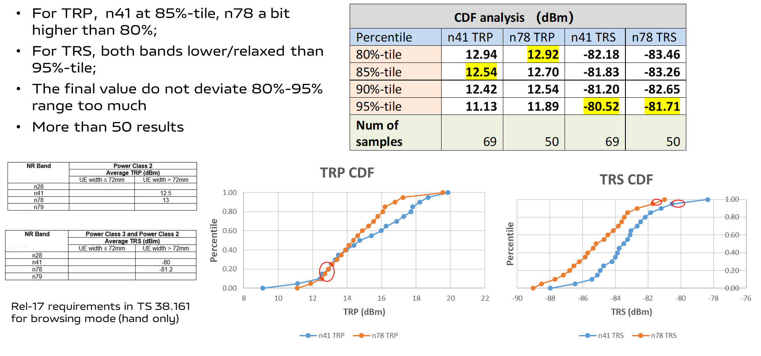

*The analysis of Rel-18 data pool CDF and passing rate in R4-2408098:*



***Moderator:*** *It should be emphasized that the group stick to the agreed per-band CDF discussion approach. The overall passing rate is just for information.*

***Moderator:*** *The LTE requirements defined in other SDOs outside are listed in Annex part of this summary, which is just for sharing industry information. RAN4 will not specify NR requirements based on LTE offset approach.*

**Issue 2-1-1: Requirements for Rel-18 TRP TRS based on measurement campaign data pool**

* Proposals
  + **Proposal 1: Conclude the TRP TRS requirements based on the proposals this meeting.**

|  |  |  |  |  |  |  |  |  |  |  |  |  |  |  |  |  |
| --- | --- | --- | --- | --- | --- | --- | --- | --- | --- | --- | --- | --- | --- | --- | --- | --- |
| ***Req.*** | **Talk mode TRP** | | | | **Talk mode TRS** | | | | **Browsing mode TRP** | | ***Browsing mode TRP in spec*** | | **Browsing mode TRS** | | ***Browsing mode TRS in spec*** | |
| **n1 PC3** | **n28 PC3** | **n41 PC2** | **n78 PC2** | **n1 TRS** | **n28 TRS** | **n41 TRS** | **n78 TRS** | **n1 PC3** | **n28 PC3** | ***n41 PC2*** | ***n78 PC2*** | **n1 TRS** | **n28 TRS** | ***n41 TRS*** | ***n78 TRS*** |
| ***Chair*** | **[10.5]** | **[7.0]** |  |  | **[-87.3]** | **[-80.2]** |  |  | **[11.5]** | **[9.5]** | ***12.5*** | ***13*** | **[-88.5]** | **[-83.5]** | ***-80*** | ***-81.2*** |
| ***Operators new*** | **10.9** | **8.0** | **13.46** | **13.58** | **-87** | **-80** | **-82** | **-83.4** | **12.05** | **11.06** | **-89.41** | **-83.85** |
| **OEMs new** |  |  | **10** | **10.5** |  |  | **-79** | **-79.5** |  |  |  |  |

* Recommended WF
  + Discuss and agree TRP/TRS requirements

***Moderator:*** *The Rel-18 TT value was recommended to RAN5 in Reply LS R4-2406079:*

*RAN4 has discussed the TT value, the agreements are listed as following:*

* *TT value is recommended as a ratio of MU, where TT=0.62*MU; according to currently available analysis of MU of AC system in RAN4, these TT values should be:*
  + *For browsing mode: TRP TT is 1.1dB for above 3GHz bands and 1dB for below 3GHz bands, TRS TT is 1.3 dB for above 3GHz bands and 1.2 dB for below 3GHz bands;*
  + *For talk mode: TRP TT is 1.2dB for above 3GHz bands and 1.1dB for below 3GHz bands, TRS TT is 1.5 dB for above 3GHz bands and 1.4 dB for below 3GHz bands;*

**Issue 2-1-2: TT value for Rel-18 TRP TRS based on measurement campaign data pool**

* Proposals
  + **Proposal 1: To adopt TT = 0.**
* Recommended WF
  + Discuss and confirm TT value

### Sub-topic 2-2 CR for approval

**Issue 2-2-1: CR to TS 38.161 on Rel-18 TRP TRS requirements**

* Proposals
  + **Proposal 1: approve the CR on Rel-18 TRP TRS requirement based on the outcome this meeting. R4-2412053 is the starting point.**
* Recommended WF
  + TBA

# Annex: Industry LTE requirements information (just for infor)

#### ETSI LTE BHH requirements-PDA hand

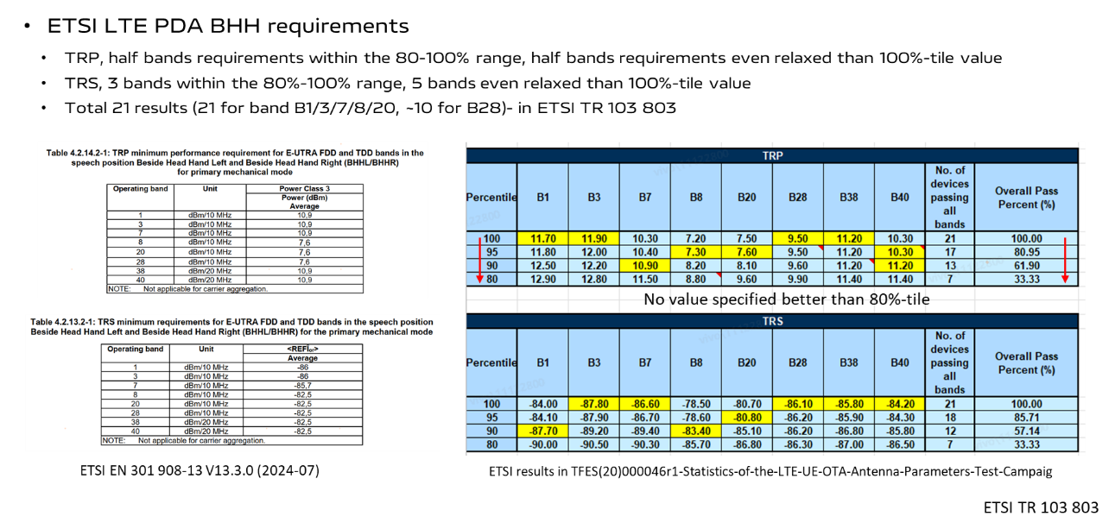

#### ETSI LTE BHH requirements- Wide Grip hand

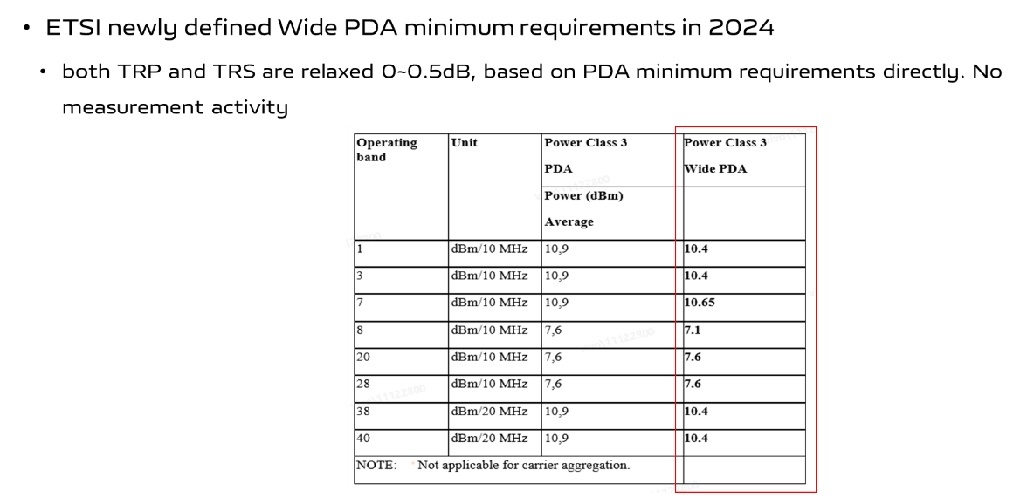

#### CCSA LTE BHH requirements- PDA and Wide Grip hand

