3GPP TSG-RAN WG4 Meeting #112 R4-24xxxxx
Maastricht, Netherlands, 19th – 23rd August, 2024
Source: Samsung
Title: TP to TR 38.908 U6GHz EEIRP mask requirement
Agenda item: 8.11.2
Document for: Approval

1. Introduction
In ITU-R world radiocommunication conference (WRC) in Nov. 20 - Dec. 15 2023, the frequency band of 6 425-7 125 MHz was identified in every ITU region as in the RR Footnotes 5.6A12, 5.6B12 and 5.6C12 with associated technical condition of limits on the expected equivalent isotropically radiated power (EIRP) spectral density of IMT base-stations, for the purpose of protecting earth-to-space fixed satellite services (FSS) as in Resolution 220 (WRC-23). Based on the newly released ITU-R regulation, the expected EIRP limits have been established which require the harmonized specification for compliance tests to be developed as the task in 3GPP.
In the RAN#103 meeting, new WI for Rel-19 BS RF evolution has been approved and it’s expected to start the normative work from April meeting. In this Text Proposal (TP), the section for U6GHz EEIRP mask requirements is provided.

<Start of the change>

5 RF requirement
OTA spatial emission requirements are defined to set upper limits on radiated power in specific directions. This requirement shall be applied to BS operating in band n104 to protect FSS (Earth-to-space) satellite receiver.
For BS type 1-H and BS type 1-O operating in band n104, the Expected EIRP (EEIRP) in the frequency range 6425 – 7075 MHz, shall not exceed the values specified in table 5-1.
Expected EIRP (EEIRP) is defined as the average value of the EIRP, with the averaging being performed over the supported weighted beamforming directions within the BS horizontal and vertical steering range and the averaging being performed over horizontal angles from −180° to +180° and the specified elevation angle range θ_{HL} ≤ θ < θ_{HH} in table 5-1.
Table 5-1: EEIRP limits as function of elevation above horizon
Elevation angular range  θ_{HL} ≤ θ < θ_{HH} (Degrees) | EEIRP limit  (dBm/MHz)
0<θ<5 | 27
5<θ<10 | 23
10<θ<15 | 19
15<θ<20 | 18
20<θ<30 | 16
30<θ<60 | 15
60<θ<90 | 15
NOTE: The requirement shall apply to all supported mechanical tilts.

The definitions of elevation angle θ_{HL} and θ_{HH} are illustrated in Figure 5-1.

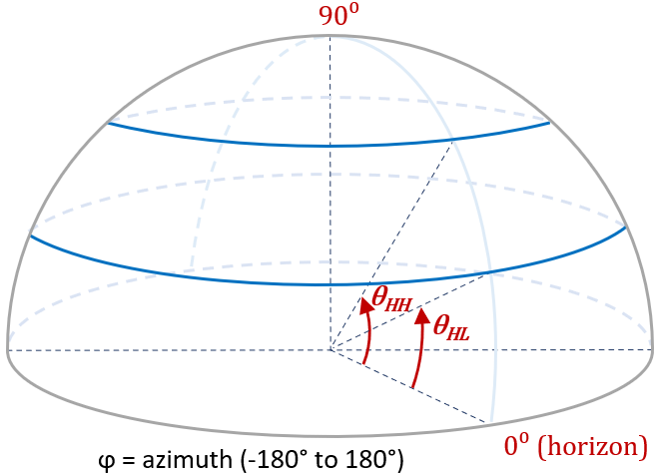
Figure 5-1: Definitions of θ_{HL} and θ_{HH} angles.
<End of the change>

