3GPP TSG-RAN WG4 Meeting #112 draft R4-2413504

Maastricht, Netherlands, 19th – 23rd August, 2024

**Title: Draft LS on reuse of FR2 UE conformance test requirements for NCR testing purposes**

**Response to: -**

**Release: Rel-18**

**Work Item: NR network-controlled repeaters (NR_netcon_repeater-Perf)**

**Source: Huawei**

**To:** **RAN WG5**

**Cc: -**

**Contact person: Michal Szydelko**

[**Michal.szydelko@huawei.com**](mailto:Michal.szydelko@huawei.com)

**Send any reply LS to: 3GPP Liaisons Coordinator,** [**mailto:3GPPLiaison@etsi.org**](mailto:3GPPLiaison@etsi.org)

**Attachments:** **-**

# 1 Overall description

During RAN4#111 meeting, Rel-18 work item on NR network-controlled repeaters has been declared completed. Network Controlled Repeater (NCR) is composed of NCR-Fwd (Forward) and NCR-MT (Mobile Termination) entities. While NCR-Fwd entity has similar functionality as Rel-17 NR Repeater, the newly introduced NCR-MT entity enables control link communication over Uu interface, to exchange side control information.

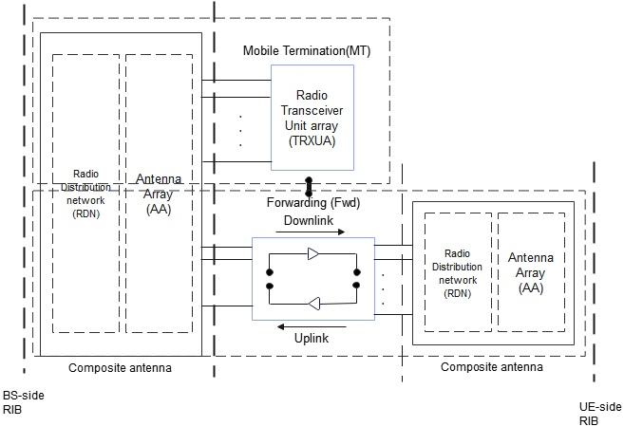

Practical NCR-MT implementation of the NCR type 2-O is expected to reuse FR2 UE chipset. Therefore, related MT-specific RF requirements were following FR2 UE specification. When it comes to NCR type 2-O conformance testing (TS 38.115-2), it was decided in RAN4 to simply reuse some of the RAN5 test requirements (including TT values) for MT-specific testing, as captured in TS 38.521-2. More specifically, the following tests in TS 38.115-2 refer to RAN5 specification TS 38.521-2:

OTA ACLR, OTA OBUE, OTA Tx spurious emissions, OTA transmitter transient period, OTA reference sensitivity, OTA maximum input level, OTA adjacent channel selectivity, OTA blocking characteristics, OTA spurious emissions

Due to NCR product dimensions expected to be not smaller than the FR2 UE, the device size limitations (i.e. 30cm) captured in TS 38.521-2 were also reflected in TS 38.115-2.

In case of OTA maximum input level, OTA ACS and OTA blocking characteristics, it was observed that those test requirements in TS 38.521-2 do have open issues, or are considered as not testable due to OTA testability issues. Those test limitations were also properly reflected in TS 38.115-2 specification.

It is not expected that RAN5 initiates any additional work relating to NCR or expands the scope of any other WI based on this LS, however RAN WG4 would appreciate if RAN WG5 could inform RAN4 in case open issues or testability issues of the above-mentioned requirements (i.e. OTA maximum input level, OTA ACS and OTA blocking characteristics) for UEs would be resolved as a result of other WI.

# 2 Actions

**To RAN WG5**

**ACTION:** It is not expected that RAN5 initiates any additional work relating to NCR or expands the scope of any other WI based on this LS, however RAN WG4 respectfully asks RAN WG5 to inform RAN4 in case open issues or testability issues of OTA maximum input level, OTA ACS and OTA blocking TS 38.521-2 would be resolved for UEs in other WI.

# 3 Dates of next RAN WG4 meetings

RAN4#112-bis 2024-10-14 - 2024-10-18 Hefei, China

RAN4#113 2024-11-18 - 2024-11-22 Orlando, US