**3GPP TSG-RAN WG4 Meeting #112 R4-2413884**

**Maastricht, Netherlands, Aug. 19th – Aug. 23rd, 2024**

**Agenda item:** 8.21.3

**Source:** Ericsson

**Title:** Coffee break discussion minutes for [112][222] Netw_Energy_NR_enh

**Document for:** Approval

# Introduction

This is the ad-hoc minutes for ad-hoc session for Netw_Energy_NR_enh WI.

**Issue 2-2-2: Case 1 - OD-SSB based deactivated SCell measurement before OD-SSB indication**

* Proposals
  + Option 1: Nokia, CMCC
    - The L3 deactivated SCell measurement requirement should be re-designed.
      * UE is not expected to perform any measurement on the deactivated SCell before OD-SSB is triggered.
        + The existing measurement requirements for a deactivated SCell do not apply.
* Discussion
  + Moderator: The issue includes both (Case #1, Scenario #2) and (Case #1, Scenario #2A)
* Tentative agreement:
  + In (Case #1 Scenario #2) and (Case #1, Scenario #2A), UE is not expected to perform any measurement on the deactivated SCell before OD-SSB is triggered.

**Issue 2-2-8: Case #1 and Scenario #2 - known SCell activation**

**Issue 2-2-9: Case #1 and Scenario #2 - unknown SCell activation**

* Proposals
  + Option 1: Ericsson, CATT
    - When OD-SSB transmission is earlier than the SCell activation command, UE follows the legacy Rel-15 known SCell activation requirement if the known cell condition is met.
      * FFS: Clarify that the SSB used in activation procedure is on-demand SSB
      * FFS: the OD-SSB transmission time instance A
* Discussion
* Tentative agreement:
  + In (Case #1, Scenario #2) for deactivated SCell activation, when OD-SSB transmission is earlier than the SCell activation command,
    - UE follows the legacy Rel-15 known SCell activation requirement if the known cell condition is met.
    - Otherwise, UE follows the legacy Rel-15 unknown SCell activation requirement
      * Clarify that the SSB used in activation procedure is OD-SSB
      * FFS: the known cell condition in (Case #1, Scenario #2)

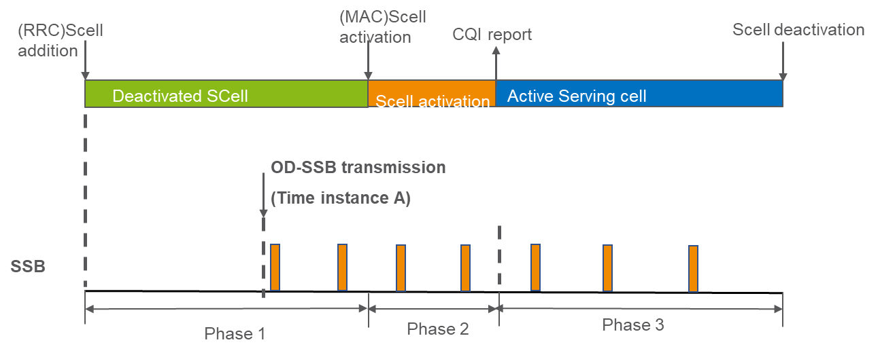

**Issue 2-2-10: Case #1 and Scenario #2A - unknown SCell activation**

* Proposals
  + Option 1: Nokia, CMCC, Ericsson, CATT
    - RAN4 shall specify the OD-SSB based unknown SCell activation delay in Case #1 and Scenario #2A.
      * Not to define known SCell activation in Case #1 and Scenario #2A
  + Option 1a: Ericsson, CATT
    - When OD-SSB transmission is together with the SCell activation command, UE follows the legacy Rel-15 unknown SCell activation requirement once the unknown cell condition is met.
      * FFS: Clarify that the SSB used in activation procedure is on-demand SSB
      * FFS: the OD-SSB transmission time instance A
* Discussion
* Tentative agreement:
  + RAN4 to only define unknown SCell activation in (Case #1, Scenario #2A).

**Issue 2-3-1: Case 2 Scenario 2 - Deactivated SCell measurement**

* Proposals
  + Option 1: Ericsson
    - The UE is assumed to perform measurement based on legacy SSB before UE receiving OD-SSB transmission indicated during deactivated Scell.
    - The UE is assumed to switch to OD-SSB to perform measurement/Scell activation when OD-SSB transmission is indicated.
  + Option 2: Nokia
    - RAN4 to discuss how to handle the measurement on the always-on SSBs and OD-SSBs.
      * The UE measurement based on always-on SSBs in the SCell shall be considered to reduce the SCell activation delay.
  + Option 3: CMCC
    - L3 measurement requirement after on-demand SSB triggering and during the SSB periodicity transition period should be re-designed.
  + Option 4: Xiaomi
    - For Rel19 NES capable UE, the requirements under case2 shall assume only OD-SSB to be used.
* Discussion
* Tentative agreement:
  + Further discussion

**Issue 2-4-3: Searcher assumption for OD-SSB**

* Proposals
  + Option 1: vivo
    - RAN4 to discuss the searcher assumption of OD-SSB based cell identification, which would impact the CSSF of intra-frequency L3 or L1 measurements.
* Discussion

Moderator: Any CSSF enhancement is better to capture in NR_RRM_Ph5.

* Recommended WF
  + Further discussion

**Issue 2-2-6: Case 1 - SCell activation known condition**

* Proposals
  + Option 1: CATT
    - RAN4 to discuss known condition of SCell activation based on on-demand SSB measurement considering the following possible aspects.
      * Option 1a: The configuration of the on-demand SSB and the measurement report.(Qualcomm)
      * Option 1b: The new L3 deactivated SCell measurement requirement.(CMCC for Scenario 2)
* Discussion
* Recommended WF
  + Further discussion